**–007翔鑫堡工業股份有限公司**

**報　　　告**

部　門： 系統開發部 編號：

報告人： 張軒瑜 日期： 2025 年 10 月 30 日

|  |  |
| --- | --- |
| 主  題 | MPS for ciMES系統需求規格書1.8.2 |
| 董事長 |  |
| 執  行  副  總 |  |
| 管  理  本  部 |  |
| 會  簽  部  門  意  見 |  |
| 部  門  主  管 |  |

sw7048



MPS for ciMES系統

需求規格書v1.8.2

MPS for ciMES System – Specification

系統整合二部

2025/10/30

Louis 製

目錄

一、 版本更新說明 2

二、 引言 4

01. 系統概述： 4

三、 系統程式與功能說明 5

**01.** **「MPS000 System connect」 (系統介接)** 5

**02.** **「MPS001 Print Material Sheet」MPS001 列印發料單** 7

**03.** **「MPS002 Reprint Material Sheet」MPS002 重列印發料單** 29

**04.** **「MPS003 Print Material Sheet (OEM Order)」MPS003 列印發料單(代工訂單)** 52

**05.** **「MPS004 Reprint Material Sheet (OEM Order)」MPS004重列印發料單(代工訂單)** 64

**06.** **「MPS005 Print Material Sheet (Replenishment)」MPS005 列印發料單(補料)** 75

**07.** **「MPS006 Reprint Material Sheet (Replenishment)」MPS006 重列印發料單(補料)** 90

**08.** **「MPS007 Print AA In/Out Sheet (Replenishment)」MPS007列印AA其他出入單據(補料)** 104

**09.** **「MPS008 Print AA Material Sheet A4 Format」MPS008 列印AA發料單(A4格式)** 109

**10.** **「MPS009 Print Material Sheet」MPS009 皮料欠數查詢與列印** 118

**11.** **「MPS010 Print Material Sheet」MPS010 皮料欠數查詢與列印 (OEM)** 127

**12.** **「MPS101 Print Pickup Form」MPS101 列印取料單** 135

**13.** **「MPS102 Reprint Pickup Form」MPS102 重列印取料單** 179

**14.** **「MPS103 Print Pickup Form (OEM Order)」MPS103列印取料單(代工訂單)** 215

**15.** **「MPS104 Reprint Pickup Form (OEM Order)」MPS104重列印取料單(代工訂單)** 229

**16.** **「MPS105 Print Transfer Sheet (Pickup Form)」MPS105列印轉交單(取料單)** 247

**17.** **「MPS106 Scan Transfer Sheet (Pickup Form)」MPS106掃描轉交單(取料單)** 254

**18.** **「MPS201 Pickup Form Status Change」MPS201 取料單狀態變更** 256

**19.** **「MPS202 Cancel Pickup Form」MPS202 取消取料單** 261

**20.** **「MPS203 PO Close」MPS203 訂單結案** 263

**21.** **「MPS301 Material Calling PA」MPS301 PA料號叫料** 266

**22.** **「MPS302 Material Calling UA」MPS302 UA料號叫料** 271

**23.** **「MPS303 Material Calling BA」MPS303 BA料號叫料** 276

**24.** **「MPS304 Material Calling FA」MPS304 FA料號叫料** 281

**25.** **「MPS305 Material Calling AA」MPS305 AA料號叫料** 286

26. **「MPS306 Material Calling (OEM PUF)」MPS306委託他廠代工叫料** 290

四、 附錄 295

1. 版本更新說明

|  |  |  |  |  |
| --- | --- | --- | --- | --- |
| 版次 | 修訂日期 | 更修者 | 描述 | 備註 |
| v1.0.0 | 2023/02/21 | 張軒瑜 | 系統建置 | 無需求單號 |
| v1.0.1 | 2023/02/28 | 張軒瑜 | 新增MPS006~MPS009，Material Calling PA、UA、BA、FA | 無需求單號 |
| v1.0.2 | 2023/03/17 | 張軒瑜 | 新增MPS005 Pickup Form Status Change | 無需求單號 |
| v1.0.3 | 2023/03/23 | 張軒瑜 | 新增MPS201、MPS202，取消取料單、訂單結案 | 無需求單號 |
| v1.0.4 | 2023/03/31 | 張軒瑜 | 新增MPS002 重列印發料單 | 無需求單號 |
| v1.0.5 | 2023/04/03 | 張軒瑜 | MPS001、MPS002新增資料JOIN條件 | 無需求單號 |
| v1.0.6 | 2023/04/05 | 張軒瑜 | MPS006~MPS009，可叫料時，按鈕顯示為綠色 | 無需求單號 |
| v1.0.7 | 2023/04/06 | 張軒瑜 | MPS001、MPS002無尺寸、有尺寸，判斷方式調整 | 無需求單號 |
| v1.0.8 | 2023/05/05 | 張軒瑜 | 新增MPS003 列印取料單 | 無需求單號 |
| v1.0.9 | 2023/05/08 | 張軒瑜 | 新增MPS010 發料單重印(代工訂單) | 無需求單號 |
| v1.1.0 | 2023/05/09 | 張軒瑜 | MPS001、MPS002 新增判斷是否為重包裝工單 | 無需求單號 |
| v1.1.1 | 2023/05/11 | 張軒瑜 | 移除所有FACTORY的JOIN條件 | 無需求單號 |
| v1.1.2 | 2023/05/12 | 張軒瑜 | MPS001、MPS002，材料名稱欄位調整 | 無需求單號 |
| v1.1.3 | 2023/05/15 | 張軒瑜 | 新增MPS011 列印取料單(代工訂單) | 無需求單號 |
| v1.1.4 | 2023/05/18 | 張軒瑜 | MPS001、MPS002，材料名稱欄位JOIN條件調整 | 無需求單號 |
| v1.1.5 | 2023/05/18 | 張軒瑜 | MPS003 [SEQUENCE]邏輯調整、MPS010搜尋條件MATERIAL_NAME條件調整 | 無需求單號 |
| v1.1.6 | 2023/06/01 | 張軒瑜 | 1.MPS003、MPS011，取消，取料單列印時，同時列印出發料單  2.MPS001、MPS002搜尋條件調整  3.程式編號調整  4.新增列印發料單(代工訂單) | 無需求單號 |
| v1.1.7 | 2023/06/17 | 張軒瑜 | 新增MPS005列印發料單(補料)，MPS006重列印發料單(補料) | 無需求單號 |
| v1.1.8 | 2023/06/20 | 張軒瑜 | 發料單邏輯調整、新增Model Name欄位 | 無需求單號 |
| v1.1.9 | 2023/06/27 | 張軒瑜 | 取料單邏輯調整 | 無需求單號 |
| v1.2.0 | 2023/07/03 | 張軒瑜 | 材料名稱全部改抓MATERIAL_SPEC | 無需求單號 |
| v1.2.1 | 2023/07/05 | 張軒瑜 | MPS301~MPS304 Material Calling PA、UA、BA、FA邏輯調整 | 無需求單號 |
| v1.2.2 | 2023/07/07 | 張軒瑜 | MPS001、MPS002，材料名稱欄位JOIN條件調整 | 無需求單號 |
| v1.2.3 | 2023/07/08 | 張軒瑜 | 發料單(MPS001~MPS004)、取料單(MPS001)邏輯調整 | 無需求單號 |
| v1.2.4 | 2023/07/12 | 張軒瑜 | 1.MPS001~MPS006 調整排序欄位  2.MPS301~MPS304 Material Calling PA、UA、BA、FA增加參數 | 無需求單號 |
| v1.2.5 | 2023/07/14 | 張軒瑜 | 發料單 補料(MPS005~6) 改使用Procedure | 無需求單號 |
| v1.2.6 | 2023/07/28 | 張軒瑜 | 1.MPS001、002料號名稱位置調整  2.MPS001、002合併發料單增加欄位  3.MPS003、004查詢條件調整 | 無需求單號 |
| v1.2.7 | 2023/08/01 | 張軒瑜 | MPS005、MPS006 Usage_Qty邏輯調整 | 無需求單號 |
| v1.2.8 | 2023/08/09 | 張軒瑜 | 發料單、取料單，新增Production Line欄位 | 無需求單號 |
| v1.2.9 | 2023/08/12 | 張軒瑜 | 發料單新增搜尋條件，取料單搜尋邏輯調整 | 無需求單號 |
| v1.3.0 | 2023/08/14 | 張軒瑜 | 1.MPS001、MPS002新增預補原因  2.新增重印取料單(MPS102)  3.Production Line欄位位置調整 | 無需求單號 |
| v1.3.1 | 2023/08/15 | 張軒瑜 | MPS301~4，新增 取料單需列印過，才可進行叫料 | 無需求單號 |
| v1.3.2 | 2023/08/16 | 張軒瑜 | 調整取料單列印類型的判斷邏輯 | 無需求單號 |
| v1.3.3 | 2023/08/17 | 張軒瑜 | 調整補料發料單，小布標列印為有尺寸格式 | 無需求單號 |
| v1.3.4 | 2023/08/18 | 張軒瑜 | MPS001、MPS002新增Kind欄位、新增Null選項 | 無需求單號 |
| v1.3.5 | 2023/08/21 | 張軒瑜 | 1.MPS001、MPS002新增Null選項  2.新增MPS305，AA叫料  3.MPS101、MPS102，新增AA SQL Case | 無需求單號 |
| v1.3.6 | 2023/08/25 | 張軒瑜 | MPS301~5，改使用PUFGROUP欄位叫料 | 無需求單號 |
| v1.3.7 | 2023/08/31 | 張軒瑜 | 排除已刪除的發料單與取料單 | 無需求單號 |
| v1.3.8 | 2023/09/12 | 張軒瑜 | MPS005、MPS006新增補料單號欄位 | 無需求單號 |
| v1.3.9 | 2023/09/13 | 張軒瑜 | MPS002、MSP004、MPS006、MPS102新增重印原因，並顯示重印次數 | 無需求單號 |
| v1.4.0 | 2023/09/27 | 張軒瑜 | 1.MPS001,MPS002,MPS005,MPS006,MPS101,MPS102顯示出貨國家  2.MPS101,MPS102取料單，發料單號欄位改為C_MATERIAL_SHEET_NO  3.MPS101,MPS102,MPS103取料單，排除已Terminate的取料單 | 無需求單號 |
| v1.4.1 | 2023/10/03 | Louis | MPS005、MPS006 add search criteria : Replenishment No | 無需求單號 |
| v1.4.2 | 2023/10/10 | Louis | MPS105列印轉交單(取料單)、MPS106掃描轉交單(取料單) | 需求單號後補 |
| v1.4.3 | 2023/10/14 | Louis | MPS101、MPS102新增顯示預縮、裁中條、裁小條AA料號資訊 | SHC-R230900044 |
| v1.4.4 | 2023/10/25 | Louis | 1. MPS101,MPS102取料單 scheduling dispatch date改為生產進度表: CUT_START_DATE 面部PA預計開始日  2. MPS105列印轉交單欄位調整 (remove C_MATERIAL_SHEET_NO column ) | 無需求單號 |
| V1.4.5 | 2023/11/01 | Louis | MPS101、MPS102新增顯示預縮、裁中條、裁小條AA料號資訊 (for 合併取料單) | SHC-R230900044 |
| V1.4.6 | 2023/11/06 | Louis | 1. MPS105列印轉交單(取料單)，新增針車線別欄位 2. 調整MPS101、102、105 SQL查詢效能 | 無需求單號 |
| V1.4.7 | 2023/11/09 | Louis | 合併取料單上新增合併取料單號，合併取料單迴轉Bug | SHC-R231100005 |
| V1.4.9 | 2023/11/21 | Louis | 委外代工發料單、取料單新增領料廠別  發料單數量讀取ERP_OSISSUE : QUANTITY | 無需求單號  (Karen提出) |
| V1.5.0 | 2023/11/28 | Louis | 委外代工發料單排除已刪除發料單 ( search T1.DELETE_FLAG <> 'X') | 無需求單號 |
| V1.5.1 | 2024/01/03 | Louis | 委外代工發料單不分批次，但ERP_SOBatch分批次，調整查詢畫面與取料單列印SQL改以PO_NO為join條件 | 無需求單號 |
| V1.5.2 | 2024/01/24 | Louis | 委外代工取料單新增重新列印功能 | 無需求單號 |
| V1.5.3 | 2024/03/06 | Louis | 取料單狀態改變，掃描Dispatch功能時，判斷非BA取料單才需進行Calling的檢查 | 無需求單號 |
| V1.5.4 | 2024/06/14 | Louis | 補料發料單列印SAP計畫性預補作業” 預補備料工單”Order No | 無需求單號 |
| V1.5.5 | 2024/07/13 | Louis | PA AA UA BA FA 叫料畫面新增類別、刪除取料單Mat. Standard onhand date | 無需求單號 |
| V1.5.6 | 2024/09/05 | Louis | PA取料單新增類別、調整取料單Scheduling Mat. Dispatch date | SHC-R240800015 |
| V1.5.7 | 2024/10/24 | Louis | MPS003列印委外代工發料單查詢畫面新增”排除料號”功能、新增Supplier Code查詢條件、 | 無需求單號 |
| V1.5.8 | 2024/10/29 | Louis | 新增MPS007 AA補料列印其他出其他入單據、補料發料單新增列印開補申請料號 | 無需求單號 |
| V1.5.9 | 2024/11/06 | Louis | MPS003列印委外代工發料單查詢畫面新增”Article”搜尋功能 | 無需求單號 |
| V1.6.0 | 2024/11/08 | Louis | AA取料單不用回轉表就可以列印pickup form | 無需求單號 |
| V1.6.1 | 2024/11/16 | Louis | 所有發料單列印新增類別(AA、PA、SA、UA、FA) | 無需求單號 |
| V1.6.2 | 2024/11/23 | Louis | 1. 發料單MPS001、MPS002查詢畫面，區分合併發料單搜尋SQL，調整效能 2. MPS007列印AA其他出入單據:SQL新增判斷DELETE_FLAG | 無需求單號 |
| V1.6.3 | 2024/12/03 | Louis | 新增卡控 : 當天開補的申請單,生管不能當天列印補料發料單 | 無需求單號 |
| V1.6.4 | 2024/12/10 | Louis | 補料項次新增Remark功能 : 並列印到補料發料單 | 無需求單號 |
| V1.6.5 | 2024/12/20 | Louis | TSH 同一張RA、AA發料單，對應到2個工作中心，需印出2張不同取料單 | TSH-R250100013 |
| V1.6.6 | 2025/02/04 | Louis | 1. 發料單列印新增料號搜尋條件MPS001、MPS002、MPS003、MPS004 2. AA裁條資訊前，增加分隔線條 | TSH-R250100010 |
| V1.6.7 | 2025/02/17 | Louis | TSH 同一張RA、AA發料單，對應到2個工作中心，因應特殊工段調整SQL | TSH-R250100013 |
| V1.6.8 | 2025/03/17 | Louis | 如果參數檔MES_WPC_EXTENDITEM 有定義CLASS=PUF_SCAN_READY_GROUP  則對應的使用者群組才有權限刷Ready  防止濫刷Ready提早叫料 |  |
| V1.6.9 | 2025/03/26 | Louis | TSH AA發料單，多筆列印A4功能 | TSH-R250100013 |
| V1.7.0 | 2025/04/02 | Louis | 新增Precise Query (check box)，勾選時不執行模糊比對 |  |
| V1.7.1 | 2025/05/24 | Louis | AA取料單移除材條資訊，新增MT Instruction |  |
| V1.7.2 | 2025/05/24 | Louis | AA發料單多個工作中心，新增工作中心、數量於Remark  MPS001、MPS002、MPS008 |  |
| V1.7.3 | 2025/06/10 | Louis | - MPS003、004ZP01發料單，顯示PO批次  -調整有尺寸發料單迴轉資訊問題  -取料單新增針車線別 |  |
| V1.7.4 | 2025/06/17 | Louis | - MPS003、MPS004調整委外發料單KIND類別 |  |
| V1.7.5 | 2025/06/21 | Louis | - 發料類別(C、F) MPS001、MPS002預補發料新增SIZE雙數 |  |
| V1.7.6 | 2025/06/30 | Louis | - MPS301~MPS305叫料新增參數:Login_User |  |
| V1.7.7 | 2025/07/30 | Louis | PA發料單多個工作中心，新增工作中心、數量於Remark  MPS001、MPS002 |  |
| V1.7.8 | 2025/08/07 | Louis | AA取料單MT Instruction : SQL 調整 |  |
| V1.7.9 | 2025/08/11 | Louis | TSH PA取料單 AA、RA分別列印在新的頁面 | TSH-R250400014 |
| V1.8.0 | 2025/09/15 | Louis | TSH (Factory = '2020') need not to print PA Strip information |  |
| V1.8.1 | 2025/10/09 | Louis | 委託他廠代工叫料，新增叫料程式 C0306 |  |
| V1.8.2 | 2025/10/30 | Louis | MPS009、MPS010皮料欠數發料單查詢與列印 |  |
|  |  |  |  |  |

1. 引言
3. 1. 系統概述：

MPS for ciMES系統

1. 系統程式與功能說明
   1. **「MPS000 System connect」 (系統介接)**
   2. 程式名稱：**System connect logic** 系統介接方式
   3. 功能目的：從ciMES開啟MPS功能程式
   4. 使用部門：MPS使用者
   5. 程式說明：

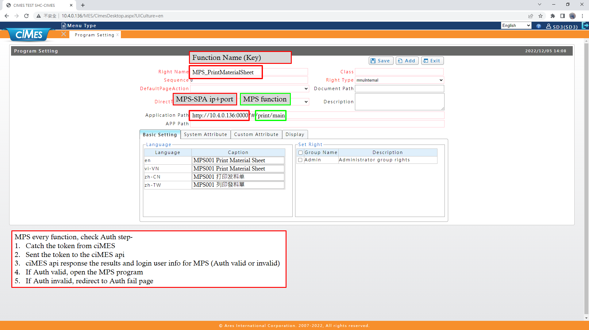

[圖MPS000_1] ciMES，Menu設定畫面

|  |  |  |  |  |  |  |
| --- | --- | --- | --- | --- | --- | --- |
| **System connect** **系統介接** | | | | | | |
| NO | 顯示名稱 | 必輸 | 唯讀 | 存改 | 對應欄位 | 欄位型態  欄位說明 |
|  | Right Name  權限名稱 | V |  |  |  | String  設定權限名稱 |
|  | Application Path  程式路徑 | V |  |  |  | String  設定程式路徑 |
|  | en  程式名稱(英文) |  |  |  |  | String |
|  | vi-VN  程式名稱(越文) |  |  |  |  | String |
|  | zh-CN  程式名稱(簡體中文) |  |  |  |  | String |
|  | zh-TW  程式名稱(繁體中文) |  |  |  |  | String |

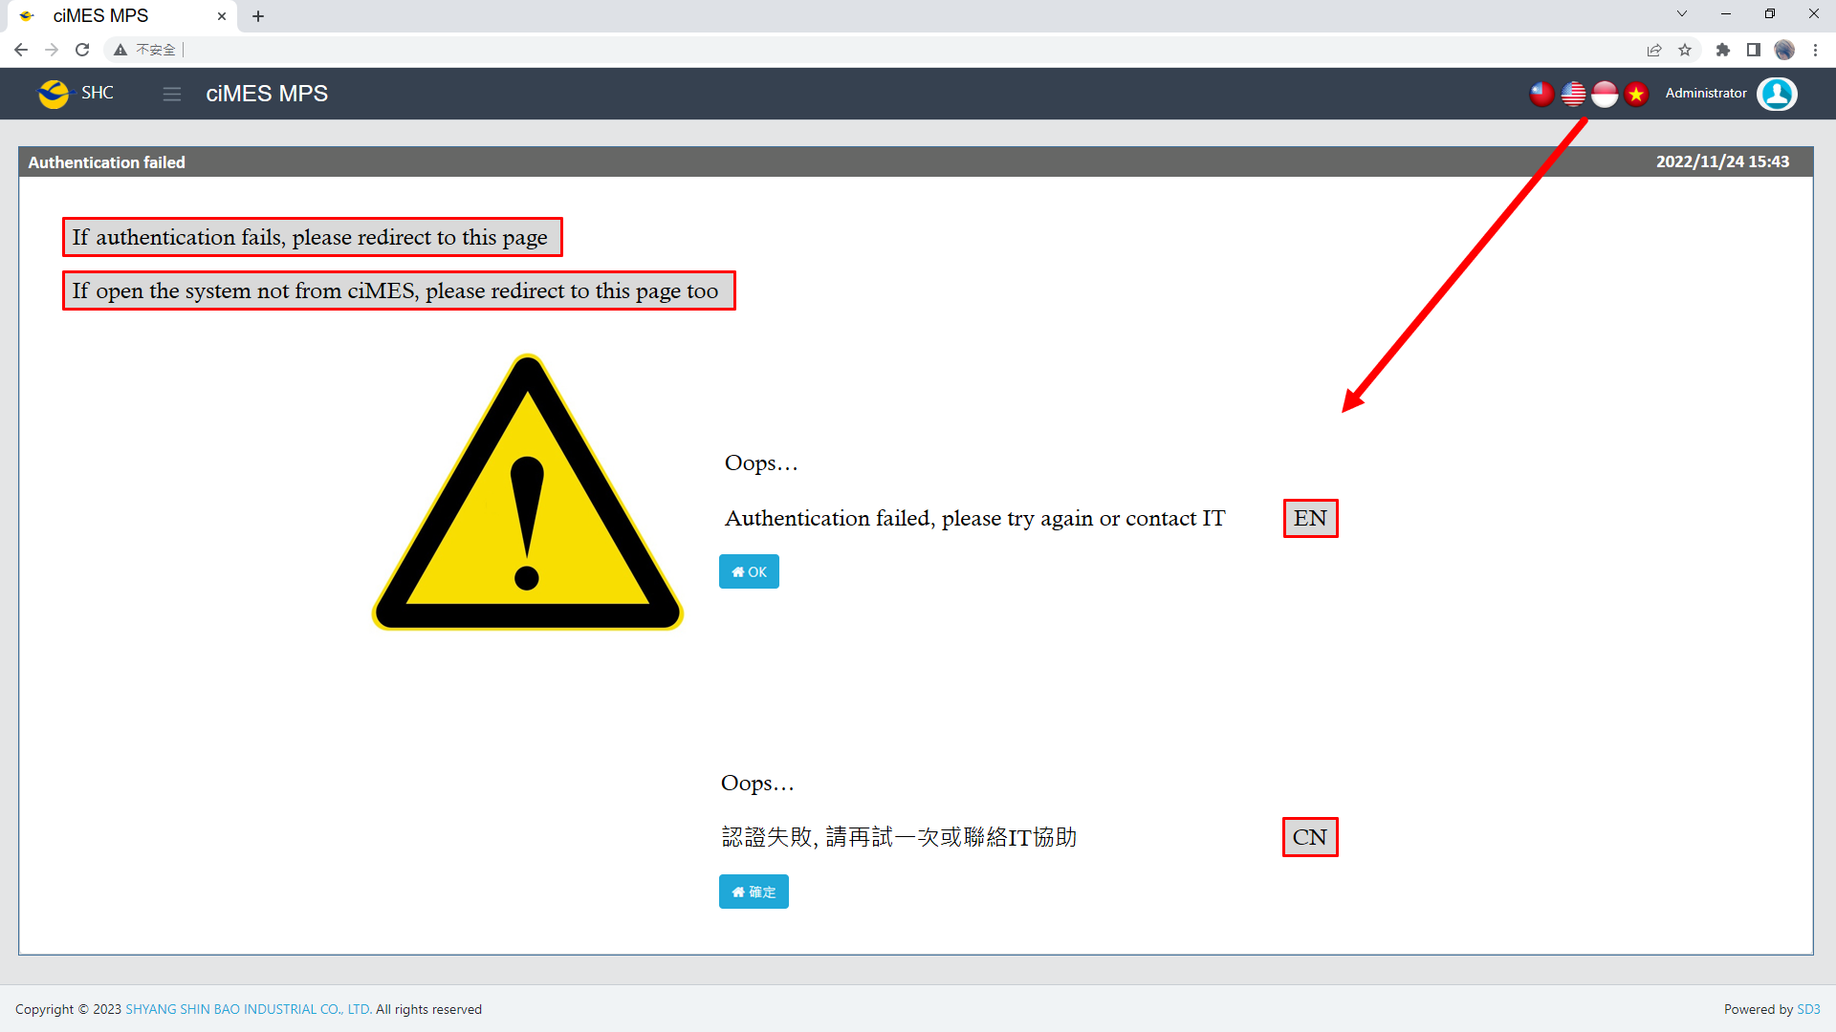

[圖MPS000_2] Auth failed page

|  |  |  |  |  |  |  |
| --- | --- | --- | --- | --- | --- | --- |
| Auth failed page **認證失敗頁面** | | | | | | |
| NO | 顯示名稱 | 必輸 | 唯讀 | 存改 | 對應欄位 | 欄位型態  欄位說明 |
|  | Auth failed message  認證失敗訊息 |  |  |  |  | String |
|  | OK  確定 |  |  |  |  | Button  Click back to ciMES system |

系統介接，MPS邏輯：

MPS **every function**, check Auth step

1. Catch the token from ciMES.
2. Sent the token to the ciMES api
3. ciMES api response the results and login user info for MPS (Auth valid or invalid)
4. If Auth valid, open the MPS program
5. If Auth invalid, redirect to Auth fail page

ciMES API：

http://10.4.0.136/API/CST/Customize/CheckToken?Token=iBRm%2bKjB1%2bh0orXmsKdzw4NGeW6CnM6%2b4q5pdWghI59zCBrR419t2DxPs9a7HWKf8jj0arFrBO31YLK3rmVBWw%3d%3d

* 1. **「MPS001 Print Material Sheet」MPS001 列印發料單**
  2. 程式名稱：同標題 (Right Name: MPS_Print.Material.Sheet)
  3. 功能目的：查詢/列印
  4. 使用部門：
  5. 程式說明：

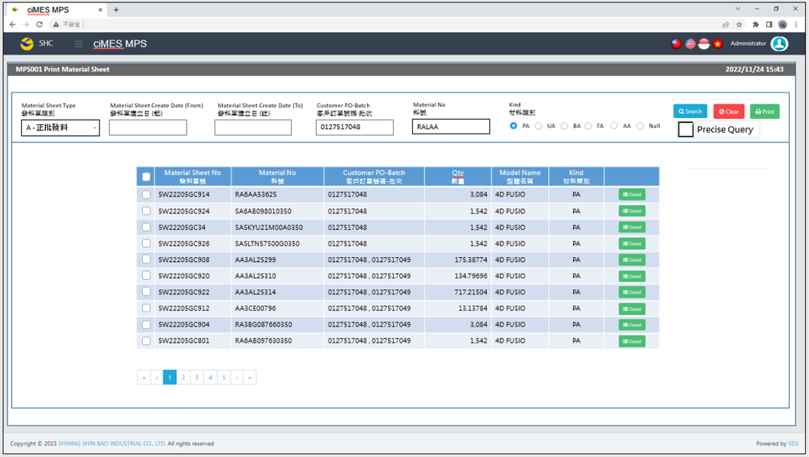

[圖MPS001_1] Main Page主畫面

|  |  |  |  |  |  |  |
| --- | --- | --- | --- | --- | --- | --- |
| Program header 程式標頭 | | | | | | |
| NO | 顯示名稱 | 必填 | 唯讀 | 存改 | 對應欄位 | 說明 |
|  | Title  標題 |  | V |  | CAPTION | String  If there is no get data, please show “Right Name”  SELECT T2.LANGUAGE, T2.CAPTION  FROM [MES_SEC_RIGHT] AS T1  JOIN [MES_MENU_ITEM] AS T2  ON T1.SEC_RIGHT_SID = T2.SEC_RIGHT_SID  WHERE T1.GROUPRIGHTS = 'MPS_Print.Material.Sheet' --(Right Name) |
|  | System Time  系統時間 |  | V |  | Show current server time | Datetime  yyyy/MM/dd HH:mm |

|  |  |  |  |  |  |  |
| --- | --- | --- | --- | --- | --- | --- |
| Operation button 操作按鈕 | | | | | | |
| NO | 顯示名稱 | 必填 | 唯讀 | 存改 | 對應欄位 | 說明 |
|  | Search  搜尋 |  |  |  |  | Required「Material Sheet Create Date」or「Customer PO-Batch」to search |
|  | Clear  清除 |  |  |  |  | Clear Search Condition and Results |
|  | Print  列印 |  |  |  |  | Print the select row data |
|  | Detail  明細 |  |  |  |  | Show detail data |

|  |  |  |  |  |  |  |
| --- | --- | --- | --- | --- | --- | --- |
| Search Condition 搜尋條件 | | | | | | |
| NO | 顯示名稱 | 必填 | 唯讀 | 存改 | 對應欄位 | 欄位型態  欄位說明 |
|  | Material Sheet Type  發料單類別 | V |  | V |  | Dropdown list  select REMARK01, REMARK01 + '-' + REMARK02 AS Material_Sheet_Type  from MES_WPC_EXTENDITEM  where CLASS = 'ISSUE_TYPE'  and (REMARK03 <> 'Y' or REMARK03 is null )  order by REMARK01 |
|  | Material Sheet Create Date (From)  發料單建立日(起) |  |  | V | Filter Material Sheet Create Date column | String  yyyy/MM/dd |
|  | Material Sheet Create Date (To)  發料單建立日(訖) |  |  | V | Filter Material Sheet Create Date column | String  yyyy/MM/dd |
|  | Customer PO-Batch  客戶訂單號碼-批次 |  |  | V | Filter Customer PO-Batch column | String  If chkPrecise is checked  Must exactly matched  Remove % in Search SQL |
|  | Material No  料號 |  |  | V | Filter MATERIALNO column | String |
|  | Kind  材料類別 |  |  | V | According to the situation to add this condition  Result = 1 : Enable and add this condition  Result = 0 : Disable and no need this condition  SELECT Count(*) AS Result  FROM MES_WPC_EXTENDITEM  where CLASS = 'ISSUE_TYPE'  AND REMARK04 = 'N' -- Always = N  AND REMARK01 = 'A' -- (Material Sheet Type) | Radio button  PA、UA、BA、FA、AA、Null  Default = PA |
|  | Precise Query  精準比對 |  |  | V |  | Check Box : chkPrecise (default : not cheched)  If chkPrecise is checked  Filter Customer PO-Batch column  Must exactly matched  (Remove % in Search SQL Ex : PO_BATCH like '090007695001-1' ) |

|  |  |  |  |  |  |  |
| --- | --- | --- | --- | --- | --- | --- |
| Search 搜尋 | | | | | | |
| NO | 顯示名稱 | 必填 | 唯讀 | 存改 | 對應欄位 | 欄位型態  欄位說明 |
|  | Selector  選擇器 |  |  | V |  | Check Box |
|  | Material Sheet No  發料單號 |  | V |  | C_MATERIAL_SHEET_NO | String |
|  | Material No  料號 |  | V |  | MATERIAL_NO | String |
|  | Customer PO-Batch  客戶訂單號碼-批次 |  | V |  | PO_BATCH | String |
|  | Qty  數量 |  | V |  | QUANTITY | Numeric |
|  | Model Name  型體名稱 |  | V |  | MODEL_NAME | String |
|  | Kind  材料類別 |  |  |  | KIND | String |
|  | Detail button  明細按鈕 |  |  |  | Open detail page | Button |
| 程式邏輯說明：  填入Material Sheet Create Date 或 Customer PO-Batch後(擇一必填)，點選 [Search搜尋] 按鈕，即可帶出資料。  SQL：  SELECT T1.C_MATERIAL_SHEET_NO, MIN(T2.MATERIAL_NO) AS MATERIAL_NO  , CASE max(T1.ISSUE_TYPE)  WHEN 'I' THEN max(T1.COMBINE_PO_BATCH)  ELSE max(T2.PO_BATCH)  END PO_BATCH  , SUM(T2.QUANTITY) AS QUANTITY, MIN(T2.MODEL_NAME) AS MODEL_NAME , min(T2.kind) KIND  FROM dbo.ERP_ISSUE AS T1,  (  select a.C_MATERIAL_SHEET_NO, min(MATERIALNO) AS MATERIAL_NO, sum(a.QUANTITY) AS QUANTITY, a.PO_BATCH, min(c.MODEL_NAME) AS MODEL_NAME , min(b.kind) kind  from dbo.ERP_ISSUE_DTL AS a,  (  select a2.C_MATERIAL_SHEET_NO , max(a3.KIND) Kind  from ERP_ISSUE a1  inner join ERP_ISSUE_DTL a2 on a1.C_MATERIAL_SHEET_NO = a2.C_MATERIAL_SHEET_NO  left join dbo.CST_MPS_PICKFORM_DETAIL a4 on a2.C_MATERIAL_SHEET_NO = a4.C_MATERIAL_SHEET_NO  left join dbo.CST_MPS_PICKFORM a3 on a3.PUF = a4.PUF and a2.PO_BATCH = a3.PO_BATCH  where a2.UPDATETIME >= '2023/05/01' -- (Material Sheet Create Date(From))  and a2.UPDATETIME <= DATEADD(DAY, 1, '2023/07/30') -- (Material Sheet Create Date(To)) + 1  and a2.PO_BATCH like '090007695001-1%' -- (Customer PO-Batch) if first character <> ‘C’ , add this line  and a1.COMBINE_PO_BATCH = 'C241002001' -- (Customer PO-Batch) if first character = ‘C’ , add this line  and a2.MATERIALNO like 'AA2AB%' -- (Material No)  and a2.[STATUS] <> 'D' -- (Always is D)  group by a2.C_MATERIAL_SHEET_NO  ) AS b, dbo.ERP_SOBATCH AS c  where a.C_MATERIAL_SHEET_NO = b.C_MATERIAL_SHEET_NO  and a.PO_BATCH = c.PO_BATCH  group by a.C_MATERIAL_SHEET_NO, a.PO_BATCH  ) AS T2  WHERE T1.C_MATERIAL_SHEET_NO = T2.C_MATERIAL_SHEET_NO  AND T1.PRINT_CNT = 0  AND T1.ISSUE_TYPE = 'A' -- (Material Sheet Type)  AND kind = 'PA' -- (Material Type) (According to the situation to add this condition)  GROUP BY T1.C_MATERIAL_SHEET_NO  ORDER BY MATERIAL_NO | | | | | | |

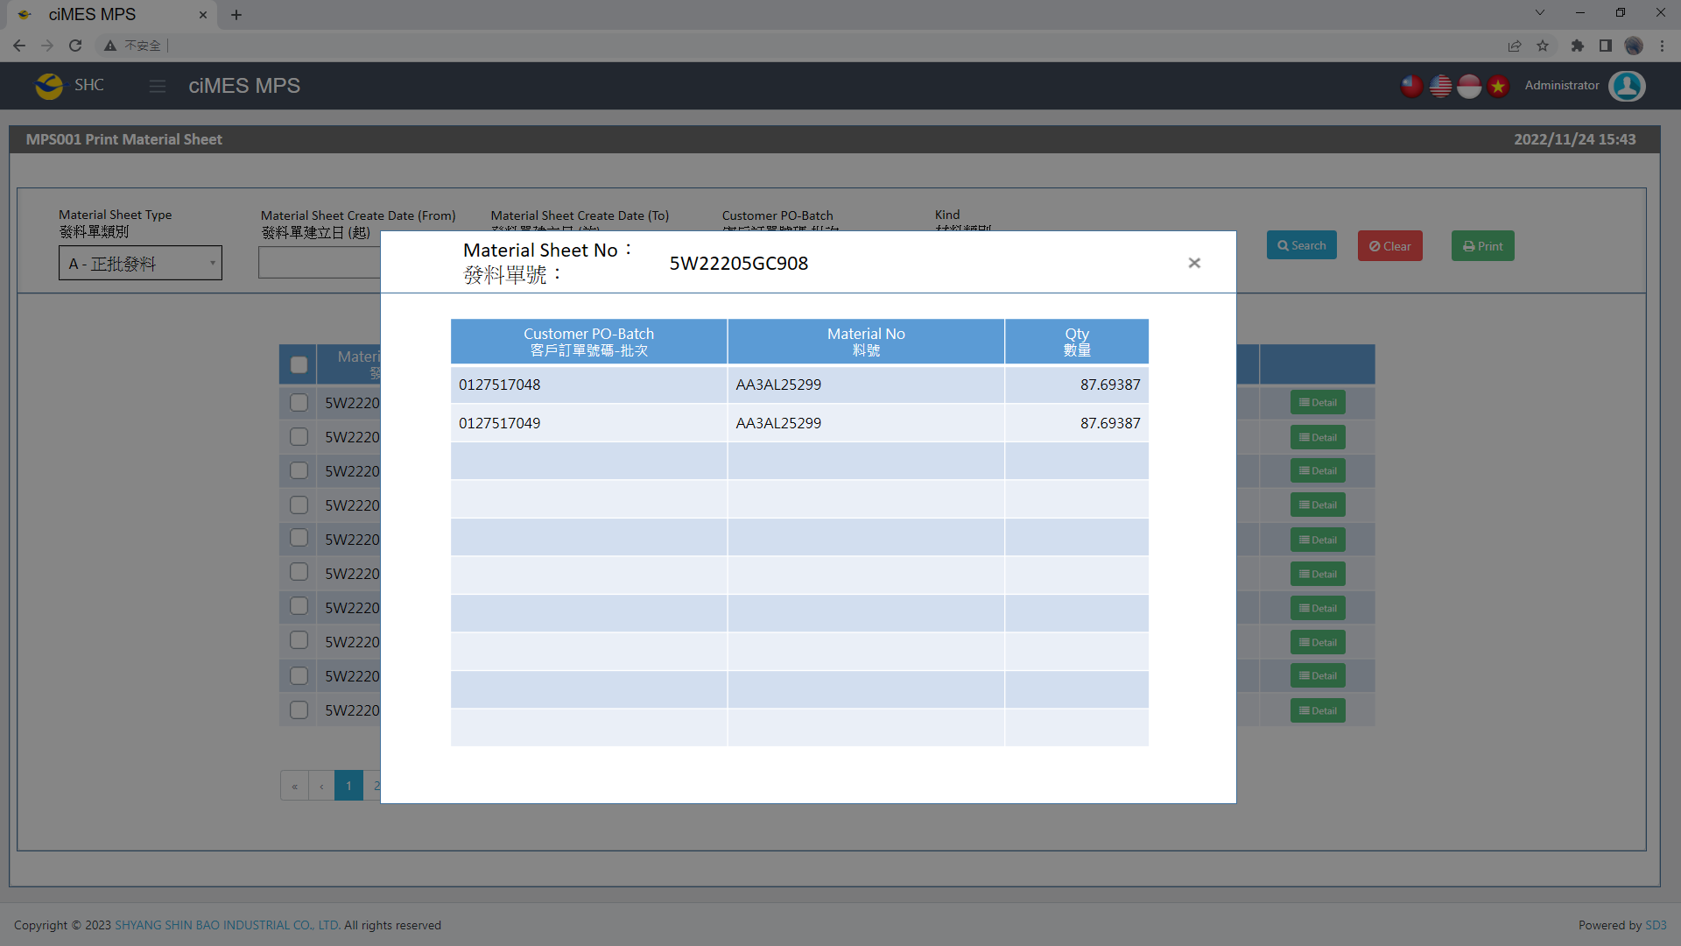

[圖MPS001_2] Detail明細畫面

|  |  |  |  |  |  |  |
| --- | --- | --- | --- | --- | --- | --- |
| Detail 明細 | | | | | | |
| NO | 顯示名稱 | 必填 | 唯讀 | 存改 | 對應欄位 | 欄位型態  欄位說明 |
|  | Material Sheet No  發料單號 |  | V |  | User selected row | String |
|  | Customer PO-Batch  客戶訂單號碼-批次 |  | V |  | PO_BATCH | String |
|  | Material No  料號 |  | V |  | MATERIALNO | String |
|  | Qty  數量 |  | V |  | QUANTITY | Numeric |
| 程式邏輯說明：  依照User點選的資料列，帶出該資料列的明細資料。  SQL：  SELECT C_MATERIAL_SHEET_NO, PO_BATCH, MATERIALNO, QUANTITY  FROM ERP_ISSUE_DTL  WHERE C_MATERIAL_SHEET_NO = '5W22205GC904' -- (User selected row)  ORDER BY PO_BATCH, MATERIALNO | | | | | | |

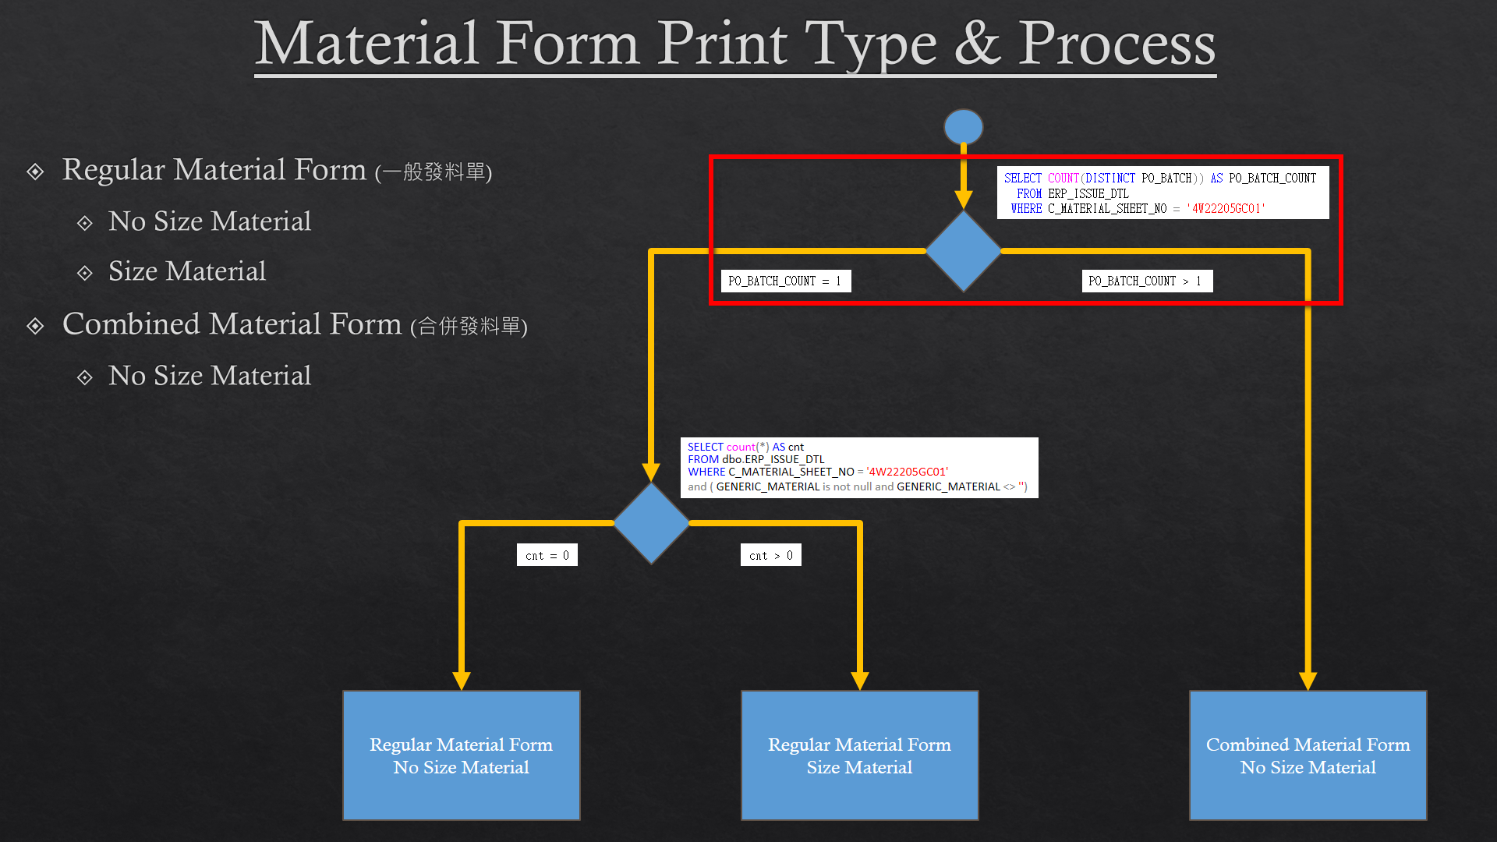

[圖MPS001_3] Material Form Print Type & Process，Check Regular or Combined Material Form

|  |  |  |  |  |  |  |
| --- | --- | --- | --- | --- | --- | --- |
| Print列印 | | | | | | |
| NO | 顯示名稱 | 必填 | 唯讀 | 存改 | 對應欄位 | 欄位型態  欄位說明 |
|  |  |  |  |  |  |  |
| 程式邏輯說明：  選擇資料列後，點選列印，印出發料單(A4中三刀)，邏輯如下  First Step: Check is「A：Regular Material Form」or「B：Combined Material Form」  If PO_BATCH_COUNT = 1，Print「**Regular Material Form」**  If PO_BATCH_COUNT > 1，Print「**Combined Material Form」**  SQL：  SELECT COUNT(DISTINCT(PO_BATCH)) AS PO_BATCH_COUNT  FROM ERP_ISSUE_DTL  WHERE C_MATERIAL_SHEET_NO = '4W22205GC01' | | | | | | |

**A：Print Regular Material Form 列印一般發料單**：

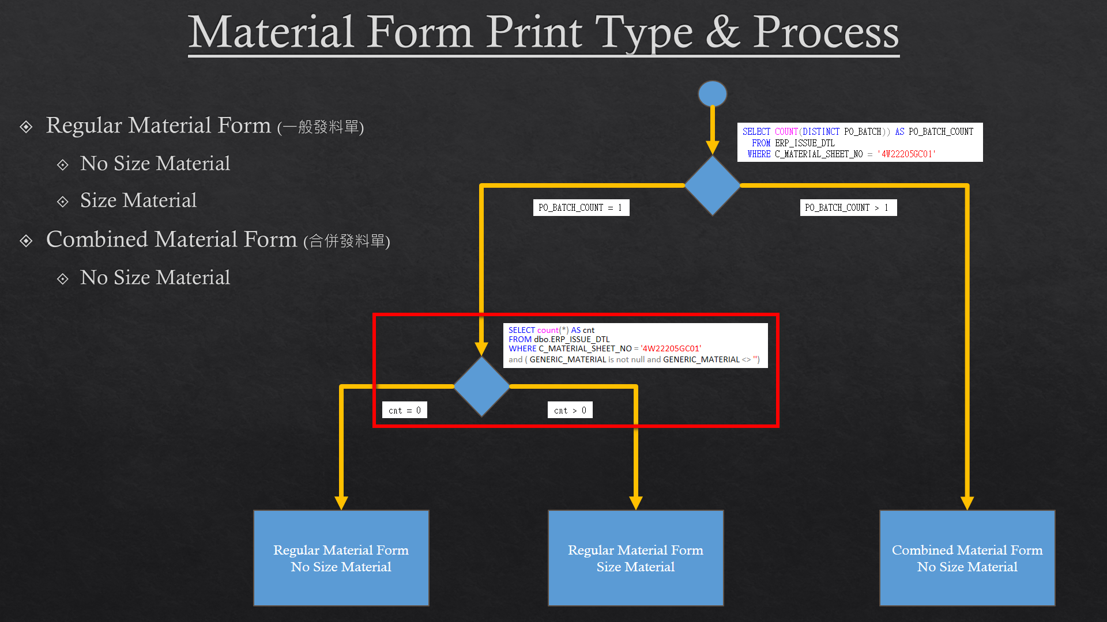

[圖MPS001_4] Material Form Print Type & Process，Check whether there is Size Run

|  |  |  |  |  |  |  |
| --- | --- | --- | --- | --- | --- | --- |
| Print Regular Material Form列印一般發料單 | | | | | | |
| NO | 顯示名稱 | 必填 | 唯讀 | 存改 | 對應欄位 | 欄位型態  欄位說明 |
|  |  |  |  |  |  |  |
| 程式邏輯說明：  Regular Material Form need check is Size Run or not  If cnt = 0，Print「**Regular Material Form – No Size Material」**  If cnt > 0，Print「**Regular Material Form – Size Material」**  SQL：  -- cnt > 0， 有尺寸發料單，列印size run  -- cnt = 0， 無尺寸發料單  SELECT count(*) AS cnt  FROM dbo.ERP_ISSUE_DTL  WHERE C_MATERIAL_SHEET_NO = '4W22205GC01'  and ( GENERIC_MATERIAL is not null and GENERIC_MATERIAL <> '') | | | | | | |

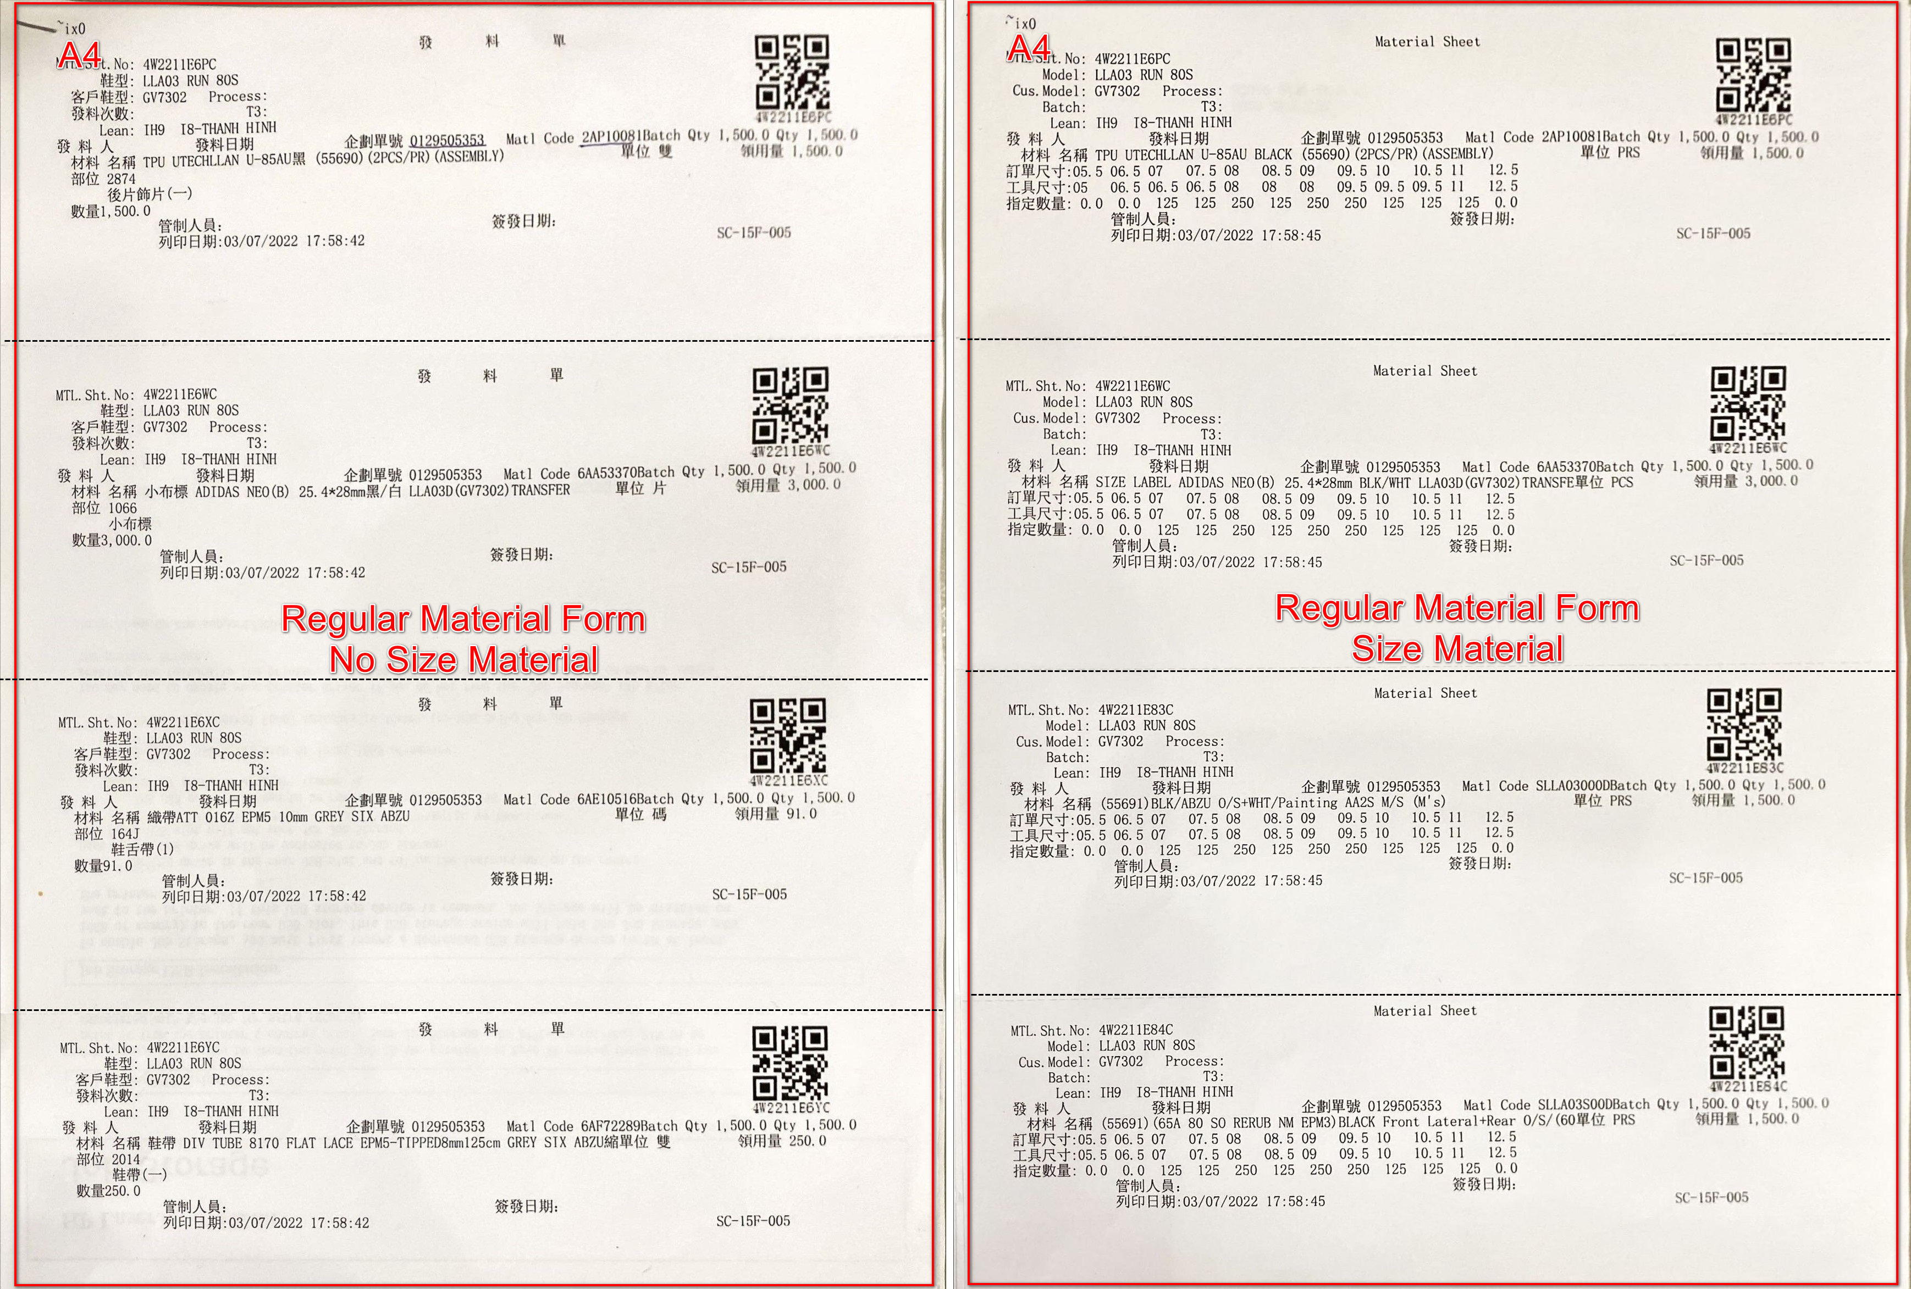

[圖MPS001_5] Regular Material Form，A4中三刀，示意圖

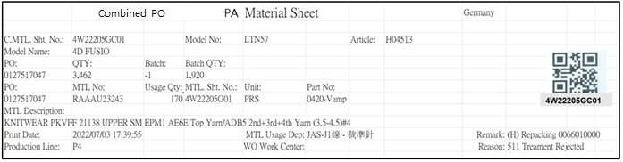

[圖MPS001_6] Regular Material Form – No Size Material

|  |  |  |  |  |  |  |
| --- | --- | --- | --- | --- | --- | --- |
| Print Regular Material Form – No Size Material 列印一般發料單 – 無尺寸發料單 | | | | | | |
| NO | 顯示名稱 | 必填 | 唯讀 | 存改 | 對應欄位 | 欄位型態  欄位說明 |
|  | Form Title Type |  |  |  | "("+ISSUE_TYPE+") "+REMARK05 | String |
| SQL for Type  -- If REMARK05 = Null or Empty, No need to show Form Title Type  select t1.ISSUE_TYPE, t2.REMARK05  from dbo.ERP_ISSUE t1  inner join MES_WPC_EXTENDITEM t2  on t2.CLASS = 'ISSUE_TYPE'  and t1.ISSUE_TYPE = t2.REMARK01  where t1.C_MATERIAL_SHEET_NO = 'C4W250516000374' --(User select row) | | | | | | |
|  | Kind  材料類別 |  |  |  |  | String |
| SQL for kind  -- Get Material Sheet Kind : by C_MATERIAL_SHEET_NO  select top 1 t1.KIND  FROM  (  select PUF  from CST_MPS_PICKFORM_DETAIL  where C_MATERIAL_SHEET_NO = 'C4W240603000886R' --(User select row)  ) t0  inner join dbo.CST_MPS_PICKFORM t1 on t0.PUF = t1.PUF and t1.[STATUS] <> 'Terminate'  **-- IF No Data found, Get Kind by following SQL again**  select top 1 t1.KIND  FROM  (  select top 1 PO_BATCH , MATERIALNO  from ERP_ISSUE_DTL  where C_MATERIAL_SHEET_NO = 'C4W240603000886R' --(User select row)  and [STATUS] <> 'D'  ) t0  inner join dbo.CST_MPS_PICKFORM t1 on t0.PO_BATCH = t1.PO_BATCH and t1.[STATUS] <> 'Terminate'  inner join dbo.CST_MPS_PICKFORM_DETAIL t2 on t1.PUF = t2.PUF and t2.MATERIALNO = t0.MATERIALNO | | | | | | |
|  | Shipping Location  出貨地點 |  |  |  | SHIPPING_LOCATION | String |
| SQL  select top 1 t1.SHIPPING_LOCATION  from [dbo].[ERP_SO] t1  inner join [dbo].[ERP_SOBatch] t2 on t1.SO_NO = t2.SO_NO  where t2.PO_BATCH = '0132957503-4' | | | | | | |
|  | C.MTL. Sht. No.  合併發料單號 |  |  |  | User selected row | String |
|  | Model No  型體編號 |  |  |  | MODEL_NO | String |
|  | Article  Article |  |  |  | ARTICLE | String |
|  | Model Name  型體名稱 |  |  |  | MODEL_NAME | String |
|  | PO  訂單編號 |  |  |  | PO_NO | String |
|  | Batch  批次 |  |  |  | BATCH | String |
|  | Batch Qty  批次數量 |  |  |  | QUANTITY | Numeric |
| SQL：  -- 訂單批次基本資訊 (根據 : C_MATERIAL_SHEET_NO 發料單號)  -- Get PO Batch information ( by C_MATERIAL_SHEET_NO )  SELECT b.PO_NO , a.PO_BATCH , REPLACE(a.PO_BATCH, b.PO_NO,'') BATCH , b.QUANTITY, c.ARTICLE , c.MODEL_NAME , c.MODEL_NO  FROM ( select top 1 b.PO_BATCH from dbo.ERP_ISSUE a , dbo.ERP_ISSUE_DTL b  where a.C_MATERIAL_SHEET_NO = '4W22205GC01' and a.C_MATERIAL_SHEET_NO = b.C_MATERIAL_SHEET_NO ) a  left join dbo.ERP_SOBATCH b on a.PO_BATCH = b.PO_BATCH  left join dbo.ERP_SO c on b.PO_NO = c.PO_NO | | | | | | |
|  | QTY  訂單數量 |  |  |  | QUANTITY | Numeric |
| SQL：  -- 訂單Qty (根據 : PO_NO)  -- Get PO information ( by PO_NO )  SELECT sum(QUANTITY) QUANTITY  FROM ERP_SOBATCH  where PO_NO = '0127517047' | | | | | | |
|  | PO  訂單號碼 |  |  |  | PO_NO | String |
|  | MTL No  料號 |  |  |  | MATERIALNO | String |
|  | Usage Qty  領用量 |  |  |  | QUANTITY | Numeric |
|  | Unit  單位 |  |  |  | UNIT | String |
|  | MTL. Sht. No  發料單號 |  |  |  | MATERIAL_SHEET_NO | String |
|  | Part No  部位 |  |  |  | PART_NO_NAME | String |
|  | MTL Description  材料名稱 |  |  |  | MATERIAL_SPEC | String |
| SQL：  -- 面部材料 : 如果2個部位使用相同的原材料，會是列印在1張發料單號 (發料單號相同) ， 使用string_AGG 合併部位資訊在一個欄位  --NO SIZE MATERIAL : data list ( by C_MATERIAL_SHEET_NO )  SQL01  Select TOP 1 min(a.PO_NO) PO_NO , a.MATERIALNO , min(b.MATERIAL_SPEC) MATERIAL_SPEC , sum(a.QUANTITY) QUANTITY  , min(a.MATERIAL_SHEET_NO) MATERIAL_SHEET_NO , min(a.UNIT) UNIT , MAX(a.PART_NO ) + '-' + MAX(a.PART_NAME) PART_NO_NAME  , min(a.Label_Info)　Label_Info  FROM dbo.ERP_ISSUE_DTL a  left join dbo.ERP_MATERIAL b on a.MATERIALNO = b.MATERIALNO  where C_MATERIAL_SHEET_NO = 'C4W250111009879R '  group by a.MATERIALNO  order by MATERIALNO | | | | | | |
| -- ISSUE_TYPE: C、F , Print Size label information  Check Form Title Type : ISSUE_TYPE  IF (ISSUE_TYPE = ‘C’ or ISSUE_TYPE = ‘F’ ) and (“MATERIALNO”) .Substring(2,3) = ‘LAA’  Begin  Get (“Label_Info”) from SQL01 (previous page SQL)  IF (“Label_Info”) <> ‘’、NULL  Begin  Print row : (PO SIZE、Qty) according to (“Label_Info”)  Label_Info : PO SIZE(Qty)/PO SIZE(Qty)/PO SIZE(Qty) ……………..  example :  0400(22)/0450(22)/0500(22)/0550(34)/0600(41)/0650(64)/0700(64)  /0750(64)/0800(84)/0850(104)/0900(126)/0950(116)/1000(64)  /1050(52)/1100(10)/1150(20)/1200(2)    End  END | | | | | | |
|  | Print Date  列印日期 |  |  |  | User print date and time  (Get from server side) | DateTime  yyyy/MM/dd HH:mm:ss |
|  | MTL Usage Dep  領料單位 |  |  |  | DEPT_DESC | String |
|  | WO Work Center  工單工作中心 |  |  |  | DEPT_DESC_WorkCenter | String  If DEPT_DESC_WorkCenter is Empty, hide this column |
| SQL：  EXEC dbo.PRD_GET_MPS_Dispatch_WorkCenter_ISSUEform '4W22205GC01' | | | | | | |
|  | Remark  備註 |  |  |  | "("+ISSUE_TYPE+") "+REMARK05+" "+ PO_BATCH_Old  + Dept_ID_Qty | String  e.g: (H) Repacking 0066010000 |
| SQL：  -- First Remark: Material Sheet's Type  -- If REMARK05 = Null or Empty, No need to show Material Sheet's Type  SQL_Remark01:  select t1.ISSUE_TYPE, t2.REMARK05  from dbo.ERP_ISSUE t1  inner join MES_WPC_EXTENDITEM t2  on t2.CLASS = 'ISSUE_TYPE'  and t1.issue_type = 'H' -- (Always = H)  and t1.ISSUE_TYPE = t2.REMARK01  where t1.C_MATERIAL_SHEET_NO = '4W22205GC01'  IF rows.count > 0 ( in SQL_Remark01 )  Begin  -- Second Remark: Old PO  select TOP 1 t3.PO_BATCH AS PO_BATCH_Old  from dbo.ERP_ISSUE t1 , dbo.ERP_ISSUE_DTL t2 , dbo.ERP_SOBatch t3  where t1.C_MATERIAL_SHEET_NO = '4W22205GC01'  and t1.issue_type = 'H' -- (Always = H)  and t1.C_MATERIAL_SHEET_NO = t2.C_MATERIAL_SHEET_NO  and t2.SO_NO = t3.SO_NO  and t2.SO_NO is not null  ELSE  PO_BATCH_Old = ‘’ (Remark =’’)  END  IF Kind = ‘AA’ or Kind = ‘PA’ (Form Title : Kind 材料類別)  Begin  SQL_DEPT:  select C_Material_Sheet_NO , STRING_AGG( Dept_ID_Qty , ';') Dept_ID_Qty  from  (  select C_Material_Sheet_NO  , Dept_ID + '(' + cast(cast(sum(Quantity) as float) as varchar) + ')' Dept_ID_Qty  from ERP_ISSUE_DTL_Dept_DTL  where C_Material_Sheet_NO = 'C4W250312001278' --(User select row)  group by C_Material_Sheet_NO , Dept_ID  ) t1  group by C_Material_Sheet_NO  IF rows.count > 0 and (“Dept_ID_Qty”).IndexOf(";") >= 0 (SQL_DEPT)  Begin  Print (“Dept_ID_Qty”) at Remark (Remark = Remark + (“Dept_ID_Qty”) )  End  -- test data : TSH test DB, PO_batch : 0900351525001 , C_MATERIAL_SHEET_NO : C4W250312001278  END | | | | | | |
|  | Production Line  成型線別 |  |  |  | AS_CELL | String |
| SQL：  -- Production Line (by PO_Batch)  SELECT AS_CELL  FROM ERP_PROD_SCHED  WHERE PO_Batch = '0132855033-1' | | | | | | |
|  | Reason  預補原因 |  |  |  | Reason | String |
| SQL：  -- Get Reason by C_Material_Sheet_NO  SELECT top 1 ( t1.REPLENISHMENT_CODE + ' ' + t2.DESCR_EN ) Reason  FROM dbo.ERP_ISSUE_DTL t1  left join dbo.CST_REPLN_REASON t2 on t1.REPLENISHMENT_CODE = t2.REASON_CODE  where t1.C_Material_Sheet_NO like 'C4W2308111592R%' | | | | | | |
| After Print，Update [ERP_ISSUE].[PRINT_CNT] and [ERP_ISSUE].[PRINT_TIME] (use server time)  SQL：  update dbo.ERP_ISSUE  set PRINT_CNT = PRINT_CNT + 1  , PRINT_TIME = GETDATE() -- Server time，yyyy/MM/dd HH:mm:ss  WHERE C_MATERIAL_SHEET_NO = '4W22205GC01' --(User select row) | | | | | | |
| After Print，Call procedure  SQL：  EXEC dbo. PRD_CST_MPS_PICKFORM_Auto_insert '4W22205GC01' --(User select row) | | | | | | |

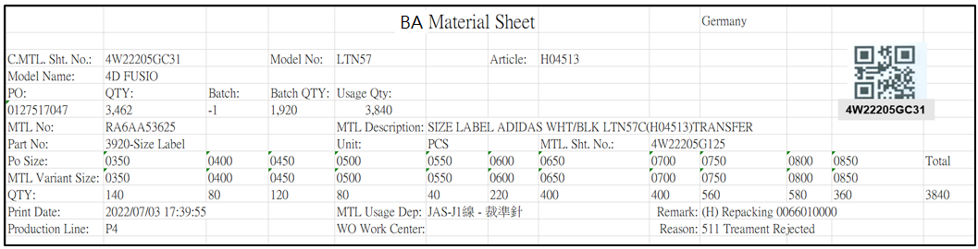

[圖MPS001_7] Regular Material Form – Size Material

|  |  |  |  |  |  |  |
| --- | --- | --- | --- | --- | --- | --- |
| Print Regular Material Form – Size Material 列印一般發料單 – 有尺寸發料單 | | | | | | |
| NO | 顯示名稱 | 必填 | 唯讀 | 存改 | 對應欄位 | 欄位型態  欄位說明 |
|  | Form Title Type |  |  |  | "("+ISSUE_TYPE+") "+REMARK05 | String |
| SQL for Type  -- If REMARK05 = Null or Empty, No need to show Form Title Type  select t1.ISSUE_TYPE, t2.REMARK05  from dbo.ERP_ISSUE t1  inner join MES_WPC_EXTENDITEM t2  on t2.CLASS = 'ISSUE_TYPE'  and t1.ISSUE_TYPE = t2.REMARK01  where t1.C_MATERIAL_SHEET_NO = 'C4W250516000374' --(User select row) | | | | | | |
|  | Kind  材料類別 |  |  |  |  | String |
| SQL for kind  -- Get Material Sheet Kind : by C_MATERIAL_SHEET_NO  select top 1 t1.KIND  FROM  (  select PUF  from CST_MPS_PICKFORM_DETAIL  where C_MATERIAL_SHEET_NO = 'C4W240603000886R' --(User select row)  ) t0  inner join dbo.CST_MPS_PICKFORM t1 on t0.PUF = t1.PUF and t1.[STATUS] <> 'Terminate'  **-- IF No Data found, Get Kind by following SQL again**  select top 1 t1.KIND  FROM  (  select top 1 PO_BATCH , MATERIALNO  from ERP_ISSUE_DTL  where C_MATERIAL_SHEET_NO = 'C4W240603000886R' --(User select row)  and [STATUS] <> 'D'  ) t0  inner join dbo.CST_MPS_PICKFORM t1 on t0.PO_BATCH = t1.PO_BATCH and t1.[STATUS] <> 'Terminate'  inner join dbo.CST_MPS_PICKFORM_DETAIL t2 on t1.PUF = t2.PUF and t2.MATERIALNO = t0.MATERIALNO | | | | | | |
|  | Shipping Location  出貨地點 |  |  |  | SHIPPING_LOCATION | String |
| SQL  select top 1 t1.SHIPPING_LOCATION  from [dbo].[ERP_SO] t1  inner join [dbo].[ERP_SOBatch] t2 on t1.SO_NO = t2.SO_NO  where t2.PO_BATCH = '0132957503-4' | | | | | | |
|  | C.MTL. Sht. No.  合併發料單號 |  |  |  | User selected row | String |
|  | Model No  型體編號 |  |  |  | MODEL_NO | String |
|  | Article  Article |  |  |  | ARTICLE | String |
|  | Model Name  型體名稱 |  |  |  | MODEL_NAME | String |
|  | PO  訂單編號 |  |  |  | PO_NO | String |
|  | Batch  批次 |  |  |  | BATCH | String |
|  | Batch Qty  批次數量 |  |  |  | QUANTITY | Numeric |
| SQL：  -- 訂單批次基本資訊 (根據 : C_MATERIAL_SHEET_NO 發料單號)  -- Get PO Batch information ( by C_MATERIAL_SHEET_NO )  SELECT b.PO_NO , a.PO_BATCH , REPLACE(a.PO_BATCH, b.PO_NO,'') BATCH , b.QUANTITY, c.ARTICLE , c.MODEL_NAME , c.MODEL_NO  FROM ( select top 1 b.PO_BATCH from dbo.ERP_ISSUE a , dbo.ERP_ISSUE_DTL b  where a.C_MATERIAL_SHEET_NO = '4W22205GC01' and a.C_MATERIAL_SHEET_NO = b.C_MATERIAL_SHEET_NO ) a  left join dbo.ERP_SOBATCH b on a.PO_BATCH = b.PO_BATCH  left join dbo.ERP_SO c on b.PO_NO = c.PO_NO | | | | | | |
|  | QTY  訂單數量 |  |  |  | QUANTITY | Numeric |
| SQL：  -- 訂單Qty (根據 : PO_NO)  -- Get PO information ( by PO_NO )  SELECT sum(QUANTITY) QUANTITY  FROM ERP_SOBATCH  where PO_NO = '0127517047' | | | | | | |
|  | MTL No  料號 |  |  |  | TOP 1 GENERIC_MATERIAL | String |
|  | MTL Description  材料名稱 |  |  |  | TOP 1 MATERIAL_SPEC | String |
|  | MTL. Sht. No.  發料單號 |  |  |  | TOP 1 MATERIAL_SHEET_NO | String |
| SQL：  -- 有尺寸 : 材料明細資訊 (根據發料單號)  select a.GENERIC_MATERIAL , a.MATERIALNO , b.MATERIAL_SPEC , a.QUANTITY , a.MATERIAL_SHEET_NO , a.UNIT , a.PART_NO , a.PART_NAME  FROM dbo.ERP_ISSUE_DTL a  left join dbo.ERP_MATERIAL b on a.GENERIC_MATERIAL = b.MATERIALNO  where C_MATERIAL_SHEET_NO = '4W22205GC01'  order by a.MATERIALNO | | | | | | |
|  | Usage Qty  領用量 |  |  |  | SUM(QUANTITY) | Numeric |
|  | Part No  部位 |  |  |  | TOP 1 PART_NO_NAME | String |
|  | Unit  單位 |  |  |  | TOP 1 UNIT | String |
|  | PO SIZE  訂單尺寸 |  |  |  | PO_SIZE | String |
|  | MTL Variant SIZE  MTL Variant SIZE |  |  |  | MATERIAL_SIZE | String |
|  | Qty  數量 |  |  |  | QUANTITY | Numeric |
|  | Total  合計 |  |  |  | SUM(QUANTITY) | Numeric |
| SQL：  -- 有尺寸 PO SIZE 、 MATERIAL_SIZE 明細 (根據 : 發料單號)  -- SIZE MATERIAL : data list ( by C_MATERIAL_SHEET_NO )  select PO_SIZE , MATERIAL_SIZE, cast( sum(QUANTITY) as float) QUANTITY , max(UNIT) UNIT  , max(PART_NO) PART_NO , max(PART_NAME) PART_NAME , max(PART_NO) + '-' + max(PART_NAME) AS PART_NO_NAME  from dbo.ERP_ISSUE_DTL  where C_MATERIAL_SHEET_NO = 'C4W250602005617'  group by PO_SIZE , MATERIAL_SIZE  order by PO_SIZE | | | | | | |
|  | Print Date  列印日期 |  |  |  | User print date and time  (Get from server side) | DateTime  yyyy/MM/dd HH:mm:ss |
|  | MTL Usage Dep  領料單位 |  |  |  | DEPT_DESC | String |
|  | WO Work Center  工單工作中心 |  |  |  | DEPT_DESC_WorkCenter | String  If DEPT_DESC_WorkCenter is Empty, hide this column |
| SQL：  EXEC dbo.PRD_GET_MPS_Dispatch_WorkCenter_ISSUEform '4W22205GC01' | | | | | | |
|  | Remark  備註 |  |  |  | "("+ISSUE_TYPE+") "+REMARK05+" "+ PO_BATCH_Old  + Dept_ID_Qty | String  e.g: (H) Repacking 0066010000 |
| SQL：  -- First Remark: Material Sheet's Type  -- If REMARK05 = Null or Empty, No need to show Material Sheet's Type  SQL_Remark01:  select t1.ISSUE_TYPE, t2.REMARK05  from dbo.ERP_ISSUE t1  inner join MES_WPC_EXTENDITEM t2  on t2.CLASS = 'ISSUE_TYPE'  and t1.issue_type = 'H' -- (Always = H)  and t1.ISSUE_TYPE = t2.REMARK01  where t1.C_MATERIAL_SHEET_NO = '4W22205GC01'  IF rows.count > 0 ( in SQL_Remark01 )  Begin  -- Second Remark: Old PO  select TOP 1 t3.PO_BATCH AS PO_BATCH_Old  from dbo.ERP_ISSUE t1 , dbo.ERP_ISSUE_DTL t2 , dbo.ERP_SOBatch t3  where t1.C_MATERIAL_SHEET_NO = '4W22205GC01'  and t1.issue_type = 'H' -- (Always = H)  and t1.C_MATERIAL_SHEET_NO = t2.C_MATERIAL_SHEET_NO  and t2.SO_NO = t3.SO_NO  and t2.SO_NO is not null  ELSE  PO_BATCH_Old = ‘’ (Remark =’’)  END  IF Kind = ‘AA’ or Kind = ‘PA’ (Form Title : Kind 材料類別)  Begin  SQL_DEPT:  select C_Material_Sheet_NO , STRING_AGG( Dept_ID_Qty , ';') Dept_ID_Qty  from  (  select C_Material_Sheet_NO  , Dept_ID + '(' + cast(cast(sum(Quantity) as float) as varchar) + ')' Dept_ID_Qty  from ERP_ISSUE_DTL_Dept_DTL  where C_Material_Sheet_NO = 'C4W250312001278' --(User select row)  group by C_Material_Sheet_NO , Dept_ID  ) t1  group by C_Material_Sheet_NO  IF rows.count > 0 and (“Dept_ID_Qty”).IndexOf(";") >= 0 (SQL_DEPT)  Begin  Print (“Dept_ID_Qty”) at Remark (Remark = Remark + (“Dept_ID_Qty”) )  End  -- test data : TSH test DB, PO_batch : 0900351525001 , C_MATERIAL_SHEET_NO : C4W250312001278  END | | | | | | |
|  | Production Line  成型線別 |  |  |  | AS_CELL | String |
| SQL：  -- Production Line (by PO_Batch)  SELECT AS_CELL  FROM ERP_PROD_SCHED  WHERE PO_Batch = '0132855033-1' | | | | | | |
|  | Reason  預補原因 |  |  |  | Reason | String |
| SQL：  -- Get Reason by C_Material_Sheet_NO  SELECT top 1 ( t1.REPLENISHMENT_CODE + ' ' + t2.DESCR_EN ) Reason  FROM dbo.ERP_ISSUE_DTL t1  left join dbo.CST_REPLN_REASON t2 on t1.REPLENISHMENT_CODE = t2.REASON_CODE  where t1.C_Material_Sheet_NO like 'C4W2308111592R%' | | | | | | |
| After Print，Update [ERP_ISSUE].[PRINT_CNT] and [ERP_ISSUE].[PRINT_TIME] (use server time)  SQL：  update dbo.ERP_ISSUE  set PRINT_CNT = PRINT_CNT + 1  , PRINT_TIME = GETDATE() -- Server time，yyyy/MM/dd HH:mm:ss  WHERE C_MATERIAL_SHEET_NO = '4W22205GC01' --(User select row) | | | | | | |
| After Print，Call procedure  SQL：  EXEC dbo. PRD_CST_MPS_PICKFORM_Auto_insert '4W22205GC01' --(User select row) | | | | | | |

**B：Print Combined Material Form 列印合併發料單**：

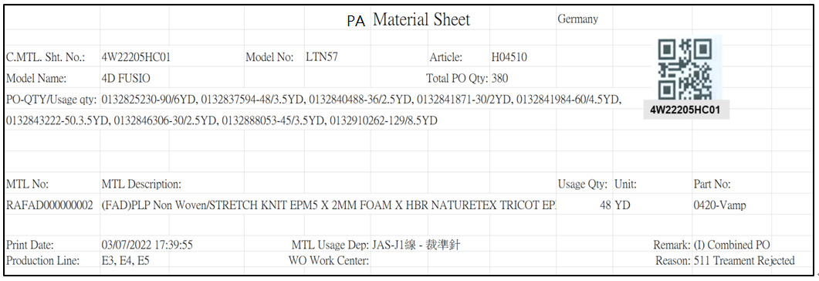

[圖MPS001_8] Combined Material Form

|  |  |  |  |  |  |  |
| --- | --- | --- | --- | --- | --- | --- |
| Print Combined Material Form 列印合併發料單 | | | | | | |
| NO | 顯示名稱 | 必填 | 唯讀 | 存改 | 對應欄位 | 欄位型態  欄位說明 |
|  | Form Title Type |  |  |  | "("+ISSUE_TYPE+") "+REMARK05 | String |
| SQL for Type  -- If REMARK05 = Null or Empty, No need to show Form Title Type  select t1.ISSUE_TYPE, t2.REMARK05  from dbo.ERP_ISSUE t1  inner join MES_WPC_EXTENDITEM t2  on t2.CLASS = 'ISSUE_TYPE'  and t1.ISSUE_TYPE = t2.REMARK01  where t1.C_MATERIAL_SHEET_NO = 'C4W250516000374' --(User select row) | | | | | | |
|  | Kind  材料類別 |  |  |  |  | String |
| SQL for kind  -- Get Material Sheet Kind : by C_MATERIAL_SHEET_NO  select top 1 t1.KIND  FROM  (  select PUF  from CST_MPS_PICKFORM_DETAIL  where C_MATERIAL_SHEET_NO = 'C4W240603000886R' --(User select row)  ) t0  inner join dbo.CST_MPS_PICKFORM t1 on t0.PUF = t1.PUF and t1.[STATUS] <> 'Terminate'  **-- IF No Data found, Get Kind by following SQL again**  select top 1 t1.KIND  FROM  (  select top 1 PO_BATCH , MATERIALNO  from ERP_ISSUE_DTL  where C_MATERIAL_SHEET_NO = 'C4W240603000886R' --(User select row)  and [STATUS] <> 'D'  ) t0  inner join dbo.CST_MPS_PICKFORM t1 on t0.PO_BATCH = t1.PO_BATCH and t1.[STATUS] <> 'Terminate'  inner join dbo.CST_MPS_PICKFORM_DETAIL t2 on t1.PUF = t2.PUF and t2.MATERIALNO = t0.MATERIALNO | | | | | | |
|  | Shipping Location  出貨地點 |  |  |  | SHIPPING_LOCATION | String |
| SQL  select top 1 t1.SHIPPING_LOCATION  from [dbo].[ERP_SO] t1  inner join [dbo].[ERP_SOBatch] t2 on t1.SO_NO = t2.SO_NO  where t2.PO_BATCH = '0132957503-4' --(TOP 1 PO_BATCH) | | | | | | |
|  | C.MTL. Sht. No.  合併發料單號 |  |  |  | User selected row | String |
|  | Model No  型體編號 |  |  |  | MODEL_NO | String |
|  | Article  Article |  |  |  | ARTICLE | String |
|  | Model Name  型體名稱 |  |  |  | MODEL_NAME | String |
| SQL：  -- 訂單批次基本資訊 (根據 : C_MATERIAL_SHEET_NO 發料單號)  -- Get PO Batch information ( by C_MATERIAL_SHEET_NO )  SELECT TOP 1 b.PO_NO , a.PO_BATCH , c.ARTICLE , c.MODEL_NAME , c.MODEL_NO  FROM ( select TOP 1 PO_BATCH from dbo.ERP_ISSUE_DTL  where C_MATERIAL_SHEET_NO = 'C4W2307030020' ) a -- (User select row)  left join dbo.ERP_SOBATCH b on a.PO_BATCH = b.PO_BATCH  left join dbo.ERP_SO c on b.PO_NO = c.PO_NO | | | | | | |
|  | Total PO Qty |  |  |  | SUM(QUANTITY) | Numeric |
|  | PO-QTY/Usage qty  訂單號碼/使用量 |  |  |  | PO_BATCH + "-" + QUANTITY + "/" + Issue_QUANTITY + UNIT  And join all data by ", " | String  e.g:0132825230-90/8YD, 0132837594-48/4.5YD |
| SQL：  -- PO-QTY/Usage_qty Unit (全部排在一起，最多可能有15張合併訂單)  -- e.g:0132825230-90/8YD, 0132837594-48/4.5YD  SELECT a.PO_BATCH , b.QUANTITY, a.Issue_QUANTITY , a.UNIT  FROM ( select PO_BATCH , sum(QUANTITY) Issue_QUANTITY , max(UNIT) UNIT from dbo.ERP_ISSUE_DTL  where C_MATERIAL_SHEET_NO = 'C4W2307030020' group by PO_Batch ) a  left join dbo.ERP_SOBATCH b on a.PO_BATCH = b.PO_BATCH  order by a.PO_BATCH | | | | | | |
|  | MTL No  料號 |  |  |  | MATERIALNO | String |
|  | MTL Description  材料名稱 |  |  |  | MATERIAL_SPEC | String |
|  | Usage Qty  領用量 |  |  |  | QUANTITY | Numeric |
|  | Unit  單位 |  |  |  | UNIT | String |
|  | Part No  部位 |  |  |  | PART_NO_NAME | String |
| SQL：  select t1.MATERIALNO , t2.MATERIAL_SPEC , t1.QUANTITY , t1.UNIT , t1.PART_NO_NAME  from  (  select max(MATERIALNO) MATERIALNO , sum(QUANTITY) QUANTITY , max(UNIT) UNIT , max(PART_NO + ' ' + PART_NAME) PART_NO_NAME  from dbo.ERP_ISSUE_DTL  where C_MATERIAL_SHEET_NO = 'C4W2307030020' -- (User select row)  group by C_MATERIAL_SHEET_NO  ) t1  left join dbo.ERP_MATERIAL t2 on t1.MATERIALNO = t2.MATERIALNO | | | | | | |
|  | Print Date  列印日期 |  |  |  | User print date and time  (Get from server side) | DateTime  yyyy/MM/dd HH:mm:ss |
|  | MLT Usage Dep  領料單位 |  |  |  | DEPT_DESC | String |
|  | WO Work Center  工單工作中心 |  |  |  | DEPT_DESC_WorkCenter | String  If DEPT_DESC_WorkCenter is Empty, hide this column |
| SQL：  EXEC dbo.PRD_GET_MPS_Dispatch_WorkCenter_ISSUEform 'C4W2307030020' | | | | | | |
|  | Remark  備註 |  |  |  | "("+ISSUE_TYPE+") "+REMARK05+" "+ PO_BATCH_Old  + Dept_ID_Qty | String  e.g: (H) Repacking 0066010000 |
| SQL：  -- First Remark: Material Sheet's Type  -- If REMARK05 = Null or Empty, No need to show Material Sheet's Type  SQL_Remark01:  select t1.ISSUE_TYPE, t2.REMARK05  from dbo.ERP_ISSUE t1  inner join MES_WPC_EXTENDITEM t2  on t2.CLASS = 'ISSUE_TYPE'  and t1.issue_type = 'H' -- (Always = H)  and t1.ISSUE_TYPE = t2.REMARK01  where t1.C_MATERIAL_SHEET_NO = '4W22205GC01'  IF rows.count > 0 ( in SQL_Remark01 )  Begin  -- Second Remark: Old PO  select TOP 1 t3.PO_BATCH AS PO_BATCH_Old  from dbo.ERP_ISSUE t1 , dbo.ERP_ISSUE_DTL t2 , dbo.ERP_SOBatch t3  where t1.C_MATERIAL_SHEET_NO = '4W22205GC01'  and t1.issue_type = 'H' -- (Always = H)  and t1.C_MATERIAL_SHEET_NO = t2.C_MATERIAL_SHEET_NO  and t2.SO_NO = t3.SO_NO  and t2.SO_NO is not null  ELSE  PO_BATCH_Old = ‘’ (Remark =’’)  END  IF Kind = ‘AA’ or Kind = ‘PA’ (Form Title : Kind 材料類別)  Begin  SQL_DEPT:  select C_Material_Sheet_NO , STRING_AGG( Dept_ID_Qty , ';') Dept_ID_Qty  from  (  select C_Material_Sheet_NO  , Dept_ID + '(' + cast(cast(sum(Quantity) as float) as varchar) + ')' Dept_ID_Qty  from ERP_ISSUE_DTL_Dept_DTL  where C_Material_Sheet_NO = 'C4W250312001278' --(User select row)  group by C_Material_Sheet_NO , Dept_ID  ) t1  group by C_Material_Sheet_NO  IF rows.count > 0 and (“Dept_ID_Qty”).IndexOf(";") >= 0 (SQL_DEPT)  Begin  Print (“Dept_ID_Qty”) at Remark (Remark = Remark + (“Dept_ID_Qty”) )  End  -- test data : TSH test DB, PO_batch : 0900351525001 , C_MATERIAL_SHEET_NO : C4W250312001278  END | | | | | | |
|  | Production Line  成型線別 |  |  |  | AS_CELL  join all data by ", " | String  e.g: E3, E4, E5 |
| SQL：  -- Distinct Production Line (by All PO_Batch)  SELECT DISTINCT AS_CELL  FROM ERP_PROD_SCHED  WHERE PO_Batch in ('0132855033', '0132855034', '0132855035', '0132855036') | | | | | | |
|  | Reason  預補原因 |  |  |  | Reason | String |
| SQL：  -- Get Reason by C_Material_Sheet_NO  SELECT top 1 ( t1.REPLENISHMENT_CODE + ' ' + t2.DESCR_EN ) Reason  FROM dbo.ERP_ISSUE_DTL t1  left join dbo.CST_REPLN_REASON t2 on t1.REPLENISHMENT_CODE = t2.REASON_CODE  where t1.C_Material_Sheet_NO like 'C4W2308111592R%' | | | | | | |
| After Print，Update [ERP_ISSUE].[PRINT_CNT] and [ERP_ISSUE].[PRINT_TIME] (use server time)  SQL：  update dbo.ERP_ISSUE  set PRINT_CNT = PRINT_CNT + 1  , PRINT_TIME = GETDATE() -- Server time，yyyy/MM/dd HH:mm:ss  WHERE C_MATERIAL_SHEET_NO = 'C4W2307030020' --(User select row) | | | | | | |
| After Print，Call procedure  SQL：  EXEC dbo. PRD_CST_MPS_PICKFORM_Auto_insert 'C4W2307030020' --(User select row) | | | | | | |

* 1. **「MPS002 Reprint Material Sheet」MPS002 重列印發料單**
  2. 程式名稱：同標題 (Right Name: MPS_Reprint.Material.Sheet)
  3. 功能目的：查詢/列印
  4. 使用部門：
  5. 程式說明：

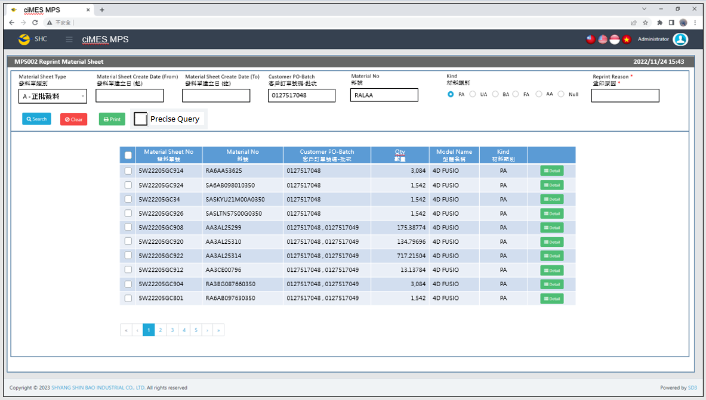

[圖MPS002_1] Main Page主畫面

|  |  |  |  |  |  |  |
| --- | --- | --- | --- | --- | --- | --- |
| Program header 程式標頭 | | | | | | |
| NO | 顯示名稱 | 必填 | 唯讀 | 存改 | 對應欄位 | 說明 |
|  | Title  標題 |  | V |  | CAPTION | String  If there is no get data, please show “Right Name”  SELECT T2.LANGUAGE, T2.CAPTION  FROM [MES_SEC_RIGHT] AS T1  JOIN [MES_MENU_ITEM] AS T2  ON T1.SEC_RIGHT_SID = T2.SEC_RIGHT_SID  WHERE T1.GROUPRIGHTS = 'MPS_Reprint.Material.Sheet' --(Right Name) |
|  | System Time  系統時間 |  | V |  | Show current server time | Datetime  yyyy/MM/dd HH:mm |

|  |  |  |  |  |  |  |
| --- | --- | --- | --- | --- | --- | --- |
| Operation button 操作按鈕 | | | | | | |
| NO | 顯示名稱 | 必填 | 唯讀 | 存改 | 對應欄位 | 說明 |
|  | Search  搜尋 |  |  |  |  | Required「Material Sheet Create Date」or「Customer PO-Batch」to search |
|  | Clear  清除 |  |  |  |  | Clear Search Condition and Results |
|  | Print  列印 |  |  |  |  | Print the select row data |
|  | Detail  明細 |  |  |  |  | Show detail data |

|  |  |  |  |  |  |  |
| --- | --- | --- | --- | --- | --- | --- |
| Search Condition 搜尋條件 | | | | | | |
| NO | 顯示名稱 | 必填 | 唯讀 | 存改 | 對應欄位 | 欄位型態  欄位說明 |
|  | Material Sheet Type  發料單類別 | V |  | V |  | Dropdown list  select REMARK01, REMARK01 + '-' + REMARK02 AS Material_Sheet_Type  from MES_WPC_EXTENDITEM  where CLASS = 'ISSUE_TYPE'  and (REMARK03 <> 'Y' or REMARK03 is null )  order by REMARK01 |
|  | Material Sheet Create Date (From)  發料單建立日(起) |  |  | V | Filter Material Sheet Create Date column | String  yyyy/MM/dd |
|  | Material Sheet Create Date (To)  發料單建立日(訖) |  |  | V | Filter Material Sheet Create Date column | String  yyyy/MM/dd |
|  | Customer PO-Batch  客戶訂單號碼-批次 |  |  | V | Filter Customer PO-Batch column | String  If chkPrecise is checked  Must exactly matched  Remove % in Search SQL |
|  | Material No  料號 |  |  | V | Filter MATERIALNO column | String |
|  | Kind  材料類別 |  |  | V | According to the situation to add this condition  Result = 1 : Enable and add this condition  Result = 0 : Disable and no need this condition  SELECT Count(*) AS Result  FROM MES_WPC_EXTENDITEM  where CLASS = 'ISSUE_TYPE'  AND REMARK04 = 'N' -- Always = N  AND REMARK01 = 'A' -- (Material Sheet Type) | Radio button  PA、UA、BA、FA、AA、Null |
|  | Reprint Reason  重印原因 | V |  | V |  | String  Required when printing |
|  | Precise Query  精準比對 |  |  | V |  | Check Box : chkPrecise (default : not cheched)  If chkPrecise is checked  Filter Customer PO-Batch column  Must exactly matched  (Remove % in Search SQL Ex : PO_BATCH like '090007695001-1' ) |

|  |  |  |  |  |  |  |
| --- | --- | --- | --- | --- | --- | --- |
| Search 搜尋 | | | | | | |
| NO | 顯示名稱 | 必填 | 唯讀 | 存改 | 對應欄位 | 欄位型態  欄位說明 |
|  | Selector  選擇器 |  |  | V |  | Check Box |
|  | Material Sheet No  發料單號 |  | V |  | C_MATERIAL_SHEET_NO | String |
|  | Material No  料號 |  | V |  | MATERIAL_NO | String |
|  | Customer PO-Batch  客戶訂單號碼-批次 |  | V |  | PO_BATCH | String |
|  | Qty  數量 |  | V |  | QUANTITY | Numeric |
|  | Model Name  型體名稱 |  | V |  | MODEL_NAME | String |
|  | Kind  材料類別 |  |  |  | KIND | String |
|  | Detail button  明細按鈕 |  |  |  | Open detail page | Button |
| 程式邏輯說明：  填入Material Sheet Create Date 或 Customer PO-Batch後(擇一必填)，點選 [Search搜尋] 按鈕，即可帶出資料。  SQL：  SELECT T1.C_MATERIAL_SHEET_NO, MIN(T2.MATERIAL_NO) AS MATERIAL_NO  , CASE max(T1.ISSUE_TYPE)  WHEN 'I' THEN max(T1.COMBINE_PO_BATCH)  ELSE max(T2.PO_BATCH)  END PO_BATCH  , SUM(T2.QUANTITY) AS QUANTITY, MIN(T2.MODEL_NAME) AS MODEL_NAME , min(T2.kind) KIND  FROM dbo.ERP_ISSUE AS T1,  (  select a.C_MATERIAL_SHEET_NO, min(MATERIALNO) AS MATERIAL_NO, sum(a.QUANTITY) AS QUANTITY, a.PO_BATCH, min(c.MODEL_NAME) AS MODEL_NAME , min(b.kind) kind  from dbo.ERP_ISSUE_DTL AS a,  (  select a2.C_MATERIAL_SHEET_NO , max(a3.KIND) Kind  from ERP_ISSUE a1  inner join ERP_ISSUE_DTL a2 on a1.C_MATERIAL_SHEET_NO = a2.C_MATERIAL_SHEET_NO  left join dbo.CST_MPS_PICKFORM_DETAIL a4 on a2.C_MATERIAL_SHEET_NO = a4.C_MATERIAL_SHEET_NO  left join dbo.CST_MPS_PICKFORM a3 on a3.PUF = a4.PUF and a2.PO_BATCH = a3.PO_BATCH  where a2.UPDATETIME >= '2023/05/01' -- (Material Sheet Create Date(From))  and a2.UPDATETIME <= DATEADD(DAY, 1, '2023/07/30') -- (Material Sheet Create Date(To)) + 1  and a2.PO_BATCH like '090007695001-1%' -- (Customer PO-Batch) if first character <> ‘C’ , add this line  and a1.COMBINE_PO_BATCH = 'C241002001' -- (Customer PO-Batch) if first character = ‘C’ , add this line  and a2.MATERIALNO like 'AA2AB%' -- (Material No)  and a2.[STATUS] <> 'D' -- (Always is D)  group by a2.C_MATERIAL_SHEET_NO  ) AS b, dbo.ERP_SOBATCH AS c  where a.C_MATERIAL_SHEET_NO = b.C_MATERIAL_SHEET_NO  and a.PO_BATCH = c.PO_BATCH  group by a.C_MATERIAL_SHEET_NO, a.PO_BATCH  ) AS T2  WHERE T1.C_MATERIAL_SHEET_NO = T2.C_MATERIAL_SHEET_NO  AND T1.PRINT_CNT > 0  AND T1.ISSUE_TYPE = 'D' -- (Material Sheet Type)  AND kind = 'PA' -- (Material Type) (According to the situation to add this conditions)  GROUP BY T1.C_MATERIAL_SHEET_NO  ORDER BY MATERIAL_NO | | | | | | |

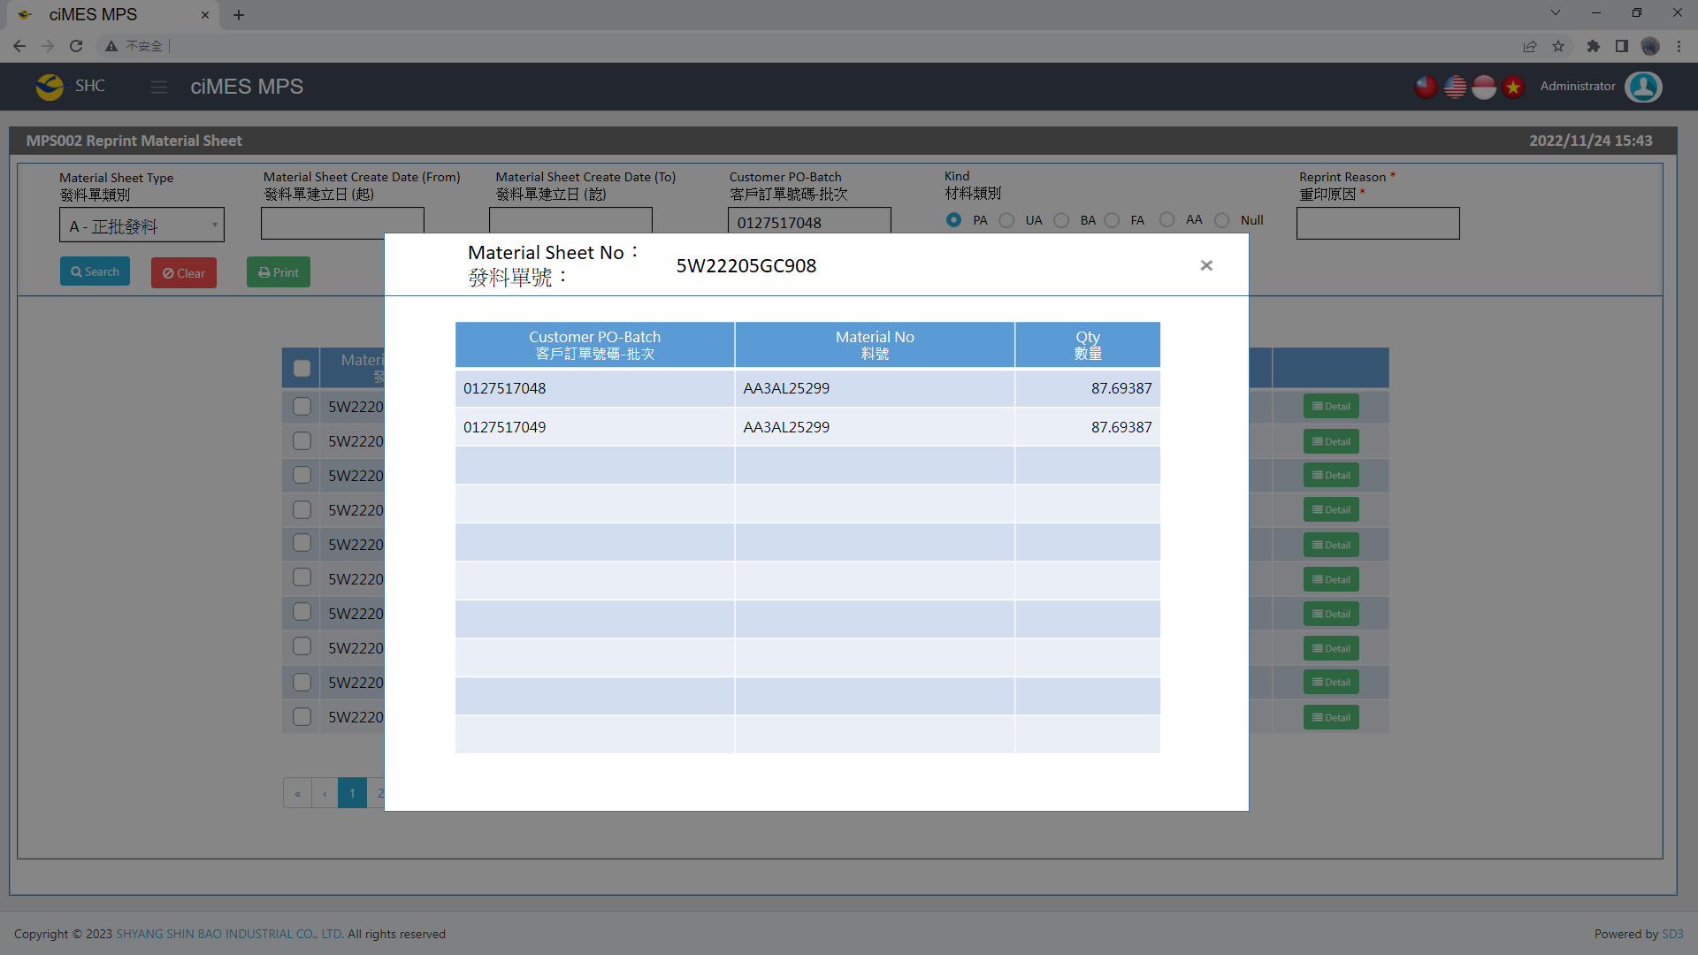

[圖MPS002_2] Detail明細畫面

|  |  |  |  |  |  |  |
| --- | --- | --- | --- | --- | --- | --- |
| Detail 明細 | | | | | | |
| NO | 顯示名稱 | 必填 | 唯讀 | 存改 | 對應欄位 | 欄位型態  欄位說明 |
|  | Material Sheet No  發料單號 |  | V |  | User selected row | String |
|  | Customer PO-Batch  客戶訂單號碼-批次 |  | V |  | PO_BATCH | String |
|  | Material No  料號 |  | V |  | MATERIALNO | String |
|  | Qty  數量 |  | V |  | QUANTITY | Numeric |
| 程式邏輯說明：  依照User點選的資料列，帶出該資料列的明細資料。  SQL：  SELECT C_MATERIAL_SHEET_NO, PO_BATCH, MATERIALNO, QUANTITY  FROM ERP_ISSUE_DTL  WHERE C_MATERIAL_SHEET_NO = '5W22205GC904' -- (User selected row)  ORDER BY PO_BATCH, MATERIALNO | | | | | | |



[圖MPS002_3] Material Form Print Type & Process，Check Regular or Combined Material Form

|  |  |  |  |  |  |  |
| --- | --- | --- | --- | --- | --- | --- |
| Print列印 | | | | | | |
| NO | 顯示名稱 | 必填 | 唯讀 | 存改 | 對應欄位 | 欄位型態  欄位說明 |
|  |  |  |  |  |  |  |
| 程式邏輯說明：  選擇資料列後，點選列印，印出發料單(A4中三刀)，邏輯如下  First Step: Check is「A：Regular Material Form」or「B：Combined Material Form」  If PO_BATCH_COUNT = 1，Print「**Regular Material Form」**  If PO_BATCH_COUNT > 1，Print「**Combined Material Form」**  SQL：  SELECT COUNT(DISTINCT(PO_BATCH)) AS PO_BATCH_COUNT  FROM ERP_ISSUE_DTL  WHERE C_MATERIAL_SHEET_NO = '4W22205GC01' | | | | | | |

**A：Print Regular Material Form 列印一般發料單**：



[圖MPS002_4] Material Form Print Type & Process，Check whether there is Size Run

|  |  |  |  |  |  |  |
| --- | --- | --- | --- | --- | --- | --- |
| Print Regular Material Form列印一般發料單 | | | | | | |
| NO | 顯示名稱 | 必填 | 唯讀 | 存改 | 對應欄位 | 欄位型態  欄位說明 |
|  |  |  |  |  |  |  |
| 程式邏輯說明：  Regular Material Form need check is Size Run or not  If cnt = 0，Print「**Regular Material Form – No Size Material」**  If cnt > 0，Print「**Regular Material Form – Size Material」**  SQL：  -- cnt > 0， 有尺寸發料單，列印size run  -- cnt = 0， 無尺寸發料單  SELECT count(*) AS cnt  FROM dbo.ERP_ISSUE_DTL  WHERE C_MATERIAL_SHEET_NO = '4W22205GC01'  and ( GENERIC_MATERIAL is not null and GENERIC_MATERIAL <> '') | | | | | | |



[圖MPS002_5] Regular Material Form，A4中三刀，示意圖

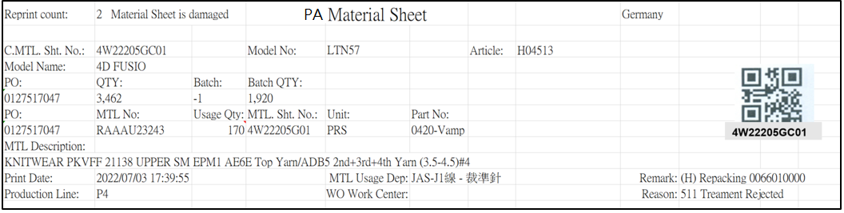

[圖MPS002_6] Regular Material Form – No Size Material

|  |  |  |  |  |  |  |
| --- | --- | --- | --- | --- | --- | --- |
| Print Regular Material Form – No Size Material 列印一般發料單 – 無尺寸發料單 | | | | | | |
| NO | 顯示名稱 | 必填 | 唯讀 | 存改 | 對應欄位 | 欄位型態  欄位說明 |
|  | Reprint count  重印次數 |  |  |  | REPRINT_CNT | Int |
|  | Reprint Reason  重印原因 |  |  |  | User key in Reprint Reason | String |
| SQL  select PRINT_CNT AS REPRINT_CNT  from dbo.ERP_ISSUE  where C_MATERIAL_SHEET_NO = '4W22205GC01' | | | | | | |
|  | Form Title Type |  |  |  | "("+ISSUE_TYPE+") "+REMARK05 | String |
| SQL for Type  -- If REMARK05 = Null or Empty, No need to show Form Title Type  select t1.ISSUE_TYPE, t2.REMARK05  from dbo.ERP_ISSUE t1  inner join MES_WPC_EXTENDITEM t2  on t2.CLASS = 'ISSUE_TYPE'  and t1.ISSUE_TYPE = t2.REMARK01  where t1.C_MATERIAL_SHEET_NO = 'C4W250516000374' --(User select row) | | | | | | |
|  | Kind  材料類別 |  |  |  |  | String |
| SQL for kind  -- Get Material Sheet Kind : by C_MATERIAL_SHEET_NO  select top 1 t1.KIND  FROM  (  select PUF  from CST_MPS_PICKFORM_DETAIL  where C_MATERIAL_SHEET_NO = 'C4W240603000886R' --(User select row)  ) t0  inner join dbo.CST_MPS_PICKFORM t1 on t0.PUF = t1.PUF and t1.[STATUS] <> 'Terminate'  **-- IF No Data found, Get Kind by following SQL again**  select top 1 t1.KIND  FROM  (  select top 1 PO_BATCH , MATERIALNO  from ERP_ISSUE_DTL  where C_MATERIAL_SHEET_NO = 'C4W240603000886R' --(User select row)  and [STATUS] <> 'D'  ) t0  inner join dbo.CST_MPS_PICKFORM t1 on t0.PO_BATCH = t1.PO_BATCH and t1.[STATUS] <> 'Terminate'  inner join dbo.CST_MPS_PICKFORM_DETAIL t2 on t1.PUF = t2.PUF and t2.MATERIALNO = t0.MATERIALNO | | | | | | |
|  | Shipping Location  出貨地點 |  |  |  | SHIPPING_LOCATION | String |
| SQL  select top 1 t1.SHIPPING_LOCATION  from [dbo].[ERP_SO] t1  inner join [dbo].[ERP_SOBatch] t2 on t1.SO_NO = t2.SO_NO  where t2.PO_BATCH = '0132957503-4' | | | | | | |
|  | C.MTL. Sht. No.  合併發料單號 |  |  |  | User selected row | String |
|  | Model No  型體編號 |  |  |  | MODEL_NO | String |
|  | Article  Article |  |  |  | ARTICLE | String |
|  | Model Name  型體名稱 |  |  |  | MODEL_NAME | String |
|  | PO  訂單編號 |  |  |  | PO_NO | String |
|  | Batch  批次 |  |  |  | BATCH | String |
|  | Batch Qty  批次數量 |  |  |  | QUANTITY | Numeric |
| SQL：  -- 訂單批次基本資訊 (根據 : C_MATERIAL_SHEET_NO 發料單號)  -- Get PO Batch information ( by C_MATERIAL_SHEET_NO )  SELECT b.PO_NO , a.PO_BATCH , REPLACE(a.PO_BATCH, b.PO_NO,'') BATCH , b.QUANTITY, c.ARTICLE , c.MODEL_NAME , c.MODEL_NO  FROM ( select top 1 b.PO_BATCH from dbo.ERP_ISSUE a , dbo.ERP_ISSUE_DTL b  where a.C_MATERIAL_SHEET_NO = '4W22205GC01' and a.C_MATERIAL_SHEET_NO = b.C_MATERIAL_SHEET_NO ) a  left join dbo.ERP_SOBATCH b on a.PO_BATCH = b.PO_BATCH  left join dbo.ERP_SO c on b.PO_NO = c.PO_NO | | | | | | |
|  | QTY  訂單數量 |  |  |  | QUANTITY | Numeric |
| SQL：  -- 訂單Qty (根據 : PO_NO)  -- Get PO information ( by PO_NO )  SELECT sum(QUANTITY) QUANTITY  FROM ERP_SOBATCH  where PO_NO = '0127517047' | | | | | | |
|  | PO  訂單號碼 |  |  |  | PO_NO | String |
|  | MTL No  料號 |  |  |  | MATERIALNO | String |
|  | Usage Qty  領用量 |  |  |  | QUANTITY | Numeric |
|  | Unit  單位 |  |  |  | UNIT | String |
|  | MTL. Sht. No  發料單號 |  |  |  | MATERIAL_SHEET_NO | String |
|  | Part No  部位 |  |  |  | PART_NO_NAME | String |
|  | MTL Description  材料名稱 |  |  |  | MATERIAL_SPEC | String |
| SQL：  -- 面部材料 : 如果2個部位使用相同的原材料，會是列印在1張發料單號 (發料單號相同) ， 使用string_AGG 合併部位資訊在一個欄位  --NO SIZE MATERIAL : data list ( by C_MATERIAL_SHEET_NO )  SQL01  Select TOP 1 min(a.PO_NO) PO_NO , a.MATERIALNO , min(b.MATERIAL_SPEC) MATERIAL_SPEC , sum(a.QUANTITY) QUANTITY  , min(a.MATERIAL_SHEET_NO) MATERIAL_SHEET_NO , min(a.UNIT) UNIT , MAX(a.PART_NO ) + '-' + MAX(a.PART_NAME) PART_NO_NAME  , min(a.Label_Info)　Label_Info  FROM dbo.ERP_ISSUE_DTL a  left join dbo.ERP_MATERIAL b on a.MATERIALNO = b.MATERIALNO  where C_MATERIAL_SHEET_NO = 'C4W250111009879R  group by a.MATERIALNO  order by MATERIALNO | | | | | | |
| -- ISSUE_TYPE: C、F , Print Size label information  Check Form Title Type : ISSUE_TYPE  IF (ISSUE_TYPE = ‘C’ or ISSUE_TYPE = ‘F’ ) and (“MATERIALNO”) .Substring(2,3) = ‘LAA’  Begin  Get (“Label_Info”) from SQL01 (previous page SQL)  IF (“Label_Info”) <> ‘’、NULL  Begin  Print row : (PO SIZE、Qty) according to (“Label_Info”)  Label_Info : PO SIZE(Qty)/PO SIZE(Qty)/PO SIZE(Qty) ……………..  example :  0400(22)/0450(22)/0500(22)/0550(34)/0600(41)/0650(64)/0700(64)  /0750(64)/0800(84)/0850(104)/0900(126)/0950(116)/1000(64)  /1050(52)/1100(10)/1150(20)/1200(2)    End  END | | | | | | |
|  | Print Date  列印日期 |  |  |  | User print date and time  (Get from server side) | DateTime  yyyy/MM/dd HH:mm:ss |
|  | MLT Usage Dep  領料單位 |  |  |  | DEPT_DESC | String |
|  | WO Work Center  工單工作中心 |  |  |  | DEPT_DESC_WorkCenter | String  If DEPT_DESC_WorkCenter is Empty, hide this column |
| SQL：  EXEC dbo.PRD_GET_MPS_Dispatch_WorkCenter_ISSUEform '4W22205GC01' | | | | | | |
|  | Remark  備註 |  |  |  | "("+ISSUE_TYPE+") "+REMARK05+" "+ PO_BATCH_Old  + Dept_ID_Qty | String  e.g: (H) Repacking 0066010000 |
| SQL：  -- First Remark: Material Sheet's Type  -- If REMARK05 = Null or Empty, No need to show Material Sheet's Type  SQL_Remark01:  select t1.ISSUE_TYPE, t2.REMARK05  from dbo.ERP_ISSUE t1  inner join MES_WPC_EXTENDITEM t2  on t2.CLASS = 'ISSUE_TYPE'  and t1.issue_type = 'H' -- (Always = H)  and t1.ISSUE_TYPE = t2.REMARK01  where t1.C_MATERIAL_SHEET_NO = '4W22205GC01'  IF rows.count > 0 ( in SQL_Remark01 )  Begin  -- Second Remark: Old PO  select TOP 1 t3.PO_BATCH AS PO_BATCH_Old  from dbo.ERP_ISSUE t1 , dbo.ERP_ISSUE_DTL t2 , dbo.ERP_SOBatch t3  where t1.C_MATERIAL_SHEET_NO = '4W22205GC01'  and t1.issue_type = 'H' -- (Always = H)  and t1.C_MATERIAL_SHEET_NO = t2.C_MATERIAL_SHEET_NO  and t2.SO_NO = t3.SO_NO  and t2.SO_NO is not null  ELSE  PO_BATCH_Old = ‘’ (Remark =’’)  END  IF Kind = ‘AA’ or Kind = ‘PA’ (Form Title : Kind 材料類別)  Begin  SQL_DEPT:  select C_Material_Sheet_NO , STRING_AGG( Dept_ID_Qty , ';') Dept_ID_Qty  from  (  select C_Material_Sheet_NO  , Dept_ID + '(' + cast(cast(sum(Quantity) as float) as varchar) + ')' Dept_ID_Qty  from ERP_ISSUE_DTL_Dept_DTL  where C_Material_Sheet_NO = 'C4W250312001278' --(User select row)  group by C_Material_Sheet_NO , Dept_ID  ) t1  group by C_Material_Sheet_NO  IF rows.count > 0 and (“Dept_ID_Qty”).IndexOf(";") >= 0 (SQL_DEPT)  Begin  Print (“Dept_ID_Qty”) at Remark (Remark = Remark + (“Dept_ID_Qty”) )  End  -- test data : TSH test DB, PO_batch : 0900351525001 , C_MATERIAL_SHEET_NO : C4W250312001278  END | | | | | | |
|  | Production Line  成型線別 |  |  |  | AS_CELL | String |
| SQL：  -- Production Line (by PO_Batch)  SELECT AS_CELL  FROM ERP_PROD_SCHED  WHERE PO_Batch = '0132855033-1' | | | | | | |
|  | Reason  預補原因 |  |  |  | Reason | String |
| SQL：  -- Get Reason by C_Material_Sheet_NO  SELECT top 1 ( t1.REPLENISHMENT_CODE + ' ' + t2.DESCR_EN ) Reason  FROM dbo.ERP_ISSUE_DTL t1  left join dbo.CST_REPLN_REASON t2 on t1.REPLENISHMENT_CODE = t2.REASON_CODE  where t1.C_Material_Sheet_NO like 'C4W2308111592R%' | | | | | | |
| After Print，Update [ERP_ISSUE].[PRINT_CNT] and [ERP_ISSUE].[PRINT_TIME] (use server time)  SQL：  update dbo.ERP_ISSUE  set PRINT_CNT = PRINT_CNT + 1  , REPRINT_REASON = 'Material Sheet is damaged' --(User key in Reprint Reason)  , PRINT_TIME = GETDATE() -- Server time，yyyy/MM/dd HH:mm:ss  WHERE C_MATERIAL_SHEET_NO = '4W22205GC01' --(User select row) | | | | | | |

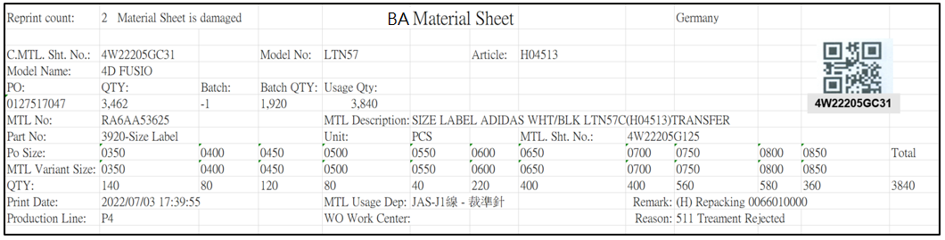

[圖MPS002_7] Regular Material Form – Size Material

|  |  |  |  |  |  |  |
| --- | --- | --- | --- | --- | --- | --- |
| Print Regular Material Form – Size Material 列印一般發料單 – 有尺寸發料單 | | | | | | |
| NO | 顯示名稱 | 必填 | 唯讀 | 存改 | 對應欄位 | 欄位型態  欄位說明 |
|  | Reprint count  重印次數 |  |  |  | REPRINT_CNT | Int |
|  | Reprint Reason  重印原因 |  |  |  | User key in Reprint Reason | String |
| SQL  select PRINT_CNT AS REPRINT_CNT  from dbo.ERP_ISSUE  where C_MATERIAL_SHEET_NO = '4W22205GC01' | | | | | | |
|  | Form Title Type |  |  |  | "("+ISSUE_TYPE+") "+REMARK05 | String |
| SQL for Type  -- If REMARK05 = Null or Empty, No need to show Form Title Type  select t1.ISSUE_TYPE, t2.REMARK05  from dbo.ERP_ISSUE t1  inner join MES_WPC_EXTENDITEM t2  on t2.CLASS = 'ISSUE_TYPE'  and t1.ISSUE_TYPE = t2.REMARK01  where t1.C_MATERIAL_SHEET_NO = 'C4W250516000374' --(User select row) | | | | | | |
|  | Kind  材料類別 |  |  |  |  | String |
| SQL for kind  -- Get Material Sheet Kind : by C_MATERIAL_SHEET_NO  select top 1 t1.KIND  FROM  (  select PUF  from CST_MPS_PICKFORM_DETAIL  where C_MATERIAL_SHEET_NO = 'C4W240603000886R' --(User select row)  ) t0  inner join dbo.CST_MPS_PICKFORM t1 on t0.PUF = t1.PUF and t1.[STATUS] <> 'Terminate'  **-- IF No Data found, Get Kind by following SQL again**  select top 1 t1.KIND  FROM  (  select top 1 PO_BATCH , MATERIALNO  from ERP_ISSUE_DTL  where C_MATERIAL_SHEET_NO = 'C4W240603000886R' --(User select row)  and [STATUS] <> 'D'  ) t0  inner join dbo.CST_MPS_PICKFORM t1 on t0.PO_BATCH = t1.PO_BATCH and t1.[STATUS] <> 'Terminate'  inner join dbo.CST_MPS_PICKFORM_DETAIL t2 on t1.PUF = t2.PUF and t2.MATERIALNO = t0.MATERIALNO | | | | | | |
|  | Shipping Location  出貨地點 |  |  |  | SHIPPING_LOCATION | String |
| SQL  select top 1 t1.SHIPPING_LOCATION  from [dbo].[ERP_SO] t1  inner join [dbo].[ERP_SOBatch] t2 on t1.SO_NO = t2.SO_NO  where t2.PO_BATCH = '0132957503-4' | | | | | | |
|  | C.MTL. Sht. No.  合併發料單號 |  |  |  | User selected row | String |
|  | Model No  型體編號 |  |  |  | MODEL_NO | String |
|  | Article  Article |  |  |  | ARTICLE | String |
|  | Model Name  型體名稱 |  |  |  | MODEL_NAME | String |
|  | PO  訂單編號 |  |  |  | PO_NO | String |
|  | Batch  批次 |  |  |  | BATCH | String |
|  | Batch Qty  批次數量 |  |  |  | QUANTITY | Numeric |
| SQL：  -- 訂單批次基本資訊 (根據 : C_MATERIAL_SHEET_NO 發料單號)  -- Get PO Batch information ( by C_MATERIAL_SHEET_NO )  SELECT b.PO_NO , a.PO_BATCH , REPLACE(a.PO_BATCH, b.PO_NO,'') BATCH , b.QUANTITY, c.ARTICLE , c.MODEL_NAME , c.MODEL_NO  FROM ( select top 1 b.PO_BATCH from dbo.ERP_ISSUE a , dbo.ERP_ISSUE_DTL b  where a.C_MATERIAL_SHEET_NO = '4W22205GC01' and a.C_MATERIAL_SHEET_NO = b.C_MATERIAL_SHEET_NO ) a  left join dbo.ERP_SOBATCH b on a.PO_BATCH = b.PO_BATCH  left join dbo.ERP_SO c on b.PO_NO = c.PO_NO | | | | | | |
|  | QTY  訂單數量 |  |  |  | QUANTITY | Numeric |
| SQL：  -- 訂單Qty (根據 : PO_NO)  -- Get PO information ( by PO_NO )  SELECT sum(QUANTITY) QUANTITY  FROM ERP_SOBATCH  where PO_NO = '0127517047' | | | | | | |
|  | MTL No  料號 |  |  |  | TOP 1 GENERIC_MATERIAL | String |
|  | MTL Description  材料名稱 |  |  |  | TOP 1 MATERIAL_SPEC | String |
|  | MTL. Sht. No.  發料單號 |  |  |  | TOP 1 MATERIAL_SHEET_NO | String |
| SQL：  -- 有尺寸 : 材料明細資訊 (根據發料單號)  select a.GENERIC_MATERIAL , a.MATERIALNO , b.MATERIAL_SPEC , a.QUANTITY , a.MATERIAL_SHEET_NO , a.UNIT , a.PART_NO , a.PART_NAME  FROM dbo.ERP_ISSUE_DTL a  left join dbo.ERP_MATERIAL b on a.GENERIC_MATERIAL = b.MATERIALNO  where C_MATERIAL_SHEET_NO = '4W22205GC925'  order by a.MATERIALNO | | | | | | |
|  | Usage Qty  領用量 |  |  |  | SUM(QUANTITY) | Numeric |
|  | Part No  部位 |  |  |  | TOP 1 PART_NO_NAME | String |
|  | Unit  單位 |  |  |  | TOP 1 UNIT | String |
|  | PO SIZE  訂單尺寸 |  |  |  | PO_SIZE | String |
|  | MTL Variant SIZE  MTL Variant SIZE |  |  |  | MATERIAL_SIZE | String |
|  | Qty  數量 |  |  |  | QUANTITY | Numeric |
|  | Total  合計 |  |  |  | SUM(QUANTITY) | Numeric |
| SQL：  -- 有尺寸 PO SIZE 、 MATERIAL_SIZE 明細 (根據 : 發料單號)  -- SIZE MATERIAL : data list ( by C_MATERIAL_SHEET_NO )  select PO_SIZE , MATERIAL_SIZE, cast( sum(QUANTITY) as float) QUANTITY , max(UNIT) UNIT  , max(PART_NO) PART_NO , max(PART_NAME) PART_NAME , max(PART_NO) + '-' + max(PART_NAME) AS PART_NO_NAME  from dbo.ERP_ISSUE_DTL  where C_MATERIAL_SHEET_NO = 'C4W250602005617'  group by PO_SIZE , MATERIAL_SIZE  order by PO_SIZE | | | | | | |
|  | Print Date  列印日期 |  |  |  | User print date and time  (Get from server side) | DateTime  yyyy/MM/dd HH:mm:ss |
|  | MTL Usage Dep  領料單位 |  |  |  | DEPT_DESC | String |
|  | WO Work Center  工單工作中心 |  |  |  | DEPT_DESC_WorkCenter | String  If DEPT_DESC_WorkCenter is Empty, hide this column |
| SQL：  EXEC dbo.PRD_GET_MPS_Dispatch_WorkCenter_ISSUEform '4W22205GC01' | | | | | | |
|  | Remark  備註 |  |  |  | "("+ISSUE_TYPE+") "+REMARK05+" "+ PO_BATCH_Old  + Dept_ID_Qty | String  e.g: (H) Repacking 0066010000 |
| SQL：  -- First Remark: Material Sheet's Type  -- If REMARK05 = Null or Empty, No need to show Material Sheet's Type  SQL_Remark01:  select t1.ISSUE_TYPE, t2.REMARK05  from dbo.ERP_ISSUE t1  inner join MES_WPC_EXTENDITEM t2  on t2.CLASS = 'ISSUE_TYPE'  and t1.issue_type = 'H' -- (Always = H)  and t1.ISSUE_TYPE = t2.REMARK01  where t1.C_MATERIAL_SHEET_NO = '4W22205GC01'  IF rows.count > 0 ( in SQL_Remark01 )  Begin  -- Second Remark: Old PO  select TOP 1 t3.PO_BATCH AS PO_BATCH_Old  from dbo.ERP_ISSUE t1 , dbo.ERP_ISSUE_DTL t2 , dbo.ERP_SOBatch t3  where t1.C_MATERIAL_SHEET_NO = '4W22205GC01'  and t1.issue_type = 'H' -- (Always = H)  and t1.C_MATERIAL_SHEET_NO = t2.C_MATERIAL_SHEET_NO  and t2.SO_NO = t3.SO_NO  and t2.SO_NO is not null  ELSE  PO_BATCH_Old = ‘’ (Remark =’’)  END  IF Kind = ‘AA’ or Kind = ‘PA’ (Form Title : Kind 材料類別)  Begin  SQL_DEPT:  select C_Material_Sheet_NO , STRING_AGG( Dept_ID_Qty , ';') Dept_ID_Qty  from  (  select C_Material_Sheet_NO  , Dept_ID + '(' + cast(cast(sum(Quantity) as float) as varchar) + ')' Dept_ID_Qty  from ERP_ISSUE_DTL_Dept_DTL  where C_Material_Sheet_NO = 'C4W250312001278' --(User select row)  group by C_Material_Sheet_NO , Dept_ID  ) t1  group by C_Material_Sheet_NO  IF rows.count > 0 and (“Dept_ID_Qty”).IndexOf(";") >= 0 (SQL_DEPT)  Begin  Print (“Dept_ID_Qty”) at Remark (Remark = Remark + (“Dept_ID_Qty”) )  End  -- test data : TSH test DB, PO_batch : 0900351525001 , C_MATERIAL_SHEET_NO : C4W250312001278  END | | | | | | |
|  | Production Line  成型線別 |  |  |  | AS_CELL | String |
| SQL：  -- Production Line (by PO_Batch)  SELECT AS_CELL  FROM ERP_PROD_SCHED  WHERE PO_Batch = '0132855033-1' | | | | | | |
|  | Reason  預補原因 |  |  |  | Reason | String |
| SQL：  -- Get Reason by C_Material_Sheet_NO  SELECT top 1 ( t1.REPLENISHMENT_CODE + ' ' + t2.DESCR_EN ) Reason  FROM dbo.ERP_ISSUE_DTL t1  left join dbo.CST_REPLN_REASON t2 on t1.REPLENISHMENT_CODE = t2.REASON_CODE  where t1.C_Material_Sheet_NO like 'C4W2308111592R%' | | | | | | |
| After Print，Update [ERP_ISSUE].[PRINT_CNT] and [ERP_ISSUE].[PRINT_TIME] (use server time)  SQL：  update dbo.ERP_ISSUE  set PRINT_CNT = PRINT_CNT + 1  , REPRINT_REASON = 'Material Sheet is damaged' --(User key in Reprint Reason)  , PRINT_TIME = GETDATE() -- Server time，yyyy/MM/dd HH:mm:ss  WHERE C_MATERIAL_SHEET_NO = '4W22205GC01' --(User select row) | | | | | | |

**B：Print Combined Material Form 列印合併發料單**：

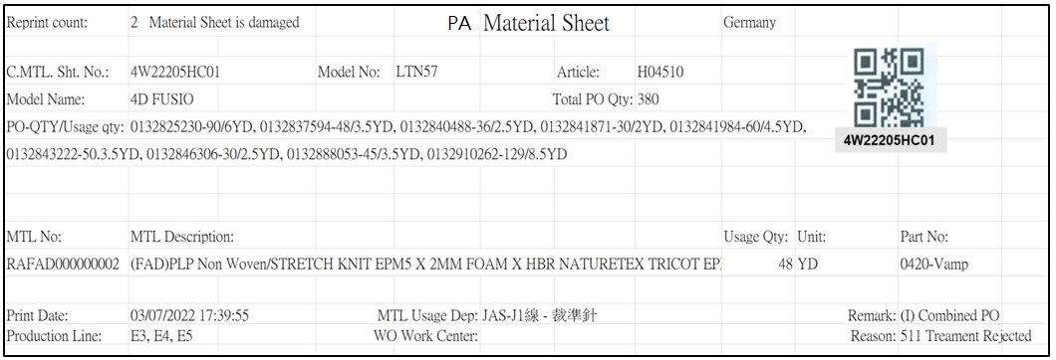

[圖MPS002_8] Combined Material Form

|  |  |  |  |  |  |  |
| --- | --- | --- | --- | --- | --- | --- |
| Print Combined Material Form 列印合併發料單 | | | | | | |
| NO | 顯示名稱 | 必填 | 唯讀 | 存改 | 對應欄位 | 欄位型態  欄位說明 |
|  | Reprint count  重印次數 |  |  |  | REPRINT_CNT | Int |
|  | Reprint Reason  重印原因 |  |  |  | User key in Reprint Reason | String |
| SQL  select PRINT_CNT AS REPRINT_CNT  from dbo.ERP_ISSUE  where C_MATERIAL_SHEET_NO = 'C4W2307030020' | | | | | | |
|  | Form Title Type |  |  |  | "("+ISSUE_TYPE+") "+REMARK05 | String |
| SQL for Type  -- If REMARK05 = Null or Empty, No need to show Form Title Type  select t1.ISSUE_TYPE, t2.REMARK05  from dbo.ERP_ISSUE t1  inner join MES_WPC_EXTENDITEM t2  on t2.CLASS = 'ISSUE_TYPE'  and t1.ISSUE_TYPE = t2.REMARK01  where t1.C_MATERIAL_SHEET_NO = 'C4W250516000374' --(User select row) | | | | | | |
|  | Kind  材料類別 |  |  |  |  | String |
| SQL for kind  -- Get Material Sheet Kind : by C_MATERIAL_SHEET_NO  select top 1 t1.KIND  FROM  (  select PUF  from CST_MPS_PICKFORM_DETAIL  where C_MATERIAL_SHEET_NO = 'C4W240603000886R' --(User select row)  ) t0  inner join dbo.CST_MPS_PICKFORM t1 on t0.PUF = t1.PUF and t1.[STATUS] <> 'Terminate'  **-- IF No Data found, Get Kind by following SQL again**  select top 1 t1.KIND  FROM  (  select top 1 PO_BATCH , MATERIALNO  from ERP_ISSUE_DTL  where C_MATERIAL_SHEET_NO = 'C4W240603000886R' --(User select row)  and [STATUS] <> 'D'  ) t0  inner join dbo.CST_MPS_PICKFORM t1 on t0.PO_BATCH = t1.PO_BATCH and t1.[STATUS] <> 'Terminate'  inner join dbo.CST_MPS_PICKFORM_DETAIL t2 on t1.PUF = t2.PUF and t2.MATERIALNO = t0.MATERIALNO | | | | | | |
|  | Shipping Location  出貨地點 |  |  |  | SHIPPING_LOCATION | String |
| SQL  select top 1 t1.SHIPPING_LOCATION  from [dbo].[ERP_SO] t1  inner join [dbo].[ERP_SOBatch] t2 on t1.SO_NO = t2.SO_NO  where t2.PO_BATCH = '0132957503-4' --(TOP 1 PO_BATCH) | | | | | | |
|  | C.MTL. Sht. No.  合併發料單號 |  |  |  | User selected row | String |
|  | Model No  型體編號 |  |  |  | MODEL_NO | String |
|  | Article  Article |  |  |  | ARTICLE | String |
|  | Model Name  型體名稱 |  |  |  | MODEL_NAME | String |
| SQL：  -- 訂單批次基本資訊 (根據 : C_MATERIAL_SHEET_NO 發料單號)  -- Get PO Batch information ( by C_MATERIAL_SHEET_NO )  SELECT TOP 1 b.PO_NO , a.PO_BATCH , c.ARTICLE , c.MODEL_NAME , c.MODEL_NO  FROM ( select TOP 1 PO_BATCH from dbo.ERP_ISSUE_DTL  where C_MATERIAL_SHEET_NO = 'C4W2307030020' ) a -- (User select row)  left join dbo.ERP_SOBATCH b on a.PO_BATCH = b.PO_BATCH  left join dbo.ERP_SO c on b.PO_NO = c.PO_NO | | | | | | |
|  | Total PO Qty |  |  |  | SUM(QUANTITY) | Numeric |
|  | PO-QTY/Usage qty  訂單號碼/使用量 |  |  |  | PO_BATCH + "-" + QUANTITY + "/" + Issue_QUANTITY + UNIT  And join all data by ", " | String  e.g:0132825230-90/8YD, 0132837594-48/4.5YD |
| SQL：  -- PO-QTY/Usage_qty Unit (全部排在一起，最多可能有15張合併訂單)  -- e.g:0132825230-90/8YD, 0132837594-48/4.5YD  SELECT a.PO_BATCH , b.QUANTITY, a.Issue_QUANTITY , a.UNIT  FROM ( select PO_BATCH , sum(QUANTITY) Issue_QUANTITY , max(UNIT) UNIT from dbo.ERP_ISSUE_DTL  where C_MATERIAL_SHEET_NO = 'C4W2307030020' group by PO_Batch ) a  left join dbo.ERP_SOBATCH b on a.PO_BATCH = b.PO_BATCH  order by a.PO_BATCH | | | | | | |
|  | MTL No  料號 |  |  |  | MATERIALNO | String |
|  | MTL Description  材料名稱 |  |  |  | Material_SPEC | String |
|  | Usage Qty  領用量 |  |  |  | QUANTITY | Numeric |
|  | Unit  單位 |  |  |  | UNIT | String |
|  | Part No  部位 |  |  |  | PART_NO_NAME | String |
| SQL：  select t1.MATERIALNO , t2.MATERIAL_SPEC , t1.QUANTITY , t1.UNIT , t1.PART_NO_NAME  from  (  select max(MATERIALNO) MATERIALNO , sum(QUANTITY) QUANTITY , max(UNIT) UNIT , max(PART_NO + ' ' + PART_NAME) PART_NO_NAME  from dbo.ERP_ISSUE_DTL  where C_MATERIAL_SHEET_NO = 'C4W2307030020' -- (User select row)  group by C_MATERIAL_SHEET_NO  ) t1  left join dbo.ERP_MATERIAL t2 on t1.MATERIALNO = t2.MATERIALNO | | | | | | |
|  | Print Date  列印日期 |  |  |  | User print date and time  (Get from server side) | DateTime  yyyy/MM/dd HH:mm:ss |
|  | MLT Usage Dep  領料單位 |  |  |  | DEPT_DESC | String |
|  | WO Work Center  工單工作中心 |  |  |  | DEPT_DESC_WorkCenter | String  If DEPT_DESC_WorkCenter is Empty, hide this column |
| SQL：  EXEC dbo.PRD_GET_MPS_Dispatch_WorkCenter_ISSUEform 'C4W2307030020' | | | | | | |
|  | Remark  備註 |  |  |  | "("+ISSUE_TYPE+") "+REMARK05+" "+ PO_BATCH_Old  + Dept_ID_Qty | String  e.g: (H) Repacking 0066010000 |
| SQL：  -- First Remark: Material Sheet's Type  -- If REMARK05 = Null or Empty, No need to show Material Sheet's Type  SQL_Remark01:  select t1.ISSUE_TYPE, t2.REMARK05  from dbo.ERP_ISSUE t1  inner join MES_WPC_EXTENDITEM t2  on t2.CLASS = 'ISSUE_TYPE'  and t1.issue_type = 'H' -- (Always = H)  and t1.ISSUE_TYPE = t2.REMARK01  where t1.C_MATERIAL_SHEET_NO = '4W22205GC01'  IF rows.count > 0 ( in SQL_Remark01 )  Begin  -- Second Remark: Old PO  select TOP 1 t3.PO_BATCH AS PO_BATCH_Old  from dbo.ERP_ISSUE t1 , dbo.ERP_ISSUE_DTL t2 , dbo.ERP_SOBatch t3  where t1.C_MATERIAL_SHEET_NO = '4W22205GC01'  and t1.issue_type = 'H' -- (Always = H)  and t1.C_MATERIAL_SHEET_NO = t2.C_MATERIAL_SHEET_NO  and t2.SO_NO = t3.SO_NO  and t2.SO_NO is not null  ELSE  PO_BATCH_Old = ‘’ (Remark =’’)  END  IF Kind = ‘AA’ or Kind = ‘PA’ (Form Title : Kind 材料類別)  Begin  SQL_DEPT:  select C_Material_Sheet_NO , STRING_AGG( Dept_ID_Qty , ';') Dept_ID_Qty  from  (  select C_Material_Sheet_NO  , Dept_ID + '(' + cast(cast(sum(Quantity) as float) as varchar) + ')' Dept_ID_Qty  from ERP_ISSUE_DTL_Dept_DTL  where C_Material_Sheet_NO = 'C4W250312001278' --(User select row)  group by C_Material_Sheet_NO , Dept_ID  ) t1  group by C_Material_Sheet_NO  IF rows.count > 0 and (“Dept_ID_Qty”).IndexOf(";") >= 0 (SQL_DEPT)  Begin  Print (“Dept_ID_Qty”) at Remark (Remark = Remark + (“Dept_ID_Qty”) )  End  -- test data : TSH test DB, PO_batch : 0900351525001 , C_MATERIAL_SHEET_NO : C4W250312001278  END | | | | | | |
|  | Production Line  成型線別 |  |  |  | AS_CELL  join all data by ", " | String  e.g: E3, E4, E5 |
| SQL：  -- Distinct Production Line (by All PO_Batch)  SELECT DISTINCT AS_CELL  FROM ERP_PROD_SCHED  WHERE PO_Batch in ('0132855033', '0132855034', '0132855035', '0132855036') | | | | | | |
|  | Reason  預補原因 |  |  |  | Reason | String |
| SQL：  -- Get Reason by C_Material_Sheet_NO  SELECT top 1 ( t1.REPLENISHMENT_CODE + ' ' + t2.DESCR_EN ) Reason  FROM dbo.ERP_ISSUE_DTL t1  left join dbo.CST_REPLN_REASON t2 on t1.REPLENISHMENT_CODE = t2.REASON_CODE  where t1.C_Material_Sheet_NO like 'C4W2308111592R%' | | | | | | |
| After Print，Update [ERP_ISSUE].[PRINT_CNT] and [ERP_ISSUE].[PRINT_TIME] (use server time)  SQL：  update dbo.ERP_ISSUE  set PRINT_CNT = PRINT_CNT + 1  , REPRINT_REASON = 'Material Sheet is damaged' --(User key in Reprint Reason)  , PRINT_TIME = GETDATE() -- Server time，yyyy/MM/dd HH:mm:ss  WHERE C_MATERIAL_SHEET_NO = '5W22205GC02' --(User select row) | | | | | | |

* 1. **「MPS003 Print Material Sheet (OEM Order)」MPS003 列印發料單(代工訂單)**
  2. 程式名稱：同標題 (Right Name: MPS_Print.Material.Sheet.OEM.Order)
  3. 功能目的：查詢/列印
  4. 使用部門：
  5. 程式說明：

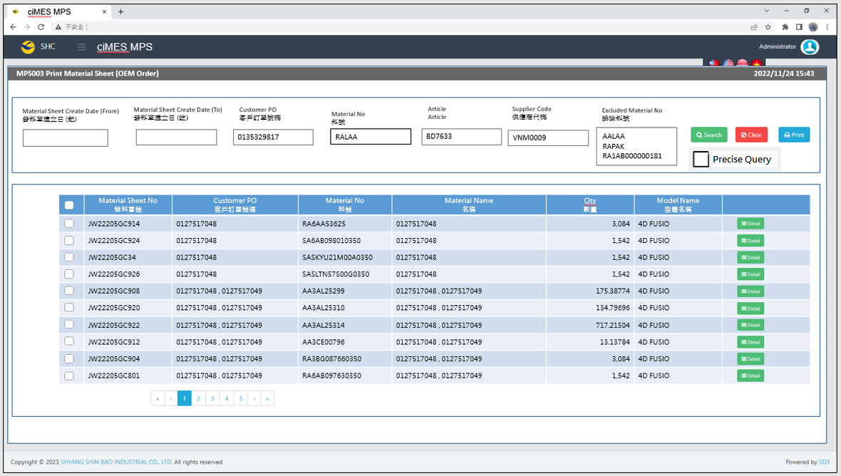

[圖MPS003_1] Main Page主畫面

|  |  |  |  |  |  |  |
| --- | --- | --- | --- | --- | --- | --- |
| Program header 程式標頭 | | | | | | |
| NO | 顯示名稱 | 必填 | 唯讀 | 存改 | 對應欄位 | 說明 |
|  | Title  標題 |  | V |  | CAPTION | String  If there is no get data, please show “Right Name”  SELECT T2.LANGUAGE, T2.CAPTION  FROM [MES_SEC_RIGHT] AS T1  JOIN [MES_MENU_ITEM] AS T2  ON T1.SEC_RIGHT_SID = T2.SEC_RIGHT_SID  WHERE T1.GROUPRIGHTS = 'MPS_Reprint.Material.Sheet.OEM.Order' --(Right Name) |
|  | System Time  系統時間 |  | V |  | Show current server time | Datetime  yyyy/MM/dd HH:mm |

|  |  |  |  |  |  |  |
| --- | --- | --- | --- | --- | --- | --- |
| Operation button 操作按鈕 | | | | | | |
| NO | 顯示名稱 | 必填 | 唯讀 | 存改 | 對應欄位 | 說明 |
|  | Search  搜尋 |  |  |  |  | Required「Material Sheet Create Date」or「Customer PO」to search |
|  | Clear  清除 |  |  |  |  | Clear Search Condition and Results |
|  | Print  列印 |  |  |  |  | Print the select row data |
|  | Detail  明細 |  |  |  |  | Show detail data |
| Search Condition 搜尋條件 | | | | | | |
| NO | 顯示名稱 | 必填 | 唯讀 | 存改 | 對應欄位 | 欄位型態  欄位說明 |
|  | Material Sheet Create Date (From)  發料單建立日(起) |  |  | V | Filter Material Sheet Create Date column | String  yyyy/MM/dd |
|  | Material Sheet Create Date (To)  發料單建立日(訖) |  |  | V | Filter Material Sheet Create Date column | String  yyyy/MM/dd |
|  | Customer PO  客戶訂單號碼 |  |  | V | Filter Customer PO column | String  If chkPrecise is checked  Must exactly matched  Remove % in Search SQL |
|  | Material No  料號 |  |  | V | Filter MATERIALNO column | String |
|  | ARTICLE  ARTICLE |  |  | V | Filter Article column | String |
|  | Supplier Code  供應商代碼 |  |  | V | Filter SUPPLIER_CODE column | String |
|  | Excluded Material No  排除料號 |  |  | V | Filter Excluded MATERIAL_NO column | String (Multi-Line textbox)  After get data by SQL, if Material_No prefix character equal to any item in Excluded Material No list , then remove and need not to show in result gridview  Ex : Excluded Material No List :  AALAA  RAPAK  RA1AB000000181  Then  AALAA000000138  RAPAK000000001  RAPAK000000002  RAPAK000000001  RA1AB000000181  Should all be removed |
|  | Precise Query  精準比對 |  |  | V |  | Check Box : chkPrecise (default : not cheched)  If chkPrecise is checked  Filter Customer PO-Batch column  Must exactly matched  (Remove % in Search SQL Ex : PO_BATCH like '090007695001-1' )  Need not to change : Filter Excluded MATERIAL_NO column |

|  |  |  |  |  |  |  |
| --- | --- | --- | --- | --- | --- | --- |
| Search 搜尋 | | | | | | |
| NO | 顯示名稱 | 必填 | 唯讀 | 存改 | 對應欄位 | 欄位型態  欄位說明 |
|  | Selector  選擇器 |  |  | V |  | Check Box |
|  | Material Sheet No  發料單號 |  | V |  | MATERIAL_SHEET_NO | String |
|  | Customer PO  客戶訂單號碼 |  | V |  | PO_NO | String |
|  | Material No  料號 |  | V |  | MATERIAL_NO | String |
|  | Material Name  料號名稱 |  | V |  | MATERIAL_NAME | String |
|  | Qty  數量 |  | V |  | QUANTITY | Numeric |
|  | Model Name  型體名稱 |  | V |  | MODEL_NAME | String |
|  | Detail button  明細按鈕 |  |  |  | Open detail page | Button |
| 程式邏輯說明：  填入Material Sheet Create Date 或 Customer PO後(擇一必填)，點選 [Search搜尋] 按鈕，即可帶出資料。  SQL：  select tb1.* , tb2.MATERIAL_NAME from  (  SELECT T1.MATERIAL_SHEET_NO, MIN(T2.MATERIAL_NO) AS MATERIAL_NO, String_AGG(T2.PO_NO, ', ') AS PO_NO, SUM(T2.QUANTITY) AS QUANTITY, MIN(T2.MODEL_NAME) AS MODEL_NAME  FROM dbo.ERP_OSISSUE AS T1,  (  select a.MATERIAL_SHEET_NO, min(MATERIALNO) AS MATERIAL_NO, sum(a.QUANTITY) AS QUANTITY, a.PO_NO, min(c.MODEL_NAME) AS MODEL_NAME  from dbo.ERP_OSISSUE_DTL AS a,  (  select t1.MATERIAL_SHEET_NO  from ERP_OSISSUE_DTL t1  inner join dbo.ERP_PO t2 on t1.PURCHASE_NO = t2.PURCHASE_NO and t2.PURCHASE_TYPE = 'ZP10' -- (Always ZP10)  inner join ERP_OSISSUE t3 on t1.MATERIAL_SHEET_NO = t3.MATERIAL_SHEET_NO  where t1.UPDATETIME >= '2024/08/01' -- (Material Sheet Create Date (From))  and t1.UPDATETIME < DATEADD(DAY, 1, '2024/10/31') -- (Material Sheet Create Date (To)) + 1  and t1.PO_NO like '0135329817%' -- (Customer PO)  and t1.MATERIALNO like 'AALAA%' -- (Material No)  and t3.SUPPLIER_CODE = 'VNM0009' -- ( Supplier Code)  group by t1.MATERIAL_SHEET_NO  ) AS b, dbo.ERP_SOBATCH AS c  where a.MATERIAL_SHEET_NO = b.MATERIAL_SHEET_NO  and a.PO_NO = c.PO_NO  and c.ARTICLE = 'BD7633' -- (ARTICLE)  group by a.MATERIAL_SHEET_NO, a.PO_NO  ) AS T2  WHERE T1.MATERIAL_SHEET_NO = T2.MATERIAL_SHEET_NO  And ( T1.DELETE_FLAG <> 'X' or T1.DELETE_FLAG is null )  AND T1.PRINT_CNT = 0  GROUP BY T1.MATERIAL_SHEET_NO  ) tb1  inner join ERP_MATERIAL tb2 on tb1.MATERIAL_NO = tb2.MATERIALNO  ORDER BY PO_NO, MATERIAL_SHEET_NO, MATERIAL_NO | | | | | | |

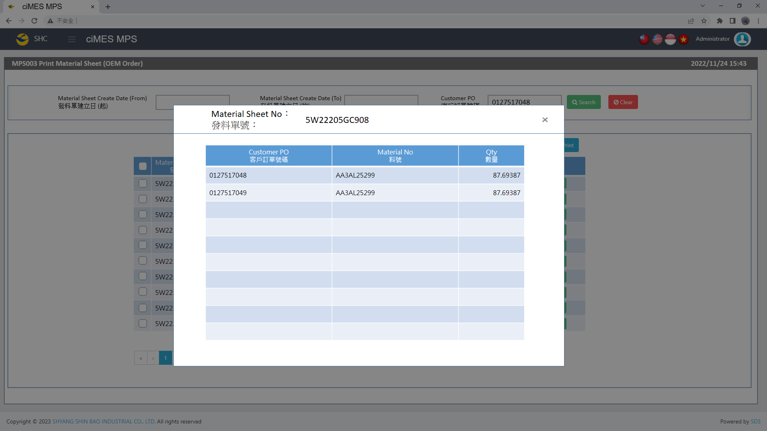

[圖MPS003_2] Detail明細畫面

|  |  |  |  |  |  |  |
| --- | --- | --- | --- | --- | --- | --- |
| Detail 明細 | | | | | | |
| NO | 顯示名稱 | 必填 | 唯讀 | 存改 | 對應欄位 | 欄位型態  欄位說明 |
|  | Material Sheet No  發料單號 |  | V |  | User selected row | String |
|  | Customer PO  客戶訂單號碼 |  | V |  | PO_NO | String |
|  | Material No  料號 |  | V |  | MATERIALNO | String |
|  | Qty  數量 |  | V |  | QUANTITY | Numeric |
| 程式邏輯說明：  依照User點選的資料列，帶出該資料列的明細資料。  SQL：  SELECT MATERIAL_SHEET_NO , PO_NO , MATERIALNO , QUANTITY  FROM dbo.ERP_OSISSUE_DTL where MATERIAL_SHEET_NO = 'JW2304250001' -- (User selected row)  order by PO_NO , MATERIALNO | | | | | | |

**Print Regular Material Form (OEM Order) 列印一般發料單 (代工訂單)**：

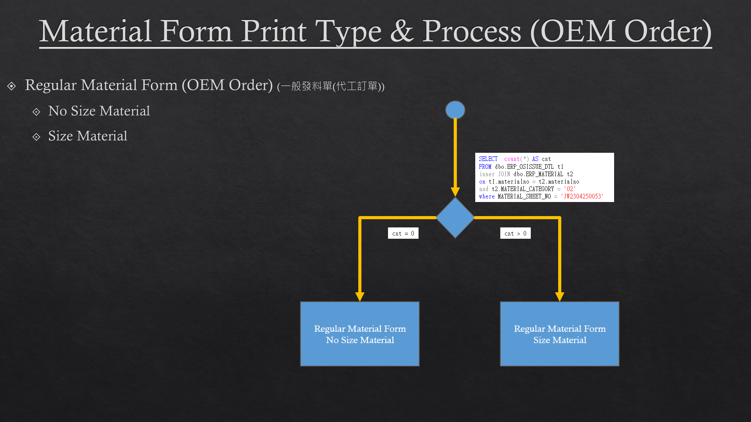

[圖MPS003_3] Material Form Print Type & Process (OEM Order)，Check whether there is Size Run

|  |  |  |  |  |  |  |
| --- | --- | --- | --- | --- | --- | --- |
| Print Regular Material Form (OEM Order)列印一般發料單 (代工訂單) | | | | | | |
| NO | 顯示名稱 | 必填 | 唯讀 | 存改 | 對應欄位 | 欄位型態  欄位說明 |
|  |  |  |  |  |  |  |
| 程式邏輯說明：  選擇資料列後，點選列印，印出發料單(A4中三刀)，邏輯如下  Regular Material Form (OEM Order) need check is Size Run or not  If cnt = 0，Print「**Regular Material Form (OEM Order) – No Size Material」**  If cnt > 0，Print「**Regular Material Form (OEM Order) – Size Material」**  SQL：  -- cnt > 0， 有尺寸發料單，列印size run  -- cnt = 0， 無尺寸發料單  SELECT count(*) AS cnt  FROM dbo.ERP_OSISSUE_DTL t1  inner JOIN dbo.ERP_MATERIAL t2  on t1.materialno = t2.materialno  and t2.MATERIAL_CATEGORY = '02'  where MATERIAL_SHEET_NO = 'JW2304250053' | | | | | | |



[圖MPS003_4] Regular Material Form (OEM Order)，A4中三刀，示意圖

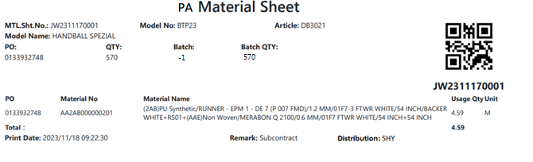

[圖MPS003_5] Regular Material Form (OEM Order) – No Size Material

|  |  |  |  |  |  |  |
| --- | --- | --- | --- | --- | --- | --- |
| Print Regular Material Form (OEM Order) – No Size Material 列印一般發料單(代工訂單) – 無尺寸發料單 | | | | | | |
| NO | 顯示名稱 | 必填 | 唯讀 | 存改 | 對應欄位 | 欄位型態  欄位說明 |
|  | Kind  材料類別 |  |  |  | Kind | String |
| SQL for kind  -- Get Material Sheet Kind : by MASTER_MATERIALNO  select top 1 CASE Substring(MASTER_MATERIALNO,1,1)  WHEN 'F' THEN 'FA'  WHEN 'U' THEN 'UA'  WHEN 'B' THEN 'BA'  WHEN 'P' THEN 'PA'  ELSE ''  END Kind  from ERP_OSISSUE_DTL  where MATERIAL_SHEET_NO = 'JW2401020113'--(User select row) | | | | | | |
|  | MTL. Sht. No.  發料單號 |  |  |  | User selected row | String |
|  | Model No  型體編號 |  |  |  | MODEL_NO | String |
|  | Article  Article |  |  |  | ARTICLE | String |
|  | Model Name  型體名稱 |  |  |  | MODEL_NAME | String |
|  | PO  訂單編號 |  |  |  | PO_NO | String |
|  | QTY  訂單數量 |  |  |  | QUANTITY | Numeric |
| SQL：  -- 訂單批次基本資訊 (根據 : MATERIAL_SHEET_NO 發料單號)  -- -- Get PO Batch information ( by MATERIAL_SHEET_NO )  SELECT b.PO_NO , b.QUANTITY, c.ARTICLE , c.MODEL_NAME , c.MODEL_NO  FROM ( select top 1 PO_NO from dbo.ERP_OSISSUE_DTL  where MATERIAL_SHEET_NO = 'JW2304250053' ) a --(User select row)  left join dbo.ERP_SOBATCH b on a.PO_NO = b.PO_NO  left join dbo.ERP_SO c on b.PO_NO = c.PO_NO  SQL：  -- 訂單Qty (根據 : PO_NO)  -- Get PO information ( by PO_NO )  SELECT sum(QUANTITY) QUANTITY  FROM dbo.ERP_SOBATCH  where PO_NO = '0131989861' | | | | | | |
|  | Batch  批次 |  |  |  | BATCH | String |
|  | Batch Qty  批次數量 |  |  |  | Batch_QUANTITY | Numeric |
| SQL Batch：  SELECT top 1 REPLACE(t2.PO_BATCH, t2.PO_NO ,'' ) BATCH , cast( t3.QUANTITY as float) Batch_QUANTITY  FROM dbo.ERP_OSISSUE_DTL t1  inner join ERP_PO t2 on t1.PURCHASE_NO = t2.PURCHASE_NO  left join ERP_SOBATCH t3 on t3.PO_BATCH = t2.PO_BATCH  where MATERIAL_SHEET_NO = 'JW2505200007' --(User select row)  and t3.PO_BATCH like t1.PO_NO + '%' | | | | | | |
|  | PO  訂單號碼 |  |  |  | PO_NO | String |
|  | Material No  料號 |  |  |  | MATERIALNO | String |
|  | Material Name  材料名稱 |  |  |  | MATERIAL_SPEC | String |
|  | Usage Qty  領用量 |  |  |  | QUANTITY | Numeric |
|  | Unit  單位 |  |  |  | UNIT | String |
|  | Total  合計 |  |  |  | SUM(QUANTITY) | Numeric |
|  | Print Date  列印日期 |  |  |  | User print date and time  (Get from server side) | DateTime  yyyy/MM/dd HH:mm:ss |
|  | Remark  備註 |  |  |  | Show "Subcontract" | String |
|  | Distribution  領料部門 |  |  |  | SUPPLIER_CODE | String |
| SQL：  --NO SIZE MATERIAL : data list ( by MATERIAL_SHEET_NO )  select min(a.PO_NO) AS PO_NO , a.MATERIALNO , min(b.MATERIAL_SPEC) AS MATERIAL_SPEC , min(c.QUANTITY) AS QUANTITY, min(a.UNIT) AS UNIT  , min(c.SUPPLIER_CODE) SUPPLIER_CODE  FROM ( select * from dbo.ERP_OSISSUE_DTL  where MATERIAL_SHEET_NO = 'JW2311170001' ----(User select row)  ) a  left join dbo.ERP_MATERIAL b on a.MATERIALNO = b.MATERIALNO  inner join dbo.ERP_OSISSUE c on a.MATERIAL_SHEET_NO = c.MATERIAL_SHEET_NO  ~~where MATERIAL_SHEET_NO = 'JW2304250053' --(User select row)~~  group by a.MATERIALNO  order by MATERIALNO | | | | | | |
| After Print，Update [ERP_OSISSUE].[PRINT_CNT] and [ERP_OSISSUE].[PRINT_TIME] (use server time)  SQL：  update dbo.ERP_OSISSUE  set PRINT_CNT = PRINT_CNT + 1  , PRINT_TIME = GETDATE() -- Server time，yyyy/MM/dd HH:mm:ss  where MATERIAL_SHEET_NO = 'JW2304250053' --(User select row) | | | | | | |
| After Print，Call procedure  SQL：  EXEC dbo. PRD_CST_MPS_PICKFORM_Auto_insert 'JW2304250053' --(User select row) | | | | | | |

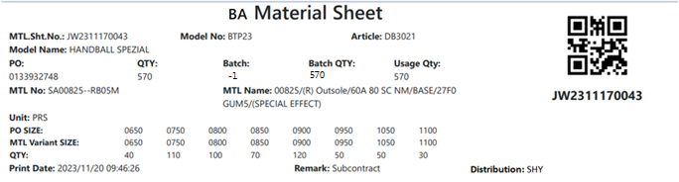

[圖MPS003_6] Regular Material Form (OEM Order) – Size Material

|  |  |  |  |  |  |  |
| --- | --- | --- | --- | --- | --- | --- |
| Print Regular Material Form (OEM Order) – Size Material 列印一般發料單(代工訂單) – 有尺寸發料單 | | | | | | |
| NO | 顯示名稱 | 必填 | 唯讀 | 存改 | 對應欄位 | 欄位型態  欄位說明 |
|  | Kind  材料類別 |  |  |  | Kind | String |
| SQL for kind  -- Get Material Sheet Kind : by MASTER_MATERIALNO  select top 1 CASE Substring(MASTER_MATERIALNO,1,1)  WHEN 'F' THEN 'FA'  WHEN 'U' THEN 'UA'  WHEN 'B' THEN 'BA'  WHEN 'P' THEN 'PA'  ELSE ''  END Kind  from ERP_OSISSUE_DTL  where MATERIAL_SHEET_NO = 'JW2401020113'--(User select row) | | | | | | |
|  | MTL. Sht. No.  發料單號 |  |  |  | User selected row | String |
|  | Model No  型體編號 |  |  |  | MODEL_NO | String |
|  | Article  Article |  |  |  | ARTICLE | String |
|  | Model Name  型體名稱 |  |  |  | MODEL_NAME | String |
|  | PO  訂單編號 |  |  |  | PO_NO | String |
|  | QTY  訂單數量 |  |  |  | QUANTITY | Numeric |
| SQL：  -- 訂單批次基本資訊 (根據 : MATERIAL_SHEET_NO 發料單號)  -- -- Get PO Batch information ( by MATERIAL_SHEET_NO )  SELECT b.PO_NO , b.QUANTITY, c.ARTICLE , c.MODEL_NAME , c.MODEL_NO  FROM ( select top 1 PO_NO from dbo.ERP_OSISSUE_DTL  where MATERIAL_SHEET_NO = 'JW2304250054' ) a --(User select row)  left join dbo.ERP_SOBATCH b on a.PO_NO = b.PO_NO  left join dbo.ERP_SO c on b.PO_NO = c.PO_NO  SQL：  -- 訂單Qty (根據 : PO_NO)  -- Get PO information ( by PO_NO )  SELECT sum(QUANTITY) QUANTITY  FROM dbo.ERP_SOBATCH  where PO_NO = '0131989861' | | | | | | |
|  | Batch  批次 |  |  |  | BATCH | String |
|  | Batch Qty  批次數量 |  |  |  | Batch_QUANTITY | Numeric |
| SQL Batch：  SELECT top 1 REPLACE(t2.PO_BATCH, t2.PO_NO ,'' ) BATCH , cast( t3.QUANTITY as float) Batch_QUANTITY  FROM dbo.ERP_OSISSUE_DTL t1  inner join ERP_PO t2 on t1.PURCHASE_NO = t2.PURCHASE_NO  left join ERP_SOBATCH t3 on t3.PO_BATCH = t2.PO_BATCH  where MATERIAL_SHEET_NO = 'JW2505200007' --(User select row)  and t3.PO_BATCH like t1.PO_NO + '%' | | | | | | |
|  | Material No  料號 |  |  |  | GENERIC_MATERIAL | String |
|  | Material Name  材料名稱 |  |  |  | MATERIAL_SPEC | String |
|  | Unit  單位 |  |  |  | UNIT | String |
| SQL：  -- 有尺寸材料 GENERIC_MATERIAL , MATERIAL_SPEC , UNIT  -- by MATERIAL_SHEET_NO  select t2.GENERIC_MATERIAL , t3.MATERIAL_SPEC , t2.UNIT  from ( Select top 1 MATERIALNO  from dbo.ERP_OSISSUE_DTL  where MATERIAL_SHEET_NO = 'JW2304250054' ) t1  left join dbo.ERP_MATERIAL t2 on t1.materialno = t2.materialno  left join dbo.ERP_MATERIAL t3 on t3.materialno = t2.GENERIC_MATERIAL | | | | | | |
|  | Usage Qty  領用量 |  |  |  | SUM(QUANTITY) | Numeric |
|  | PO SIZE  訂單尺寸 |  |  |  | PO_SIZE | String |
|  | MTL Variant SIZE  MTL Variant SIZE |  |  |  | MATERIAL_SIZE | String |
|  | Qty  數量 |  |  |  | QUANTITY | Numeric |
|  | Print Date  列印日期 |  |  |  | User print date and time  (Get from server side) | DateTime  yyyy/MM/dd HH:mm:ss |
|  | Remark  備註 |  |  |  | Show "Subcontract" | String |
|  | Distribution  領料部門 |  |  |  | SUPPLIER_CODE | String |
| SQL：  -- 有尺寸 PO SIZE 、 MATERIAL_SIZE 明細 (根據 : 發料單號)  -- SIZE MATERIAL : data list ( by MATERIAL_SHEET_NO )  select PO_SIZE , MATERIAL_SIZE, QUANTITY  from dbo.ERP_OSISSUE_DTL  where MATERIAL_SHEET_NO = ' JW2311170043' --(User select row)  and trim(ITEM_NO) <> '0'  order by PO_SIZE  -- Distribution  select Supplier_Code  from dbo.ERP_OSISSUE  where MATERIAL_SHEET_NO = 'JW2311170043' --(User select row) | | | | | | |
| After Print，Update [ERP_OSISSUE].[PRINT_CNT] and [ERP_OSISSUE].[PRINT_TIME] (use server time)  SQL：  update dbo.ERP_OSISSUE  set PRINT_CNT = PRINT_CNT + 1  , PRINT_TIME = GETDATE() -- Server time，yyyy/MM/dd HH:mm:ss  where MATERIAL_SHEET_NO = 'JW2304250054' --(User select row) | | | | | | |
| After Print，Call procedure  SQL：  EXEC dbo. PRD_CST_MPS_PICKFORM_Auto_insert 'JW2304250054' --(User select row) | | | | | | |

* 1. **「MPS004 Reprint Material Sheet (OEM Order)」MPS004重列印發料單(代工訂單)**
  2. 程式名稱：同標題 (Right Name: MPS_Reprint.Material.Sheet.OEM.Order)
  3. 功能目的：查詢/列印
  4. 使用部門：
  5. 程式說明：

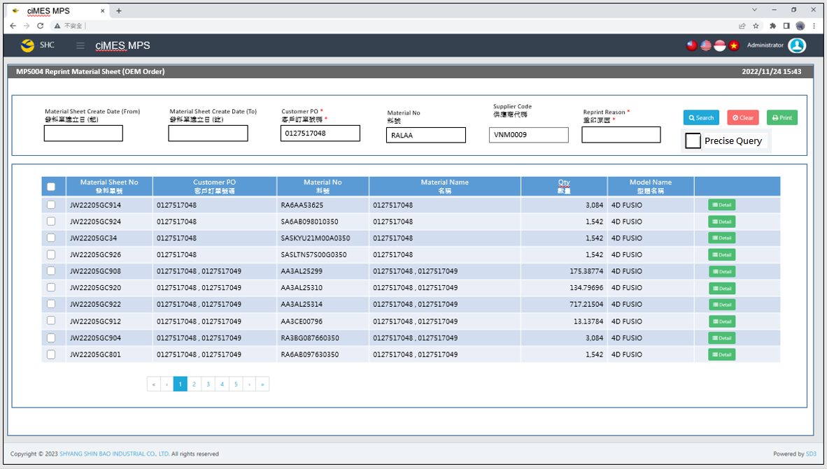

[圖MPS004_1] Main Page主畫面

|  |  |  |  |  |  |  |
| --- | --- | --- | --- | --- | --- | --- |
| Program header 程式標頭 | | | | | | |
| NO | 顯示名稱 | 必填 | 唯讀 | 存改 | 對應欄位 | 說明 |
|  | Title  標題 |  | V |  | CAPTION | String  If there is no get data, please show “Right Name”  SELECT T2.LANGUAGE, T2.CAPTION  FROM [MES_SEC_RIGHT] AS T1  JOIN [MES_MENU_ITEM] AS T2  ON T1.SEC_RIGHT_SID = T2.SEC_RIGHT_SID  WHERE T1.GROUPRIGHTS = 'MPS_Reprint.Material.Sheet.OEM.Order' --(Right Name) |
|  | System Time  系統時間 |  | V |  | Show current server time | Datetime  yyyy/MM/dd HH:mm |

|  |  |  |  |  |  |  |
| --- | --- | --- | --- | --- | --- | --- |
| Operation button 操作按鈕 | | | | | | |
| NO | 顯示名稱 | 必填 | 唯讀 | 存改 | 對應欄位 | 說明 |
|  | Search  搜尋 |  |  |  |  | Required「Material Sheet Create Date」or「Customer PO」to search |
|  | Clear  清除 |  |  |  |  | Clear Search Condition and Results |
|  | Print  列印 |  |  |  |  | Print the select row data |
|  | Detail  明細 |  |  |  |  | Show detail data |

|  |  |  |  |  |  |  |
| --- | --- | --- | --- | --- | --- | --- |
| Search Condition 搜尋條件 | | | | | | |
| NO | 顯示名稱 | 必填 | 唯讀 | 存改 | 對應欄位 | 欄位型態  欄位說明 |
|  | Material Sheet Create Date (From)  發料單建立日(起) |  |  | V | Filter Material Sheet Create Date column | String  yyyy/MM/dd |
|  | Material Sheet Create Date (To)  發料單建立日(訖) |  |  | V | Filter Material Sheet Create Date column | String  yyyy/MM/dd |
|  | Customer PO  客戶訂單號碼 |  |  | V | Filter Customer PO column | String  If chkPrecise is checked  Must exactly matched  Remove % in Search SQL |
|  | Material No  料號 |  |  | V | Filter MATERIALNO column | String |
|  | Supplier Code  供應商代碼 |  |  | V | Filter SUPPLIER_CODE column | String |
|  | Reprint Reason  重印原因 | V |  | V |  | String  Required when printing |
|  | Precise Query  精準比對 |  |  | V |  | Check Box : chkPrecise (default : not cheched)  If chkPrecise is checked  Filter Customer PO-Batch column  Must exactly matched  (Remove % in Search SQL Ex : PO_BATCH like '090007695001-1' ) |

|  |  |  |  |  |  |  |
| --- | --- | --- | --- | --- | --- | --- |
| Search 搜尋 | | | | | | |
| NO | 顯示名稱 | 必填 | 唯讀 | 存改 | 對應欄位 | 欄位型態  欄位說明 |
|  | Selector  選擇器 |  |  | V |  | Check Box |
|  | Material Sheet No  發料單號 |  | V |  | MATERIAL_SHEET_NO | String |
|  | Customer PO  客戶訂單號碼 |  | V |  | PO_NO | String |
|  | Material No  料號 |  | V |  | MATERIAL_NO | String |
|  | Material Name  料號名稱 |  | V |  | MATERIAL_NAME | String |
|  | Qty  數量 |  | V |  | QUANTITY | Numeric |
|  | Model Name  型體名稱 |  | V |  | MODEL_NAME | String |
|  | Detail button  明細按鈕 |  |  |  | Open detail page | Button |
| 程式邏輯說明：  填入Material Sheet Create Date 或 Customer PO後(擇一必填)，點選 [Search搜尋] 按鈕，即可帶出資料。  SQL：  select tb1.* , tb2.MATERIAL_NAME from  (  SELECT T1.MATERIAL_SHEET_NO, MIN(T2.MATERIAL_NO) AS MATERIAL_NO, String_AGG(T2.PO_NO, ', ') AS PO_NO, SUM(T2.QUANTITY) AS QUANTITY, MIN(T2.MODEL_NAME) AS MODEL_NAME  FROM dbo.ERP_OSISSUE AS T1,  (  select a.MATERIAL_SHEET_NO, min(MATERIALNO) AS MATERIAL_NO, sum(a.QUANTITY) AS QUANTITY, a.PO_NO, min(c.MODEL_NAME) AS MODEL_NAME  from dbo.ERP_OSISSUE_DTL AS a,  (  select t1.MATERIAL_SHEET_NO  from ERP_OSISSUE_DTL t1  inner join dbo.ERP_PO t2 on t1.PURCHASE_NO = t2.PURCHASE_NO and t2.PURCHASE_TYPE = 'ZP10' -- (Always ZP10)  inner join ERP_OSISSUE t3 on t1.MATERIAL_SHEET_NO = t3.MATERIAL_SHEET_NO  where t1.UPDATETIME >= '2024/08/01' -- (Material Sheet Create Date (From))  and t1.UPDATETIME < DATEADD(DAY, 1, '2024/10/31') -- (Material Sheet Create Date (To)) + 1  and t1.PO_NO like '0135329817%' -- (Customer PO)  and t1.MATERIALNO like 'AALAA%' -- (Material No)  and t3.SUPPLIER_CODE = 'VNM0009' -- ( Supplier Code)  group by t1.MATERIAL_SHEET_NO  ) AS b, dbo.ERP_SOBATCH AS c  where a.MATERIAL_SHEET_NO = b.MATERIAL_SHEET_NO  and a.PO_NO = c.PO_NO  group by a.MATERIAL_SHEET_NO, a.PO_NO  ) AS T2  WHERE T1.MATERIAL_SHEET_NO = T2.MATERIAL_SHEET_NO  And ( T1.DELETE_FLAG <> 'X' or T1.DELETE_FLAG is null )  AND T1.PRINT_CNT > 0  GROUP BY T1.MATERIAL_SHEET_NO  ) tb1  inner join ERP_MATERIAL tb2 on tb1.MATERIAL_NO = tb2.MATERIALNO  ORDER BY PO_NO, MATERIAL_SHEET_NO, MATERIAL_NO | | | | | | |

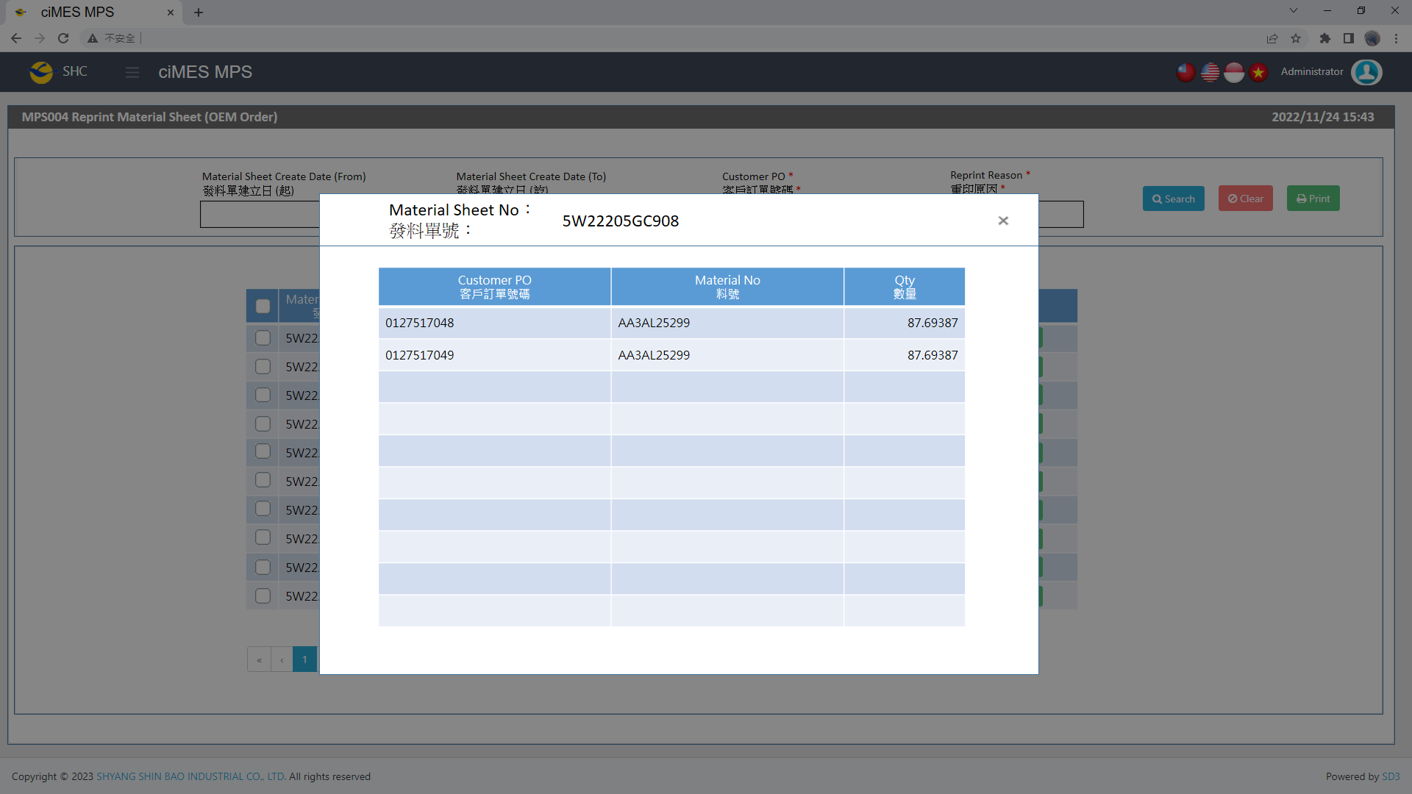

[圖MPS004_2] Detail明細畫面

|  |  |  |  |  |  |  |
| --- | --- | --- | --- | --- | --- | --- |
| Detail 明細 | | | | | | |
| NO | 顯示名稱 | 必填 | 唯讀 | 存改 | 對應欄位 | 欄位型態  欄位說明 |
|  | Material Sheet No  發料單號 |  | V |  | User selected row | String |
|  | Customer PO  客戶訂單號碼 |  | V |  | PO_NO | String |
|  | Material No  料號 |  | V |  | MATERIALNO | String |
|  | Qty  數量 |  | V |  | QUANTITY | Numeric |
| 程式邏輯說明：  依照User點選的資料列，帶出該資料列的明細資料。  SQL：  SELECT MATERIAL_SHEET_NO , PO_NO , MATERIALNO , QUANTITY  FROM dbo.ERP_OSISSUE_DTL where MATERIAL_SHEET_NO = 'JW2304250001' -- (User selected row)  order by PO_NO , MATERIALNO | | | | | | |

**Print Regular Material Form (OEM Order) 列印一般發料單 (代工訂單)**：



[圖MPS004_3] Material Form Print Type & Process (OEM Order)，Check whether there is Size Run

|  |  |  |  |  |  |  |
| --- | --- | --- | --- | --- | --- | --- |
| Print Regular Material Form (OEM Order)列印一般發料單 (代工訂單) | | | | | | |
| NO | 顯示名稱 | 必填 | 唯讀 | 存改 | 對應欄位 | 欄位型態  欄位說明 |
|  |  |  |  |  |  |  |
| 程式邏輯說明：  選擇資料列後，點選列印，印出發料單(A4中三刀)，邏輯如下  Regular Material Form (OEM Order) need check is Size Run or not  If cnt = 0，Print「**Regular Material Form (OEM Order) – No Size Material」**  If cnt > 0，Print「**Regular Material Form (OEM Order) – Size Material」**  SQL：  -- cnt > 0， 有尺寸發料單，列印size run  -- cnt = 0， 無尺寸發料單  SELECT count(*) AS cnt  FROM dbo.ERP_OSISSUE_DTL t1  inner JOIN dbo.ERP_MATERIAL t2  on t1.materialno = t2.materialno  and t2.MATERIAL_CATEGORY = '02'  where MATERIAL_SHEET_NO = 'JW2304250053' | | | | | | |



[圖MPS004_4] Regular Material Form (OEM Order)，A4中三刀，示意圖

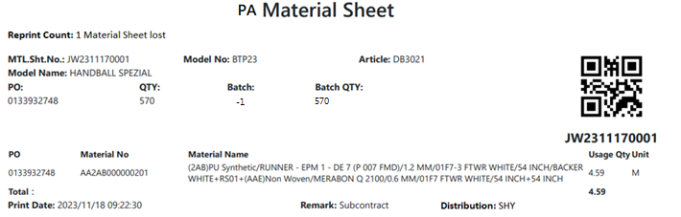

[圖MPS004_5] Regular Material Form (OEM Order) – No Size Material

|  |  |  |  |  |  |  |
| --- | --- | --- | --- | --- | --- | --- |
| Print Regular Material Form (OEM Order) – No Size Material 列印一般發料單(代工訂單) – 無尺寸發料單 | | | | | | |
| NO | 顯示名稱 | 必填 | 唯讀 | 存改 | 對應欄位 | 欄位型態  欄位說明 |
|  | Reprint count  重印次數 |  |  |  | REPRINT_CNT | Int |
|  | Reprint Reason  重印原因 |  |  |  | User key in Reprint Reason | String |
| SQL  select PRINT_CNT AS REPRINT_CNT  from dbo.ERP_OSISSUE  where MATERIAL_SHEET_NO = 'JW2304250053' | | | | | | |
|  | Kind  材料類別 |  |  |  | Kind | String |
| SQL for kind  -- Get Material Sheet Kind : by MASTER_MATERIALNO  select top 1 CASE Substring(MASTER_MATERIALNO,1,1)  WHEN 'F' THEN 'FA'  WHEN 'U' THEN 'UA'  WHEN 'B' THEN 'BA'  WHEN 'P' THEN 'PA'  ELSE ''  END Kind  from ERP_OSISSUE_DTL  where MATERIAL_SHEET_NO = 'JW2401020113'--(User select row) | | | | | | |
|  | MTL. Sht. No.  發料單號 |  |  |  | User selected row | String |
|  | Model No  型體編號 |  |  |  | MODEL_NO | String |
|  | Article  Article |  |  |  | ARTICLE | String |
|  | Model Name  型體名稱 |  |  |  | MODEL_NAME | String |
|  | PO  訂單編號 |  |  |  | PO_NO | String |
|  | QTY  訂單數量 |  |  |  | QUANTITY | Numeric |
| SQL：  -- 訂單批次基本資訊 (根據 : MATERIAL_SHEET_NO 發料單號)  -- -- Get PO Batch information ( by MATERIAL_SHEET_NO )  SELECT b.PO_NO , b.QUANTITY, c.ARTICLE , c.MODEL_NAME , c.MODEL_NO  FROM ( select top 1 PO_NO from dbo.ERP_OSISSUE_DTL  where MATERIAL_SHEET_NO = 'JW2304250053' ) a --(User select row)  left join dbo.ERP_SOBATCH b on a.PO_NO = b.PO_NO  left join dbo.ERP_SO c on b.PO_NO = c.PO_NO  SQL：  -- 訂單Qty (根據 : PO_NO)  -- Get PO information ( by PO_NO )  SELECT sum(QUANTITY) QUANTITY  FROM dbo.ERP_SOBATCH  where PO_NO = '0131989861' | | | | | | |
|  | Batch  批次 |  |  |  | BATCH | String |
|  | Batch Qty  批次數量 |  |  |  | Batch_QUANTITY | Numeric |
| SQL Batch：  SELECT top 1 REPLACE(t2.PO_BATCH, t2.PO_NO ,'' ) BATCH , cast( t3.QUANTITY as float) Batch_QUANTITY  FROM dbo.ERP_OSISSUE_DTL t1  inner join ERP_PO t2 on t1.PURCHASE_NO = t2.PURCHASE_NO  left join ERP_SOBATCH t3 on t3.PO_BATCH = t2.PO_BATCH  where MATERIAL_SHEET_NO = 'JW2505200007' --(User select row)  and t3.PO_BATCH like t1.PO_NO + '%' | | | | | | |
|  | QTY  訂單數量 |  |  |  | QUANTITY | Numeric |
|  | | | | | | |
|  | PO  訂單號碼 |  |  |  | PO_NO | String |
|  | Material No  料號 |  |  |  | MATERIALNO | String |
|  | Material Name  材料名稱 |  |  |  | MATERIAL_SPEC | String |
|  | Qty  領用量 |  |  |  | QUANTITY | Numeric |
|  | Unit  單位 |  |  |  | UNIT | String |
|  | Total  合計 |  |  |  | SUM(QUANTITY) | Numeric |
|  | Print Date  列印日期 |  |  |  | User print date and time  (Get from server side) | DateTime  yyyy/MM/dd HH:mm:ss |
|  | Remark  備註 |  |  |  | Show "Subcontract" | String |
|  | Distribution  領料部門 |  |  |  | SUPPLIER_CODE | String |
| SQL：  --NO SIZE MATERIAL : data list ( by MATERIAL_SHEET_NO )  select min(a.PO_NO) AS PO_NO , a.MATERIALNO , min(b.MATERIAL_SPEC) AS MATERIAL_SPEC , min(c.QUANTITY) AS QUANTITY, min(a.UNIT) AS UNIT  , min(c.SUPPLIER_CODE) SUPPLIER_CODE  FROM ( select * from dbo.ERP_OSISSUE_DTL  where MATERIAL_SHEET_NO = 'JW2311170001' ----(User select row)  ) a  left join dbo.ERP_MATERIAL b on a.MATERIALNO = b.MATERIALNO  inner join dbo.ERP_OSISSUE c on a.MATERIAL_SHEET_NO = c.MATERIAL_SHEET_NO  ~~where MATERIAL_SHEET_NO = 'JW2304250053' --(User select row)~~  group by a.MATERIALNO  order by MATERIALNO | | | | | | |
| After Print，Update [ERP_OSISSUE].[PRINT_CNT] and [ERP_OSISSUE].[PRINT_TIME] (use server time)  SQL：  update dbo.ERP_OSISSUE  set PRINT_CNT = PRINT_CNT + 1  , REPRINT_REASON = 'Material Sheet is damaged' --(User key in Reprint Reason)  , PRINT_TIME = GETDATE() -- Server time，yyyy/MM/dd HH:mm:ss  where MATERIAL_SHEET_NO = 'JW2304250053' --(User select row) | | | | | | |

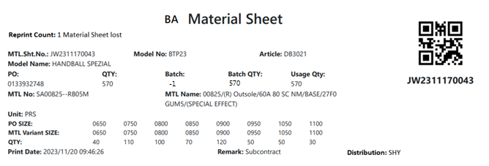

[圖MPS004_6] Regular Material Form (OEM Order) – Size Material

|  |  |  |  |  |  |  |
| --- | --- | --- | --- | --- | --- | --- |
| Print Regular Material Form (OEM Order) – Size Material 列印一般發料單(代工訂單) – 有尺寸發料單 | | | | | | |
| NO | 顯示名稱 | 必填 | 唯讀 | 存改 | 對應欄位 | 欄位型態  欄位說明 |
|  | Reprint count  重印次數 |  |  |  | REPRINT_CNT | Int |
|  | Reprint Reason  重印原因 |  |  |  | User key in Reprint Reason | String |
| SQL  select PRINT_CNT AS REPRINT_CNT  from dbo.ERP_OSISSUE  where MATERIAL_SHEET_NO = 'JW2304250054' | | | | | | |
|  | Kind  材料類別 |  |  |  | Kind | String |
| SQL for kind  -- Get Material Sheet Kind : by MASTER_MATERIALNO  select top 1 CASE Substring(MASTER_MATERIALNO,1,1)  WHEN 'F' THEN 'FA'  WHEN 'U' THEN 'UA'  WHEN 'B' THEN 'BA'  WHEN 'P' THEN 'PA'  ELSE ''  END Kind  from ERP_OSISSUE_DTL  where MATERIAL_SHEET_NO = 'JW2401020113'--(User select row) | | | | | | |
|  | MTL. Sht. No.  發料單號 |  |  |  | User selected row | String |
|  | Model No  型體編號 |  |  |  | MODEL_NO | String |
|  | Article  Article |  |  |  | ARTICLE | String |
|  | Model Name  型體名稱 |  |  |  | MODEL_NAME | String |
|  | PO  訂單編號 |  |  |  | PO_NO | String |
|  | QTY  訂單數量 |  |  |  | QUANTITY | Numeric |
| SQL：  -- 訂單批次基本資訊 (根據 : MATERIAL_SHEET_NO 發料單號)  -- -- Get PO Batch information ( by MATERIAL_SHEET_NO )  SELECT b.PO_NO , b.QUANTITY, c.ARTICLE , c.MODEL_NAME , c.MODEL_NO  FROM ( select top 1 PO_NO from dbo.ERP_OSISSUE_DTL  where MATERIAL_SHEET_NO = 'JW2304250054' ) a --(User select row)  left join dbo.ERP_SOBATCH b on a.PO_NO = b.PO_NO  left join dbo.ERP_SO c on b.PO_NO = c.PO_NO  SQL：  -- 訂單Qty (根據 : PO_NO)  -- Get PO information ( by PO_NO )  SELECT sum(QUANTITY) QUANTITY  FROM dbo.ERP_SOBATCH  where PO_NO = '0131989861' | | | | | | |
|  | Batch  批次 |  |  |  | BATCH | String |
|  | Batch Qty  批次數量 |  |  |  | Batch_QUANTITY | Numeric |
| SQL Batch：  SELECT top 1 REPLACE(t2.PO_BATCH, t2.PO_NO ,'' ) BATCH , cast( t3.QUANTITY as float) Batch_QUANTITY  FROM dbo.ERP_OSISSUE_DTL t1  inner join ERP_PO t2 on t1.PURCHASE_NO = t2.PURCHASE_NO  left join ERP_SOBATCH t3 on t3.PO_BATCH = t2.PO_BATCH  where MATERIAL_SHEET_NO = 'JW2505200007' --(User select row)  and t3.PO_BATCH like t1.PO_NO + '%' | | | | | | |
|  | Material No  料號 |  |  |  | GENERIC_MATERIAL | String |
|  | Material Name  材料名稱 |  |  |  | MATERIAL_SPEC | String |
|  | Unit  單位 |  |  |  | UNIT | String |
| SQL：  -- 有尺寸材料 GENERIC_MATERIAL , MATERIAL_SPEC , UNIT  -- by MATERIAL_SHEET_NO  select t2.GENERIC_MATERIAL , t3.MATERIAL_SPEC , t2.UNIT  from ( Select top 1 MATERIALNO  from dbo.ERP_OSISSUE_DTL  where MATERIAL_SHEET_NO = 'JW2304250054' ) t1  left join dbo.ERP_MATERIAL t2 on t1.materialno = t2.materialno  left join dbo.ERP_MATERIAL t3 on t3.materialno = t2.GENERIC_MATERIAL | | | | | | |
|  | Usage Qty  領用量 |  |  |  | SUM(QUANTITY) | Numeric |
|  | PO SIZE  訂單尺寸 |  |  |  | PO_SIZE | String |
|  | MTL Variant SIZE  MTL Variant SIZE |  |  |  | MATERIAL_SIZE | String |
|  | Qty  數量 |  |  |  | QUANTITY | Numeric |
|  | Print Date  列印日期 |  |  |  | User print date and time  (Get from server side) | DateTime  yyyy/MM/dd HH:mm:ss |
|  | Remark  備註 |  |  |  | Show "Subcontract" | String |
|  | Distribution  領料部門 |  |  |  | SUPPLIER_CODE | String |
| SQL：  -- 有尺寸 PO SIZE 、 MATERIAL_SIZE 明細 (根據 : 發料單號)  -- SIZE MATERIAL : data list ( by MATERIAL_SHEET_NO )  select PO_SIZE , MATERIAL_SIZE, QUANTITY  from dbo.ERP_OSISSUE_DTL  where MATERIAL_SHEET_NO = 'JW2304250054' --(User select row)  and trim(ITEM_NO) <> '0'  order by PO_SIZE  -- Distribution  select Supplier_Code  from dbo.ERP_OSISSUE  where MATERIAL_SHEET_NO = 'JW2311170043' --(User select row) | | | | | | |
| After Print，Update [ERP_OSISSUE].[PRINT_CNT] and [ERP_OSISSUE].[PRINT_TIME] (use server time)  SQL：  update dbo.ERP_OSISSUE  set PRINT_CNT = PRINT_CNT + 1  , REPRINT_REASON = 'Material Sheet is damaged' --(User key in Reprint Reason)  , PRINT_TIME = GETDATE() -- Server time，yyyy/MM/dd HH:mm:ss  where MATERIAL_SHEET_NO = 'JW2304250054' --(User select row) | | | | | | |

* 1. **「MPS005 Print Material Sheet (Replenishment)」MPS005 列印發料單(補料)**
  2. 程式名稱：同標題 (Right Name: MPS_Print.Material.Sheet.Replenishment)
  3. 功能目的：查詢/列印
  4. 使用部門：
  5. 程式說明：

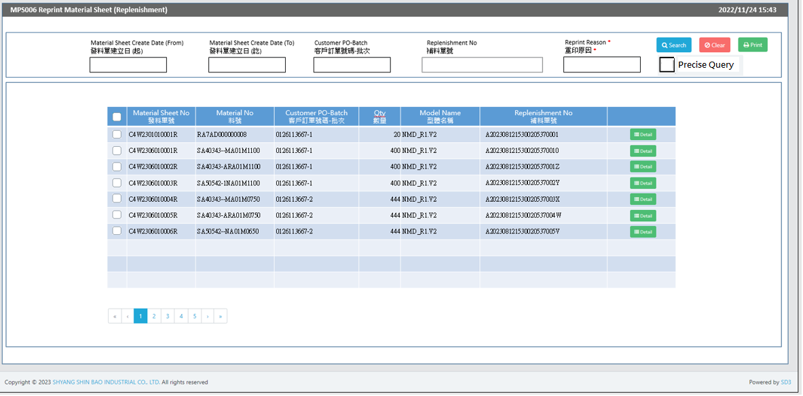

[圖MPS005_1] Main Page主畫面

|  |  |  |  |  |  |  |
| --- | --- | --- | --- | --- | --- | --- |
| Program header 程式標頭 | | | | | | |
| NO | 顯示名稱 | 必填 | 唯讀 | 存改 | 對應欄位 | 說明 |
|  | Title  標題 |  | V |  | CAPTION | String  If there is no get data, please show “Right Name”  SELECT T2.LANGUAGE, T2.CAPTION  FROM [MES_SEC_RIGHT] AS T1  JOIN [MES_MENU_ITEM] AS T2  ON T1.SEC_RIGHT_SID = T2.SEC_RIGHT_SID  WHERE T1.GROUPRIGHTS = 'MPS_Print.Material.Sheet.Replenishment' --(Right Name) |
|  | System Time  系統時間 |  | V |  | Show current server time | Datetime  yyyy/MM/dd HH:mm |

|  |  |  |  |  |  |  |
| --- | --- | --- | --- | --- | --- | --- |
| Operation button 操作按鈕 | | | | | | |
| NO | 顯示名稱 | 必填 | 唯讀 | 存改 | 對應欄位 | 說明 |
|  | Search  搜尋 |  |  |  |  | Required「Customer PO-Batch」  Or 「Replenishment No」to search |
|  | Clear  清除 |  |  |  |  | Clear Search Condition and Results |
|  | Print  列印 |  |  |  |  | Print the select row data |
|  | Detail  明細 |  |  |  |  | Show detail data |

|  |  |  |  |  |  |  |
| --- | --- | --- | --- | --- | --- | --- |
| Search Condition 搜尋條件 | | | | | | |
| NO | 顯示名稱 | 必填 | 唯讀 | 存改 | 對應欄位 | 欄位型態  欄位說明 |
|  | Material Sheet Create Date (From)  發料單建立日(起) |  |  | V | Filter Material Sheet Create Date column | String  yyyy/MM/dd |
|  | Material Sheet Create Date (To)  發料單建立日(訖) |  |  | V | Filter Material Sheet Create Date column | String  yyyy/MM/dd |
|  | Customer PO-Batch  客戶訂單號碼-批次 | V |  | V | Filter Customer PO-Batch column | String  Required  Just enter any one field (Customer PO-Batch or Replenishment No)  If chkPrecise is checked  Must exactly matched  Remove % in Search SQL |
|  | Replenishment No  補料單號 | V |  | V | Filter Replenishment No column | String  Required  Just enter any one field (Customer PO-Batch or Replenishment No) |
|  | Precise Query  精準比對 |  |  | V |  | Check Box : chkPrecise (default : not cheched)  If chkPrecise is checked  Filter Customer PO-Batch column  Must exactly matched  (Remove % in Search SQL Ex : PO_BATCH like '090007695001-1' ) |

|  |  |  |  |  |  |  |
| --- | --- | --- | --- | --- | --- | --- |
| Search 搜尋 | | | | | | |
| NO | 顯示名稱 | 必填 | 唯讀 | 存改 | 對應欄位 | 欄位型態  欄位說明 |
|  | Selector  選擇器 |  |  | V |  | Check Box |
|  | Material Sheet No  發料單號 |  | V |  | C_MATERIAL_SHEET_NO | String |
|  | Material No  料號 |  | V |  | MATERIAL_NO | String |
|  | Customer PO-Batch  客戶訂單號碼-批次 |  | V |  | PO_BATCH | String |
|  | Qty  數量 |  | V |  | QUANTITY | Numeric |
|  | Model Name  型體名稱 |  | V |  | MODEL_NAME | String |
|  | Replenishment No  補料單號 |  | V |  | REPLENISHMENT_NO | String |
|  | Detail button  明細按鈕 |  |  |  | Open detail page | Button |
| 程式邏輯說明：  填入Customer PO-Batch或Replenishment No後(擇一必填) ，點選 [Search搜尋] 按鈕，即可帶出資料。  Input : Material Sheet Create Date or Customer PO-Batch or Replenishment No，(any one of them is necessary) ，click [Search] button，and shows the search result。  SQL：  SELECT T1.C_MATERIAL_SHEET_NO, MIN(T2.MATERIAL_NO) AS MATERIAL_NO, String_AGG(T2.PO_BATCH, ', ') AS PO_BATCH, SUM(T2.QUANTITY) AS QUANTITY, MIN(T2.MODEL_NAME) AS MODEL_NAME  , MIN(T1.REPLENISHMENT_NO) AS REPLENISHMENT_NO  FROM dbo.ERP_ISSUE AS T1,  (  select a.C_MATERIAL_SHEET_NO, min(MATERIALNO) AS MATERIAL_NO, sum(a.QUANTITY) AS QUANTITY, a.PO_BATCH, min(c.MODEL_NAME) AS MODEL_NAME  from dbo.ERP_ISSUE_DTL AS a,  (  select C_MATERIAL_SHEET_NO  from ERP_ISSUE_DTL  where UPDATETIME >= '2023/06/01' -- (Material Sheet Create Date(From))  and UPDATETIME <= DATEADD(DAY, 1, '2023/06/01') -- (Material Sheet Create Date(To)) + 1  and PO_BATCH like '0126113667%' -- (Customer PO-Batch)  and [STATUS] <> 'D' -- (Always is D)  group by C_MATERIAL_SHEET_NO  ) AS b, dbo.ERP_SOBATCH AS c  where a.C_MATERIAL_SHEET_NO = b.C_MATERIAL_SHEET_NO  and a.PO_BATCH = c.PO_BATCH  group by a.C_MATERIAL_SHEET_NO, a.PO_BATCH  ) AS T2  WHERE T1.C_MATERIAL_SHEET_NO = T2.C_MATERIAL_SHEET_NO  and T1.REPLENISHMENT_NO is not null  and T1.REPLENISHMENT_NO = 'A2023081808404708270001' --(Replenishment No)  AND T1.PRINT_CNT = 0  AND T1.ISSUE_TYPE = 'B' -- (Always = B)  GROUP BY T1.C_MATERIAL_SHEET_NO  ORDER BY PO_BATCH, C_MATERIAL_SHEET_NO, MATERIAL_NO | | | | | | |

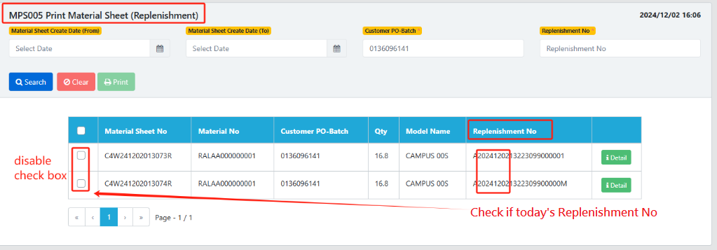

Loop Query results (rows in gridview)

IF (“REPLENISHMENT_NO”) <> “”

IF ‘A’ + DateTime.Now.ToString(“yyyyMMdd”) == (“REPLENISHMENT_NO”).Substring(0, 9)

Then Disable checkbox – Can’t print

End Loop

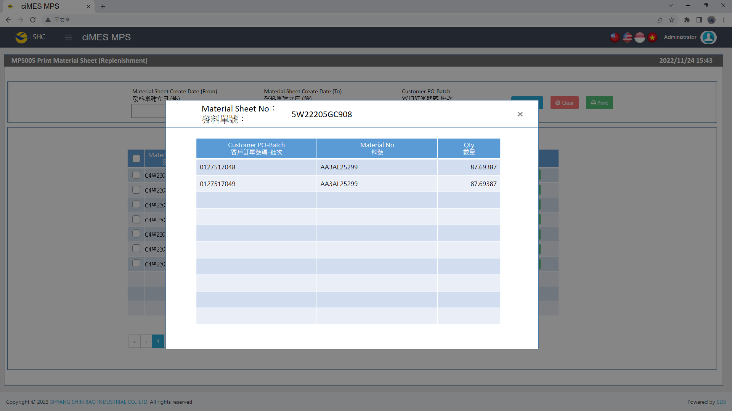

[圖MPS005_2] Detail明細畫面

|  |  |  |  |  |  |  |
| --- | --- | --- | --- | --- | --- | --- |
| Detail 明細 | | | | | | |
| NO | 顯示名稱 | 必填 | 唯讀 | 存改 | 對應欄位 | 欄位型態  欄位說明 |
|  | Material Sheet No  發料單號 |  | V |  | User selected row | String |
|  | Customer PO-Batch  客戶訂單號碼-批次 |  | V |  | PO_BATCH | String |
|  | Material No  料號 |  | V |  | MATERIALNO | String |
|  | Qty  數量 |  | V |  | QUANTITY | Numeric |
| 程式邏輯說明：  依照User點選的資料列，帶出該資料列的明細資料。  SQL：  SELECT C_MATERIAL_SHEET_NO , PO_BATCH , MATERIALNO , QUANTITY  FROM dbo.ERP_ISSUE_DTL  WHERE C_MATERIAL_SHEET_NO = 'C4W2306010001R' -- (User selected row)  ORDER BY PO_BATCH , MATERIALNO | | | | | | |

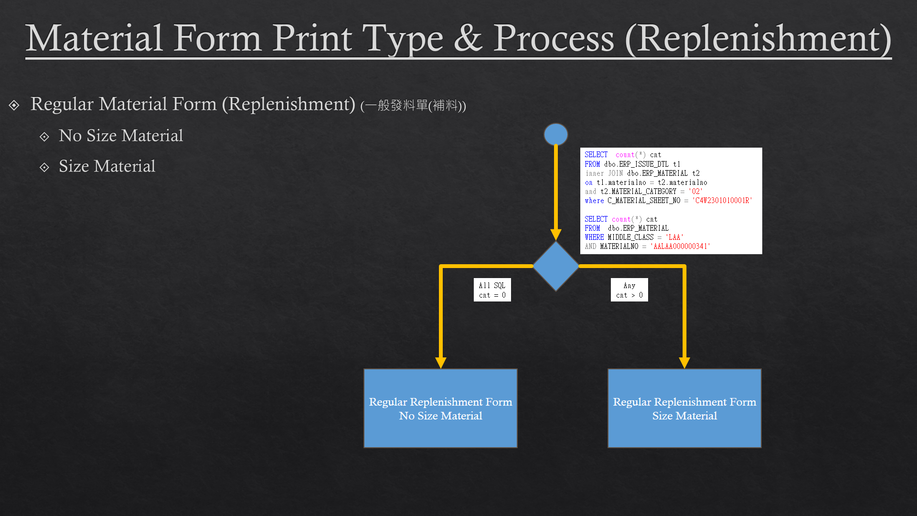

[圖MPS005_3] Material Form Print Type & Process (Replenishment)，Check whether there is Size Run

|  |  |  |  |  |  |  |
| --- | --- | --- | --- | --- | --- | --- |
| Print Regular Material Form (Replenishment)列印一般發料單 (補料) | | | | | | |
| NO | 顯示名稱 | 必填 | 唯讀 | 存改 | 對應欄位 | 欄位型態  欄位說明 |
|  |  |  |  |  |  |  |
| 程式邏輯說明：  Regular Material Form (Replenishment) need check is Size Run or not  If all SQL cnt = 0，Print「**Regular Material Form (Replenishment) – No Size Material」**  Else，Print「**Regular Material Form (Replenishment) – Size Material」**  SQL：  -- All SQL cnt = 0， 無尺寸補料單  -- Else， 有尺寸補料單，列印size run  SELECT count(*) cnt  FROM dbo.ERP_ISSUE_DTL t1  inner JOIN dbo.ERP_MATERIAL t2  on t1.materialno = t2.materialno  and t2.MATERIAL_CATEGORY = '02' -- (Always = '02')  where C_MATERIAL_SHEET_NO = 'C4W2301010001R'  SELECT count(*) cnt  FROM dbo.ERP_MATERIAL  WHERE MIDDLE_CLASS = 'LAA' -- (Always = 'LAA')  AND MATERIALNO = 'AALAA000000341' -- (User select row) | | | | | | |



[圖MPS005_4] Regular Material Form (Replenishment)，A4中三刀，示意圖

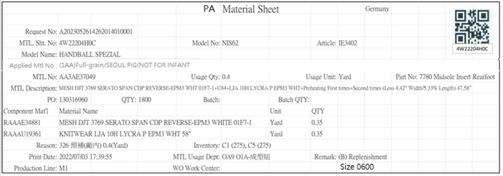

[圖MPS005_5] Regular Material Form (Replenishment) – No Size Material

|  |  |  |  |  |  |  |
| --- | --- | --- | --- | --- | --- | --- |
| Print Regular Material Form (Replenishment) – No Size Material 列印一般發料單(補料) – 無尺寸發料單 | | | | | | |
| NO | 顯示名稱 | 必填 | 唯讀 | 存改 | 對應欄位 | 欄位型態  欄位說明 |
|  | Kind  材料類別 |  |  |  |  | String |
| SQL for kind  -- Get Material Sheet Kind : by C_MATERIAL_SHEET_NO  select top 1 t1.KIND  FROM  (  select top 1 PO_BATCH , MATERIALNO  from ERP_ISSUE_DTL  where C_MATERIAL_SHEET_NO = 'C4W2401104825R' --(User select row)  and [STATUS] <> 'D'  ) t0  inner join dbo.CST_MPS_PICKFORM t1 on t0.PO_BATCH = t1.PO_BATCH and t1.[STATUS] <> 'Terminate'  inner join dbo.CST_MPS_PICKFORM_DETAIL t2 on t1.PUF = t2.PUF and t2.MATERIALNO = t0.MATERIALNO | | | | | | |
|  | Shipping Location  出貨地點 |  |  |  | SHIPPING_LOCATION | String |
| SQL  select top 1 t1.SHIPPING_LOCATION  from [dbo].[ERP_SO] t1  inner join [dbo].[ERP_SOBatch] t2 on t1.SO_NO = t2.SO_NO  where t2.PO_BATCH = '0132957503-4' | | | | | | |
|  | Request No  補料申請單號 |  |  |  | REPLENISHMENT_NO | String |
| SQL：  -- Get Request No: ( REPLENISHMENT_NO，補料申請單號 ) by C_MATERIAL_SHEET_NO  SELECT REPLENISHMENT_NO  FROM dbo.ERP_ISSUE  where C_MATERIAL_SHEET_NO = 'C4W2306010001R' --(User select row) | | | | | | |
|  | Order No  預補備料工單 |  |  |  | Order_No | String |
| -- Get Order No: (Order_No，預補備料工單) by C_MATERIAL_SHEET_NO  exec PRD_GET_REPLN_PRELOSS_Order_No @C_MATERIAL_SHEET_NO = 'C4W240608000003P'  (if return string is empty , print nothing) | | | | | | |
|  | MTL. Sht. No.  發料單號 |  |  |  | User selected row | String |
|  | Model No  型體編號 |  |  |  | MODEL_NO | String |
|  | Article  Article |  |  |  | ARTICLE | String |
|  | Model Name  型體名稱 |  |  |  | MODEL_NAME | String |
|  | PO  訂單編號 |  |  |  | PO_NO | String |
|  | Batch  批次 |  |  |  | BATCH | String |
|  | Batch Qty  批次數量 |  |  |  | BATCH_QTY | Numeric |
| SQL：  -- 訂單批次基本資訊 (根據 : C_MATERIAL_SHEET_NO 發料單號)  -- Get PO Batch information ( by C_MATERIAL_SHEET_NO )  SELECT b.PO_NO , a.PO_BATCH , REPLACE(a.PO_BATCH, b.PO_NO,'') BATCH , b.QUANTITY AS BATCH_QTY, c.ARTICLE , c.MODEL_NAME , c.MODEL_NO  FROM ( select top 1 b.PO_BATCH from dbo.ERP_ISSUE a , dbo.ERP_ISSUE_DTL b  where a.C_MATERIAL_SHEET_NO = 'C4W2306010001R' and a.C_MATERIAL_SHEET_NO = b.C_MATERIAL_SHEET_NO ) a  left join dbo.ERP_SOBATCH b on a.PO_BATCH = b.PO_BATCH  left join dbo.ERP_SO c on b.PO_NO = c.PO_NO | | | | | | |
|  | QTY  訂單數量 |  |  |  | QUANTITY | Numeric |
| SQL：  -- 訂單Qty (根據 : PO_NO)  -- Get PO information ( by PO_NO )  SELECT sum(QUANTITY) QUANTITY  FROM dbo.ERP_SOBATCH  where PO_NO = '0126113667' | | | | | | |
|  | Applied MTL No  開補料號資訊 |  |  |  | Applied_MTL_No | String |
|  | EXEC dbo.PRD_GET_REPLN_ISSUE_Applied_Info @C_MATERIAL_SHEET_NO = 'C4W240401000074R' | | | | | |
|  | MTL No  料號 |  |  |  | MATERIALNO | String |
|  | MTL Description  材料名稱 |  |  |  | MATERIAL_SPEC | String |
|  | Usage Qty  領用量 |  |  |  | Usage_Qty | Numeric |
|  | Usage Unit  領用量單位 |  |  |  | Usage_UNIT | String |
|  | Part No  部位 |  |  |  | Part_NO + " " + PART_Name | String |
|  | Reason  原因 |  |  |  | REASON_CODE + " " + REASON + " " + QTY + "(" + UNIT + ")" | String  e.g: 003 Material defects 100(PCS) |
| SQL：  -- SQL04  EXEC dbo.PRD_GET_REPLN_ISSUE_DETAIL_NO_SIZE 'C4W2307060031R' | | | | | | |
|  | Component Mat'l  部件材料 |  |  |  | MATERIALNO | String |
|  | Material Name  材料名稱 |  |  |  | MATERIAL_SPEC | String |
|  | Unit  單位 |  |  |  | UNIT | String |
|  | QTY  數量 |  |  |  | QUANTITY | Numeric |
| SQL：  -- Component Mtl information  -- PROCEDURE [dbo].[PRD_GET_REPLN_Component_List]  -- input parameters : @C_MATERIAL_SHEET_NO, @MATERIALNO( SQL04 MATERIALNO )  -- Output Columns : MATERIALNO, Material Name, Unit, QTY  EXEC dbo.PRD_GET_REPLN_Component_List 'C4W2301010001R' , 'RA7AD000000008' | | | | | | |
|  | Inventory  庫存 |  |  |  | WAREHOUSE + " (" + Qty + ")"  And join all data by ", " | String  e.g: C1 (275), C5 (275) |
| SQL：  -- Get C1、C5 Inventory (by SQL04 TOP 1 MATERIALNO)  select t1.REMARK02 WAREHOUSE , isnull(sum(t2.AVAILQTY ),0) Qty  from MES_WPC_EXTENDITEM t1  left join MES_WMS_LOT t2  on t2.MATERIALNO = 'RA7AD000000008' --( SQL04 MATERIALNO )  and t1.REMARK02 = t2.WAREHOUSE  and t2.INV_TYPE_STATUS = 'Load'  where t1.CLASS = 'Material_AB_Warehouse'  and t1.REMARK01 = 'UA' -- (Always = UA)  group by REMARK02  order by REMARK02 | | | | | | |
|  | Print Date  列印日期 |  |  |  | User print date and time  (Get from server side) | DateTime  yyyy/MM/dd HH:mm:ss |
|  | MTL Usage Dept  領料單位 |  |  |  | DEPT_DESC | String |
|  | WO Work Center  工單工作中心 |  |  |  | DEPT_DESC_WorkCenter | String  If DEPT_DESC_WorkCenter is Empty, hide this column |
| SQL：  EXEC dbo.PRD_GET_MPS_Dispatch_WorkCenter_ISSUEform 'C4W2301010001R' -- , @DEPT_DESC OUTPUT , @DEPT_DESC_WorkCenter OUTPUT | | | | | | |
|  | Remark  備註 |  |  |  | "("+REMARK01+") "+ REMARK05 | String |
| SQL：  select REMARK01, REMARK05  from MES_WPC_EXTENDITEM  WHERE CLASS = 'ISSUE_TYPE'  and REMARK01 = 'B'  --Next Line : print detail remark  select top 1 t4.REMARK from  (  select C_MATERIAL_SHEET_NO  from dbo.ERP_ISSUE_DTL  where C_MATERIAL_SHEET_NO = 'C4W2401202438R' --(User select row)  and [STATUS] <> 'D'  ) t1  inner join dbo.ERP_ISSUE t2 on t1.C_MATERIAL_SHEET_NO = t2.C_MATERIAL_SHEET_NO  inner join dbo.CST_REPLN_SAP_DETAIL t3 on t2.REPLENISHMENT_NO = t3.CST_REPLN_ITEM_GROUP_SID  inner join dbo.CST_REPLN_ITEM t4 on t3.CST_REPLN_ITEM_SID = t4.CST_REPLN_ITEM_SID  INNER join dbo.CST_REPLN_BATCH t5 on t3.CST_REPLN_BATCH_SID = t5.CST_REPLN_BATCH_SID | | | | | | |
|  | Production Line  成型線別 |  |  |  | AS_CELL | String |
| SQL：  -- Production Line (by PO_Batch)  SELECT AS_CELL  from ERP_PROD_SCHED  where PO_Batch = '0126113667-1' | | | | | | |
| After Print，Update [ERP_ISSUE].[PRINT_CNT] and [ERP_ISSUE].[PRINT_TIME] (use server time)  SQL：  update dbo.ERP_ISSUE  set PRINT_CNT = PRINT_CNT + 1  , PRINT_TIME = GETDATE() -- Server time，yyyy/MM/dd HH:mm:ss  where C_MATERIAL_SHEET_NO = 'C4W2306010001R' --(User select row) | | | | | | |
| After Print，Call procedure  SQL：  EXEC dbo. PRD_CST_MPS_PICKFORM_Auto_insert 'C4W2306010001R' --(User select row) | | | | | | |

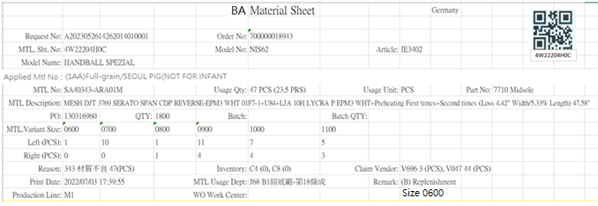

[圖MPS005_6] Regular Material Form (Replenishment) – Size Material

|  |  |  |  |  |  |  |
| --- | --- | --- | --- | --- | --- | --- |
| Print Regular Material Form (Replenishment) – Size Material 列印一般發料單(補料) – 有尺寸發料單 | | | | | | |
| NO | 顯示名稱 | 必填 | 唯讀 | 存改 | 對應欄位 | 欄位型態  欄位說明 |
|  | Kind  材料類別 |  |  |  |  | String |
| SQL for kind  -- Get Material Sheet Kind : by C_MATERIAL_SHEET_NO  select top 1 t1.KIND  FROM  (  select top 1 PO_BATCH , MATERIALNO  from ERP_ISSUE_DTL  where C_MATERIAL_SHEET_NO = 'C4W2401104825R' --(User select row)  and [STATUS] <> 'D'  ) t0  inner join dbo.CST_MPS_PICKFORM t1 on t0.PO_BATCH = t1.PO_BATCH and t1.[STATUS] <> 'Terminate'  inner join dbo.CST_MPS_PICKFORM_DETAIL t2 on t1.PUF = t2.PUF and t2.MATERIALNO = t0.MATERIALNO | | | | | | |
|  | Shipping Location  出貨地點 |  |  |  | SHIPPING_LOCATION | String |
| SQL  select top 1 t1.SHIPPING_LOCATION  from [dbo].[ERP_SO] t1  inner join [dbo].[ERP_SOBatch] t2 on t1.SO_NO = t2.SO_NO  where t2.PO_BATCH = '0132957503-4' | | | | | | |
|  | Request No  補料申請單號 |  |  |  | REPLENISHMENT_NO | String |
| SQL：  -- Get Request No: ( REPLENISHMENT_NO，補料申請單號 ) by C_MATERIAL_SHEET_NO  SELECT REPLENISHMENT_NO  FROM dbo.ERP_ISSUE  where C_MATERIAL_SHEET_NO = 'C4W2306010002R' --(User select row) | | | | | | |
|  | Order No  預補備料工單 |  |  |  | Order_No | String |
| -- Get Order No: (Order_No，預補備料工單) by C_MATERIAL_SHEET_NO  exec PRD_GET_REPLN_PRELOSS_Order_No @C_MATERIAL_SHEET_NO = 'C4W240608000003P'  (if return string is empty , print nothing) | | | | | | |
|  | MTL. Sht. No.  發料單號 |  |  |  | User selected row | String |
|  | Model No  型體編號 |  |  |  | MODEL_NO | String |
|  | Article  Article |  |  |  | ARTICLE | String |
|  | Model Name  型體名稱 |  |  |  | MODEL_NAME | String |
|  | PO  訂單編號 |  |  |  | PO_NO | String |
|  | Batch  批次 |  |  |  | BATCH | String |
|  | Batch Qty  批次數量 |  |  |  | BATCH_QTY | Numeric |
| SQL：  -- 訂單批次基本資訊 (根據 : C_MATERIAL_SHEET_NO 發料單號)  -- Get PO Batch information ( by C_MATERIAL_SHEET_NO )  SELECT b.PO_NO , a.PO_BATCH , REPLACE(a.PO_BATCH, b.PO_NO,'') BATCH , b.QUANTITY AS BATCH_QTY, c.ARTICLE , c.MODEL_NAME , c.MODEL_NO  FROM ( select top 1 b.PO_BATCH from dbo.ERP_ISSUE a , dbo.ERP_ISSUE_DTL b  where a.C_MATERIAL_SHEET_NO = 'C4W2306010002R' and a.C_MATERIAL_SHEET_NO = b.C_MATERIAL_SHEET_NO ) a  left join dbo.ERP_SOBATCH b on a.PO_BATCH = b.PO_BATCH  left join dbo.ERP_SO c on b.PO_NO = c.PO_NO | | | | | | |
|  | QTY  訂單數量 |  |  |  | QUANTITY | Numeric |
| SQL：  -- 訂單Qty (根據 : PO_NO)  -- Get PO information ( by PO_NO )  SELECT sum(QUANTITY) QUANTITY  FROM dbo.ERP_SOBATCH  where PO_NO = '0126113667' | | | | | | |
|  | Applied MTL No  開補料號資訊 |  |  |  | Applied_MTL_No | String |
|  | EXEC dbo.PRD_GET_REPLN_ISSUE_Applied_Info @C_MATERIAL_SHEET_NO = 'C4W240401000074R' | | | | | |
|  | MTL No  料號 |  |  |  | TOP 1 GENERIC_MATERIAL | String |
|  | Usage Qty  領用量 |  |  |  | SUM(Usage_Qty) | String  IF Usage_UNIT = "PCS"，Please show  Usage_Qty+" ("+Usage_Qty/2+" PRS)"  e.g: 47 (23.5 PRS) |
|  | Usage Unit  領用量單位 |  |  |  | TOP 1 Usage_UNIT | String |
|  | Part No  部位 |  |  |  | TOP 1 (Part_NO + " " + PART_Name) | String |
|  | MTL.Variant Size  MTL.Variant Size |  |  |  | MATERIAL_SIZE | String |
|  | Left (PCS)  左腳數量(支) |  |  |  | LEFT_QTY | Numeric |
|  | Right (PCS)  右腳數量(支) |  |  |  | RIGHT_QTY | Numeric |
|  | Reason  原因 |  |  |  | REASON_CODE + " " + REASON + " " + SUM(LEFT_QTY + RIGHT_QTY) + "(" + UNIT + ")"  GROUP BY REASON_CODE, UNIT  And join all data by ", " | String  e.g: 003 Material defects 100(PCS), 002 Needle breakage 300(PCS) |
|  | Claim Vendor  索賠供應商 |  |  |  | CLAIM_VENDOR + SUM(LEFT_QTY + RIGHT_QTY) + "(" + UNIT + ")"  GROUP BY CLAIM_VENDOR  And join all data by ", " | String  e.g: VNM0075 100(PCS), VNM0076 300(PCS) |
| SQL：  -- SQL01  EXEC dbo.PRD_GET_REPLN_ISSUE_DETAIL_WITH_SIZE 'C4W2307060061R' | | | | | | |
|  | MTL Description  材料名稱 |  |  |  | MATERIAL_SPEC | String |
| SQL：  -- Material Description  SELECT MATERIAL_SPEC  FROM dbo.ERP_MATERIAL  where MATERIALNO = 'SA40343-ARA01M' -- (SQL01 TOP1 GENERIC_MATERIAL) | | | | | | |
|  | Inventory  庫存 |  |  |  | WAREHOUSE + " (" + Qty + ")"  And join all data by ", " | String  e.g: C4 (0), C8 (0) |
| SQL：  -- Get C4、C8 Inventory (by SQL01 TOP 1 GENERIC_MATERIAL)  select t1.REMARK02 WAREHOUSE , isnull(sum(t2.AVAILQTY ),0) Qty  from MES_WPC_EXTENDITEM t1  left join MES_WMS_LOT t2  on t2.MATERIALNO = 'SA40343-ARA01M' --( SQL01 TOP 1 GENERIC_MATERIAL )  and t1.REMARK02 = t2.WAREHOUSE  and t2.INV_TYPE_STATUS = 'Load'  where t1.CLASS = 'Material_AB_Warehouse'  and t1.REMARK01 = 'BA' -- (Always = BA)  group by REMARK02  order by REMARK02 | | | | | | |
|  | Print Date  列印日期 |  |  |  | User print date and time  (Get from server side) | DateTime  yyyy/MM/dd HH:mm:ss |
|  | MTL Usage Dept  領料單位 |  |  |  | DEPT_DESC | String |
|  | WO Work Center  工單工作中心 |  |  |  | DEPT_DESC_WorkCenter | String  If DEPT_DESC_WorkCenter is Empty, hide this column |
| SQL：  EXEC dbo.PRD_GET_MPS_Dispatch_WorkCenter_ISSUEform 'C4W2301010002R' -- , @DEPT_DESC OUTPUT , @DEPT_DESC_WorkCenter OUTPUT | | | | | | |
|  | Remark  備註 |  |  |  | "("+REMARK01+") "+ REMARK05 | String |
| SQL：  select REMARK01, REMARK05  from MES_WPC_EXTENDITEM  WHERE CLASS = 'ISSUE_TYPE'  and REMARK01 = 'B'  --Next Line : print detail remark  select top 1 t4.REMARK from  (  select C_MATERIAL_SHEET_NO  from dbo.ERP_ISSUE_DTL  where C_MATERIAL_SHEET_NO = 'C4W2401202438R' --(User select row)  and [STATUS] <> 'D'  ) t1  inner join dbo.ERP_ISSUE t2 on t1.C_MATERIAL_SHEET_NO = t2.C_MATERIAL_SHEET_NO  inner join dbo.CST_REPLN_SAP_DETAIL t3 on t2.REPLENISHMENT_NO = t3.CST_REPLN_ITEM_GROUP_SID  inner join dbo.CST_REPLN_ITEM t4 on t3.CST_REPLN_ITEM_SID = t4.CST_REPLN_ITEM_SID  INNER join dbo.CST_REPLN_BATCH t5 on t3.CST_REPLN_BATCH_SID = t5.CST_REPLN_BATCH_SID | | | | | | |
|  | Production Line  成型線別 |  |  |  | AS_CELL | String |
| SQL：  -- Production Line (by PO_Batch)  SELECT AS_CELL  from ERP_PROD_SCHED  where PO_Batch = '0126113667-1' | | | | | | |
| After Print，Update [ERP_ISSUE].[PRINT_CNT] and [ERP_ISSUE].[PRINT_TIME] (use server time)  SQL：  update dbo.ERP_ISSUE  set PRINT_CNT = PRINT_CNT + 1  , PRINT_TIME = GETDATE() -- Server time，yyyy/MM/dd HH:mm:ss  where C_MATERIAL_SHEET_NO = 'C4W2306010002R' --(User select row) | | | | | | |
| After Print，Call procedure  SQL：  EXEC dbo. PRD_CST_MPS_PICKFORM_Auto_insert 'C4W2306010002R' --(User select row) | | | | | | |

* 1. **「MPS006 Reprint Material Sheet (Replenishment)」MPS006 重列印發料單(補料)**
  2. 程式名稱：同標題 (Right Name: MPS_Reprint.Material.Sheet.Replenishment)
  3. 功能目的：查詢/列印
  4. 使用部門：
  5. 程式說明：

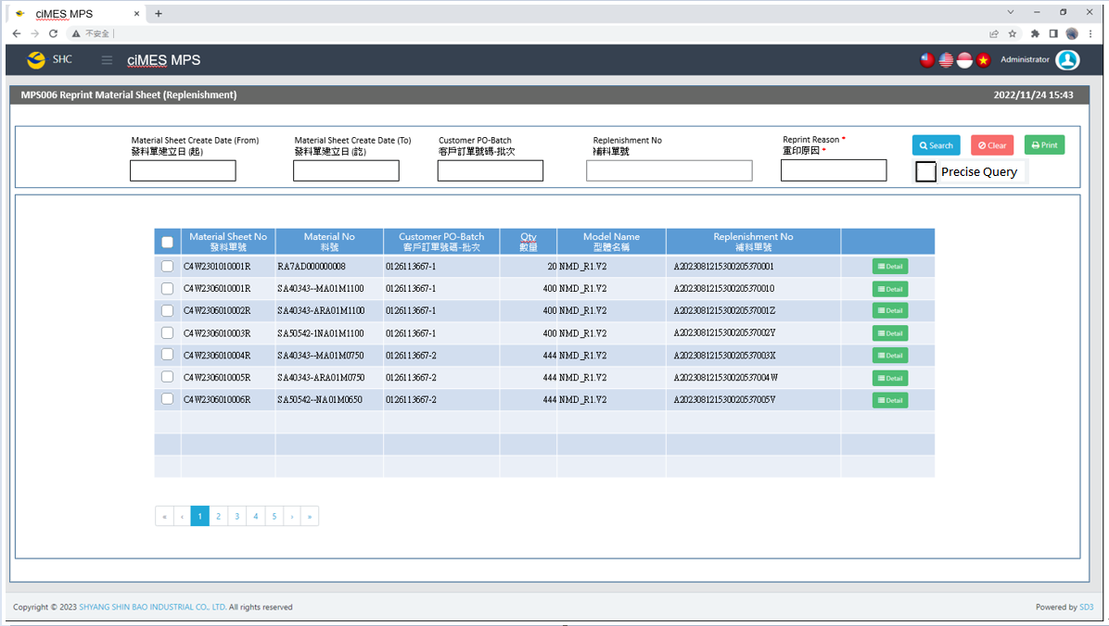

[圖MPS006_1] Main Page主畫面

|  |  |  |  |  |  |  |
| --- | --- | --- | --- | --- | --- | --- |
| Program header 程式標頭 | | | | | | |
| NO | 顯示名稱 | 必填 | 唯讀 | 存改 | 對應欄位 | 說明 |
|  | Title  標題 |  | V |  | CAPTION | String  If there is no get data, please show “Right Name”  SELECT T2.LANGUAGE, T2.CAPTION  FROM [MES_SEC_RIGHT] AS T1  JOIN [MES_MENU_ITEM] AS T2  ON T1.SEC_RIGHT_SID = T2.SEC_RIGHT_SID  WHERE T1.GROUPRIGHTS = 'MPS_Reprint.Material.Sheet.Replenishment' --(Right Name) |
|  | System Time  系統時間 |  | V |  | Show current server time | Datetime  yyyy/MM/dd HH:mm |

|  |  |  |  |  |  |  |
| --- | --- | --- | --- | --- | --- | --- |
| Operation button 操作按鈕 | | | | | | |
| NO | 顯示名稱 | 必填 | 唯讀 | 存改 | 對應欄位 | 說明 |
|  | Search  搜尋 |  |  |  |  | Required or「Customer PO-Batch」  Or 「Replenishment No」to search |
|  | Clear  清除 |  |  |  |  | Clear Search Condition and Results |
|  | Print  列印 |  |  |  |  | Print the select row data |
|  | Detail  明細 |  |  |  |  | Show detail data |

|  |  |  |  |  |  |  |
| --- | --- | --- | --- | --- | --- | --- |
| Search Condition 搜尋條件 | | | | | | |
| NO | 顯示名稱 | 必填 | 唯讀 | 存改 | 對應欄位 | 欄位型態  欄位說明 |
|  | Material Sheet Create Date (From)  發料單建立日(起) |  |  | V | Filter Material Sheet Create Date column | String  yyyy/MM/dd |
|  | Material Sheet Create Date (To)  發料單建立日(訖) |  |  | V | Filter Material Sheet Create Date column | String  yyyy/MM/dd |
|  | Customer PO-Batch  客戶訂單號碼-批次 | V |  | V | Filter Customer PO-Batch column | String  Required  Just enter any one field (Customer PO-Batch or Replenishment No)  If chkPrecise is checked  Must exactly matched  Remove % in Search SQL |
|  | Replenishment No  補料單號 | V |  | V | Filter Replenishment No column | String  Required  Just enter any one field (Customer PO-Batch or Replenishment No) |
|  | Reprint Reason  重印原因 | V |  | V |  | String  Required when printing |
|  | Precise Query  精準比對 |  |  | V |  | Check Box : chkPrecise (default : not cheched)  If chkPrecise is checked  Filter Customer PO-Batch column  Must exactly matched  (Remove % in Search SQL Ex : PO_BATCH like '090007695001-1' ) |

|  |  |  |  |  |  |  |
| --- | --- | --- | --- | --- | --- | --- |
| Search 搜尋 | | | | | | |
| NO | 顯示名稱 | 必填 | 唯讀 | 存改 | 對應欄位 | 欄位型態  欄位說明 |
|  | Selector  選擇器 |  |  | V |  | Check Box |
|  | Material Sheet No  發料單號 |  | V |  | C_MATERIAL_SHEET_NO | String |
|  | Material No  料號 |  | V |  | MATERIAL_NO | String |
|  | Customer PO-Batch  客戶訂單號碼-批次 |  | V |  | PO_BATCH | String |
|  | Qty  數量 |  | V |  | QUANTITY | Numeric |
|  | Model Name  型體名稱 |  | V |  | MODEL_NAME | String |
|  | Replenishment No  補料單號 |  | V |  | REPLENISHMENT_NO | String |
|  | Detail button  明細按鈕 |  |  |  | Open detail page | Button |
| 程式邏輯說明：  填入 Customer PO-Batch or Replenishment No後(必填)，點選 [Search搜尋] 按鈕，即可帶出資料。  Input : Customer PO-Batch or Replenishment No，(any one of them is necessary) ，click [Search] button，and shows the search result。  SQL：  SELECT T1.C_MATERIAL_SHEET_NO, MIN(T2.MATERIAL_NO) AS MATERIAL_NO, String_AGG(T2.PO_BATCH, ', ') AS PO_BATCH, SUM(T2.QUANTITY) AS QUANTITY, MIN(T2.MODEL_NAME) AS MODEL_NAME  , MIN(T1.REPLENISHMENT_NO) AS REPLENISHMENT_NO  FROM dbo.ERP_ISSUE AS T1,  (  select a.C_MATERIAL_SHEET_NO, min(MATERIALNO) AS MATERIAL_NO, sum(a.QUANTITY) AS QUANTITY, a.PO_BATCH, min(c.MODEL_NAME) AS MODEL_NAME  from dbo.ERP_ISSUE_DTL AS a,  (  select C_MATERIAL_SHEET_NO  from ERP_ISSUE_DTL  where UPDATETIME >= '2023/06/01' -- (Material Sheet Create Date(From))  and UPDATETIME <= DATEADD(DAY, 1, '2023/06/01') -- (Material Sheet Create Date(To)) + 1  and PO_BATCH like '0126113667%' -- (Customer PO-Batch)  and [STATUS] <> 'D' -- (Always is D)  group by C_MATERIAL_SHEET_NO  ) AS b, dbo.ERP_SOBATCH AS c  where a.C_MATERIAL_SHEET_NO = b.C_MATERIAL_SHEET_NO  and a.PO_BATCH = c.PO_BATCH  group by a.C_MATERIAL_SHEET_NO, a.PO_BATCH  ) AS T2  WHERE T1.C_MATERIAL_SHEET_NO = T2.C_MATERIAL_SHEET_NO  and T1.REPLENISHMENT_NO is not null  and T1.REPLENISHMENT_NO = 'A2023081808404708270001' --(Replenishment No)  AND T1.PRINT_CNT > 0  AND T1.ISSUE_TYPE = 'B' -- (Always = B)  GROUP BY T1.C_MATERIAL_SHEET_NO  ORDER BY PO_BATCH, C_MATERIAL_SHEET_NO, MATERIAL_NO | | | | | | |

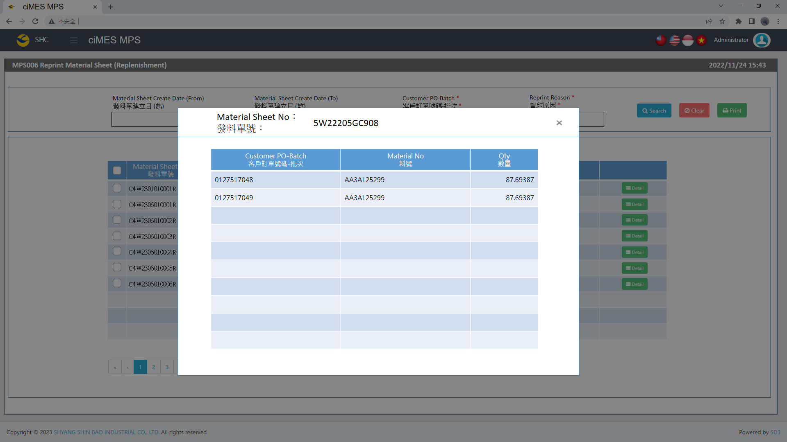

[圖MPS006_2] Detail明細畫面

|  |  |  |  |  |  |  |
| --- | --- | --- | --- | --- | --- | --- |
| Detail 明細 | | | | | | |
| NO | 顯示名稱 | 必填 | 唯讀 | 存改 | 對應欄位 | 欄位型態  欄位說明 |
|  | Material Sheet No  發料單號 |  | V |  | User selected row | String |
|  | Customer PO-Batch  客戶訂單號碼-批次 |  | V |  | PO_BATCH | String |
|  | Material No  料號 |  | V |  | MATERIALNO | String |
|  | Qty  數量 |  | V |  | QUANTITY | Numeric |
| 程式邏輯說明：  依照User點選的資料列，帶出該資料列的明細資料。  SQL：  SELECT C_MATERIAL_SHEET_NO , PO_BATCH , MATERIALNO , QUANTITY  FROM dbo.ERP_ISSUE_DTL  WHERE C_MATERIAL_SHEET_NO = 'C4W2306010001R' -- (User selected row)  ORDER BY PO_BATCH , MATERIALNO | | | | | | |



[圖MPS006_3] Material Form Print Type & Process (Replenishment)，Check whether there is Size Run

|  |  |  |  |  |  |  |
| --- | --- | --- | --- | --- | --- | --- |
| Print Regular Material Form (Replenishment)列印一般發料單 (補料) | | | | | | |
| NO | 顯示名稱 | 必填 | 唯讀 | 存改 | 對應欄位 | 欄位型態  欄位說明 |
|  |  |  |  |  |  |  |
| 程式邏輯說明：  Regular Material Form (Replenishment) need check is Size Run or not  If all SQL cnt = 0，Print「**Regular Material Form (Replenishment) – No Size Material」**  Else，Print「**Regular Material Form (Replenishment) – Size Material」**  SQL：  -- All SQL cnt = 0， 無尺寸補料單  -- Else， 有尺寸補料單，列印size run  SELECT count(*) cnt  FROM dbo.ERP_ISSUE_DTL t1  inner JOIN dbo.ERP_MATERIAL t2  on t1.materialno = t2.materialno  and t2.MATERIAL_CATEGORY = '02' -- (Always = '02')  where C_MATERIAL_SHEET_NO = 'C4W2301010001R'  SELECT count(*) cnt  FROM dbo.ERP_MATERIAL  WHERE MIDDLE_CLASS = 'LAA' -- (Always = 'LAA')  AND MATERIALNO = 'AALAA000000341' -- (User select row) | | | | | | |



[圖MPS006_4] Regular Material Form (Replenishment)，A4中三刀，示意圖

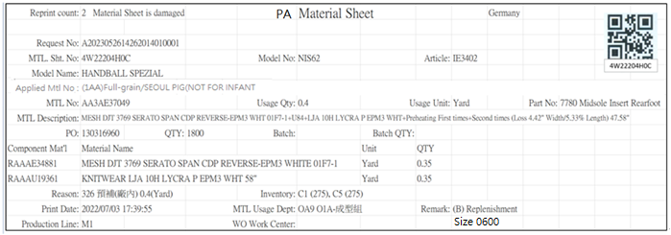

[圖MPS006_5] Regular Material Form (Replenishment) – No Size Material

|  |  |  |  |  |  |  |
| --- | --- | --- | --- | --- | --- | --- |
| Print Regular Material Form (Replenishment) – No Size Material 列印一般發料單(補料) – 無尺寸發料單 | | | | | | |
| NO | 顯示名稱 | 必填 | 唯讀 | 存改 | 對應欄位 | 欄位型態  欄位說明 |
|  | Reprint count  重印次數 |  |  |  | REPRINT_CNT | Int |
|  | Reprint Reason  重印原因 |  |  |  | User key in Reprint Reason | String |
|  | Request No  補料申請單號 |  |  |  | REPLENISHMENT_NO | String |
| SQL：  -- Get Request No: ( REPLENISHMENT_NO，補料申請單號 ) by C_MATERIAL_SHEET_NO  SELECT REPLENISHMENT_NO , PRINT_CNT AS REPRINT_CNT  FROM dbo.ERP_ISSUE  where C_MATERIAL_SHEET_NO = 'C4W2306010001R' --(User select row) | | | | | | |
|  | Kind  材料類別 |  |  |  |  | String |
| SQL for kind  -- Get Material Sheet Kind : by C_MATERIAL_SHEET_NO  select top 1 t1.KIND  FROM  (  select top 1 PO_BATCH , MATERIALNO  from ERP_ISSUE_DTL  where C_MATERIAL_SHEET_NO = 'C4W2401104825R' --(User select row)  and [STATUS] <> 'D'  ) t0  inner join dbo.CST_MPS_PICKFORM t1 on t0.PO_BATCH = t1.PO_BATCH and t1.[STATUS] <> 'Terminate'  inner join dbo.CST_MPS_PICKFORM_DETAIL t2 on t1.PUF = t2.PUF and t2.MATERIALNO = t0.MATERIALNO | | | | | | |
|  | Shipping Location  出貨地點 |  |  |  | SHIPPING_LOCATION | String |
| SQL  select top 1 t1.SHIPPING_LOCATION  from [dbo].[ERP_SO] t1  inner join [dbo].[ERP_SOBatch] t2 on t1.SO_NO = t2.SO_NO  where t2.PO_BATCH = '0132957503-4' | | | | | | |
|  | MTL. Sht. No.  發料單號 |  |  |  | User selected row | String |
|  | Model No  型體編號 |  |  |  | MODEL_NO | String |
|  | Article  Article |  |  |  | ARTICLE | String |
|  | Model Name  型體名稱 |  |  |  | MODEL_NAME | String |
|  | PO  訂單編號 |  |  |  | PO_NO | String |
|  | Batch  批次 |  |  |  | BATCH | String |
|  | Batch Qty  批次數量 |  |  |  | BATCH_QTY | Numeric |
| SQL：  -- 訂單批次基本資訊 (根據 : C_MATERIAL_SHEET_NO 發料單號)  -- Get PO Batch information ( by C_MATERIAL_SHEET_NO )  SELECT b.PO_NO , a.PO_BATCH , REPLACE(a.PO_BATCH, b.PO_NO,'') BATCH , b.QUANTITY AS BATCH_QTY, c.ARTICLE , c.MODEL_NAME , c.MODEL_NO  FROM ( select top 1 b.PO_BATCH from dbo.ERP_ISSUE a , dbo.ERP_ISSUE_DTL b  where a.C_MATERIAL_SHEET_NO = 'C4W2306010001R' and a.C_MATERIAL_SHEET_NO = b.C_MATERIAL_SHEET_NO ) a  left join dbo.ERP_SOBATCH b on a.PO_BATCH = b.PO_BATCH  left join dbo.ERP_SO c on b.PO_NO = c.PO_NO | | | | | | |
|  | QTY  訂單數量 |  |  |  | QUANTITY | Numeric |
| SQL：  -- 訂單Qty (根據 : PO_NO)  -- Get PO information ( by PO_NO )  SELECT sum(QUANTITY) QUANTITY  FROM dbo.ERP_SOBATCH  where PO_NO = '0126113667' | | | | | | |
|  | Applied MTL No  開補料號資訊 |  |  |  | Applied_MTL_No | String |
|  | EXEC dbo.PRD_GET_REPLN_ISSUE_Applied_Info @C_MATERIAL_SHEET_NO = 'C4W240401000074R' | | | | | |
|  | MTL No  料號 |  |  |  | MATERIALNO | String |
|  | MTL Description  材料名稱 |  |  |  | MATERIAL_SPEC | String |
|  | Usage Qty  領用量 |  |  |  | Usage_Qty | Numeric |
|  | Usage Unit  領用量單位 |  |  |  | Usage_UNIT | String |
|  | Part No  部位 |  |  |  | Part_NO + " " + PART_Name | String |
|  | Reason  原因 |  |  |  | REASON_CODE + " " + REASON + " " + QTY + "(" + UNIT + ")" | String  e.g: 003 Material defects 100(PCS) |
| SQL：  -- SQL04  EXEC dbo.PRD_GET_REPLN_ISSUE_DETAIL_NO_SIZE 'C4W2307060031R' | | | | | | |
|  | Component Mat'l  部件材料 |  |  |  | MATERIALNO | String |
|  | Material Name  材料名稱 |  |  |  | MATERIAL_SPEC | String |
|  | Unit  單位 |  |  |  | UNIT | String |
|  | QTY  數量 |  |  |  | QUANTITY | Numeric |
| SQL：  -- Component Mtl information  -- PROCEDURE [dbo].[PRD_GET_REPLN_Component_List]  -- input parameters : @C_MATERIAL_SHEET_NO, @MATERIALNO( SQL04 MATERIALNO )  -- Output Columns : MATERIALNO, Material Name, Unit, QTY  EXEC dbo.PRD_GET_REPLN_Component_List 'C4W2301010001R' , 'RA7AD000000008' | | | | | | |
|  | Inventory  庫存 |  |  |  | WAREHOUSE + " (" + Qty + ")"  And join all data by ", " | String  e.g: C1 (275), C5 (275) |
| SQL：  -- Get C1、C5 Inventory (by SQL04 TOP 1 MATERIALNO)  select t1.REMARK02 WAREHOUSE , isnull(sum(t2.AVAILQTY ),0) Qty  from MES_WPC_EXTENDITEM t1  left join MES_WMS_LOT t2  on t2.MATERIALNO = 'RA7AD000000008' --( SQL04 MATERIALNO )  and t1.REMARK02 = t2.WAREHOUSE  and t2.INV_TYPE_STATUS = 'Load'  where t1.CLASS = 'Material_AB_Warehouse'  and t1.REMARK01 = 'UA' -- (Always = UA)  group by REMARK02  order by REMARK02 | | | | | | |
|  | Print Date  列印日期 |  |  |  | User print date and time  (Get from server side) | DateTime  yyyy/MM/dd HH:mm:ss |
|  | MTL Usage Dept  領料單位 |  |  |  | DEPT_DESC | String |
|  | WO Work Center  工單工作中心 |  |  |  | DEPT_DESC_WorkCenter | String  If DEPT_DESC_WorkCenter is Empty, hide this column |
| SQL：  EXEC dbo.PRD_GET_MPS_Dispatch_WorkCenter_ISSUEform 'C4W2301010001R' -- , @DEPT_DESC OUTPUT , @DEPT_DESC_WorkCenter OUTPUT | | | | | | |
|  | Remark  備註 |  |  |  | "("+REMARK01+") "+ REMARK05 | String |
| SQL：  select REMARK01, REMARK05  from MES_WPC_EXTENDITEM  WHERE CLASS = 'ISSUE_TYPE'  and REMARK01 = 'B'  --Next Line : print detail remark  select top 1 t4.REMARK from  (  select C_MATERIAL_SHEET_NO  from dbo.ERP_ISSUE_DTL  where C_MATERIAL_SHEET_NO = 'C4W2401202438R' --(User select row)  and [STATUS] <> 'D'  ) t1  inner join dbo.ERP_ISSUE t2 on t1.C_MATERIAL_SHEET_NO = t2.C_MATERIAL_SHEET_NO  inner join dbo.CST_REPLN_SAP_DETAIL t3 on t2.REPLENISHMENT_NO = t3.CST_REPLN_ITEM_GROUP_SID  inner join dbo.CST_REPLN_ITEM t4 on t3.CST_REPLN_ITEM_SID = t4.CST_REPLN_ITEM_SID  INNER join dbo.CST_REPLN_BATCH t5 on t3.CST_REPLN_BATCH_SID = t5.CST_REPLN_BATCH_SID | | | | | | |
|  | Production Line  成型線別 |  |  |  | AS_CELL | String |
| SQL：  -- Production Line (by PO_Batch)  SELECT AS_CELL  from ERP_PROD_SCHED  where PO_Batch = '0126113667-1' | | | | | | |
| After Print，Update [ERP_ISSUE].[PRINT_CNT] and [ERP_ISSUE].[PRINT_TIME] (use server time)  SQL：  update dbo.ERP_ISSUE  set PRINT_CNT = PRINT_CNT + 1  , REPRINT_REASON = 'Material Sheet is damaged' --(User key in Reprint Reason)  , PRINT_TIME = GETDATE() -- Server time，yyyy/MM/dd HH:mm:ss  where C_MATERIAL_SHEET_NO = 'C4W2306010001R' --(User select row) | | | | | | |

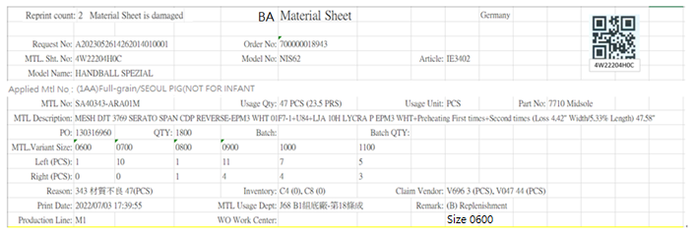

[圖MPS006_6] Regular Material Form (Replenishment) – Size Material

|  |  |  |  |  |  |  |
| --- | --- | --- | --- | --- | --- | --- |
| Print Regular Material Form (Replenishment) – Size Material 列印一般發料單(補料) – 有尺寸發料單 | | | | | | |
| NO | 顯示名稱 | 必填 | 唯讀 | 存改 | 對應欄位 | 欄位型態  欄位說明 |
|  | Reprint count  重印次數 |  |  |  | REPRINT_CNT | Int |
|  | Reprint Reason  重印原因 |  |  |  | User key in Reprint Reason | String |
|  | Request No  補料申請單號 |  |  |  | REPLENISHMENT_NO | String |
| SQL：  -- Get Request No: ( REPLENISHMENT_NO，補料申請單號 ) by C_MATERIAL_SHEET_NO  SELECT REPLENISHMENT_NO , PRINT_CNT AS REPRINT_CNT  FROM dbo.ERP_ISSUE  where C_MATERIAL_SHEET_NO = 'C4W2306010002R' --(User select row) | | | | | | |
|  | Kind  材料類別 |  |  |  |  | String |
| SQL for kind  -- Get Material Sheet Kind : by C_MATERIAL_SHEET_NO  select top 1 t1.KIND  FROM  (  select top 1 PO_BATCH , MATERIALNO  from ERP_ISSUE_DTL  where C_MATERIAL_SHEET_NO = 'C4W2401104825R' --(User select row)  and [STATUS] <> 'D'  ) t0  inner join dbo.CST_MPS_PICKFORM t1 on t0.PO_BATCH = t1.PO_BATCH and t1.[STATUS] <> 'Terminate'  inner join dbo.CST_MPS_PICKFORM_DETAIL t2 on t1.PUF = t2.PUF and t2.MATERIALNO = t0.MATERIALNO | | | | | | |
|  | Shipping Location  出貨地點 |  |  |  | SHIPPING_LOCATION | String |
| SQL  select top 1 t1.SHIPPING_LOCATION  from [dbo].[ERP_SO] t1  inner join [dbo].[ERP_SOBatch] t2 on t1.SO_NO = t2.SO_NO  where t2.PO_BATCH = '0132957503-4' | | | | | | |
|  | MTL. Sht. No.  發料單號 |  |  |  | User selected row | String |
|  | Model No  型體編號 |  |  |  | MODEL_NO | String |
|  | Article  Article |  |  |  | ARTICLE | String |
|  | Model Name  型體名稱 |  |  |  | MODEL_NAME | String |
|  | PO  訂單編號 |  |  |  | PO_NO | String |
|  | Batch  批次 |  |  |  | BATCH | String |
|  | Batch Qty  批次數量 |  |  |  | BATCH_QTY | Numeric |
| SQL：  -- 訂單批次基本資訊 (根據 : C_MATERIAL_SHEET_NO 發料單號)  -- Get PO Batch information ( by C_MATERIAL_SHEET_NO )  SELECT b.PO_NO , a.PO_BATCH , REPLACE(a.PO_BATCH, b.PO_NO,'') BATCH , b.QUANTITY AS BATCH_QTY, c.ARTICLE , c.MODEL_NAME , c.MODEL_NO  FROM ( select top 1 b.PO_BATCH from dbo.ERP_ISSUE a , dbo.ERP_ISSUE_DTL b  where a.C_MATERIAL_SHEET_NO = 'C4W2306010002R' and a.C_MATERIAL_SHEET_NO = b.C_MATERIAL_SHEET_NO ) a  left join dbo.ERP_SOBATCH b on a.PO_BATCH = b.PO_BATCH  left join dbo.ERP_SO c on b.PO_NO = c.PO_NO | | | | | | |
|  | QTY  訂單數量 |  |  |  | QUANTITY | Numeric |
| SQL：  -- 訂單Qty (根據 : PO_NO)  -- Get PO information ( by PO_NO )  SELECT sum(QUANTITY) QUANTITY  FROM dbo.ERP_SOBATCH  where PO_NO = '0126113667' | | | | | | |
|  | Applied MTL No  開補料號資訊 |  |  |  | Applied_MTL_No | String |
|  | EXEC dbo.PRD_GET_REPLN_ISSUE_Applied_Info @C_MATERIAL_SHEET_NO = 'C4W240401000074R' | | | | | |
|  | MTL No  料號 |  |  |  | TOP 1 GENERIC_MATERIAL | String |
|  | Usage Qty  領用量 |  |  |  | SUM(Usage_Qty) | String  IF Usage_UNIT = "PCS"，Please show  Usage_Qty+" ("+Usage_Qty/2+" PRS)"  e.g: 47 (23.5 PRS) |
|  | Usage Unit  領用量單位 |  |  |  | TOP 1 Usage_UNIT | String |
|  | Part No  部位 |  |  |  | TOP 1 (Part_NO + " " + PART_Name) | String |
|  | MTL.Variant Size  MTL.Variant Size |  |  |  | MATERIAL_SIZE | String |
|  | Left (PCS)  左腳數量(支) |  |  |  | LEFT_QTY | Numeric |
|  | Right (PCS)  右腳數量(支) |  |  |  | RIGHT_QTY | Numeric |
|  | Reason  原因 |  |  |  | REASON_CODE + " " + REASON + " " + SUM(LEFT_QTY + RIGHT_QTY) + "(" + UNIT + ")"  GROUP BY REASON_CODE, UNIT  And join all data by ", " | String  e.g: 003 Material defects 100(PCS), 002 Needle breakage 300(PCS) |
|  | Claim Vendor  索賠供應商 |  |  |  | CLAIM_VENDOR + SUM(LEFT_QTY + RIGHT_QTY) + "(" + UNIT + ")"  GROUP BY CLAIM_VENDOR  And join all data by ", " | String  e.g: VNM0075 100(PCS), VNM0076 300(PCS) |
| SQL：  -- SQL01  EXEC dbo.PRD_GET_REPLN_ISSUE_DETAIL_WITH_SIZE 'C4W2307060061R' | | | | | | |
|  | MTL Description  材料名稱 |  |  |  | MATERIAL_SPEC | String |
| SQL：  -- Material Description  SELECT MATERIAL_SPEC  FROM dbo.ERP_MATERIAL  where MATERIALNO = 'SA40343-ARA01M' -- (SQL01 TOP1 GENERIC_MATERIAL) | | | | | | |
|  | Inventory  庫存 |  |  |  | WAREHOUSE + " (" + Qty + ")"  And join all data by ", " | String  e.g: C4 (0), C8 (0) |
| SQL：  -- Get C4、C8 Inventory (by SQL01 TOP 1 GENERIC_MATERIAL)  select t1.REMARK02 WAREHOUSE , isnull(sum(t2.AVAILQTY ),0) Qty  from MES_WPC_EXTENDITEM t1  left join MES_WMS_LOT t2  on t2.MATERIALNO = 'SA40343-ARA01M' --( SQL01 TOP 1 GENERIC_MATERIAL )  and t1.REMARK02 = t2.WAREHOUSE  and t2.INV_TYPE_STATUS = 'Load'  where t1.CLASS = 'Material_AB_Warehouse'  and t1.REMARK01 = 'BA' -- (Always = BA)  group by REMARK02  order by REMARK02 | | | | | | |
|  | | | | | | |
|  | Print Date  列印日期 |  |  |  | User print date and time  (Get from server side) | DateTime  yyyy/MM/dd HH:mm:ss |
|  | MTL Usage Dept  領料單位 |  |  |  | DEPT_DESC | String |
|  | WO Work Center  工單工作中心 |  |  |  | DEPT_DESC_WorkCenter | String  If DEPT_DESC_WorkCenter is Empty, hide this column |
| SQL：  EXEC dbo.PRD_GET_MPS_Dispatch_WorkCenter_ISSUEform 'C4W2301010002R' -- , @DEPT_DESC OUTPUT , @DEPT_DESC_WorkCenter OUTPUT | | | | | | |
|  | Remark  備註 |  |  |  | "("+REMARK01+") "+ REMARK05 | String |
| SQL：  select REMARK01, REMARK05  from MES_WPC_EXTENDITEM  WHERE CLASS = 'ISSUE_TYPE'  and REMARK01 = 'B'  --Next Line : print detail remark  select top 1 t4.REMARK from  (  select C_MATERIAL_SHEET_NO  from dbo.ERP_ISSUE_DTL  where C_MATERIAL_SHEET_NO = 'C4W2401202438R' --(User select row)  and [STATUS] <> 'D'  ) t1  inner join dbo.ERP_ISSUE t2 on t1.C_MATERIAL_SHEET_NO = t2.C_MATERIAL_SHEET_NO  inner join dbo.CST_REPLN_SAP_DETAIL t3 on t2.REPLENISHMENT_NO = t3.CST_REPLN_ITEM_GROUP_SID  inner join dbo.CST_REPLN_ITEM t4 on t3.CST_REPLN_ITEM_SID = t4.CST_REPLN_ITEM_SID  INNER join dbo.CST_REPLN_BATCH t5 on t3.CST_REPLN_BATCH_SID = t5.CST_REPLN_BATCH_SID | | | | | | |
|  | Production Line  成型線別 |  |  |  | AS_CELL | String |
| SQL：  -- Production Line (by PO_Batch)  SELECT AS_CELL  from ERP_PROD_SCHED  where PO_Batch = '0126113667-1' | | | | | | |
| After Print，Update [ERP_ISSUE].[PRINT_CNT] and [ERP_ISSUE].[PRINT_TIME] (use server time)  SQL：  update dbo.ERP_ISSUE  set PRINT_CNT = PRINT_CNT + 1  , REPRINT_REASON = 'Material Sheet is damaged' --(User key in Reprint Reason)  , PRINT_TIME = GETDATE() -- Server time，yyyy/MM/dd HH:mm:ss  where C_MATERIAL_SHEET_NO = 'C4W2306010002R' --(User select row) | | | | | | |

* 1. **「MPS007 Print AA In/Out Sheet (Replenishment)」MPS007列印AA其他出入單據(補料)**
  2. 程式名稱：同標題 (Right Name: MPS_print.AA.InOut.Sheet.Replenishment)
  3. 功能目的：查詢/列印
  4. 使用部門：
  5. 程式說明：

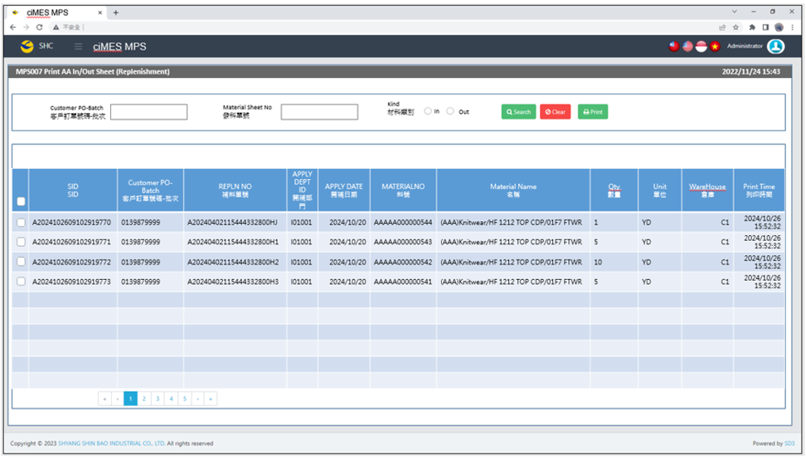

[圖MPS007_1] Main Page主畫面

|  |  |  |  |  |  |  |
| --- | --- | --- | --- | --- | --- | --- |
| Program header 程式標頭 | | | | | | |
| NO | 顯示名稱 | 必填 | 唯讀 | 存改 | 對應欄位 | 說明 |
|  | Title  標題 |  | V |  | CAPTION | String  If there is no get data, please show “Right Name”  SELECT T2.LANGUAGE, T2.CAPTION  FROM [MES_SEC_RIGHT] AS T1  JOIN [MES_MENU_ITEM] AS T2  ON T1.SEC_RIGHT_SID = T2.SEC_RIGHT_SID  WHERE T1.GROUPRIGHTS = 'MPS_Print.AA.InOut.Sheet.Replenishment' --(Right Name) |
|  | System Time  系統時間 |  | V |  | Show current server time | Datetime  yyyy/MM/dd HH:mm |

|  |  |  |  |  |  |  |
| --- | --- | --- | --- | --- | --- | --- |
| Operation button 操作按鈕 | | | | | | |
| NO | 顯示名稱 | 必填 | 唯讀 | 存改 | 對應欄位 | 說明 |
|  | Search  搜尋 |  |  |  |  | Input「Customer PO-Batch  」and「Material Sheet No」 (enter at least one)、「Kind」(Required) to search |
|  | Clear  清除 |  |  |  |  | Clear Search Condition and Results |
|  | Print  列印 |  |  |  |  | Print the select row data |

|  |  |  |  |  |  |  |
| --- | --- | --- | --- | --- | --- | --- |
| Search Condition 搜尋條件 | | | | | | |
| NO | 顯示名稱 | 必填 | 唯讀 | 存改 | 對應欄位 | 欄位型態  欄位說明 |
|  | Customer PO-Batch  客戶訂單號碼-批次 |  |  | V | Filter Customer PO-Batch column | String  Customer PO-Batch  Material Sheet No  At least input 1 search condition |
|  | Material Sheet No  發料單號 |  |  | V | Material Sheet No column | String  Customer PO-Batch  Material Sheet No  At least input 1 search condition |
|  | Kind  類別 | V |  | V | CTRL_CODE column | Radio Button (Required to select)  Out : CTRL_CODE = 1  In : CTRL_CODE = 2 |

|  |  |  |  |  |  |  |
| --- | --- | --- | --- | --- | --- | --- |
| Search 搜尋 | | | | | | |
| NO | 顯示名稱 | 必填 | 唯讀 | 存改 | 對應欄位 | 欄位型態  欄位說明 |
|  | Selector  選擇器 |  |  | V |  | Check Box |
|  | SID  SID |  | V |  | SID | String |
|  | Customer PO-Batch  客戶訂單號碼-批次 |  | V |  | PO_BATCH | String |
|  | REPLN NO  補料單號 |  | V |  | REPLN_NO | String |
|  | APPLY DEPT ID  開補部門 |  | V |  | APPLY_DEPT_ID | String |
|  | APPLY DATE  開補日期 |  | V |  | APPLY_DATE | String |
|  | MATERIALNO  料號 |  | V |  | MATERIALNO | String |
|  | Material Name  名稱 |  | V |  | MATERIAL_NAME | String |
|  | Qty  數量 |  | V |  | Qty | Numeric |
|  | Unit  單位 |  | V |  | Unit | String |
|  | WareHouse  倉庫 |  | V |  | WAREHOUSE | String |
|  | Print Time  列印時間 |  | V |  | Print_Time | String |
| 程式邏輯說明：  點選 [Search搜尋] 按鈕，依照User填入的搜尋條件(若有)，即可帶出資料。  SQL：  select distinct t3.PA_REPLN_INOUT_SID SID  , t3.PO_BATCH , t3.REPLN_NO  , t1.APPLY_DEPT_ID , t1.APPLY_DATE  , t3.MATERIALNO , t2.MATERIAL_NAME  , cast( t3.Qty as float) Qty  , t3.Unit , t3.WAREHOUSE , t3.Print_Time  from ( select PO_BATCH , CST_REPLN_ITEM_GROUP_SID  , max(APPLY_DEPT_ID) APPLY_DEPT_ID , max(APPLY_DATE) APPLY_DATE  from CST_REPLN_REPORT_DETAIL  where 1=1  and PO_BATCH = '0135204117' -- (Customer PO-Batch)  and C_MATERIAL_SHEET_NO like '%' + 'C4W240405001769R' + '%' -- (Material Sheet No)  group by PO_BATCH , CST_REPLN_ITEM_GROUP_SID  ) t1  inner join ERP_PA_REPLN_INOUT t3  on t1.CST_REPLN_ITEM_GROUP_SID = t3.REPLN_NO  and t1.PO_BATCH = t3.PO_BATCH  and t3.CTRL_CODE = 1 -- (Kind: Radio Button)  and ( t3.DELETE_FLAG <> 'D' or t3.DELETE_FLAG is null )  inner join ERP_MATERIAL t2 on t3.MATERIALNO = t2.MATERIALNO  where 1=1  order by t3.PO_BATCH , t3.REPLN_NO , t3.MATERIALNO | | | | | | |

|  |
| --- |
| 程式邏輯說明：  1. All selected rows are printed with QR code (QR code data is from column ‘SID’), A4 Size, detail in [Fig MPS007_2] , print “Kind” radiobutton value at end of title  Kind = In : AA Material Sheet for Material Treatment (In)  Kind = Out : AA Material Sheet for Material Treatment (Out)  QR code : SID  PO#: PO_BATCH  REPLN No: REPLN_NO  MTL Component No: MATERIALNO  Usage Qty: Qty  Usage Unit: Unit  Warehouse: WAREHOUSE  MTL Component Description: MATERIAL_NAME  2. After print AA In/Out Sheet，loop all rows to Update Print_Time by PA_REPLN_INOUT_SID  SQL :  update dbo.ERP_PA_REPLN_INOUT  set Print_Time = GETDATE() -- Server time，yyyy/MM/dd HH:mm:ss  where PA_REPLN_INOUT_SID = 'A2024102609102919770' -- selected row Column : SID    3. Keep textbox data (Customer PO-Batch、Material Sheet No), do not clear,  Refresh Gridview Data (show Print_Time for printed rows ) and un-check selected rows |

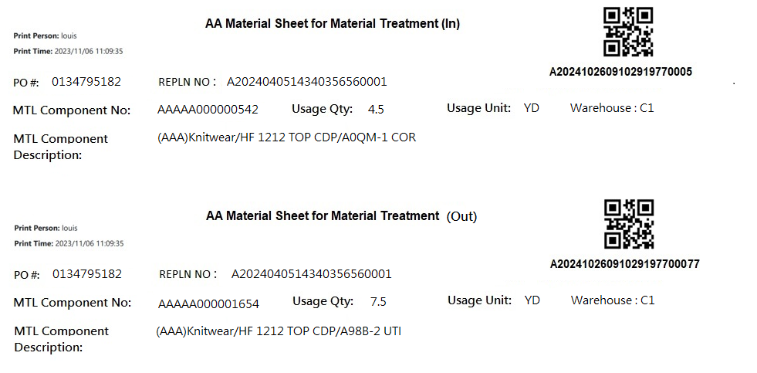

[Fig MPS007_2] AA In/Out Sheet，A4 size

* 1. **「MPS008 Print AA Material Sheet A4 Format」MPS008 列印AA發料單(A4格式)**
  2. 程式名稱：同標題 (Right Name: MPS_Print.Material.Sheet.AA.A4)
  3. 功能目的：查詢/列印
  4. 使用部門：
  5. 程式說明：

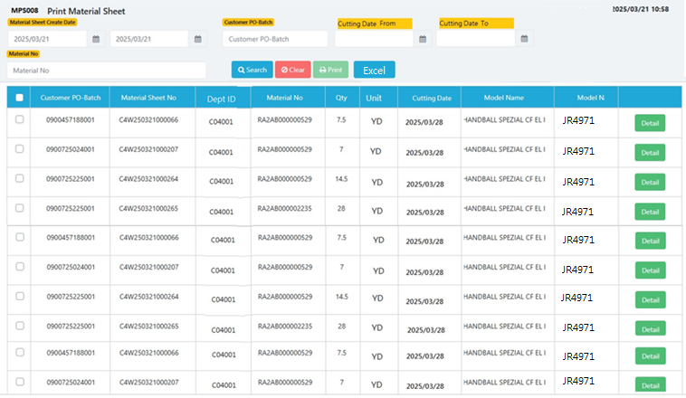

[圖MPS008_1] Main Page主畫面

|  |  |  |  |  |  |  |
| --- | --- | --- | --- | --- | --- | --- |
| Program header 程式標頭 | | | | | | |
| NO | 顯示名稱 | 必填 | 唯讀 | 存改 | 對應欄位 | 說明 |
|  | Title  標題 |  | V |  | CAPTION | String  If there is no get data, please show “Right Name”  SELECT T2.LANGUAGE, T2.CAPTION  FROM [MES_SEC_RIGHT] AS T1  JOIN [MES_MENU_ITEM] AS T2  ON T1.SEC_RIGHT_SID = T2.SEC_RIGHT_SID  WHERE T1.GROUPRIGHTS = 'MPS_Print.Material.Sheet.AA.A4' --(Right Name) |
|  | System Time  系統時間 |  | V |  | Show current server time | Datetime  yyyy/MM/dd HH:mm |

|  |  |  |  |  |  |  |
| --- | --- | --- | --- | --- | --- | --- |
| Operation button 操作按鈕 | | | | | | |
| NO | 顯示名稱 | 必填 | 唯讀 | 存改 | 對應欄位 | 說明 |
|  | Search  搜尋 |  |  |  |  | Required「Material Sheet Create Date」or「Customer PO-Batch」to search |
|  | Clear  清除 |  |  |  |  | Clear Search Condition and Results |
|  | Print  列印 |  |  |  |  | Print the select row data |
|  | Detail  明細 |  |  |  |  | Show detail data |
|  | Excel  匯出Excel |  |  |  |  | Export to Excel function:  After Search data , export all gridview data to Excel and allow user to save as specific filename |

|  |  |  |  |  |  |  |
| --- | --- | --- | --- | --- | --- | --- |
| Search Condition 搜尋條件 | | | | | | |
| NO | 顯示名稱 | 必填 | 唯讀 | 存改 | 對應欄位 | 欄位型態  欄位說明 |
|  | Material Sheet Create Date (From)  發料單建立日(起) |  |  | V | Filter Material Sheet Create Date column | String  yyyy/MM/dd  default value : Today() |
|  | Material Sheet Create Date (To)  發料單建立日(訖) |  |  | V | Filter Material Sheet Create Date column | String  yyyy/MM/dd  default value : Today()  check Date To – Date From must <=6  Ex : 2025/03/22 ~ 2025/03/28  If date range > 6 , show error message(‘Max Material create date range is 7days’)  error message(‘發料單日期區間最長為7天’) |
|  | Customer PO-Batch  客戶訂單號碼-批次 |  |  | V | Filter Customer PO-Batch column | String |
|  | Material No  料號 |  |  | V | Filter MATERIALNO column | String |
|  | Cut Start Date(From)  裁斷開始日(起) |  |  | V | Filter Cut Start Date column | String (default Empty)  The column in database format is yyyyMMdd, please change date format for SQL from yyyy/MM/dd to yyyyMMdd  2025/03/21 => 20250321 |
|  | Cut Start Date(To)  裁斷開始日(訖) |  |  | V | Filter Cut Start Date column | String (default Empty)  The column in database format is yyyyMMdd, please change date format for SQL from yyyy/MM/dd to yyyyMMdd  2025/03/21 => 20250321 |

|  |  |  |  |  |  |  |
| --- | --- | --- | --- | --- | --- | --- |
| Search 搜尋 | | | | | | |
| NO | 顯示名稱 | 必填 | 唯讀 | 存改 | 對應欄位 | 欄位型態  欄位說明 |
|  | Selector  選擇器 |  |  | V |  | Check Box |
|  | Customer PO-Batch  客戶訂單號碼-批次 |  | V |  | PO_BATCH | String |
|  | Material Sheet No  發料單號 |  | V |  | C_MATERIAL_SHEET_NO | String |
|  | DEPT_ID  工作中心 |  | V |  | DEPT_ID | String (click gridview header to sort data) |
|  | Material No  料號 |  | V |  | MATERIAL_NO | String(click gridview header to sort data) |
|  | Qty  數量 |  | V |  | QUANTITY | Numeric |
|  | Unit  單位 |  | V |  | Unit | String |
|  | Cut Start Date  裁斷開始日 |  | V |  | Cut_Start_Date | String(click gridview header to sort data)  The string in DB format is yyyyMMdd, please display yyyy/MM/dd |
|  | Model Name  型體名稱 |  | V |  | MODEL_NAME | String |
|  | Article  Article |  | V |  | Article | String |
|  | Detail button  明細按鈕 |  |  |  | Open detail page | Button |
| 程式邏輯說明：  填入Material Sheet Create Date 或 Customer PO-Batch後(擇一必填)，點選 [Search搜尋] 按鈕，即可帶出資料。  Display all data in one page , don’t separate data into many pages,  Gridview height is able to display 10 rows at a time and with a scroll bar  SQL： Can refer to MPS001, The difference is marked with a sky blue background  Begin (New SQL Group)  **-- Step1 : get datetable : #tmp_AA**  SELECT  CASE max(T1.ISSUE_TYPE)  WHEN 'I' THEN max(T1.COMBINE_PO_BATCH)  ELSE max(T2.PO_BATCH)  END PO_BATCH  ,T1.C_MATERIAL_SHEET_NO  , MIN(T2.DEPT_ID) AS DEPT_ID  , MIN(T2.MATERIAL_NO) AS MATERIAL_NO  , SUM(T2.QUANTITY) AS QUANTITY  , min(T2.Unit) AS Unit  , MIN(T3.Cut_Start_Date) AS Cut_Start_Date  , MIN(T2.MODEL_NAME) AS MODEL_NAME  , MIN (T2.Article) AS Article  , MIN(T4.MATERIAL_SPEC) AS MATERIAL_SPEC  into #tmp_AA  FROM dbo.ERP_ISSUE AS T1,  (  select a.C_MATERIAL_SHEET_NO , min(a.DEPT_ID) DEPT_ID , min(MATERIALNO) AS MATERIAL_NO  , sum(a.QUANTITY) AS QUANTITY  , min(a.UNIT) AS Unit  , a.PO_BATCH  , min(c.MODEL_NAME) AS MODEL_NAME  , min (c.Article) AS Article  , min(b.kind) kind  from dbo.ERP_ISSUE_DTL AS a,  (  select a2.C_MATERIAL_SHEET_NO , max(a3.KIND) Kind  from ERP_ISSUE a1  inner join ERP_ISSUE_DTL a2 on a1.C_MATERIAL_SHEET_NO = a2.C_MATERIAL_SHEET_NO  left join dbo.CST_MPS_PICKFORM_DETAIL a4 on a2.C_MATERIAL_SHEET_NO = a4.C_MATERIAL_SHEET_NO  left join dbo.CST_MPS_PICKFORM a3 on a3.PUF = a4.PUF and a2.PO_BATCH = a3.PO_BATCH  where a2.UPDATETIME >= '2025/03/17' -- (Material Sheet Create Date(From))  and a2.UPDATETIME <= DATEADD(DAY, 1, '2025/03/21') -- (Material Sheet Create Date(To)) + 1  and a2.PO_BATCH like '0900646080001%' -- (Customer PO-Batch) if first character <> ‘C’ , add this line  and a1.COMBINE_PO_BATCH = 'C250321001' -- (Customer PO-Batch) if first character = ‘C’ , add this line  --and a2.MATERIALNO like 'RAAAE%' -- (Material No)  and a2.[STATUS] <> 'D' -- (Always is D)  group by a2.C_MATERIAL_SHEET_NO  ) AS b, dbo.ERP_SOBATCH AS c  where a.C_MATERIAL_SHEET_NO = b.C_MATERIAL_SHEET_NO  and a.PO_BATCH = c.PO_BATCH  group by a.C_MATERIAL_SHEET_NO, a.PO_BATCH  ) AS T2  , ERP_PROD_SCHED T3  , ERP_MATERIAL T4  WHERE T1.C_MATERIAL_SHEET_NO = T2.C_MATERIAL_SHEET_NO  and T2.PO_BATCH = t3.PO_BATCH  and T2.MATERIAL_NO = T4.MATERIALNO  AND T1.PRINT_CNT = 0  AND kind = 'AA' -- (Material Type) (Always = ‘AA’)  and T3.Cut_Start_Date >= '20250324' -- '2025/03/21' -- (Material Sheet Create Date(From))  and T3.Cut_Start_Date <= '20250325' -- DATEADD(DAY, 1, '2025/03/21') -- (Material Sheet Create Date(To)) + 1  GROUP BY T1.C_MATERIAL_SHEET_NO  ORDER BY MATERIAL_NO , DEPT_ID , Cut_Start_Date  (default is order by MATERIAL_NO , DEPT_ID , Cut_Start_Date  If user click gridview header“DEPT_ID” : order by DEPT_ID , MATERIAL_NO , Cut_Start_Date  If user click gridview header“MATERIAL_NO” : order by MATERIAL_NO , DEPT_ID , Cut_Start_Date  If user click gridview header“Cut_Start_Date” : order by Cut_Start_Date , DEPT_ID , MATERIAL_NO)  **-- Step2 : get datetable : #tmp_AA_MULTI_DEPT**  select t1.C_MATERIAL_SHEET_NO  into #tmp_AA_MULTI_DEPT  from #tmp_AA t1  inner join ERP_ISSUE_DTL_Dept_DTL t2  on t1.C_MATERIAL_SHEET_NO = t2.C_MATERIAL_SHEET_NO  group by t1.C_MATERIAL_SHEET_NO  having count(*) > 1  and max(t2.DEPT_ID) <> min(t2.DEPT_ID) | | | | | | |
| **-- Step3 : get datetable : #tmp_AA_MULTI_DEPT_Qty**  select C_Material_Sheet_NO , STRING_AGG( Dept_ID_Qty , ';') Dept_ID_Qty  into #tmp_AA_MULTI_DEPT_Qty  from  (  select t2.C_Material_Sheet_NO , Dept_ID + '(' + cast(cast(sum(Quantity) as float) as varchar) + ')' Dept_ID_Qty  from #tmp_AA_MULTI_DEPT t1  inner join ERP_ISSUE_DTL_Dept_DTL t2  on t1.C_Material_Sheet_NO = t2.C_Material_Sheet_NO  group by t2.C_Material_Sheet_NO , Dept_ID  ) t1  group by C_Material_Sheet_NO  **-- Step4 : #tmp_AA left #tmp_AA_MULTI_DEPT_Qty and show data to gridview**  select t1.* , t2.Dept_ID_Qty  from #tmp_AA t1  left join #tmp_AA_MULTI_DEPT_Qty t2  on t1.C_MATERIAL_SHEET_NO = t2.C_Material_Sheet_NO  END (New SQL Group)  Export to Excel function:  Export all gridview rows data (from above SQL) to Excel and allow user to save as specific filename  (including MODEL_NAME、Article)  Main Title : AA Material Sheet (A4 Format)  With label : Material Sheet Create Date From ~ To (from Search Condition)  With label : print person、print time  Excel columns are all the same with gridview column  (only “Material Desctiption” is from SQL “MATERIAL_SPEC”, ~~and remove model name column~~ ) | | | | | | |

[圖MPS008_1_1] Excel format



[圖MPS008_2] Detail明細畫面

|  |  |  |  |  |  |  |
| --- | --- | --- | --- | --- | --- | --- |
| Detail 明細 | | | | | | |
| NO | 顯示名稱 | 必填 | 唯讀 | 存改 | 對應欄位 | 欄位型態  欄位說明 |
|  | Material Sheet No  發料單號 |  | V |  | User selected row | String |
|  | Customer PO-Batch  客戶訂單號碼-批次 |  | V |  | PO_BATCH | String |
|  | Material No  料號 |  | V |  | MATERIALNO | String |
|  | Qty  數量 |  | V |  | QUANTITY | Numeric |
| 程式邏輯說明：  依照User點選的資料列，帶出該資料列的明細資料。  Same with MPS001  SQL：  SELECT C_MATERIAL_SHEET_NO, PO_BATCH, MATERIALNO, QUANTITY  FROM ERP_ISSUE_DTL  WHERE C_MATERIAL_SHEET_NO = 'C4W250320003490' -- (User selected row)  ORDER BY PO_BATCH, MATERIALNO | | | | | | |

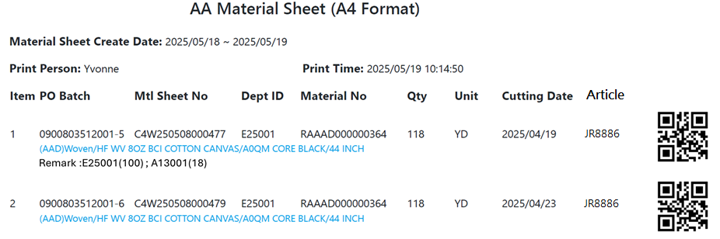

[圖MPS008_1] AA Material Sheet (A4 Format)

|  |  |  |  |  |  |
| --- | --- | --- | --- | --- | --- |
| Print AA Material Sheet Form (A4 Foramt)列印AA發料單-A4尺寸 | | | | | |
| 顯示名稱 | 必填 | 唯讀 | 存改 | 對應欄位 | 欄位型態  欄位說明 | |
| Item |  | V |  | Gridview Row No | String | |
| Customer PO-Batch  客戶訂單號碼-批次 |  | V |  | PO_BATCH | String | |
| Material Sheet No  發料單號 |  | V |  | C_MATERIAL_SHEET_NO | String | |
| DEPT_ID  工作中心 |  | V |  | DEPT_ID | String | |
| Material No  料號 |  | V |  | MATERIAL_NO | String | |
| Qty  數量 |  | V |  | QUANTITY | Numeric | |
| Unit  單位 |  | V |  | Unit | String | |
| Cut Start Date  裁斷開始日 |  | V |  | Cut_Start_Date | String  yyyy/MM/dd | |
| Article |  | V |  | Article | String | |
|  |  | V |  | C_MATERIAL_SHEET_NO | QR Code | |
| MATERIAL_SPEC  材料名稱 |  | V |  | MATERIAL_SPEC | String | |
| Dept_ID_Qty  工作中心+數量 |  | V |  | Dept_ID_Qty | String | |
|  |  |  |  |  |  | |
| Check Combined PO-Batch  (Same with MPS001 , page 22 column : PO-QTY/Usage qty )  )  If substring(PO_BATCH,1,1) == ‘C’ -- (Pringing Row)  Begin  -- Add 1 Row for Combined PO-Batch information:  -- PO-QTY/Usage qty (訂單號碼/使用量)  -- PO_BATCH + "-" + QUANTITY + "/" + Issue_QUANTITY + UNIT  -- And join all data by ", "  -- e.g:0132825230-90/8YD, 0132837594-48/4.5YD  SQL :  SELECT a.PO_BATCH , b.QUANTITY, a.Issue_QUANTITY , a.UNIT  FROM ( select PO_BATCH , sum(QUANTITY) Issue_QUANTITY , max(UNIT) UNIT  from dbo.ERP_ISSUE_DTL  where C_MATERIAL_SHEET_NO = 'C4W250320003957' -- (Printing row: C_MATERIAL_SHEET_NO)  group by PO_Batch ) a  left join dbo.ERP_SOBATCH b on a.PO_BATCH = b.PO_BATCH  order by a.PO_BATCH  End | | | | | |
| Print page number at buttom of A4 | | | | | |
| After Print，Loop all selected rows to Update [ERP_ISSUE].[PRINT_CNT] and [ERP_ISSUE].[PRINT_TIME] (use server time) and refresh Gridview  SQL：  update dbo.ERP_ISSUE  set PRINT_CNT = PRINT_CNT + 1  , PRINT_TIME = GETDATE() -- Server time，yyyy/MM/dd HH:mm:ss  WHERE C_MATERIAL_SHEET_NO = 'C4W250320003957' --(User select row) | | | | | |

* 1. **「MPS009 Print Material Sheet」MPS009 皮料欠數查詢與列印**
  2. 程式名稱：同標題 (Right Name: MPS_Print.Material.Sheet.LackQty)
  3. 功能目的：查詢/列印
  4. 使用部門：
  5. 程式說明：

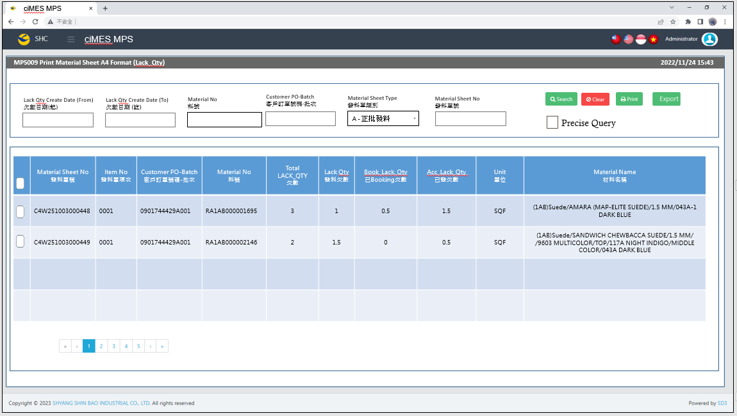

[圖MPS009_1] Main Page主畫面

|  |  |  |  |  |  |  |
| --- | --- | --- | --- | --- | --- | --- |
| Program header 程式標頭 | | | | | | |
| NO | 顯示名稱 | 必填 | 唯讀 | 存改 | 對應欄位 | 說明 |
|  | Title  標題 |  | V |  | CAPTION | String  If there is no get data, please show “Right Name”  SELECT T2.LANGUAGE, T2.CAPTION  FROM [MES_SEC_RIGHT] AS T1  JOIN [MES_MENU_ITEM] AS T2  ON T1.SEC_RIGHT_SID = T2.SEC_RIGHT_SID  WHERE T1.GROUPRIGHTS =  'MPS_Print.Material.Sheet.LackQty' --(Right Name) |
|  | System Time  系統時間 |  | V |  | Show current server time | Datetime  yyyy/MM/dd HH:mm |

|  |  |  |  |  |  |  |
| --- | --- | --- | --- | --- | --- | --- |
| Operation button 操作按鈕 | | | | | | |
| NO | 顯示名稱 | 必填 | 唯讀 | 存改 | 對應欄位 | 說明 |
|  | Search  搜尋 |  |  |  |  | Required「Lack Qty Create Date (from~to)」  or「Customer PO-Batch」  or 「Material No」  or「Material Sheet No」  to search |
|  | Clear  清除 |  |  |  |  | Clear Search Condition and Results |
|  | Print  列印 |  |  |  |  | Print the select row data |
|  | Export  匯出 |  |  |  |  | Export searched gridview data to Excel |

|  |  |  |  |  |  |  |
| --- | --- | --- | --- | --- | --- | --- |
| Search Condition 搜尋條件 | | | | | | |
| NO | 顯示名稱 | 必填 | 唯讀 | 存改 | 對應欄位 | 欄位型態  欄位說明 |
|  | Lack Qty Create Date (From)  發料單建立日(起) |  |  | V | Filter Lack Qty Create Date column (LACK_DATE) | String  yyyy/MM/dd |
|  | Lack Qty Create Date (To)  發料單建立日(訖) |  |  | V | Filter Lack Qty Create Date column  (LACK_DATE) | String  yyyy/MM/dd |
|  | Material No  料號 |  |  | V | Filter MATERIALNO column | String |
|  | Customer PO-Batch  客戶訂單號碼-批次 |  |  | V | Filter Customer PO-Batch column | String  If chkPrecise is checked  Must exactly matched  Remove % in Search SQL |
|  | Material Sheet Type  發料單類別 |  |  | V | Filter ISSUE_TYPE column | Dropdown list  select REMARK01, REMARK01 + '-' + REMARK02 AS Material_Sheet_Type  from MES_WPC_EXTENDITEM  where CLASS = 'ISSUE_TYPE'  and (REMARK03 <> 'Y' or REMARK03 is null )  order by REMARK01  Add a Null in Dropdown list |
|  | Material Sheet No  發料單號 |  |  | V | Filter C_MATERIAL_SHEET_NO column | String |
|  | Precise Query  精準比對 |  |  | V |  | Check Box : chkPrecise (default : not cheched)  If chkPrecise is checked  Filter Customer PO-Batch column  Must exactly matched  (Remove % in Search SQL Ex : PO_BATCH like '090007695001-1' ) |

|  |  |  |  |  |  |  |
| --- | --- | --- | --- | --- | --- | --- |
| Search 搜尋 | | | | | | |
| NO | 顯示名稱 | 必填 | 唯讀 | 存改 | 對應欄位 | 欄位型態  欄位說明 |
|  | Selector  選擇器 |  |  | V |  | Check Box |
|  | Material Sheet No  發料單號 |  | V |  | C_MATERIAL_SHEET_NO | String |
|  | Item No  發料單項次 |  | V |  | ITEM_NO | String |
|  | Customer PO-Batch  客戶訂單號碼-批次 |  | V |  | PO_BATCH | String |
|  | Material No  料號 |  | V |  | MATERIALNO | String |
|  | Total LACK_QTY  欠數 |  | V |  | LACK_QTY | Numeric |
|  | Lack Qty  發料欠數 |  | V |  | LACK_QTY_now | Numeric |
|  | Book_Lack_Qty  已Booking欠數 |  | V |  | BOOK_LACK_QTY | Numeric |
|  | Acc_Lack_Qty  已發欠數 |  | V |  | ACC_LACK_QTY | Numeric |
|  | Unit  單位 |  | V |  | UNIT | String |
|  | Material Name  材料名稱 |  | V |  | MATERIAL_SPEC | String |
| 程式邏輯說明：  填入Material Sheet Create Date 或 Customer PO-Batch後(擇一必填)，點選 [Search搜尋] 按鈕，即可帶出資料。  (display 4 rows/page in gridview)  SQL：  SELECT C_MATERIAL_SHEET_NO, ITEM_NO, t1.PO_BATCH, t1.MATERIALNO  , LACK_QTY, LACK_QTY_now, Isnull(BOOK_LACK_QTY,0) BOOK_LACK_QTY , Isnull(ACC_LACK_QTY,0) ACC_LACK_QTY  , t1.UNIT, ISSUE_TYPE , t3.MATERIAL_SPEC  FROM (  select a2.C_MATERIAL_SHEET_NO, ITEM_NO, PO_BATCH, MATERIALNO  , LACK_QTY  , ( LACK_QTY - Isnull(BOOK_LACK_QTY,0) - Isnull(ACC_LACK_QTY,0) ) LACK_QTY_now  , Isnull(BOOK_LACK_QTY,0) BOOK_LACK_QTY , Isnull(ACC_LACK_QTY,0) ACC_LACK_QTY  , UNIT  , a1.ISSUE_TYPE  from ERP_ISSUE a1  inner join ERP_ISSUE_DTL a2 on a1.C_MATERIAL_SHEET_NO = a2.C_MATERIAL_SHEET_NO  where 1 = 1  and a2.LACK_DATE >= '2025/10/01' -- (Lack Qty Create Date (From))  and a2.LACK_DATE <= DATEADD(DAY, 1, '2025/10/31') -- (Lack Qty Create Date (To) ) + 1  and a2.PO_BATCH like '0901744429A001%' -- (Customer PO-Batch)  and a2.MATERIALNO like 'RA1AB%' -- (Material No)  and a2.[STATUS] <> 'D' -- (Always is D)  ) t1  inner join dbo.ERP_SOBATCH t2 on t1.PO_BATCH = t2.PO_BATCH  inner join dbo.ERP_MATERIAL t3 on t1.MATERIALNO = t3.MATERIALNO  WHERE ( LACK_QTY <> 0 and LACK_QTY is not NULL)  --and C_MATERIAL_SHEET_NO = 'C4W251003000448' -- Material Sheet No  --AND T1.ISSUE_TYPE = 'A' -- (Material Sheet Type)  ORDER BY C_MATERIAL_SHEET_NO desc | | | | | | |

|  |  |  |  |  |  |  |
| --- | --- | --- | --- | --- | --- | --- |
| Print列印 | | | | | | |
| NO | 顯示名稱 | 必填 | 唯讀 | 存改 | 對應欄位 | 欄位型態  欄位說明 |
|  |  |  |  |  |  |  |
| 程式邏輯說明：  選擇資料列後，點選列印，印出發料單(A4中三刀)，邏輯如下  Always Print「**Regular Material Form – No Size Material」**  **4 Material Form in 1 page** | | | | | | |

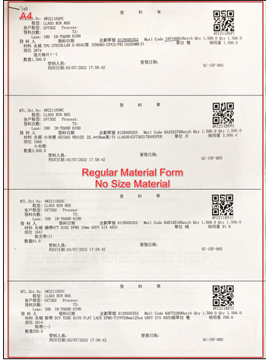

[圖MPS009_2] Regular Material Form，A4中三刀，示意圖

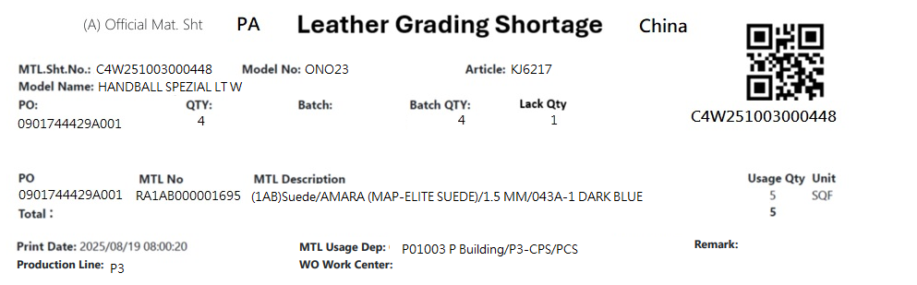

[圖MPS009_3] Regular Material Form – No Size Material

|  |  |  |  |  |  |  |
| --- | --- | --- | --- | --- | --- | --- |
| Print Regular Material Form – No Size Material 列印一般發料單 – 無尺寸發料單 | | | | | | |
| NO | 顯示名稱 | 必填 | 唯讀 | 存改 | 對應欄位 | 欄位型態  欄位說明 |
|  | Form Title Type |  |  |  | "("+ISSUE_TYPE+") "+REMARK05 | String |
| SQL for Type  -- If REMARK05 = Null or Empty, No need to show Form Title Type  select t1.ISSUE_TYPE, t2.REMARK05  from dbo.ERP_ISSUE t1  inner join MES_WPC_EXTENDITEM t2  on t2.CLASS = 'ISSUE_TYPE'  and t1.ISSUE_TYPE = t2.REMARK01  where t1.C_MATERIAL_SHEET_NO = 'C4W251003000448' --(User select row) | | | | | | |
|  | Kind  材料類別 |  |  |  |  | String |
| SQL for kind  -- Get Material Sheet Kind : by C_MATERIAL_SHEET_NO  select top 1 t1.KIND  FROM  (  select PUF  from CST_MPS_PICKFORM_DETAIL  where C_MATERIAL_SHEET_NO = 'C4W251003000448' --(User select row)  ) t0  inner join dbo.CST_MPS_PICKFORM t1 on t0.PUF = t1.PUF and t1.[STATUS] <> 'Terminate'  **-- IF No Data found, Get Kind by following SQL again**  select top 1 t1.KIND  FROM  (  select top 1 PO_BATCH , MATERIALNO  from ERP_ISSUE_DTL  where C_MATERIAL_SHEET_NO = 'C4W251003000448' --(User select row)  and [STATUS] <> 'D'  ) t0  inner join dbo.CST_MPS_PICKFORM t1 on t0.PO_BATCH = t1.PO_BATCH and t1.[STATUS] <> 'Terminate'  inner join dbo.CST_MPS_PICKFORM_DETAIL t2 on t1.PUF = t2.PUF and t2.MATERIALNO = t0.MATERIALNO | | | | | | |
|  | Leather Grading Shortage |  |  |  |  | String |
|  | Shipping Location  出貨地點 |  |  |  | SHIPPING_LOCATION | String |
| SQL  select top 1 t1.SHIPPING_LOCATION  from [dbo].[ERP_SO] t1  inner join [dbo].[ERP_SOBatch] t2 on t1.SO_NO = t2.SO_NO  where t2.PO_BATCH = '0901744429A001' | | | | | | |
|  | C.MTL. Sht. No.  合併發料單號 |  |  |  | User selected row | String |
|  | Model No  型體編號 |  |  |  | MODEL_NO | String |
|  | Article  Article |  |  |  | ARTICLE | String |
|  | Model Name  型體名稱 |  |  |  | MODEL_NAME | String |
|  | PO  訂單編號 |  |  |  | PO_NO | String |
|  | Batch  批次 |  |  |  | BATCH | String |
|  | Batch Qty  批次數量 |  |  |  | QUANTITY | Numeric |
|  | Lack Qty  發料欠數 |  |  |  | LACK_QTY_now | Numeric |
| SQL：  -- 訂單批次基本資訊 (根據 : C_MATERIAL_SHEET_NO 發料單號)  -- Get PO Batch information ( by C_MATERIAL_SHEET_NO、PO_BATCH、MATERIALNO、ITEM_NO )  SELECT top 1 b.PO_NO , a.PO_BATCH , REPLACE(a.PO_BATCH, b.PO_NO,'') BATCH  , b.QUANTITY, c.ARTICLE , c.MODEL_NAME , c.MODEL_NO  , ( LACK_QTY - Isnull(BOOK_LACK_QTY,0) - Isnull(ACC_LACK_QTY,0) ) LACK_QTY_now  FROM ( select * from dbo.ERP_ISSUE_DTL  where C_MATERIAL_SHEET_NO = 'C4W251003000448' --(User select row)  and PO_BATCH = '0901744429A001' --(User select row)  and MATERIALNO = 'RA1AB000001695' --(User select row)  and ITEM_NO = '0001' --(User select row)  ) a  left join dbo.ERP_SOBATCH b on a.PO_BATCH = b.PO_BATCH  left join dbo.ERP_SO c on b.PO_NO = c.PO_NO | | | | | | |
|  | PO QTY  訂單數量 |  |  |  | QUANTITY | Numeric |
| SQL：  -- 訂單Qty (根據 : PO_NO)  -- Get PO information ( by PO_NO )  SELECT sum(QUANTITY) QUANTITY  FROM ERP_SOBATCH  where PO_NO = '0901744429A001' | | | | | | |
|  | PO  訂單號碼 |  |  |  | PO_NO | String |
|  | MTL No  料號 |  |  |  | MATERIALNO | String |
|  | Usage Qty  領用量 |  |  |  | QUANTITY | Numeric |
|  | Unit  單位 |  |  |  | UNIT | String |
|  | Part No  部位 |  |  |  | PART_NO_NAME | String |
|  | MTL Description  材料名稱 |  |  |  | MATERIAL_SPEC | String |
| SQL：  -- 面部材料 : 如果2個部位使用相同的原材料，會是列印在1張發料單號 (發料單號相同) ， 使用string_AGG 合併部位資訊在一個欄位  --NO SIZE MATERIAL : data list ( by C_MATERIAL_SHEET_NO )  SQL01  Select TOP 1 min(a.PO_NO) PO_NO , a.MATERIALNO , min(b.MATERIAL_SPEC) MATERIAL_SPEC , sum(a.QUANTITY) QUANTITY  , min(a.UNIT) UNIT , MAX(a.PART_NO ) + '-' + MAX(a.PART_NAME) PART_NO_NAME  FROM dbo.ERP_ISSUE_DTL a  left join dbo.ERP_MATERIAL b on a.MATERIALNO = b.MATERIALNO  where C_MATERIAL_SHEET_NO = 'C4W251003000448' --(User select row)  and PO_BATCH = '0901744429A001' --(User select row)  and a.MATERIALNO = 'RA1AB000001695' --(User select row)  and ITEM_NO = '0001' --(User select row)  group by a.MATERIALNO  order by MATERIALNO | | | | | | |
|  | Print Date  列印日期 |  |  |  | User print date and time  (Get from server side) | DateTime  yyyy/MM/dd HH:mm:ss |
|  | MTL Usage Dep  領料單位 |  |  |  | DEPT_DESC | String |
|  | WO Work Center  工單工作中心 |  |  |  | DEPT_DESC_WorkCenter | String  If DEPT_DESC_WorkCenter is Empty, hide this column |
| SQL：  EXEC dbo.PRD_GET_MPS_Dispatch_WorkCenter_ISSUEform 'C4W251003000448' | | | | | | |
|  | Remark  備註 |  |  |  | NULL | String |
| SQL： | | | | | | |
|  | Production Line  成型線別 |  |  |  | AS_CELL | String |
| SQL：  -- Production Line (by PO_Batch)  SELECT AS_CELL  FROM ERP_PROD_SCHED  WHERE PO_Batch = '0901744429A001' | | | | | | |
|  | | | | | | |

* 1. **「MPS010 Print Material Sheet」MPS010 皮料欠數查詢與列印 (OEM)**
  2. 程式名稱：同標題 (Right Name: MPS_Print.Material.Sheet.OEM.LackQty)
  3. 功能目的：查詢/列印
  4. 使用部門：
  5. 程式說明：

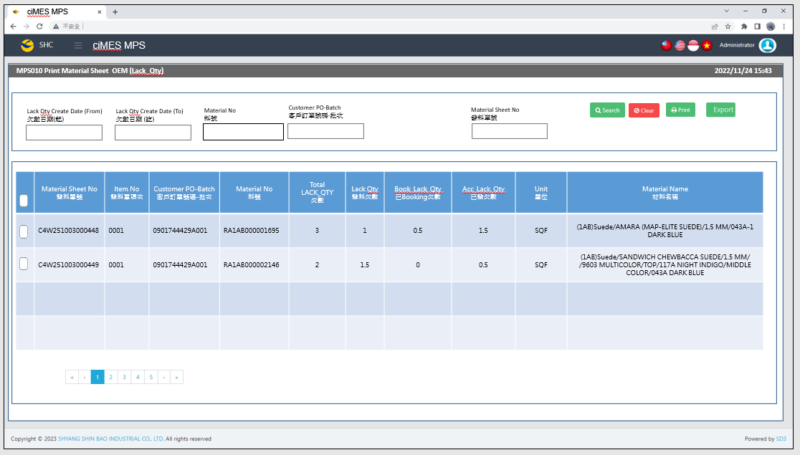

[圖MPS010_1] Main Page主畫面

|  |  |  |  |  |  |  |
| --- | --- | --- | --- | --- | --- | --- |
| Program header 程式標頭 | | | | | | |
| NO | 顯示名稱 | 必填 | 唯讀 | 存改 | 對應欄位 | 說明 |
|  | Title  標題 |  | V |  | CAPTION | String  If there is no get data, please show “Right Name”  SELECT T2.LANGUAGE, T2.CAPTION  FROM [MES_SEC_RIGHT] AS T1  JOIN [MES_MENU_ITEM] AS T2  ON T1.SEC_RIGHT_SID = T2.SEC_RIGHT_SID  WHERE T1.GROUPRIGHTS =  'MPS_Print.Material.Sheet.OEM.LackQty' --(Right Name) |
|  | System Time  系統時間 |  | V |  | Show current server time | Datetime  yyyy/MM/dd HH:mm |

|  |  |  |  |  |  |  |
| --- | --- | --- | --- | --- | --- | --- |
| Operation button 操作按鈕 | | | | | | |
| NO | 顯示名稱 | 必填 | 唯讀 | 存改 | 對應欄位 | 說明 |
|  | Search  搜尋 |  |  |  |  | Required「Lack Qty Create Date (from~to)」  or「Customer PO-Batch」  or 「Material No」  or「Material Sheet No」  to search |
|  | Clear  清除 |  |  |  |  | Clear Search Condition and Results |
|  | Print  列印 |  |  |  |  | Print the select row data |
|  | Export  匯出 |  |  |  |  | Export searched gridview data to Excel |

|  |  |  |  |  |  |  |
| --- | --- | --- | --- | --- | --- | --- |
| Search Condition 搜尋條件 | | | | | | |
| NO | 顯示名稱 | 必填 | 唯讀 | 存改 | 對應欄位 | 欄位型態  欄位說明 |
|  | Lack Qty Create Date (From)  發料單建立日(起) |  |  | V | Filter Lack Qty Create Date column (LACK_DATE) | String  yyyy/MM/dd |
|  | Lack Qty Create Date (To)  發料單建立日(訖) |  |  | V | Filter Lack Qty Create Date column  (LACK_DATE) | String  yyyy/MM/dd |
|  | Material No  料號 |  |  | V | Filter MATERIALNO column | String |
|  | Customer PO-Batch  客戶訂單號碼-批次 |  |  | V | Filter Customer PO-Batch column | String  If chkPrecise is checked  Must exactly matched  Remove % in Search SQL |
|  | ~~Material Sheet Type~~  ~~發料單類別~~ |  |  | ~~V~~ | ~~Filter ISSUE_TYPE column~~ | ~~Dropdown list~~  ~~select REMARK01, REMARK01 + '-' + REMARK02 AS Material_Sheet_Type~~  ~~from MES_WPC_EXTENDITEM~~  ~~where CLASS = 'ISSUE_TYPE'~~  ~~and (REMARK03 <> 'Y' or REMARK03 is null )~~  ~~order by REMARK01~~  ~~Add a Null in Dropdown list~~ |
|  | Material Sheet No  發料單號 |  |  | V | Filter C_MATERIAL_SHEET_NO column | String |
|  | Precise Query  精準比對 |  |  | V |  | Check Box : chkPrecise (default : not cheched)  If chkPrecise is checked  Filter Customer PO-Batch column  Must exactly matched  (Remove % in Search SQL Ex : PO_BATCH like '090007695001-1' ) |

|  |  |  |  |  |  |  |
| --- | --- | --- | --- | --- | --- | --- |
| Search 搜尋 | | | | | | |
| NO | 顯示名稱 | 必填 | 唯讀 | 存改 | 對應欄位 | 欄位型態  欄位說明 |
|  | Selector  選擇器 |  |  | V |  | Check Box |
|  | Material Sheet No  發料單號 |  | V |  | C_MATERIAL_SHEET_NO | String |
|  | Item No  發料單項次 |  | V |  | ITEM_NO | String |
|  | Customer PO-NO  客戶訂單號碼 |  | V |  | PO_NO | String |
|  | Material No  料號 |  | V |  | MATERIALNO | String |
|  | Total LACK_QTY  欠數 |  | V |  | LACK_QTY | Numeric |
|  | Lack Qty  發料欠數 |  | V |  | LACK_QTY_now | Numeric |
|  | Book_Lack_Qty  已Booking欠數 |  | V |  | BOOK_LACK_QTY | Numeric |
|  | Acc_Lack_Qty  已發欠數 |  | V |  | ACC_LACK_QTY | Numeric |
|  | Unit  單位 |  | V |  | UNIT | String |
|  | Material Name  材料名稱 |  | V |  | MATERIAL_SPEC | String |
| 程式邏輯說明：  填入Material Sheet Create Date 或 Customer PO-Batch後(擇一必填)，點選 [Search搜尋] 按鈕，即可帶出資料。  (display 4 rows/page in gridview)  SQL：  SELECT MATERIAL_SHEET_NO C_MATERIAL_SHEET_NO  , ITEM_NO, t1.PO_NO, t1.MATERIALNO  , LACK_QTY, LACK_QTY_now, Isnull(BOOK_LACK_QTY,0) BOOK_LACK_QTY , Isnull(ACC_LACK_QTY,0) ACC_LACK_QTY  , t1.UNIT , t3.MATERIAL_SPEC  FROM (  select a2.MATERIAL_SHEET_NO, ITEM_NO, PO_NO, MATERIALNO  , LACK_QTY  , ( LACK_QTY - Isnull(BOOK_LACK_QTY,0) - Isnull(ACC_LACK_QTY,0) ) LACK_QTY_now  , Isnull(BOOK_LACK_QTY,0) BOOK_LACK_QTY , Isnull(ACC_LACK_QTY,0) ACC_LACK_QTY  , UNIT , a2.PURCHASE_NO  from ERP_OSISSUE a1  inner join ERP_OSISSUE_DTL a2 on a1.MATERIAL_SHEET_NO = a2.MATERIAL_SHEET_NO  where 1 = 1  and PURCHASE_TYPE = 'ZP10'  and trim(ITEM_NO) <> '0' and trim(ITEM_NO) <> '0000'  and (a1.DELETE_FLAG <>'X' or a1.DELETE_FLAG is null )  and a2.LACK_DATE >= '2025/10/01' -- (Lack Qty Create Date (From))  and a2.LACK_DATE <= DATEADD(DAY, 1, '2025/10/31') -- (Lack Qty Create Date (To) ) + 1  and a2.PO_NO like '0901029081001%' -- (Customer PO-Batch)  and a2.MATERIALNO like 'AA%' -- (Material No)  ) t1  inner join dbo.ERP_PO t4 on t1.PURCHASE_NO = t4.PURCHASE_NO  inner join dbo.ERP_SOBATCH t2 on t4.PO_BATCH = t2.PO_BATCH  inner join dbo.ERP_MATERIAL t3 on t1.MATERIALNO = t3.MATERIALNO  WHERE ( LACK_QTY <> 0 and LACK_QTY is not NULL)  --and MATERIAL_SHEET_NO = 'JW2505200002' -- Material Sheet No  ORDER BY C_MATERIAL_SHEET_NO desc | | | | | | |

|  |  |  |  |  |  |  |
| --- | --- | --- | --- | --- | --- | --- |
| Print列印 | | | | | | |
| NO | 顯示名稱 | 必填 | 唯讀 | 存改 | 對應欄位 | 欄位型態  欄位說明 |
|  |  |  |  |  |  |  |
| 程式邏輯說明：  選擇資料列後，點選列印，印出發料單(A4中三刀)，邏輯如下  Always Print「**Regular Material Form – No Size Material」**  **4 Material Form in 1 page** | | | | | | |



[圖MPS010_2] Regular Material Form，A4中三刀，示意圖

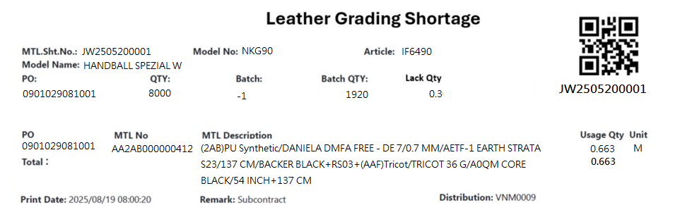

[圖MPS010_3] Regular Material Form – No Size Material

|  |  |  |  |  |  |  |
| --- | --- | --- | --- | --- | --- | --- |
| Print Regular Material Form – No Size Material 列印一般發料單 – 無尺寸發料單 | | | | | | |
| NO | 顯示名稱 | 必填 | 唯讀 | 存改 | 對應欄位 | 欄位型態  欄位說明 |
|  | ~~Form Title Type~~ |  |  |  | ~~"("+ISSUE_TYPE+") "+REMARK05~~ | ~~String~~ |
| ~~SQL for Type~~  ~~-- If REMARK05 = Null or Empty, No need to show Form Title Type~~  ~~select t1.ISSUE_TYPE, t2.REMARK05~~  ~~from dbo.ERP_ISSUE t1~~  ~~inner join MES_WPC_EXTENDITEM t2~~  ~~on t2.CLASS = 'ISSUE_TYPE'~~  ~~and t1.ISSUE_TYPE = t2.REMARK01~~  ~~where t1.C_MATERIAL_SHEET_NO = 'C4W251003000448' --(User select row)~~ | | | | | | |
|  | ~~Kind~~  ~~材料類別~~ |  |  |  |  | ~~String~~ |
| ~~SQL for kind~~  ~~-- Get Material Sheet Kind : by C_MATERIAL_SHEET_NO~~  ~~select top 1 t1.KIND~~  ~~FROM~~  ~~(~~  ~~select PUF~~  ~~from CST_MPS_PICKFORM_DETAIL~~  ~~where C_MATERIAL_SHEET_NO = 'C4W251003000448' --(User select row)~~  ~~) t0~~  ~~inner join dbo.CST_MPS_PICKFORM t1 on t0.PUF = t1.PUF and t1.[STATUS] <> 'Terminate'~~  **~~-- IF No Data found, Get Kind by following SQL again~~**  ~~select top 1 t1.KIND~~  ~~FROM~~  ~~(~~  ~~select top 1 PO_BATCH , MATERIALNO~~  ~~from ERP_ISSUE_DTL~~  ~~where C_MATERIAL_SHEET_NO = 'C4W251003000448' --(User select row)~~  ~~and [STATUS] <> 'D'~~  ~~) t0~~  ~~inner join dbo.CST_MPS_PICKFORM t1 on t0.PO_BATCH = t1.PO_BATCH and t1.[STATUS] <> 'Terminate'~~  ~~inner join dbo.CST_MPS_PICKFORM_DETAIL t2 on t1.PUF = t2.PUF and t2.MATERIALNO = t0.MATERIALNO~~ | | | | | | |
|  | Leather Grading Shortage |  |  |  |  | String |
|  | ~~Shipping Location~~  ~~出貨地點~~ |  |  |  | ~~SHIPPING_LOCATION~~ | ~~String~~ |
| SQL  ~~select top 1 t1.SHIPPING_LOCATION~~  ~~from [dbo].[ERP_SO] t1~~  ~~inner join [dbo].[ERP_SOBatch] t2 on t1.SO_NO = t2.SO_NO~~  ~~where t2.PO_BATCH = '0901744429A001'~~ | | | | | | |
|  | C.MTL. Sht. No.  合併發料單號 |  |  |  | User selected row | String |
|  | Model No  型體編號 |  |  |  | MODEL_NO | String |
|  | Article  Article |  |  |  | ARTICLE | String |
|  | Model Name  型體名稱 |  |  |  | MODEL_NAME | String |
|  | PO  訂單編號 |  |  |  | PO_NO | String |
|  | Batch  批次 |  |  |  | BATCH | String |
|  | Batch Qty  批次數量 |  |  |  | QUANTITY | Numeric |
|  | Lack Qty  發料欠數 |  |  |  | LACK_QTY_now | Numeric |
| SQL：  -- 訂單批次基本資訊 (根據 : C_MATERIAL_SHEET_NO 發料單號)  -- Get PO Batch information ( by C_MATERIAL_SHEET_NO、PO_BATCH、MATERIALNO、ITEM_NO )  SELECT top 1 b.PO_NO , t4.PO_BATCH , REPLACE(t4.PO_BATCH, b.PO_NO,'') BATCH  , b.QUANTITY, c.ARTICLE , c.MODEL_NAME , c.MODEL_NO  , ( LACK_QTY - BOOK_LACK_QTY - ACC_LACK_QTY ) LACK_QTY_now  FROM ( select * from dbo. ERP_OSISSUE_DTL  where MATERIAL_SHEET_NO = 'JW2505200001' --(User select row)  and PO_NO = '0901029081001' --(User select row)  and MATERIALNO = 'AA2AB000000412' --(User select row)  and ITEM_NO = '0001' --(User select row)  ) a  inner join dbo.ERP_PO t4 on a.PURCHASE_NO = t4.PURCHASE_NO  left join dbo.ERP_SOBATCH b on t4.PO_BATCH = b.PO_BATCH  left join dbo.ERP_SO c on b.PO_NO = c.PO_NO | | | | | | |
|  | PO QTY  訂單數量 |  |  |  | QUANTITY | Numeric |
| SQL：  -- 訂單Qty (根據 : PO_NO)  -- Get PO information ( by PO_NO )  SELECT sum(QUANTITY) QUANTITY  FROM ERP_SOBATCH  where PO_NO = '0901029081001' --(User select row) | | | | | | |
|  | PO  訂單號碼 |  |  |  | PO_NO | String |
|  | MTL No  料號 |  |  |  | MATERIALNO | String |
|  | Usage Qty  領用量 |  |  |  | QUANTITY | Numeric |
|  | Unit  單位 |  |  |  | UNIT | String |
|  | ~~MTL. Sht. No~~  ~~發料單號~~ |  |  |  | ~~MATERIAL_SHEET_NO~~ | ~~String~~ |
|  | ~~Part No~~  ~~部位~~ |  |  |  | ~~PART_NO_NAME~~ | ~~String~~ |
|  | MTL Description  材料名稱 |  |  |  | MATERIAL_SPEC | String |
| SQL：  -- 面部材料 : 如果2個部位使用相同的原材料，會是列印在1張發料單號 (發料單號相同) ， 使用string_AGG 合併部位資訊在一個欄位  --NO SIZE MATERIAL : data list ( by C_MATERIAL_SHEET_NO )  SQL01  Select TOP 1 min(a.PO_NO) PO_NO , a.MATERIALNO , min(b.MATERIAL_SPEC) MATERIAL_SPEC , sum(a.QUANTITY) QUANTITY  ~~, min(a.MATERIAL_SHEET_NO) MATERIAL_SHEET_NO~~ , min(a.UNIT) UNIT ~~, MAX(a.PART_NO ) + '-' + MAX(a.PART_NAME) PART_NO_NAME~~  FROM dbo.ERP_OSISSUE_DTL a  left join dbo.ERP_MATERIAL b on a.MATERIALNO = b.MATERIALNO  where MATERIAL_SHEET_NO = 'JW2505200001' --(User select row)  and PO_NO = '0901029081001' --(User select row)  and a.MATERIALNO = 'AA2AB000000412' --(User select row)  and ITEM_NO = '0001' --(User select row)  group by a.MATERIALNO  order by MATERIALNO | | | | | | |
|  | Print Date  列印日期 |  |  |  | User print date and time  (Get from server side) | DateTime  yyyy/MM/dd HH:mm:ss |
|  | ~~MTL Usage Dep~~  ~~領料單位~~ |  |  |  | ~~DEPT_DESC~~ | ~~String~~ |
|  | ~~WO Work Center~~  ~~工單工作中心~~ |  |  |  | ~~DEPT_DESC_WorkCenter~~ | ~~String~~  ~~If DEPT_DESC_WorkCenter is Empty, hide this column~~ |
| SQL：  ~~EXEC dbo.PRD_GET_MPS_Dispatch_WorkCenter_ISSUEform 'C4W251003000448'~~ | | | | | | |
|  | Remark  備註 |  |  |  | Show "Subcontract" | String |
|  | Distribution  領料部門 |  |  |  | SUPPLIER_CODE | String |
| SQL：  Select min(c.SUPPLIER_CODE) SUPPLIER_CODE  FROM ( select * from dbo.ERP_OSISSUE_DTL  where MATERIAL_SHEET_NO = 'JW2505200001' ----(User select row)  ) a  inner join dbo.ERP_OSISSUE c on a.MATERIAL_SHEET_NO = c.MATERIAL_SHEET_NO  group by a.MATERIALNO | | | | | | |
|  | ~~Production Line~~  ~~成型線別~~ |  |  |  | ~~AS_CELL~~ | ~~String~~ |
| ~~SQL：~~  ~~-- Production Line (by PO_Batch)~~  ~~SELECT AS_CELL~~  ~~FROM ERP_PROD_SCHED~~  ~~WHERE PO_Batch = '0901744429A001'~~ | | | | | | |
|  | | | | | | |

* 1. **「MPS101 Print Pickup Form」MPS101 列印取料單**
  2. 程式名稱：同標題 (Right Name: MPS_Print.Pickup.Form)
  3. 功能目的：查詢/列印
  4. 使用部門：
  5. 程式說明：

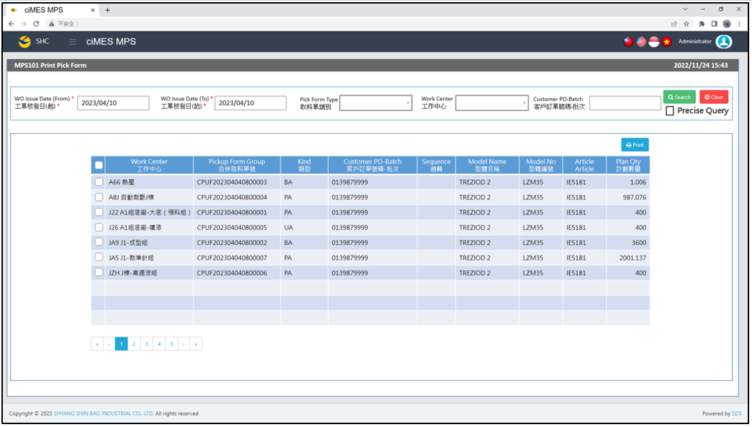

[圖MPS101_1] Main Page主畫面

|  |  |  |  |  |  |  |
| --- | --- | --- | --- | --- | --- | --- |
| Program header 程式標頭 | | | | | | |
| NO | 顯示名稱 | 必填 | 唯讀 | 存改 | 對應欄位 | 說明 |
|  | Title  標題 |  | V |  | CAPTION | String  If there is no get data, please show “Right Name”  SELECT T2.LANGUAGE, T2.CAPTION  FROM [MES_SEC_RIGHT] AS T1  JOIN [MES_MENU_ITEM] AS T2  ON T1.SEC_RIGHT_SID = T2.SEC_RIGHT_SID  WHERE T1.GROUPRIGHTS = 'MPS_Print.Pickup.Form' --(Right Name) |
|  | System Time  系統時間 |  | V |  | Show current server time | Datetime  yyyy/MM/dd HH:mm |

|  |  |  |  |  |  |  |
| --- | --- | --- | --- | --- | --- | --- |
| Operation button 操作按鈕 | | | | | | |
| NO | 顯示名稱 | 必填 | 唯讀 | 存改 | 對應欄位 | 說明 |
|  | Search  搜尋 |  |  |  |  | Required「WO Issue Date (From)  」and「WO Issue Date (To)」to search |
|  | Clear  清除 |  |  |  |  | Clear Search Condition and Results |
|  | Print  列印 |  |  |  |  | Print the select row data |

|  |  |  |  |  |  |  |
| --- | --- | --- | --- | --- | --- | --- |
| Search Condition 搜尋條件 | | | | | | |
| NO | 顯示名稱 | 必填 | 唯讀 | 存改 | 對應欄位 | 欄位型態  欄位說明 |
|  | WO Issue Date (From)  工單核發日(起) | V |  | V | Filter WO Issue Date column | String  yyyy/MM/dd  Default：Today |
|  | WO Issue Date (To)  工單核發日(訖) | V |  | V | Filter WO Issue Date column | String  yyyy/MM/dd  Default：Today |
|  | Pickup Form Type  取料單類別 |  |  | V | Filter Pickup Form Type column | Dropdown list  SELECT REMARK01 FROM MES_WPC_EXTENDITEM  WHERE CLASS = 'PICKFORM_TYPE'  ORDER BY REMARK01 |
|  | Work Center  工作中心 |  |  | V | Filter Work Center column | Dropdown list  SELECT DEPT_ID, DEPT_ID + '-' + DEPT_DESC AS DEPT_ID_DESC  FROM [ERP_ORGANIZATION]  ORDER BY DEPT_ID |
|  | Customer PO-Batch  客戶訂單號碼-批次 | V |  | V | Filter Customer PO-Batch column | String  If chkPrecise is checked  Must exactly matched  Remove % in Search SQL |
|  | Precise Query  精準比對 |  |  | V |  | Check Box : chkPrecise (default : not cheched)  If chkPrecise is checked  Filter Customer PO-Batch column  Must exactly matched  (Remove % in Search SQL Ex : PO_BATCH like '090007695001-1' ) |

|  |  |  |  |  |  |  |
| --- | --- | --- | --- | --- | --- | --- |
| Search 搜尋 | | | | | | |
| NO | 顯示名稱 | 必填 | 唯讀 | 存改 | 對應欄位 | 欄位型態  欄位說明 |
|  | Selector  選擇器 |  |  | V |  | Check Box |
|  | Work Center  工作中心 |  | V |  | DEPT_DESC | String |
|  | Pickup Form Group  合併取料單號 |  | V |  | PUFGROUP | String |
|  | Kind  類型 |  | V |  | KIND | String |
|  | Customer PO-Batch  客戶訂單號碼-批次 |  | V |  | PO_BATCH | String |
|  | Sequence  迴轉 |  | V |  | SEQUENCE | String |
|  | Model Name  型體名稱 |  | V |  | MODEL_NAME | String |
|  | Model No  型體編號 |  | V |  | MODEL_NO | String |
|  | Article  Article |  | V |  | ARTICLE | String |
|  | Plan Qty  計劃數量 |  | V |  | PLAN_QTY | Numeric |
| 程式邏輯說明：  點選 [Search搜尋] 按鈕，依照User填入的搜尋條件(若有)，即可帶出資料。  SQL：  SELECT　max(a.DEPT_ID_UA) + ' ' + max(d.DEPT_DESC) AS DEPT_DESC, a.PUFGROUP, max(T3.PO_BATCH) AS PO_BATCH, max(a.KIND) KIND,  max(a.SEQUENCE) AS SEQUENCE, max(c.MODEL_NAME) AS MODEL_NAME, max(c.MODEL_NO) AS MODEL_NO,  max(c.ARTICLE) AS ARTICLE, sum(b.PLAN_QTY) AS PLAN_QTY  FROM (  select T1.PUFGROUP,  CASE when max(T3.COMBINE_PO_BATCH) <> ''  THEN max(T3.COMBINE_PO_BATCH)  ELSE max(T1.PO_BATCH)  END AS PO_BATCH  FROM (select * from dbo.CST_MPS_PICKFORM  where PO_BATCH like '0132990865%' or COMBINE_PO_BATCH = '0132990865' ) T1  inner join dbo.CST_MPS_PICKFORM_DETAIL T2 on T1.PUF = T2.PUF  inner join dbo.ERP_ISSUE T3 on T2.C_MATERIAL_SHEET_NO = T3.C_MATERIAL_SHEET_NO  where T1.PRINT_CNT = 0  and T1.[STATUS] <> 'Terminate'  --and T1.KIND = 'PA' -- (Pickup Form Type)  --and T1.DEPT_ID_UA like 'A66' -- (Work Center)  ~~--and ( T1.PO_BATCH like '0132837594%' or T3.COMBINE_PO_BATCH = '0132837594')~~ -- (Customer PO-Batch)  --and T1.WO_ISSUE_DATE >= '2023/05/01' -- (WO Issue Date (From))  --and T1.WO_ISSUE_DATE <= DATEADD(DAY, 1, '2023/07/31') -- (WO Issue Date (To)) +1  group by T1.PUFGROUP  ) AS T3  , dbo.CST_MPS_PICKFORM AS a, dbo.CST_MPS_PICKFORM_DETAIL AS b, dbo.ERP_SOBATCH AS c, dbo.ERP_ORGANIZATION AS d  where T3.PUFGROUP = a.PUFGROUP  and a.PUF = b.PUF  and a.PO_BATCH = c.PO_BATCH  and a.DEPT_ID_UA = d.DEPT_ID  and a.PRINT_CNT = 0  group by a.PUFGROUP  order by kind, PUFGROUP | | | | | | |

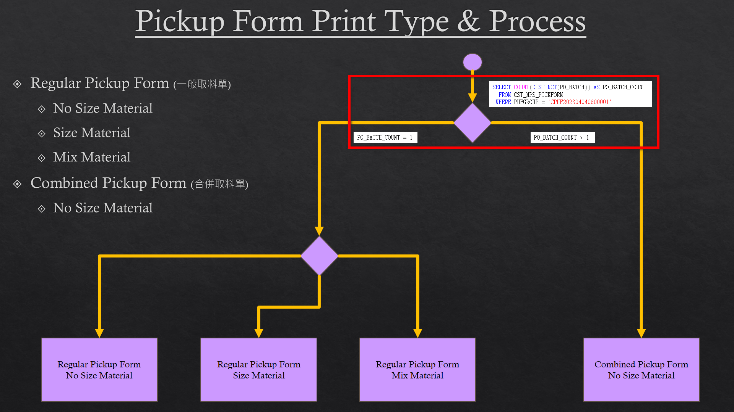

[圖MPS101_2] Pickup Form Print Type & Process，Check Regular or Combined Pickup Form

|  |  |  |  |  |  |  |
| --- | --- | --- | --- | --- | --- | --- |
| Print列印 | | | | | | |
| NO | 顯示名稱 | 必填 | 唯讀 | 存改 | 對應欄位 | 欄位型態  欄位說明 |
|  |  |  |  |  |  |  |
| 程式邏輯說明：  選擇資料列後，點選列印，印出取料單，邏輯如下  First Step: Check is「A：Regular Pickup Form」or「B：Combined Pickup Form」  If PO_BATCH_COUNT = 1，Print「**Regular Pickup Form」**  If PO_BATCH_COUNT > 1，Print「**Combined Pickup Form」**  SQL：  SELECT COUNT(DISTINCT(PO_BATCH)) AS PO_BATCH_COUNT  FROM CST_MPS_PICKFORM  WHERE PUFGROUP = 'CPUF202304040800001' | | | | | | |

**A：Print Regular Pickup Form 列印一般取料單**：

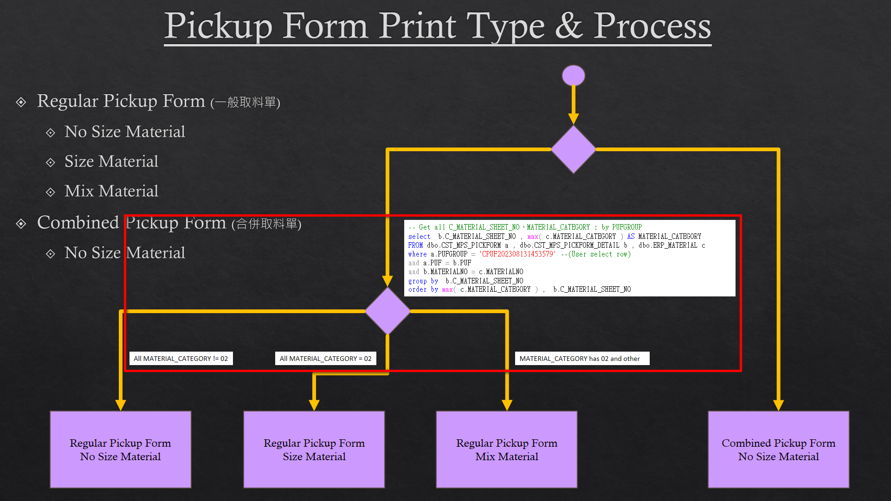

[圖MPS101_3] Pickup Form Print Type & Process，Check whether there is Size Run

|  |  |  |  |  |  |  |
| --- | --- | --- | --- | --- | --- | --- |
| Print Regular Pickup Form列印一般取料單 | | | | | | |
| NO | 顯示名稱 | 必填 | 唯讀 | 存改 | 對應欄位 | 欄位型態  欄位說明 |
|  |  |  |  |  |  |  |
| 程式邏輯說明：  Regular Material Form need check is Size Run or not Size Run or Mix Material  If All MATERIAL_CATEGORY = 02，Print「**Regular Pickup Form – Size Material」**  If All MATERIAL_CATEGORY != 02，Print「**Regular Pickup Form – No Size Material」**  If MATERIAL_CATEGORY has 02 and other，Print「**Regular Pickup Form – Mix Material」**  SQL：  -- Get all C_MATERIAL_SHEET_NO、MATERIAL_CATEGORY : by PUFGROUP  select b.C_MATERIAL_SHEET_NO , max( c.MATERIAL_CATEGORY ) AS MATERIAL_CATEGORY  FROM dbo.CST_MPS_PICKFORM a , dbo. CST_MPS_PICKFORM_DETAIL b , dbo.ERP_MATERIAL c , dbo.ERP_ISSUE_DTL d  where a.PUFGROUP = 'CPUF202308131453579' --(User select row)  and a.PUF = b.PUF  and b.MATERIALNO = c.MATERIALNO  and b.C_MATERIAL_SHEET_NO = d.C_MATERIAL_SHEET_NO  and b.MATERIALNO = d.MATERIALNO  and d.STATUS <> 'D' -- (Always is D)  group by b.C_MATERIAL_SHEET_NO  order by max( c.MATERIAL_CATEGORY ) , b.C_MATERIAL_SHEET_NO | | | | | | |

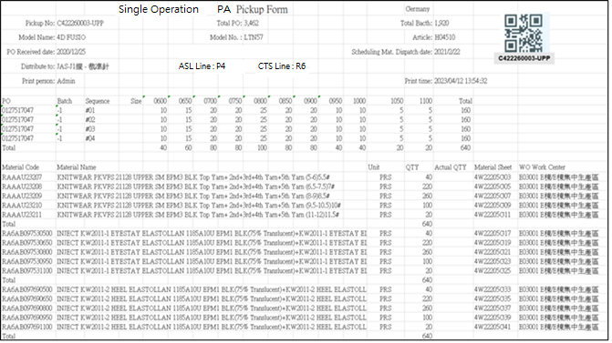

[圖MPS101_4] Regular Pickup Form – No Size Material

|  |  |  |  |  |  |  |
| --- | --- | --- | --- | --- | --- | --- |
| Print Regular Pickup Form – No Size Material 列印一般取料單-無尺寸料號 | | | | | | |
| NO | 顯示名稱 | 必填 | 唯讀 | 存改 | 對應欄位 | 欄位型態  欄位說明 |
|  | Form Title Type |  |  |  | TYPE_SPECIAL | String |
|  | Form Title Kind  表單類型 |  |  |  | KIND | String |
|  | Shipping Location  出貨地點 |  |  |  | SHIPPING_LOCATION | String |
| SQL  select top 1 t1.SHIPPING_LOCATION  from [dbo].[ERP_SO] t1  inner join [dbo].[ERP_SOBatch] t2 on t1.SO_NO = t2.SO_NO  where t2.PO_BATCH = '0132957503-4' | | | | | | |
|  | Pickup No  取料單編號 |  |  |  | User selected row | String |
|  | Total Bacth  批次數量 |  |  |  | QUANTITY | Numeric |
|  | Model Name  型體名稱 |  |  |  | MODEL_NAME | String |
|  | Model No  型體編號 |  |  |  | MODEL_NO | String |
|  | Article  Article |  |  |  | ARTICLE | String |
|  | PO Received Date  訂單接單日 |  |  |  | RECEIVED_DATE | Date  yyyy-MM-dd |
|  | PO  訂單號碼 |  |  |  | PO_No | String |
|  | Batch  批次 |  |  |  | BATCH | String |
| SQL：  -- SQL01  SELECT a.TYPE_SPECIAL , a.KIND , b.PO_NO , REPLACE(a.PO_BATCH, b.PO_NO,'') AS BATCH , a.PO_BATCH , b.QUANTITY, c.ARTICLE , c.MODEL_NAME , c.MODEL_NO , a.[SEQUENCE] , a.DEPT_ID , c.RECEIVED_DATE  FROM ( select top 1 TYPE_SPECIAL , PO_BATCH , [SEQUENCE] , DEPT_ID , KIND from dbo.CST_MPS_PICKFORM  where PUFGROUP = 'CPUF202302231300001' ) a -- (User select row)  left join dbo.ERP_SOBATCH b on a.PO_BATCH = b.PO_BATCH  left join dbo.ERP_SO c on b.PO_NO = c.PO_NO | | | | | | |
|  | Total PO  訂單數量 |  |  |  | PO_QUANTITY | Numeric |
| SQL：  -- Get PO Total Qty ( by PO_NO )  SELECT sum(QUANTITY) AS PO_QUANTITY  FROM dbo.ERP_SOBATCH  where PO_NO = '0127517048' -- (SQL01's PO_NO) | | | | | | |
|  | ~~Mat. Standard onhand date~~  ~~標準材料到廠日~~ |  |  |  | ~~Mat_Standard_Onhand_Date~~ | ~~Date~~  ~~yyyy-MM-dd~~  ~~If Mat_Standard_Onhand_Date = 00000000, let it remain empty.~~ |
|  | Scheduling Mat. Dispatch date  配送日期 |  |  |  | Scheduling_Mat_Dispatch_Date | Date  yyyy-MM-dd  If Scheduling_Mat_Dispatch_Date = 00000000, let it remain empty. |
| SQL：  ~~SELECT CASE t1.KIND~~  ~~WHEN 'AA' THEN Upper_Mat_Plan_On_Hand~~  ~~WHEN 'PA' THEN Upper_Mat_Plan_On_Hand~~  ~~WHEN 'UA' THEN Stitching_Mat_Plan_On_Hand~~  ~~WHEN 'BA' THEN Bottom_Mat_Plan_On_Hand~~  ~~WHEN 'FA' THEN Assembly_Mat_Plan_On_Hand~~  ~~ELSE ''~~  ~~END Mat_Standard_Onhand_Date~~  ~~from dbo.CST_MPS_PICKFORM t1~~  ~~inner join dbo.ERP_PROD_SCHED t2 on t1.PO_BATCH = t2.PO_BATCH~~  ~~where t1.PUFGROUP = 'CPUF202302231300073'~~  SELECT CASE t1.KIND  WHEN 'AA' THEN Upper_Mat_Plan_On_Hand  WHEN 'PA' THEN Upper_Mat_Plan_On_Hand  WHEN 'UA' THEN Stitching_Mat_Plan_On_Hand  WHEN 'BA' THEN Bottom_Mat_Plan_On_Hand  WHEN 'FA' THEN Assembly_Mat_Plan_On_Hand  ELSE ''  END Mat_Standard_onhand_date  , CASE t1.KIND  WHEN 'AA' THEN t2.CUT_START_DATE  WHEN 'PA' THEN t2.CUT_START_DATE  WHEN 'UA' THEN t2. ST_START_DATE  WHEN 'BA' THEN t2.SF_START_DATE  WHEN 'FA' THEN t2.AS_START_DATE  ELSE ''  END Scheduling_Mat_Dispatch_Date  from dbo.CST_MPS_PICKFORM t1  left join dbo.ERP_PROD_SCHED t2 on t1.PO_BATCH = t2.PO_BATCH  where t1.PUFGROUP = 'CPUF202310071463398' | | | | | | |
|  | ~~Scheduling Mat. Dispatch date~~  ~~配送日期~~ |  |  |  | ~~Scheduling_Mat_Dispatch_Date~~ | ~~Date~~  ~~yyyy-MM-dd~~ |
| SQL：  -- Scheduling Mat. Dispatch date 配送日期 (SAP 拋給MES)  ~~SELECT min(T4.ESTIMATED_START_DATE) AS Scheduling_Mat_Dispatch_Date~~  ~~FROM dbo.CST_MPS_PICKFORM T1 , dbo.CST_MPS_PICKFORM_DETAIL T2 , dbo.ERP_ISSUE_DTL T3 , dbo.ERP_WO T4~~  ~~where T1.PUFGROUP = 'CPUF202302231300001' -- (User select row)~~  ~~and T1.PUF = T2.PUF~~  ~~and T2.MATERIALNO = T3.MATERIALNO~~  ~~and T2.C_MATERIAL_SHEET_NO = T3.C_MATERIAL_SHEET_NO~~  ~~and T3.WO_GROUP = T4.WO_GROUP~~  ~~and T4.PROCESS_TYPE = T1.KIND~~ | | | | | | |
|  | Distribute to  分發給 |  |  |  | DEPT_DESC | String |
| SQL：  EXEC dbo.PRD_GET_MPS_Dispatch_WorkCenter_PickupForm 'CPUF202302231300001' | | | | | | |
|  | ASL Line  成型線別 |  |  |  | AS_CELL | String |
|  | CTS Line  針車線別 |  |  |  | ST_TEAM | String |
|  | Print Person  列印人員 |  |  |  | (Login User_Account) | String |
|  | Print Time  列印時間 |  |  |  | User print date and time  (Get from server side) | String  yyyy-MM-dd HH:mm:ss |
| SQL：  -- Production Line (by PO_Batch)  SELECT AS_CELL , ST_TEAM  FROM ERP_PROD_SCHED  WHERE PO_Batch = '0900058014001' | | | | | | |
|  | Sequence  迴轉數 |  |  |  | SEQUENCE | String |
|  | Size  尺寸 |  |  |  | (List All PO’s Size and Qty) | String |
|  | Total (Row)  加總 (每個PO) |  |  |  | SUM (Qty of PO) | Numeric |
| SQL：  -- Size Run Information SQL  -- If SEQUENCE only one number(e.g:#03), then start and end = 3  SELECT SEQUENCE , PO_SIZE , sum(QUANTITY) QUANTITY  FROM dbo.ERP_CYNO_DETAIL  where PO_BATCH = '0127517048' -- (SQL01's PO_BATCH)  and CAST(REPLACE(SEQUENCE, '#', '') AS INT) >= 1 -- (SQL01's SEQUENCE start) -- If Sequence no data, ignore this condition  and CAST(REPLACE(SEQUENCE, '#', '') AS INT) <= 4 -- (SQL01's SEQUENCE end) -- If Sequence no data, ignore this condition  group by SEQUENCE , PO_SIZE  order by SEQUENCE , PO_SIZE  IF No data found in above SQL (Size Run Information) :  Begin  --Check PUF Kind  If KIND = ‘AA’ (all gridview checked rows Kind = AA)  Begin  Need not print “Size Run Information” (leave empty)  Continue to execute subsequent programs -- keep print out all other PUF information  End    If KIND <> ‘AA’ (any one of gridview checked rows Kind <> AA)  Begin  Show alert message “PO: XXXXXXXXXX-X have no Size run data” – (from column : PO_No , BATCH)  Stop print & Exit program  End  END | | | | | | |
|  | Material Code  料號 |  |  |  | MATERIALNO | String |
|  | Material Name  材料名稱 |  |  |  | MATERIAL_SPEC | String |
|  | Unit  單位 |  |  |  | UNIT | String |
|  | QTY  數量 |  |  |  | PLAN_QTY | Numeric |
|  | Actual QTY  實際數量 |  |  |  | Let it remain empty | Numeric |
|  | Material Sheet  發料單號 |  |  |  | ~~MATERIAL_SHEET_NO~~  C_MATERIAL_SHEET_NO | String |
|  | WO Work Center  工單工作中心 |  |  |  | WO_Work_Center | String |
|  | Total  總計 |  |  |  | SUM(PLAN_QTY)  By every C_MATERIAL_SHEET_NO | Numeric |
| SQL：  -- Get all C_MATERIAL_SHEET_NO、Material Type (SA、非SA) : by PUFGROUP  **-- SQL01**  select b.C_MATERIAL_SHEET_NO , max( substring(b.MATERIALNO,1,2) )  FROM dbo.CST_MPS_PICKFORM a , dbo.CST_MPS_PICKFORM_DETAIL b , dbo.ERP_ISSUE_DTL d  where a.PUFGROUP = 'NCPUF20250802103004014W'  and a.PUF = b.PUF  and b.C_MATERIAL_SHEET_NO = d.C_MATERIAL_SHEET_NO  and b.MATERIALNO = d.MATERIALNO  and d.STATUS <> 'D' -- (Always is D)  group by b.C_MATERIAL_SHEET_NO  order by b.C_MATERIAL_SHEET_NO  -- Check TSH PA PUF (separate AA、RA material into different new pages , both need to print pickup form PUF header)  select Remark01 as Factory from MES_WPC_EXTENDITEM where CLASS = 'Factory'  If KIND = ‘PA’ and Factory = ‘2020’  Begin  Step1  --change **SQL01 data into SQL02、SQL03 (only add** MATERIALNO criteria**)**  -- SQL02  select b.C_MATERIAL_SHEET_NO , max( substring(b.MATERIALNO,1,2) )  FROM dbo.CST_MPS_PICKFORM a , dbo.CST_MPS_PICKFORM_DETAIL b , dbo.ERP_ISSUE_DTL d  where a.PUFGROUP = 'NCPUF20250802103004014W'  and a.PUF = b.PUF  and b.C_MATERIAL_SHEET_NO = d.C_MATERIAL_SHEET_NO  and b.MATERIALNO = d.MATERIALNO  and d.STATUS <> 'D' -- (Always is D)  and b.MATERIALNO like 'A%'  group by b.C_MATERIAL_SHEET_NO  order by b.C_MATERIAL_SHEET_NO  -- SQL03  select b.C_MATERIAL_SHEET_NO , max( substring(b.MATERIALNO,1,2) )  FROM dbo.CST_MPS_PICKFORM a , dbo.CST_MPS_PICKFORM_DETAIL b , dbo.ERP_ISSUE_DTL d  where a.PUFGROUP = 'NCPUF20250802103004014W'  and a.PUF = b.PUF  and b.C_MATERIAL_SHEET_NO = d.C_MATERIAL_SHEET_NO  and b.MATERIALNO = d.MATERIALNO  and d.STATUS <> 'D' -- (Always is D)  and b.MATERIALNO like 'R%'  group by b.C_MATERIAL_SHEET_NO  order by b.C_MATERIAL_SHEET_NO    Step2  Print PUF header + SQL02 data (for AA material)  (no need for PUF header if row count = 0)  New page  Print PUF header + SQL03 data (for RA material)  (no need for PUF header if row count = 0)  End  Else  Begin  --Still use **SQL01 data**  End    -- Loop all C_MATERIAL_SHEET_NO  -- Sum PLAN_QTY Total by every C_MATERIAL_SHEET_NO  SELECT distinct T1.MATERIALNO, T3.MATERIAL_SPEC, T3.UNIT, T1.PLAN_QTY, T1.C_MATERIAL_SHEET_NO,  ( ISNULL(t5.DEPT_ID , t2.DEPT_ID) + ' ' + t4.DEPT_DESC) WO_work_center  FROM dbo.CST_MPS_PICKFORM_DETAIL T1  left join dbo.ERP_ISSUE_DTL T2 on T1.C_MATERIAL_SHEET_NO = T2.C_MATERIAL_SHEET_NO and T1.MATERIALNO = T2.MATERIALNO  and T1.MATERIAL_SHEET_NO = T2.MATERIAL_SHEET_NO  inner join dbo.CST_MPS_PICKFORM T0 on T0.puf = T1.puf  left join ERP_ISSUE_DTL_Dept_DTL T5 on T5.C_MATERIAL_SHEET_NO = T1.C_MATERIAL_SHEET_NO  and T5.MATERIAL_SHEET_NO = T1.MATERIAL_SHEET_NO  and T5.MATERIALNO = T1.MATERIALNO  and T5.PO_BATCH = T0.PO_BATCH  and T5.Item_NO = T2.Item_NO  and T5.DEPT_ID = T1.DEPT_ID_Original  left join dbo.ERP_MATERIAL T3 on T2.MATERIALNO = T3.MATERIALNO and T1.MATERIALNO = T3.MATERIALNO  left join dbo.ERP_ORGANIZATION t4 on ISNULL(t5.DEPT_ID , t2.DEPT_ID) = t4.DEPT_ID  where T1.C_MATERIAL_SHEET_NO = 'C4W241212003338'  and T0.pufgroup = 'CPUF202412191593043' --User selected row  order by T1.MATERIALNO | | | | | | |
| Check if need to print “Strip information”  1. Only PA Pickup Form need to check  Form Title Kind = ‘PA’  select Remark01 as Factory from MES_WPC_EXTENDITEM where CLASS = 'Factory'  - Get materialno list need to print Strip information  SQL：  if Factory = '2020'  exit sub (do nothing, Factory 2020 need not to call procedure)  else  exec PRD_GET_MPS_Pickup_Form_AA_STRIP_MATERIALNO_List @PUFGroup = 'NCPUF202308221007059' ,@PO_BATCH = '0133474933'  - if no row return，need not to print  else  1. Print a separate line first  2. Loop all return rows  Begin  -- (call procedure PRD_GET_MPS_Pickup_Form_AA_STRIP_Info to get and print Strip information)  exec PRD_GET_MPS_Pickup_Form_AA_STRIP_Info @PUFGroup = 'NCPUF202308221007059'  ,@PO_BATCH = '0133474933' , @MATERIALNO = 'RAPAD000000124'  End   1. Only AA Pickup Form need to check “MT Instruction” (**Function MT Instruction**)   (Form Title Kind = ‘AA’)  Begin (**Function MT Instruction**)  --test data : TSH production or test DB , PO : 0900459401001 , PUF : CPUF202505130988199  Step 1 (insert into #tmp_Data )  SQL_Data:  SELECT distinct t1.PUFGROUP, t1.PO_BATCH, t2.MATERIALNO 'RA_MATERIALNO'  , t6.ISSUE_QUANTITY 'RA_Qty'  , t6.UNIT RA_Unit  , t5.MATERIALNO 'AA_MATERIALNO', t5.QUANTITY 'AA_Qty' , t5.UNIT 'AA_Unit'  , t8.MATERIAL_SPEC 'RA_MATERIAL_SPEC'  , t9.MATERIAL_SPEC 'AA_MATERIAL_SPEC'  into #tmp_Data  FROM CST_MPS_PICKFORM t1  INNER JOIN CST_MPS_PICKFORM_DETAIL t2  ON t1.PUF = t2.PUF  INNER JOIN ERP_ISSUE t3  ON t3.C_MATERIAL_SHEET_NO = t2.C_MATERIAL_SHEET_NO  inner join ERP_ISSUE_DTL t7  on t3.C_MATERIAL_SHEET_NO = t7.C_MATERIAL_SHEET_NO and (t7.[STATUS] <> 'D' or t7.[STATUS] is Null )  INNER JOIN ERP_ISSUE_DTL_Dept_DTL t4  ON t4.C_Material_Sheet_NO = t3.C_MATERIAL_SHEET_NO  and t4.PO_BATCH = t1.PO_BATCH  AND t4.Dept_ID = t1.DEPT_ID_UA  INNER JOIN ERP_WOBOM t6  ON t6.PO_BATCH = t4.PO_BATCH  AND t6.MATERIALNO = t2.MATERIALNO  INNER JOIN ERP_WO t5  ON t5.WO = t6.WO  Left join ERP_Material t8 on t2.MATERIALNO = t8.MATERIALNO  Left join ERP_Material t9 on t5.MATERIALNO = t9.MATERIALNO  WHERE (t1.PUFGROUP = 'CPUF202508010976244W' ) --user selected row  and t6.PROCESS_TYPE = 'AA'  order by t5.MATERIALNO , t1.PO_BATCH, t2.MATERIALNO  Step 2  IF no rows in #tmp_Data  Exit Function MT Instruction    [圖MPS101_4_MT_Instruction]  Step 3 (rows.count in #tmp_Data > 0)  print : MT Instruction header (Start from a new page)  (title part is almost same with Pickup form header ,  only ‘AA Pickup Form’ change to ‘MT Instruction’  and remove ‘Shipping Location’  and don’t need Reprint count information)    [圖MPS101_4_MT_Instruction_Header]    Step 4  Print size run information (If only 1 PO, don’t need Total row)    SQL_Size_Run_PO: (get all PO_Batch first)  select PO_BATCH  from dbo.CST_MPS_PICKFORM  where PUFGROUP = 'CPUF202505130988199'  group by PO_BATCH  order by PO_BATCH  Loop for all PO_Batch (SQL_Size_Run_PO)  Begin  SELECT PO_BATCH , PO_SIZE , sum(QUANTITY) QUANTITY  FROM dbo.ERP_CYNO_DETAIL  where PO_BATCH = '0900459401001'  group by PO_BATCH , PO_SIZE  order by PO_BATCH , PO_SIZE  End  Step 5 : Get #tmp_AA from #tmp_Data (get all AA_MATERIALNO)  select distinct AA_MATERIALNO  into #tmp_AA  from #tmp_Data  order by AA_MATERIALNO  Loop for all AA_MATERIALNO (#tmp_AA)  Begin  -- Start to print: MT Instruction Body PO information  (Separate a blank line from MT Instruction Header)  select PO_BATCH , max(AA_Qty) AA_Qty  , max(AA_MATERIAL_SPEC) AA_MATERIAL_SPEC , max(AA_UNIT) AA_UNIT  from #tmp_Data  where AA_MATERIALNO = 'AA2AB000001608' -- AA_MATERIALNO (#tmp_AA)  group by PO_BATCH  order by PO_BATCH    -- Round off the second decimal place (for Sub Total)  --If only 1 PO, don’t need Sub Total row  -- Start to print: MT Instruction Body RA material information  -- Get all distinct RA material first  -- SQL_RA  select distinct RA_MATERIALNO  from #tmp_Data  where AA_MATERIALNO = 'AA2AB000001608'  order by RA_MATERIALNO  Loop for all RA_MATERIALNO (SQL_RA)  BEGIN  select RA_MATERIALNO , RA_Unit , RA_MATERIAL_SPEC , PO_BATCH , RA_Qty  from #tmp_Data  where AA_MATERIALNO = 'AA2AB000001608'  and RA_MATERIALNO = 'RA2AB000000125'    -- Round off the second decimal place (for Sub Total)   1. 2 decimal places, unconditionally rounded down   5.423 => 5.4   1. 1 decimal places, unconditionally rounded up   (round up into 0.5 or 1)  5.4 => 5.5 (if 5.7 round up to 6.0)  --If only 1 PO, don’t need Sub Total row  END  End (--Loop for all AA_MATERIALNO)  -- Print Page No at end of A4 paper  End (**Function MT Instruction**)    [圖MPS101_4_1] Regular Pickup Form –No Size Material with strip material information   |  |  |  |  |  |  |  | | --- | --- | --- | --- | --- | --- | --- | |  | Material Name  料號名稱 |  |  |  | Material_SPEC | String  Put on top of grid table in one row | |  | Material Code  料號 |  |  |  | MATERIALNO | String | |  | Qty  數量 |  |  |  | Qty | Numeric | |  | Unit  單位 |  |  |  | Unit | String | |  | AA_MATERIALNO  AA料號 |  |  |  | AA_MATERIALNO | String | |  | MATERIAL Name  AA料號名稱 |  |  |  | AA_MATERIAL_SPEC | String | |  | AA_Qty  數量 |  |  |  | AA_Qty | Numeric | |  | AA_Unit  AA單位 |  |  |  | AA_Unit | String | |  | Size_Area  尺寸分布 |  |  |  | Size_Area | String | | | | | | | |
| After Print，Update [CST_MPS_PICKFORM].[PRINT_CNT] and [CST_MPS_PICKFORM].[PRINT_TIME] (use server time)  SQL：  update dbo.CST_MPS_PICKFORM  set PRINT_CNT = PRINT_CNT + 1  , PRINT_TIME = GETDATE() -- Server time，yyyy/MM/dd HH:mm:ss  where PUFGROUP = 'CPUF202304040800001' --(User select row) | | | | | | |

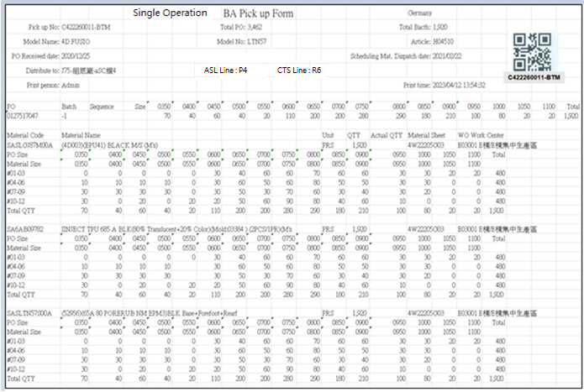

[圖MPS101_5] Regular Pickup Form – Size Material

|  |  |  |  |  |  |  |
| --- | --- | --- | --- | --- | --- | --- |
| Print Regular Pickup Form – Size Material 列印一般取料單-有尺寸料號 | | | | | | |
| NO | 顯示名稱 | 必填 | 唯讀 | 存改 | 對應欄位 | 欄位型態  欄位說明 |
|  | Form Title Type |  |  |  | TYPE_SPECIAL | String |
|  | Form Title Kind  表單類型 |  |  |  | KIND | String |
|  | Shipping Location  出貨地點 |  |  |  | SHIPPING_LOCATION | String |
| SQL  select top 1 t1.SHIPPING_LOCATION  from [dbo].[ERP_SO] t1  inner join [dbo].[ERP_SOBatch] t2 on t1.SO_NO = t2.SO_NO  where t2.PO_BATCH = '0132957503-4' | | | | | | |
|  | Pickup No  取料單編號 |  |  |  | User selected row | String |
|  | Total Bacth  批次數量 |  |  |  | QUANTITY | Numeric |
|  | Model Name  型體名稱 |  |  |  | MODEL_NAME | String |
|  | Model No  型體編號 |  |  |  | MODEL_NO | String |
|  | Article  Article |  |  |  | ARTICLE | String |
|  | PO Received Date  訂單接單日 |  |  |  | RECEIVED_DATE | Date  yyyy-MM-dd |
|  | PO  訂單號碼 |  |  |  | PO_No | String |
|  | Batch  批次 |  |  |  | BATCH | String |
| SQL：  -- SQL01  SELECT a.TYPE_SPECIAL , a.KIND , b.PO_NO , REPLACE(a.PO_BATCH, b.PO_NO,'') AS BATCH , a.PO_BATCH , b.QUANTITY, c.ARTICLE , c.MODEL_NAME , c.MODEL_NO , a.[SEQUENCE] , a.DEPT_ID , c.RECEIVED_DATE  FROM ( select top 1 TYPE_SPECIAL , PO_BATCH , [SEQUENCE] , DEPT_ID , KIND from dbo.CST_MPS_PICKFORM  where PUFGROUP = 'CPUF202302231300073' ) a -- (User select row)  left join dbo.ERP_SOBATCH b on a.PO_BATCH = b.PO_BATCH  left join dbo.ERP_SO c on b.PO_NO = c.PO_NO | | | | | | |
|  | Total PO  訂單數量 |  |  |  | PO_QUANTITY | Numeric |
| SQL：  -- Get PO Total Qty ( by PO_NO )  SELECT sum(QUANTITY) AS PO_QUANTITY  FROM dbo.ERP_SOBATCH  where PO_NO = '0127517047' -- (SQL01's PO_NO) | | | | | | |
|  | ~~Mat. Standard onhand date~~  ~~標準材料到廠日~~ |  |  |  | ~~Mat_Standard_Onhand_Date~~ | ~~Date~~  ~~yyyy-MM-dd~~  ~~If Mat_Standard_Onhand_Date = 00000000, let it remain empty.~~ |
|  | Scheduling Mat. Dispatch date  配送日期 |  |  |  | Scheduling_Mat_Dispatch_Date | Date  yyyy-MM-dd  If Scheduling_Mat_Dispatch_Date = 00000000, let it remain empty. |
| SQL：  ~~SELECT CASE t1.KIND~~  ~~WHEN 'AA' THEN Upper_Mat_Plan_On_Hand~~  ~~WHEN 'PA' THEN Upper_Mat_Plan_On_Hand~~  ~~WHEN 'UA' THEN Stitching_Mat_Plan_On_Hand~~  ~~WHEN 'BA' THEN Bottom_Mat_Plan_On_Hand~~  ~~WHEN 'FA' THEN Assembly_Mat_Plan_On_Hand~~  ~~ELSE ''~~  ~~END Mat_Standard_Onhand_Date~~  ~~from dbo.CST_MPS_PICKFORM t1~~  ~~inner join dbo.ERP_PROD_SCHED t2 on t1.PO_BATCH = t2.PO_BATCH~~  ~~where t1.PUFGROUP = 'CPUF202302231300073'~~  SELECT CASE t1.KIND  WHEN 'AA' THEN Upper_Mat_Plan_On_Hand  WHEN 'PA' THEN Upper_Mat_Plan_On_Hand  WHEN 'UA' THEN Stitching_Mat_Plan_On_Hand  WHEN 'BA' THEN Bottom_Mat_Plan_On_Hand  WHEN 'FA' THEN Assembly_Mat_Plan_On_Hand  ELSE ''  END Mat_Standard_onhand_date  , CASE t1.KIND  WHEN 'AA' THEN t2.CUT_START_DATE  WHEN 'PA' THEN t2.CUT_START_DATE  WHEN 'UA' THEN t2.ST_START_DATE  WHEN 'BA' THEN t2.SF_START_DATE  WHEN 'FA' THEN t2.AS_START_DATE  ELSE ''  END Scheduling_Mat_Dispatch_Date  from dbo.CST_MPS_PICKFORM t1  left join dbo.ERP_PROD_SCHED t2 on t1.PO_BATCH = t2.PO_BATCH  where t1.PUFGROUP = 'CPUF202310071463398' | | | | | | |
|  | ~~Scheduling Mat. Dispatch date~~  ~~配送日期~~ |  |  |  | ~~Scheduling_Mat_Dispatch_Date~~ | ~~Date~~  ~~yyyy-MM-dd~~ |
| SQL：  -- Scheduling Mat. Dispatch date 配送日期 (SAP 拋給MES)  ~~SELECT min(T4.ESTIMATED_START_DATE) AS Scheduling_Mat_Dispatch_Date~~  ~~FROM dbo.CST_MPS_PICKFORM T1 , dbo.CST_MPS_PICKFORM_DETAIL T2 , dbo.ERP_ISSUE_DTL T3 , dbo.ERP_WO T4~~  ~~where T1.PUFGROUP = 'CPUF202302231300073' -- (User select row)~~  ~~and T1.PUF = T2.PUF~~  ~~and T2.MATERIALNO = T3.MATERIALNO~~  ~~and T2.C_MATERIAL_SHEET_NO = T3.C_MATERIAL_SHEET_NO~~  ~~and T3.WO_GROUP = T4.WO_GROUP~~  ~~and T4.PROCESS_TYPE = T1.KIND~~ | | | | | | |
|  | Distribute to  分發給 |  |  |  | DEPT_DESC | String |
| SQL：  EXEC dbo.PRD_GET_MPS_Dispatch_WorkCenter_PickupForm 'CPUF202302231300073' | | | | | | |
|  | ASL Line  成型線別 |  |  |  | AS_CELL | String |
|  | CTS Line  針車線別 |  |  |  | ST_TEAM | String |
|  | Print Person  列印人員 |  |  |  | (Login User_Account) | String |
|  | Print Time  列印時間 |  |  |  | User print date and time  (Get from server side) | String  yyyy-MM-dd HH:mm:ss |
| SQL：  -- Production Line (by PO_Batch)  SELECT AS_CELL , ST_TEAM  FROM ERP_PROD_SCHED  WHERE PO_Batch = '0900058014001' | | | | | | |
|  | Sequence  迴轉數 |  |  |  | SEQUENCE | String |
|  | Size  尺寸 |  |  |  | (List All PO’s Size and Qty) | String |
|  | Total (Row)  加總 (每個PO) |  |  |  | SUM (Qty of PO) | Numeric |
| SQL：  -- Size Run Information SQL  -- If SEQUENCE only one number(e.g:#03), then start and end = 3  SELECT SEQUENCE , PO_SIZE , sum(QUANTITY) QUANTITY  FROM dbo.ERP_CYNO_DETAIL  where PO_BATCH = '0127517047-1' -- (SQL01's PO_BATCH)  --and CAST(REPLACE(SEQUENCE, '#', '') AS INT) >= 1 -- (SQL01's SEQUENCE start) -- If Sequence no data, ignore this condition  --and CAST(REPLACE(SEQUENCE, '#', '') AS INT) <= 4 -- (SQL01's SEQUENCE end) -- If Sequence no data, ignore this condition  group by SEQUENCE , PO_SIZE  order by SEQUENCE , PO_SIZE  IF No data found in above SQL (Size Run Information) :  Begin  --Check PUF Kind  If KIND = ‘AA’ (all gridview checked rows Kind = AA)  Begin  Need not print “Size Run Information” (leave empty)  Continue to execute subsequent programs -- keep print out all other PUF information  End    If KIND <> ‘AA’ (any one of gridview checked rows Kind <> AA)  Begin  Show alert message “PO: XXXXXXXXXX-X have no Size run data” – (from column : PO_No , BATCH)  Stop print & Exit program  End  END | | | | | | |
|  | Material Code  料號 |  |  |  | MATERIALNO | String |
|  | Material Name  材料名稱 |  |  |  | MATERIAL_SPEC | String |
|  | Unit  單位 |  |  |  | UNIT | String |
|  | QTY  數量 |  |  |  | SUM(PLAN_QTY)  By every C_MATERIAL_SHEET_NO | Numeric |
|  | Actual QTY  實際數量 |  |  |  | Let it remain empty. | Numeric |
|  | Material Sheet  發料單號 |  |  |  | C_MATERIAL_SHEET_NO | String |
|  | WO Work Center  工單工作中心 |  |  |  | WO_Work_Center | String |
|  | PO Size  訂單尺寸 |  |  |  | PO_SIZE | String |
|  | Material Size  材料尺寸 |  |  |  | MATERIAL_SIZE | String |
|  | Total  總計 |  |  |  | SUM(PLAN_QTY)  By every C_MATERIAL_SHEET_NO | Numeric |
| SQL：  -- Get all C_MATERIAL_SHEET_NO、Material Type (SA、非SA) : by PUFGROUP  select b.C_MATERIAL_SHEET_NO , max( substring(b.MATERIALNO,1,2) )  FROM dbo.CST_MPS_PICKFORM a , dbo.CST_MPS_PICKFORM_DETAIL b , dbo.ERP_ISSUE_DTL d  where a.PUFGROUP = 'CPUF202302231300073' -- (User select row)  and a.PUF = b.PUF  and b.C_MATERIAL_SHEET_NO = d.C_MATERIAL_SHEET_NO  and b.MATERIALNO = d.MATERIALNO  and d.STATUS <> 'D' -- (Always is D)  group by b.C_MATERIAL_SHEET_NO  order by b.C_MATERIAL_SHEET_NO  -- Loop all C_MATERIAL_SHEET_NO  -- Get GENERIC_MATERIAL 、 Material Name 、 Unit  SELECT TOP 1 T3.MATERIALNO, T3.MATERIAL_SPEC, T3.UNIT, (t2.DEPT_ID + ' ' + t4.DEPT_DESC) WO_Work_Center  FROM dbo.CST_MPS_PICKFORM_DETAIL T1  left join dbo.ERP_ISSUE_DTL T2 on T1.C_MATERIAL_SHEET_NO = T2.C_MATERIAL_SHEET_NO and T1.MATERIALNO = T2.MATERIALNO  left join dbo.ERP_MATERIAL T3 on T2.GENERIC_MATERIAL = T3.MATERIALNO  left join dbo.ERP_ORGANIZATION t4 on t2.DEPT_ID = t4.DEPT_ID  where T1.C_MATERIAL_SHEET_NO = '4W22205ABCGC020001'  -- Get max SEQUENCE by PO_BATCH  -- If max SEQUENCE is NULL or Empty, show "No Cycle Sequence data 沒有迴轉表資料" error message, and stop print all Pickup Form (user select)  -- SQL02  SELECT max(CAST(REPLACE(SEQUENCE, '#', '') AS INT)) max_SEQUENCE  FROM dbo.ERP_CYNO_DETAIL  where ( PO_BATCH = '0127517047-1')　-- (SQL01's PO_BATCH)  -- Every three SEQUENCE is a group  -- eg. if SQL02 get max_SEQUENCE = 8, please get 1~3、4~6、7~8, three rows data  -- eg. if SQL02 get max_SEQUENCE = 4, please get 1~3、4~4, two rows data  -- Sum Total QTY Total by every C_MATERIAL_SHEET_NO  select t1.PO_BATCH , t1.PO_SIZE , t2.MATERIAL_SIZE , t1.QUANTITY  from (  SELECT PO_BATCH , PO_SIZE , sum(QUANTITY) AS QUANTITY  FROM dbo.ERP_CYNO_DETAIL  where ( PO_BATCH = '0127517047-1') -- (SQL01's PO_BATCH)  and CAST(REPLACE(SEQUENCE, '#', '') AS INT) >= 1 -- Every three SEQUENCE is a group  and CAST(REPLACE(SEQUENCE, '#', '') AS INT) <= 3 -- Every three SEQUENCE is a group  group by PO_BATCH , PO_SIZE  ) AS t1  left join dbo.ERP_ISSUE_DTL t2  on t1.PO_BATCH = t2.PO_BATCH  and t1.PO_SIZE = t2.PO_SIZE  and t2.C_MATERIAL_SHEET_NO = '4W22205ABCGC020001' -- (C_MATERIAL_SHEET_NO)  order by t1.PO_BATCH , t1.PO_SIZE | | | | | | |
| Check if need to print “Strip information”  1. Only PA Pickup Form need to check  Form Title Kind = ‘PA’  select Remark01 as Factory from MES_WPC_EXTENDITEM where CLASS = 'Factory'  - Get materialno list need to print Strip information  SQL：  if Factory = '2020'  exit sub (do nothing, Factory 2020 need not to call procedure)  else  exec PRD_GET_MPS_Pickup_Form_AA_STRIP_MATERIALNO_List @PUFGroup = 'NCPUF202308221007059' ,@PO_BATCH = '0133474933'  - if no row return，need not to print  else  1. Print a separate line first  2. Loop all return rows  Begin  -- (call procedure PRD_GET_MPS_Pickup_Form_AA_STRIP_Info to get and print Strip information)  exec PRD_GET_MPS_Pickup_Form_AA_STRIP_Info @PUFGroup = 'NCPUF202308221007059'  ,@PO_BATCH = '0133474933' , @MATERIALNO = 'RAPAD000000124'  End   1. Only AA Pickup Form need to check “MT Instruction” (**Function MT Instruction**)   (Form Title Kind = ‘AA’)  (MT Instruction is all the same , click Ctrl and link to go to MT Instruction)    [圖MPS101_5_1] Regular Pickup Form – Size Material with strip material information | | | | | | |

|  |  |  |  |  |  |  |
| --- | --- | --- | --- | --- | --- | --- |
|  | Material Name  料號名稱 |  |  |  | Material_SPEC | String  Put on top of grid table in one row |
|  | Material Code  料號 |  |  |  | MATERIALNO | String |
|  | Qty  數量 |  |  |  | Qty | Numeric |
|  | Unit  單位 |  |  |  | Unit | String |
|  | AA_MATERIALNO  AA料號 |  |  |  | AA_MATERIALNO | String |
|  | MATERIAL Name  AA料號名稱 |  |  |  | AA_MATERIAL_SPEC | String |
|  | AA_Qty  數量 |  |  |  | AA_Qty | Numeric |
|  | AA_Unit  AA單位 |  |  |  | AA_Unit | String |
|  | Size_Area  尺寸分布 |  |  |  | Size_Area | String |
| After Print，Update [CST_MPS_PICKFORM].[PRINT_CNT] and [CST_MPS_PICKFORM].[PRINT_TIME] (use server time)  SQL：  update dbo.CST_MPS_PICKFORM  set PRINT_CNT = PRINT_CNT + 1  , PRINT_TIME = GETDATE() -- Server time，yyyy/MM/dd HH:mm:ss  where PUFGROUP = 'CPUF202302231300073' --(User select row) | | | | | | |

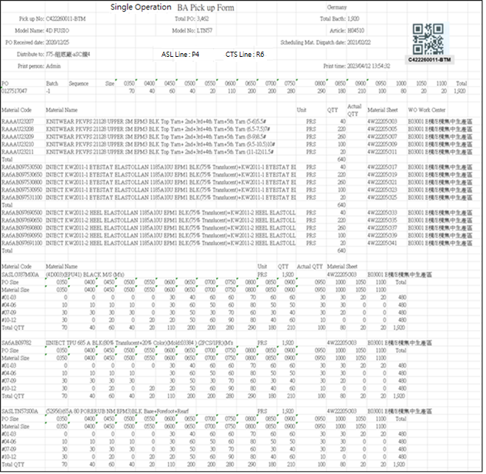

[圖MPS101_6] Regular Pickup Form – Mix Material

|  |  |  |  |  |  |  |
| --- | --- | --- | --- | --- | --- | --- |
| Print Regular Pickup Form – Mix Material (No size + Size) 列印一般取料單-混合料號 (無尺寸 + 有尺寸) | | | | | | |
| NO | 顯示名稱 | 必填 | 唯讀 | 存改 | 對應欄位 | 欄位型態  欄位說明 |
|  | Form Title Type |  |  |  | TYPE_SPECIAL | String |
|  | Form Title Kind  表單類型 |  |  |  | KIND | String |
|  | Shipping Location  出貨地點 |  |  |  | SHIPPING_LOCATION | String |
| SQL  select top 1 t1.SHIPPING_LOCATION  from [dbo].[ERP_SO] t1  inner join [dbo].[ERP_SOBatch] t2 on t1.SO_NO = t2.SO_NO  where t2.PO_BATCH = '0132957503-4' | | | | | | |
|  | Pickup No  取料單編號 |  |  |  | User selected row | String |
|  | Total Bacth  批次數量 |  |  |  | QUANTITY | Numeric |
|  | Model Name  型體名稱 |  |  |  | MODEL_NAME | String |
|  | Model No  型體編號 |  |  |  | MODEL_NO | String |
|  | Article  Article |  |  |  | ARTICLE | String |
|  | PO Received Date  訂單接單日 |  |  |  | RECEIVED_DATE | Date  yyyy-MM-dd |
|  | PO  訂單號碼 |  |  |  | PO_No | String |
|  | Batch  批次 |  |  |  | BATCH | String |
| SQL：  -- SQL01  SELECT a.TYPE_SPECIAL , a.KIND , b.PO_NO , REPLACE(a.PO_BATCH, b.PO_NO,'') AS BATCH , a.PO_BATCH , b.QUANTITY, c.ARTICLE , c.MODEL_NAME , c.MODEL_NO , a.[SEQUENCE] , a.DEPT_ID , c.RECEIVED_DATE  FROM ( select top 1 TYPE_SPECIAL , PO_BATCH , [SEQUENCE] , DEPT_ID , KIND from dbo.CST_MPS_PICKFORM  where PUFGROUP = 'CPUF202302231300001' ) a -- (User select row)  left join dbo.ERP_SOBATCH b on a.PO_BATCH = b.PO_BATCH  left join dbo.ERP_SO c on b.PO_NO = c.PO_NO | | | | | | |
|  | Total PO  訂單數量 |  |  |  | PO_QUANTITY | Numeric |
| SQL：  -- Get PO Total Qty ( by PO_NO )  SELECT sum(QUANTITY) AS PO_QUANTITY  FROM dbo.ERP_SOBATCH  where PO_NO = '0127517048' -- (SQL01's PO_NO) | | | | | | |
|  | ~~Mat. Standard onhand date~~  ~~標準材料到廠日~~ |  |  |  | ~~Mat_Standard_Onhand_Date~~ | ~~Date~~  ~~yyyy-MM-dd~~  ~~If Mat_Standard_Onhand_Date = 00000000, let it remain empty.~~ |
|  | Scheduling Mat. Dispatch date  配送日期 |  |  |  | Scheduling_Mat_Dispatch_Date | Date  yyyy-MM-dd  If Scheduling_Mat_Dispatch_Date = 00000000, let it remain empty. |
| SQL：  ~~SELECT CASE t1.KIND~~  ~~WHEN 'AA' THEN Upper_Mat_Plan_On_Hand~~  ~~WHEN 'PA' THEN Upper_Mat_Plan_On_Hand~~  ~~WHEN 'UA' THEN Stitching_Mat_Plan_On_Hand~~  ~~WHEN 'BA' THEN Bottom_Mat_Plan_On_Hand~~  ~~WHEN 'FA' THEN Assembly_Mat_Plan_On_Hand~~  ~~ELSE ''~~  ~~END Mat_Standard_Onhand_Date~~  ~~from dbo.CST_MPS_PICKFORM t1~~  ~~inner join dbo.ERP_PROD_SCHED t2 on t1.PO_BATCH = t2.PO_BATCH~~  ~~where t1.PUFGROUP = 'CPUF202302231300073'~~  SELECT CASE t1.KIND  WHEN 'AA' THEN Upper_Mat_Plan_On_Hand  WHEN 'PA' THEN Upper_Mat_Plan_On_Hand  WHEN 'UA' THEN Stitching_Mat_Plan_On_Hand  WHEN 'BA' THEN Bottom_Mat_Plan_On_Hand  WHEN 'FA' THEN Assembly_Mat_Plan_On_Hand  ELSE ''  END Mat_Standard_onhand_date  , CASE t1.KIND  WHEN 'AA' THEN t2.CUT_START_DATE  WHEN 'PA' THEN t2.CUT_START_DATE  WHEN 'UA' THEN t2.ST_START_DATE  WHEN 'BA' THEN t2.SF_START_DATE  WHEN 'FA' THEN t2.AS_START_DATE  ELSE ''  END Scheduling_Mat_Dispatch_Date  from dbo.CST_MPS_PICKFORM t1  left join dbo.ERP_PROD_SCHED t2 on t1.PO_BATCH = t2.PO_BATCH  where t1.PUFGROUP = 'CPUF202310071463398' | | | | | | |
|  | ~~Scheduling Mat. Dispatch date~~  ~~配送日期~~ |  |  |  | ~~Scheduling_Mat_Dispatch_Date~~ | ~~Date~~  ~~yyyy-MM-dd~~ |
| SQL：  -- Scheduling Mat. Dispatch date 配送日期 (SAP 拋給MES)  ~~SELECT min(T4.ESTIMATED_START_DATE) AS Scheduling_Mat_Dispatch_Date~~  ~~FROM dbo.CST_MPS_PICKFORM T1 , dbo.CST_MPS_PICKFORM_DETAIL T2 , dbo.ERP_ISSUE_DTL T3 , dbo.ERP_WO T4~~  ~~where T1.PUFGROUP = 'CPUF202302231300001' -- (User select row)~~  ~~and T1.PUF = T2.PUF~~  ~~and T2.MATERIALNO = T3.MATERIALNO~~  ~~and T2.C_MATERIAL_SHEET_NO = T3.C_MATERIAL_SHEET_NO~~  ~~and T3.WO_GROUP = T4.WO_GROUP~~  ~~and T4.PROCESS_TYPE = T1.KIND~~ | | | | | | |
|  | Distribute to  分發給 |  |  |  | DEPT_DESC | String |
| SQL：  EXEC dbo.PRD_GET_MPS_Dispatch_WorkCenter_PickupForm 'CPUF202302231300001' | | | | | | |
|  | ASL Line  成型線別 |  |  |  | AS_CELL | String |
|  | CTS Line  針車線別 |  |  |  | ST_TEAM | String |
|  | Print Person  列印人員 |  |  |  | (Login User_Account) | String |
|  | Print Time  列印時間 |  |  |  | User print date and time  (Get from server side) | String  yyyy-MM-dd HH:mm:ss |
| SQL：  -- Production Line (by PO_Batch)  SELECT AS_CELL , ST_TEAM  FROM ERP_PROD_SCHED  WHERE PO_Batch = '0900058014001' | | | | | | |
|  | Sequence  迴轉數 |  |  |  | SEQUENCE | String |
|  | Size  尺寸 |  |  |  | (List All PO’s Size and Qty) | String |
|  | Total (Row)  加總 (每個PO) |  |  |  | SUM (Qty of PO) | Numeric |
| SQL：  -- Size Run Information SQL  -- If SEQUENCE only one number(e.g:#03), then start and end = 3  SELECT SEQUENCE , PO_SIZE , sum(QUANTITY) QUANTITY  FROM dbo.ERP_CYNO_DETAIL  where PO_BATCH = '0127517048' -- (SQL01's PO_BATCH)  and CAST(REPLACE(SEQUENCE, '#', '') AS INT) >= 1 -- (SQL01's SEQUENCE start) -- If Sequence no data, ignore this condition  and CAST(REPLACE(SEQUENCE, '#', '') AS INT) <= 4 -- (SQL01's SEQUENCE end) -- If Sequence no data, ignore this condition  group by SEQUENCE , PO_SIZE  order by SEQUENCE , PO_SIZE  IF No data found in above SQL (Size Run Information) :  Begin  --Check PUF Kind  If KIND = ‘AA’ (all gridview checked rows Kind = AA)  Begin  Need not print “Size Run Information” (leave empty)  Continue to execute subsequent programs -- keep print out all other PUF information  End    If KIND <> ‘AA’ (any one of gridview checked rows Kind <> AA)  Begin  Show alert message “PO: XXXXXXXXXX-X have no Size run data” – (from column : PO_No , BATCH)  Stop print & Exit program  End  END | | | | | | |
| **Get all C_MATERIAL_SHEET_NO、MATERIAL_CATEGORY** | | | | | | |
| **SQL：**  -- Get all C_MATERIAL_SHEET_NO、MATERIAL_CATEGORY : by PUFGROUP  select b.C_MATERIAL_SHEET_NO , max( c.MATERIAL_CATEGORY ) AS MATERIAL_CATEGORY  FROM dbo.CST_MPS_PICKFORM a , dbo.CST_MPS_PICKFORM_DETAIL b , dbo.ERP_MATERIAL c , dbo.ERP_ISSUE_DTL d  where a.PUFGROUP = 'CPUF202304040800001' --(User select row)  and a.PUF = b.PUF  and b.MATERIALNO = c.MATERIALNO  and b.C_MATERIAL_SHEET_NO = d.C_MATERIAL_SHEET_NO  and b.MATERIALNO = d.MATERIALNO  and d.STATUS <> 'D' -- (Always is D)  group by b.C_MATERIAL_SHEET_NO  order by max( c.MATERIAL_CATEGORY ) , b.C_MATERIAL_SHEET_NO | | | | | | |
| **No Size Part：If MATERIAL_CATEGORY != ‘02’** | | | | | | |
|  | Material Code  料號 |  |  |  | MATERIALNO | String |
|  | Material Name  材料名稱 |  |  |  | MATERIAL_SPEC | String |
|  | Unit  單位 |  |  |  | UNIT | String |
|  | QTY  數量 |  |  |  | PLAN_QTY | Numeric |
|  | Actual QTY  實際數量 |  |  |  | Let it remain empty. | Numeric |
|  | Material Sheet  發料單號 |  |  |  | ~~MATERIAL_SHEET_NO~~  C_MATERIAL_SHEET_NO | String |
|  | WO Work Center  工單工作中心 |  |  |  | WO_Work_Center | String |
|  | Total  總計 |  |  |  | SUM(PLAN_QTY)  By every C_MATERIAL_SHEET_NO | Numeric |
| SQL：  -- Loop all C_MATERIAL_SHEET_NO  -- Sum PLAN_QTY Total by every C_MATERIAL_SHEET_NO  SELECT distinct T1.MATERIALNO, T3.MATERIAL_SPEC, T3.UNIT, T1.PLAN_QTY, T1.C_MATERIAL_SHEET_NO,  ( ISNULL(t5.DEPT_ID , t2.DEPT_ID) + ' ' + t4.DEPT_DESC) WO_work_center  FROM dbo.CST_MPS_PICKFORM_DETAIL T1  left join dbo.ERP_ISSUE_DTL T2 on T1.C_MATERIAL_SHEET_NO = T2.C_MATERIAL_SHEET_NO and T1.MATERIALNO = T2.MATERIALNO  and T1.MATERIAL_SHEET_NO = T2.MATERIAL_SHEET_NO  inner join dbo.CST_MPS_PICKFORM T0 on T0.puf = T1.puf  left join ERP_ISSUE_DTL_Dept_DTL T5 on T5.C_MATERIAL_SHEET_NO = T1.C_MATERIAL_SHEET_NO  and T5.MATERIAL_SHEET_NO = T1.MATERIAL_SHEET_NO  and T5.MATERIALNO = T1.MATERIALNO  and T5.PO_BATCH = T0.PO_BATCH  and T5.Item_NO = T2.Item_NO  and T5.DEPT_ID = T1.DEPT_ID_Original  left join dbo.ERP_MATERIAL T3 on T2.MATERIALNO = T3.MATERIALNO and T1.MATERIALNO = T3.MATERIALNO  left join dbo.ERP_ORGANIZATION t4 on ISNULL(t5.DEPT_ID , t2.DEPT_ID) = t4.DEPT_ID  where T1.C_MATERIAL_SHEET_NO = 'C4W241212003338'  and T0.pufgroup = 'CPUF202412191593043' --User selected row  order by T1.MATERIALNO | | | | | | |
| **Size Part：If MATERIAL_CATEGORY = ‘02’** | | | | | | |
|  | Material Code  料號 |  |  |  | TOP 1 MATERIALNO | String |
|  | Material Name  材料名稱 |  |  |  | TOP 1 MATERIAL_SPEC | String |
|  | Unit  單位 |  |  |  | TOP 1 UNIT | String |
|  | QTY  數量 |  |  |  | SUM(PLAN_QTY)  By every C_MATERIAL_SHEET_NO | Numeric |
|  | Actual QTY  實際數量 |  |  |  | Let it remain empty | Numeric |
|  | Material Sheet  發料單號 |  |  |  | C_MATERIAL_SHEET_NO | String |
|  | WO Work Center  工單工作中心 |  |  |  | TOP 1 WO_Work_Center | String |
|  | PO Size  訂單尺寸 |  |  |  | PO_SIZE | String |
|  | Material Size  材料尺寸 |  |  |  | MATERIAL_SIZE | String |
|  | Total  總計 |  |  |  | SUM(PLAN_QTY)  By every C_MATERIAL_SHEET_NO | Numeric |
| SQL：  -- Loop all C_MATERIAL_SHEET_NO  -- Get GENERIC_MATERIAL 、 Material Name 、 Unit  SELECT TOP 1 T3.MATERIALNO, T3.MATERIAL_SPEC, T3.UNIT, (t2.DEPT_ID + ' ' + t4.DEPT_DESC) WO_Work_Center  FROM dbo.CST_MPS_PICKFORM_DETAIL T1  left join dbo.ERP_ISSUE_DTL T2 on T1.C_MATERIAL_SHEET_NO = T2.C_MATERIAL_SHEET_NO and T1.MATERIALNO = T2.MATERIALNO  left join dbo.ERP_MATERIAL T3 on T2.GENERIC_MATERIAL = T3.MATERIALNO  left join dbo.ERP_ORGANIZATION t4 on t2.DEPT_ID = t4.DEPT_ID  where T1.C_MATERIAL_SHEET_NO = '4W22205ABCGC020001'  -- Get max SEQUENCE by PO_BATCH  -- If max SEQUENCE is NULL or Empty, show "No Cycle Sequence data 沒有迴轉表資料" error message, and stop print all Pickup Form (user select)  -- SQL02  SELECT max(CAST(REPLACE(SEQUENCE, '#', '') AS INT)) max_SEQUENCE  FROM dbo.ERP_CYNO_DETAIL  where ( PO_BATCH = '0127517047-1')　-- (SQL01's PO_BATCH)  -- Every three SEQUENCE is a group  -- eg. if SQL02 get max_SEQUENCE = 8, please get 1~3、4~6、7~8, three rows data  -- eg. if SQL02 get max_SEQUENCE = 4, please get 1~3、4~4, two rows data  -- Sum Total QTY Total by every C_MATERIAL_SHEET_NO  select t1.PO_BATCH , t1.PO_SIZE , t2.MATERIAL_SIZE , t1.QUANTITY  from (  SELECT PO_BATCH , PO_SIZE , sum(QUANTITY) AS QUANTITY  FROM dbo.ERP_CYNO_DETAIL  where ( PO_BATCH = '0127517047-1') -- (SQL01's PO_BATCH)  and CAST(REPLACE(SEQUENCE, '#', '') AS INT) >= 1 -- Every three SEQUENCE is a group  and CAST(REPLACE(SEQUENCE, '#', '') AS INT) <= 3 -- Every three SEQUENCE is a group  group by PO_BATCH , PO_SIZE  ) AS t1  left join dbo.ERP_ISSUE_DTL t2  on t1.PO_BATCH = t2.PO_BATCH  and t1.PO_SIZE = t2.PO_SIZE  and t2.C_MATERIAL_SHEET_NO = '4W22205ABCGC020001' -- (C_MATERIAL_SHEET_NO)  order by t1.PO_BATCH , t1.PO_SIZE | | | | | | |
| Check if need to print “Strip information”  1. Only PA Pickup Form need to check  Form Title Kind = ‘PA’  select Remark01 as Factory from MES_WPC_EXTENDITEM where CLASS = 'Factory'  - Get materialno list need to print Strip information  SQL：  if Factory = '2020'  exit sub (do nothing, Factory 2020 need not to call procedure)  else  exec PRD_GET_MPS_Pickup_Form_AA_STRIP_MATERIALNO_List @PUFGroup = 'NCPUF202308221007059' ,@PO_BATCH = '0133474933'  - if no row return，need not to print  else  1. Print a separate line first  2. Loop all return rows  Begin  -- (call procedure PRD_GET_MPS_Pickup_Form_AA_STRIP_Info to get and print Strip information)  exec PRD_GET_MPS_Pickup_Form_AA_STRIP_Info @PUFGroup = 'NCPUF202308221007059'  ,@PO_BATCH = '0133474933' , @MATERIALNO = 'RAPAD000000124'  End   1. Only AA Pickup Form need to check “MT Instruction” (**Function MT Instruction**)   (Form Title Kind = ‘AA’)  (MT Instruction is all the same , click Ctrl and link to go to MT Instruction)    [圖MPS101_6_1] Regular Pickup Form – Mix Material with strip material information   |  |  |  |  |  |  |  | | --- | --- | --- | --- | --- | --- | --- | |  | Material Name  料號名稱 |  |  |  | Material_SPEC | String  Put on top of grid table in one row | |  | Material Code  料號 |  |  |  | MATERIALNO | String | |  | Qty  數量 |  |  |  | Qty | Numeric | |  | Unit  單位 |  |  |  | Unit | String | |  | AA_MATERIALNO  AA料號 |  |  |  | AA_MATERIALNO | String | |  | MATERIAL Name  AA料號名稱 |  |  |  | AA_MATERIAL_SPEC | String | |  | AA_Qty  數量 |  |  |  | AA_Qty | Numeric | |  | AA_Unit  AA單位 |  |  |  | AA_Unit | String | |  | Size_Area  尺寸分布 |  |  |  | Size_Area | String | | | | | | | |
| After Print，Update [CST_MPS_PICKFORM].[PRINT_CNT] and [CST_MPS_PICKFORM].[PRINT_TIME] (use server time)  SQL：  update dbo.CST_MPS_PICKFORM  set PRINT_CNT = PRINT_CNT + 1  , PRINT_TIME = GETDATE() -- Server time，yyyy/MM/dd HH:mm:ss  where PUFGROUP = 'CPUF202304040800001' --(User select row) | | | | | | |

**B：Print Combined Pickup Form 列印合併取料單**：

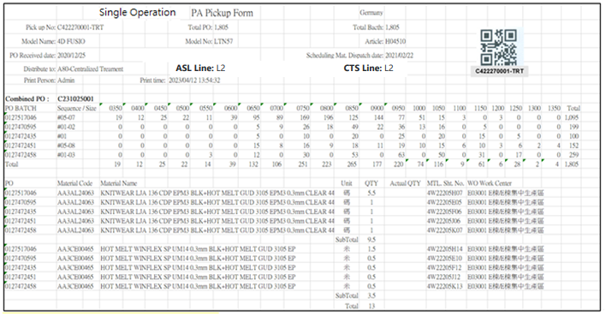

[圖MPS101_7] Combined Pickup Form

|  |  |  |  |  |  |  |
| --- | --- | --- | --- | --- | --- | --- |
| Print Combined Pickup Form 列印合併取料單 | | | | | | |
| NO | 顯示名稱 | 必填 | 唯讀 | 存改 | 對應欄位 | 欄位型態  欄位說明 |
|  | Form Title Type |  |  |  | TYPE_SPECIAL | String |
|  | Form Title Kind  表單類型 |  |  |  | KIND | String |
|  | Shipping Location  出貨地點 |  |  |  | SHIPPING_LOCATION | String |
| SQL  select top 1 t1.SHIPPING_LOCATION  from [dbo].[ERP_SO] t1  inner join [dbo].[ERP_SOBatch] t2 on t1.SO_NO = t2.SO_NO  where t2.PO_BATCH = '0132957503-4' --(TOP 1 PO_BATCH) | | | | | | |
|  | Pickup No  取料單編號 |  |  |  | User selected row | String |
|  | Total Bacth  批次數量 |  |  |  | SUM (QUANTITY) | Numeric |
|  | Model Name  型體名稱 |  |  |  | MODEL_NAME | String |
|  | Model No  型體編號 |  |  |  | TOP 1 MODEL_NO | String |
|  | Article  Article |  |  |  | TOP 1 ARTICLE | String |
|  | PO Received Date  訂單接單日 |  |  |  | TOP 1 RECEIVED_DATE | Date  yyyy-MM-dd |
|  | PO BATCH  訂單號碼 批次 |  |  |  | PO_BATCH | String |
|  | Sequence  迴轉數 |  |  |  | SEQUENCE | String |
| SQL：  --SQL01  SELECT a.TYPE_SPECIAL , a.KIND , b.PO_NO , a.PO_BATCH , b.QUANTITY, c.ARTICLE , c.MODEL_NAME , c.MODEL_NO  , a.SEQUENCE , a.DEPT_ID , c.RECEIVED_DATE  FROM ( select TYPE_SPECIAL , PO_BATCH , [SEQUENCE] , DEPT_ID , KIND from dbo.CST_MPS_PICKFORM  where PUFGROUP = 'CPUF202310250834556 ' ) AS a -- (User select row)  left join dbo.ERP_SOBATCH b on a.PO_BATCH = b.PO_BATCH  left join dbo.ERP_SO c on b.PO_NO = c.PO_NO  Loop to check  If SQL01’s [SEQUENCE] is empty  -- If SEQUENCE = ''  -- Get max SEQUENCE by PO_BATCH  -- SEQUENCE = #1-#max_SEQUENCE e.g: #1-#12 e.g: #1-#1  SELECT max(CAST([SEQUENCE] AS INT)) max_SEQUENCE  FROM dbo.ERP_CYNO_DETAIL  WHERE ( PO_BATCH = '0126113778') -- (SQL01's PO_BATCH)  IF No data found in above SQL (max_SEQUENCE) :  --Check PUF Kind  If KIND = ‘AA’ (all gridview checked rows Kind = AA)  Begin  Ignore max_SEQUENCE ( the subsequent program will not print size run information)  Continue to execute subsequent programs -- keep print out all other PUF information  End    If KIND <> ‘AA’ (any one of gridview checked rows Kind <> AA)  Begin  Show alert message “PO: XXXXXXXXXX-X have no Size run data” – (from column : PO_No , BATCH)  Stop print & Exit program  End | | | | | | |
|  | Total PO  訂單數量 |  |  |  | PO_QUANTITY | Numeric |
| SQL：  -- Get PO Total Qty ( by PO_NO )  SELECT sum(QUANTITY) AS PO_QUANTITY  FROM dbo.ERP_SOBATCH  where PO_NO in ('0127517048', '0127517049') -- (SQL01's PO_NO) | | | | | | |
|  | ~~Mat. Standard onhand date~~  ~~標準材料到廠日~~ |  |  |  | ~~Mat_Standard_Onhand_Date~~ | ~~Date~~  ~~yyyy-MM-dd~~  ~~If Mat_Standard_Onhand_Date = 00000000, let it remain empty.~~ |
|  | Scheduling Mat. Dispatch date  配送日期 |  |  |  | Scheduling_Mat_Dispatch_Date | Date  yyyy-MM-dd  If Scheduling_Mat_Dispatch_Date = 00000000, let it remain empty. |
| SQL：  ~~SELECT CASE t1.KIND~~  ~~WHEN 'AA' THEN Upper_Mat_Plan_On_Hand~~  ~~WHEN 'PA' THEN Upper_Mat_Plan_On_Hand~~  ~~WHEN 'UA' THEN Stitching_Mat_Plan_On_Hand~~  ~~WHEN 'BA' THEN Bottom_Mat_Plan_On_Hand~~  ~~WHEN 'FA' THEN Assembly_Mat_Plan_On_Hand~~  ~~ELSE ''~~  ~~END Mat_Standard_Onhand_Date~~  ~~from dbo.CST_MPS_PICKFORM t1~~  ~~inner join dbo.ERP_PROD_SCHED t2 on t1.PO_BATCH = t2.PO_BATCH~~  ~~where t1.PUFGROUP = 'CPUF202302231300073'~~  SELECT top 1 CASE t1.KIND  WHEN 'AA' THEN Upper_Mat_Plan_On_Hand  WHEN 'PA' THEN Upper_Mat_Plan_On_Hand  WHEN 'UA' THEN Stitching_Mat_Plan_On_Hand  WHEN 'BA' THEN Bottom_Mat_Plan_On_Hand  WHEN 'FA' THEN Assembly_Mat_Plan_On_Hand  ELSE ''  END Mat_Standard_onhand_date  , CASE t1.KIND  WHEN 'AA' THEN t2.CUT_START_DATE  WHEN 'PA' THEN t2.CUT_START_DATE  WHEN 'UA' THEN t2.ST_START_DATE  WHEN 'BA' THEN t2.SF_START_DATE  WHEN 'FA' THEN t2.AS_START_DATE  ELSE ''  END Scheduling_Mat_Dispatch_Date  from dbo.CST_MPS_PICKFORM t1  left join dbo.ERP_PROD_SCHED t2 on t1.PO_BATCH = t2.PO_BATCH  where t1.PUFGROUP = 'CPUF202310071463398'  and t2.CUT_START_DATE <> '00000000'  order by t2.CUT_START_DATE | | | | | | |
|  | ~~Scheduling Mat. Dispatch date~~  ~~最早PA工單開始日~~ |  |  |  | ~~Scheduling_Mat_Dispatch_Date~~ | ~~Date~~  ~~yyyy-MM-dd~~ |
| SQL：  -- Scheduling Mat. Dispatch date 配送日期 (SAP 拋給MES)  ~~SELECT min(T4.ESTIMATED_START_DATE) AS Scheduling_Mat_Dispatch_Date~~  ~~FROM dbo.CST_MPS_PICKFORM T1 , dbo.CST_MPS_PICKFORM_DETAIL T2 , dbo.ERP_ISSUE_DTL T3 , dbo.ERP_WO T4~~  ~~where T1.PUFGROUP = 'CPUF202302231300003' -- (User select row)~~  ~~and T1.PUF = T2.PUF~~  ~~and T2.MATERIALNO = T3.MATERIALNO~~  ~~and T2.C_MATERIAL_SHEET_NO = T3.C_MATERIAL_SHEET_NO~~  ~~and T3.WO_GROUP = T4.WO_GROUP~~  ~~and T4.PROCESS_TYPE = T1.KIND~~ | | | | | | |
|  | Distribute to  分發給 |  |  |  | DEPT_DESC | String |
| SQL：  EXEC dbo.PRD_GET_MPS_Dispatch_WorkCenter_PickupForm 'CPUF202302231300003' | | | | | | |
|  | ASL Line  成型線別 |  |  |  | AS_CELL  join all data by ", " | String  e.g: E3, E4, E5 |
|  | CTS Line  針車線別 |  |  |  | ST_TEAM  join all data by ", " | String  e.g: E3, E4, E5 |
|  | Print Person  列印人員 |  |  |  | (Login User_Account) | String |
|  | Print Time  列印時間 |  |  |  | User print date and time  (Get from server side) | String  yyyy-MM-dd HH:mm:ss |
| SQL：  -- Distinct Production Line (by All PO_Batch)  SELECT DISTINCT AS_CELL  FROM ERP_PROD_SCHED  WHERE PO_Batch in ('0132855033', '0132855034', '0132855035', '0132855036')  -- SQL CTS Line Combined  SELECT DISTINCT ST_TEAM  FROM ERP_PROD_SCHED  WHERE PO_Batch in ('0132855033', '0132855034', '0132855035', '0132855036') | | | | | | |
|  | Combined PO |  |  |  | COMBINE_PO_BATCH | String |
| SQL：  -- Distinct Production Line (by All PO_Batch)  select top 1 COMBINE_PO_BATCH  FROM dbo.CST_MPS_PICKFORM  where PUFGROUP = 'CPUF202311030858327' | | | | | | |
|  | Size  尺寸 |  |  |  | (List All PO’s Size and Qty) | String |
|  | Total (Column)  加總 (每個尺寸) |  |  |  | SUM (Qty of every size) | Numeric |
|  | Total (Row)  加總 (每個PO) |  |  |  | SUM (Qty of every PO) | Numeric |
| SQL：  -- SQL02  select PO_BATCH, SEQUENCE  from dbo.CST_MPS_PICKFORM  where PUFGROUP = 'CPUF202302231300003'  group by PO_BATCH, SEQUENCE  order by PO_BATCH, SEQUENCE  -- Loop all SQL02’s data and Get PO Size run information ( by All PO_BATCH and Sequence in SQL02 )  -- If SEQUENCE only one number(e.g:#03), then start and end = 3  -- SQL03  SELECT PO_BATCH , PO_SIZE , sum(QUANTITY) QUANTITY  FROM dbo.ERP_CYNO_DETAIL  where PO_BATCH = '0127517048' -- (SQL02's PO_BATCH)  and CAST(REPLACE(SEQUENCE, '#', '') AS INT) >= 9 -- (SQL02's SEQUENCE start) -- If Sequence no data, ignore this condition  and CAST(REPLACE(SEQUENCE, '#', '') AS INT) <= 10 -- (SQL02's SEQUENCE end) -- If Sequence no data, ignore this condition  group by PO_BATCH , PO_SIZE  order by PO_BATCH , PO_SIZE  IF No data found in above SQL(SQL03) (Size Run Information) :  --Check PUF Kind  If KIND = ‘AA’ (all gridview checked rows Kind = AA)  Begin  Need not print “Size Run Information” (leave empty)  Continue to execute subsequent programs -- keep print out all other PUF information  End    If KIND <> ‘AA’ (any one of gridview checked rows Kind <> AA)  Begin  Show alert message “PO: XXXXXXXXXX-X have no Size run data” – (from column : PO_No , BATCH)  Stop print & Exit program  End | | | | | | |
|  | PO  訂單號碼 |  |  |  | PO_BATCH | String |
|  | Material Code  料號 |  |  |  | MATERIALNO | String |
|  | Material Name  材料名稱 |  |  |  | MATERIAL_SPEC | String |
|  | Unit  單位 |  |  |  | UNIT | String |
|  | QTY  數量 |  |  |  | PLAN_QTY | Numeric |
|  | Actual QTY  實際數量 |  |  |  | Let it remain empty | Numeric |
|  | MTL. Sht. No.  發料單號 |  |  |  | ~~MATERIAL_SHEET_NO~~  C_MATERIAL_SHEET_NO | String |
|  | WO Work Center  工單工作中心 |  |  |  | WO_Work_Center | String |
|  | Subtotal  小記 |  |  |  | SUM(PLAN_QTY)  Group By Material No | Numeric |
|  | Total  總計 |  |  |  | SUM(PLAN_QTY) | Numeric |
| SQL：  **-- SQL01**  -- Get all C_MATERIAL_SHEET_NO、Material Type (SA、非SA) : by PUFGROUP  select b.C_MATERIAL_SHEET_NO , max( substring(b.MATERIALNO,1,2) )  FROM dbo.CST_MPS_PICKFORM a , dbo.CST_MPS_PICKFORM_DETAIL b , dbo.ERP_ISSUE_DTL d  where a.PUFGROUP = 'NCPUF20250802103004014W'  and a.PUF = b.PUF  and b.C_MATERIAL_SHEET_NO = d.C_MATERIAL_SHEET_NO  and b.MATERIALNO = d.MATERIALNO  and d.STATUS <> 'D' -- (Always is D)  group by b.C_MATERIAL_SHEET_NO  order by b.C_MATERIAL_SHEET_NO  -- Check TSH PA PUF (separate AA、RA material into different new pages , both need to print pickup form PUF header)  -- Loop all C_MATERIAL_SHEET_NO  SELECT distinct T0.PO_BATCH , T1.MATERIALNO, T3.MATERIAL_SPEC, T3.UNIT, T1.PLAN_QTY, T1.C_MATERIAL_SHEET_NO,  ( ISNULL(t5.DEPT_ID , t2.DEPT_ID) + ' ' + t4.DEPT_DESC) WO_work_center  FROM dbo.CST_MPS_PICKFORM_DETAIL T1  left join dbo.ERP_ISSUE_DTL T2 on T1.C_MATERIAL_SHEET_NO = T2.C_MATERIAL_SHEET_NO and T1.MATERIALNO = T2.MATERIALNO  and T1.MATERIAL_SHEET_NO = T2.MATERIAL_SHEET_NO  inner join dbo.CST_MPS_PICKFORM T0 on T0.puf = T1.puf  left join ERP_ISSUE_DTL_Dept_DTL T5 on T5.C_MATERIAL_SHEET_NO = T1.C_MATERIAL_SHEET_NO  and T5.MATERIAL_SHEET_NO = T1.MATERIAL_SHEET_NO  and T5.MATERIALNO = T1.MATERIALNO  and T5.PO_BATCH = T0.PO_BATCH  and T5.Item_NO = T2.Item_NO  and T5.DEPT_ID = T1.DEPT_ID_Original  left join dbo.ERP_MATERIAL T3 on T2.MATERIALNO = T3.MATERIALNO and T1.MATERIALNO = T3.MATERIALNO  left join dbo.ERP_ORGANIZATION t4 on ISNULL(t5.DEPT_ID , t2.DEPT_ID) = t4.DEPT_ID  where T1.C_MATERIAL_SHEET_NO = 'C4W241212003338'  and T0.pufgroup = 'CPUF202412191593043' --User selected row  order by T1.MATERIALNO | | | | | | |

|  |  |  |  |  |  |  |  |  |  |  |  |  |  |  |  |  |  |  |  |  |  |  |  |  |  |  |  |  |  |  |  |  |  |  |  |  |  |  |  |  |  |  |  |  |  |  |  |  |  |  |  |  |  |  |  |  |  |  |  |  |  |  |  |  |  |  |  |  |  |  |  |  |  |  |  |  |  |  |  |  |  |  |  |  |  |  |  |  |  |  |  |  |  |  |  |  |  |  |  |  |  |  |  |  |  |  |  |  |  |  |  |  |  |  |  |  |  |  |  |  |  |  |  |  |  |  |  |  |  |  |  |  |  |
| --- | --- | --- | --- | --- | --- | --- | --- | --- | --- | --- | --- | --- | --- | --- | --- | --- | --- | --- | --- | --- | --- | --- | --- | --- | --- | --- | --- | --- | --- | --- | --- | --- | --- | --- | --- | --- | --- | --- | --- | --- | --- | --- | --- | --- | --- | --- | --- | --- | --- | --- | --- | --- | --- | --- | --- | --- | --- | --- | --- | --- | --- | --- | --- | --- | --- | --- | --- | --- | --- | --- | --- | --- | --- | --- | --- | --- | --- | --- | --- | --- | --- | --- | --- | --- | --- | --- | --- | --- | --- | --- | --- | --- | --- | --- | --- | --- | --- | --- | --- | --- | --- | --- | --- | --- | --- | --- | --- | --- | --- | --- | --- | --- | --- | --- | --- | --- | --- | --- | --- | --- | --- | --- | --- | --- | --- | --- | --- | --- | --- | --- | --- | --- | --- |
| Check if need to print “Strip information”  1. Only PA combined Pickup Form need to check  Form Title Kind = ‘PA’  select Remark01 as Factory from MES_WPC_EXTENDITEM where CLASS = 'Factory'  - Get materialno list need to print Strip information  SQL：  if Factory = '2020'  exit sub (do nothing, Factory 2020 need not to call procedure)  else  exec PRD_GET_MPS_Pickup_Form_AA_STRIP_MATERIALNO_List_Combined_PUF @PUFGroup = 'CPUF202311011052982'  3. if no row return，need not to print  else  1. Print a separate line first  2. Loop all return rows  Begin  -- Print Summary  -- (call procedure PRD_GET_MPS_Pickup_Form_AA_STRIP_Info_Combined_PUF to get and print Strip information)  exec PRD_GET_MPS_Pickup_Form_AA_STRIP_Info_Combined_PUF @PUFGroup = 'CPUF202311011052982'  , @MATERIALNO = 'RA2AB000000401'    -- Print Detail  -- for all PO -- (Loop SQL01's PO_Batch List，order by PO_Batch)  Begin  -- (call procedure PRD_GET_MPS_Pickup_Form_AA_STRIP_Info to get and print Strip information)  exec PRD_GET_MPS_Pickup_Form_AA_STRIP_Info @PUFGroup = 'CPUF202311011052982'  ,@PO_BATCH = '0133809590' , @MATERIALNO = 'RA2AB000000401'  End  End    [圖MPS101_8] Combined Pickup Form -- with strip material information  Summary:   |  |  |  |  |  |  |  | | --- | --- | --- | --- | --- | --- | --- | |  | PO_Batch |  |  |  | PO_Batch | String  Put on top of grid table in one row | |  | Material Name  料號名稱 |  |  |  | Material_SPEC | String  Put on top of grid table in one row | |  | Material Code  料號 |  |  |  | MATERIALNO | String | |  | Total_Qty  數量 |  |  |  | Total_Qty | Numeric | |  | Unit  單位 |  |  |  | Unit | String | |  | AA_MATERIALNO  AA料號 |  |  |  | AA_MATERIALNO | String | |  | MATERIAL Name  AA料號名稱 |  |  |  | AA_MATERIAL_SPEC | String | |  | Total_AA_Qty  數量 |  |  |  | Total_AA_Qty | Numeric | |  | AA_Unit  AA單位 |  |  |  | AA_Unit | String | |  | Size_Area  尺寸分布 |  |  |  | Size_Area | String |   Detail:   |  |  |  |  |  |  |  | | --- | --- | --- | --- | --- | --- | --- | |  | Material Name  料號名稱 |  |  |  | Material_SPEC | String  Put on top of grid table in one row | |  | Material Code  料號 |  |  |  | MATERIALNO | String | |  | Qty  數量 |  |  |  | Qty | Numeric | |  | Unit  單位 |  |  |  | Unit | String | |  | AA_MATERIALNO  AA料號 |  |  |  | AA_MATERIALNO | String | |  | MATERIAL Name  AA料號名稱 |  |  |  | AA_MATERIAL_SPEC | String | |  | AA_Qty  數量 |  |  |  | AA_Qty | Numeric | |  | AA_Unit  AA單位 |  |  |  | AA_Unit | String | |  | Size_Area  尺寸分布 |  |  |  | Size_Area | String | |
| After Print，Update [CST_MPS_PICKFORM].[PRINT_CNT] and [CST_MPS_PICKFORM].[PRINT_TIME] (use server time)  SQL：  update dbo.CST_MPS_PICKFORM  set PRINT_CNT = PRINT_CNT + 1  , PRINT_TIME = GETDATE() -- Server time，yyyy/MM/dd HH:mm:ss  where PUFGROUP = 'CPUF202302231300003' --(User select row) |

* 1. **「MPS102 Reprint Pickup Form」MPS102 重列印取料單**
  2. 程式名稱：同標題 (Right Name: MPS_Reprint.Pickup.Form)
  3. 功能目的：查詢/列印
  4. 使用部門：
  5. 程式說明：

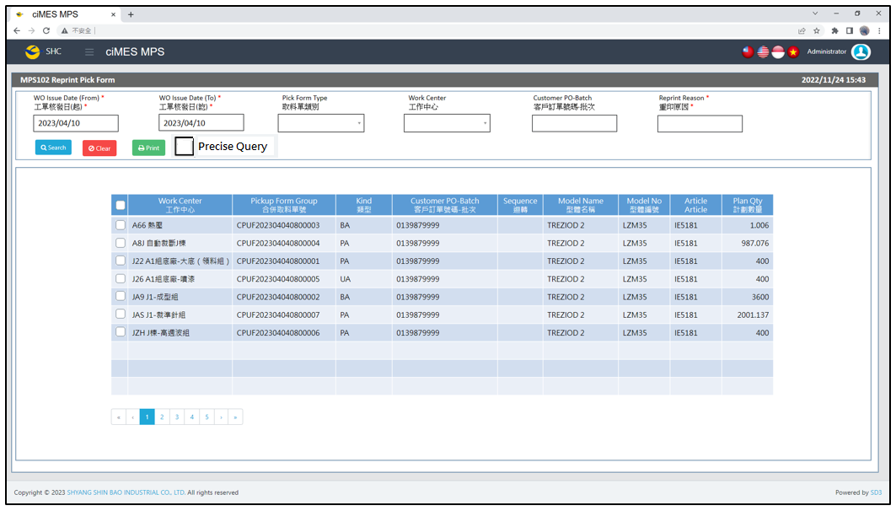

[圖MPS102_1] Main Page主畫面

|  |  |  |  |  |  |  |
| --- | --- | --- | --- | --- | --- | --- |
| Program header 程式標頭 | | | | | | |
| NO | 顯示名稱 | 必填 | 唯讀 | 存改 | 對應欄位 | 說明 |
|  | Title  標題 |  | V |  | CAPTION | String  If there is no get data, please show “Right Name”  SELECT T2.LANGUAGE, T2.CAPTION  FROM [MES_SEC_RIGHT] AS T1  JOIN [MES_MENU_ITEM] AS T2  ON T1.SEC_RIGHT_SID = T2.SEC_RIGHT_SID  WHERE T1.GROUPRIGHTS = 'MPS_Reprint.Pickup.Form' --(Right Name) |
|  | System Time  系統時間 |  | V |  | Show current server time | Datetime  yyyy/MM/dd HH:mm |

|  |  |  |  |  |  |  |
| --- | --- | --- | --- | --- | --- | --- |
| Operation button 操作按鈕 | | | | | | |
| NO | 顯示名稱 | 必填 | 唯讀 | 存改 | 對應欄位 | 說明 |
|  | Search  搜尋 |  |  |  |  | Required「WO Issue Date (From)  」and「WO Issue Date (To)」to search |
|  | Clear  清除 |  |  |  |  | Clear Search Condition and Results |
|  | Print  列印 |  |  |  |  | Print the select row data |

|  |  |  |  |  |  |  |
| --- | --- | --- | --- | --- | --- | --- |
| Search Condition 搜尋條件 | | | | | | |
| NO | 顯示名稱 | 必填 | 唯讀 | 存改 | 對應欄位 | 欄位型態  欄位說明 |
|  | WO Issue Date (From)  工單核發日(起) | V |  | V | Filter WO Issue Date column | String  yyyy/MM/dd  Default：Today |
|  | WO Issue Date (To)  工單核發日(訖) | V |  | V | Filter WO Issue Date column | String  yyyy/MM/dd  Default：Today |
|  | Pickup Form Type  取料單類別 |  |  | V | Filter Pickup Form Type column | Dropdown list  SELECT REMARK01 FROM MES_WPC_EXTENDITEM  WHERE CLASS = 'PICKFORM_TYPE'  ORDER BY REMARK01 |
|  | Work Center  工作中心 |  |  | V | Filter Work Center column | Dropdown list  SELECT DEPT_ID, DEPT_ID + '-' + DEPT_DESC AS DEPT_ID_DESC  FROM [ERP_ORGANIZATION]  ORDER BY DEPT_ID |
|  | Customer PO-Batch  客戶訂單號碼-批次 | V |  | V | Filter Customer PO-Batch column | String  If chkPrecise is checked  Must exactly matched  Remove % in Search SQL |
|  | Reprint Reason  重印原因 | V |  | V |  | String  Required when printing |
|  | Precise Query  精準比對 |  |  | V |  | Check Box : chkPrecise (default : not cheched)  If chkPrecise is checked  Filter Customer PO-Batch column  Must exactly matched  (Remove % in Search SQL Ex : PO_BATCH like '090007695001-1' ) |

|  |  |  |  |  |  |  |
| --- | --- | --- | --- | --- | --- | --- |
| Search 搜尋 | | | | | | |
| NO | 顯示名稱 | 必填 | 唯讀 | 存改 | 對應欄位 | 欄位型態  欄位說明 |
|  | Selector  選擇器 |  |  | V |  | Check Box |
|  | Work Center  工作中心 |  | V |  | DEPT_DESC | String |
|  | Pickup Form Group  合併取料單號 |  | V |  | PUFGROUP | String |
|  | Kind  類型 |  | V |  | KIND | String |
|  | Customer PO-Batch  客戶訂單號碼-批次 |  | V |  | PO_BATCH | String |
|  | Sequence  迴轉 |  | V |  | SEQUENCE | String |
|  | Model Name  型體名稱 |  | V |  | MODEL_NAME | String |
|  | Model No  型體編號 |  | V |  | MODEL_NO | String |
|  | Article  Article |  | V |  | ARTICLE | String |
|  | Plan Qty  計劃數量 |  | V |  | PLAN_QTY | Numeric |
| 程式邏輯說明：  點選 [Search搜尋] 按鈕，依照User填入的搜尋條件(若有)，即可帶出資料。  SQL：  SELECT　max(a.DEPT_ID_UA) + ' ' + max(d.DEPT_DESC) AS DEPT_DESC, a.PUFGROUP, max(T3.PO_BATCH) AS PO_BATCH, max(a.KIND) KIND,  max(a.SEQUENCE) AS SEQUENCE, max(c.MODEL_NAME) AS MODEL_NAME, max(c.MODEL_NO) AS MODEL_NO,  max(c.ARTICLE) AS ARTICLE, sum(b.PLAN_QTY) AS PLAN_QTY  FROM (  select T1.PUFGROUP,  CASE when max(T3.COMBINE_PO_BATCH) <> ''  THEN max(T3.COMBINE_PO_BATCH)  ELSE max(T1.PO_BATCH)  END AS PO_BATCH  FROM (select * from dbo.CST_MPS_PICKFORM  where PO_BATCH like '0132990865%' or COMBINE_PO_BATCH = '0132990865' ) T1  inner join dbo.CST_MPS_PICKFORM_DETAIL T2 on T1.PUF = T2.PUF  inner join dbo.ERP_ISSUE T3 on T2.C_MATERIAL_SHEET_NO = T3.C_MATERIAL_SHEET_NO  where T1.PRINT_CNT > 0  and T1.[STATUS] <> 'Terminate'  --and T1.KIND = 'PA' -- (Pickup Form Type)  --and T1.DEPT_ID_UA like 'A66' -- (Work Center)  ~~--and ( T1.PO_BATCH like '0132837594%' or T3.COMBINE_PO_BATCH = '0132837594')~~ -- (Customer PO-Batch)  --and T1.WO_ISSUE_DATE >= '2023/05/01' -- (WO Issue Date (From))  --and T1.WO_ISSUE_DATE <= DATEADD(DAY, 1, '2023/07/31') -- (WO Issue Date (To)) +1  group by T1.PUFGROUP  ) AS T3  , dbo.CST_MPS_PICKFORM AS a, dbo.CST_MPS_PICKFORM_DETAIL AS b, dbo.ERP_SOBATCH AS c, dbo.ERP_ORGANIZATION AS d  where T3.PUFGROUP = a.PUFGROUP  and a.PUF = b.PUF  and a.PO_BATCH = c.PO_BATCH  and a.DEPT_ID_UA = d.DEPT_ID  and a.PRINT_CNT > 0  group by a.PUFGROUP  order by kind, PUFGROUP | | | | | | |



[圖MPS102_2] Pickup Form Print Type & Process，Check Regular or Combined Pickup Form

|  |  |  |  |  |  |  |
| --- | --- | --- | --- | --- | --- | --- |
| Print列印 | | | | | | |
| NO | 顯示名稱 | 必填 | 唯讀 | 存改 | 對應欄位 | 欄位型態  欄位說明 |
|  |  |  |  |  |  |  |
| 程式邏輯說明：  選擇資料列後，點選列印，印出取料單，邏輯如下  First Step: Check is「A：Regular Pickup Form」or「B：Combined Pickup Form」  If PO_BATCH_COUNT = 1，Print「**Regular Pickup Form」**  If PO_BATCH_COUNT > 1，Print「**Combined Pickup Form」**  SQL：  SELECT COUNT(DISTINCT(PO_BATCH)) AS PO_BATCH_COUNT  FROM CST_MPS_PICKFORM  WHERE PUFGROUP = 'CPUF202304040800001' | | | | | | |

**A：Print Regular Pickup Form 列印一般取料單**：



[圖MPS102_3] Pickup Form Print Type & Process，Check whether there is Size Run

|  |  |  |  |  |  |  |
| --- | --- | --- | --- | --- | --- | --- |
| Print Regular Pickup Form列印一般取料單 | | | | | | |
| NO | 顯示名稱 | 必填 | 唯讀 | 存改 | 對應欄位 | 欄位型態  欄位說明 |
|  |  |  |  |  |  |  |
| 程式邏輯說明：  Regular Material Form need check is Size Run or not Size Run or Mix Material  If All MATERIAL_CATEGORY = 02，Print「**Regular Pickup Form – Size Material」**  If All MATERIAL_CATEGORY != 02，Print「**Regular Pickup Form – No Size Material」**  If MATERIAL_CATEGORY has 02 and other，Print「**Regular Pickup Form – Mix Material」**  SQL：  -- Get all C_MATERIAL_SHEET_NO、MATERIAL_CATEGORY : by PUFGROUP  select b.C_MATERIAL_SHEET_NO , max( c.MATERIAL_CATEGORY ) AS MATERIAL_CATEGORY  FROM dbo.CST_MPS_PICKFORM a , dbo.CST_MPS_PICKF0ORM_DETAIL b , dbo.ERP_MATERIAL c , dbo.ERP_ISSUE_DTL d  where a.PUFGROUP = 'CPUF202308131453579' --(User select row)  and a.PUF = b.PUF  and b.MATERIALNO = c.MATERIALNO  and b.C_MATERIAL_SHEET_NO = d.C_MATERIAL_SHEET_NO  and b.MATERIALNO = d.MATERIALNO  and d.STATUS <> 'D' -- (Always is D)  group by b.C_MATERIAL_SHEET_NO  order by max( c.MATERIAL_CATEGORY ) , b.C_MATERIAL_SHEET_NO | | | | | | |

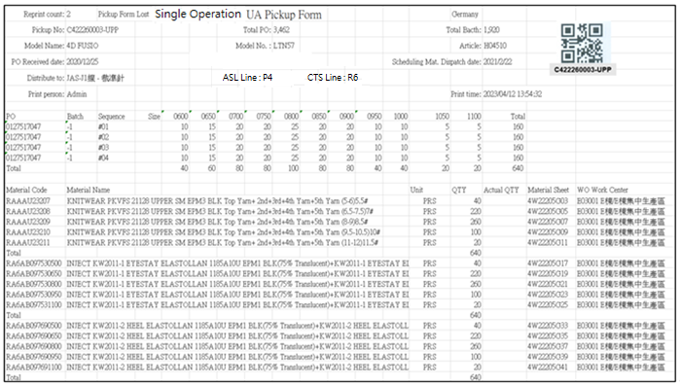

[圖MPS102_4] Regular Pickup Form – No Size Material

|  |  |  |  |  |  |  |
| --- | --- | --- | --- | --- | --- | --- |
| Print Regular Pickup Form – No Size Material 列印一般取料單-無尺寸料號 | | | | | | |
| NO | 顯示名稱 | 必填 | 唯讀 | 存改 | 對應欄位 | 欄位型態  欄位說明 |
|  | Reprint count  重印次數 |  |  |  | REPRINT_CNT | Int |
|  | Reprint Reason  重印原因 |  |  |  | User key in Reprint Reason | String |
| SQL  select PRINT_CNT AS REPRINT_CNT  from dbo.CST_MPS_PICKFORM  where PUFGROUP = 'CPUF202302231300001' -- (User select row) | | | | | | |
|  | Form Title Type |  |  |  | TYPE_SPECIAL | String |
|  | Form Title Kind  表單類型 |  |  |  | KIND | String |
|  | Shipping Location  出貨地點 |  |  |  | SHIPPING_LOCATION | String |
| SQL  select top 1 t1.SHIPPING_LOCATION  from [dbo].[ERP_SO] t1  inner join [dbo].[ERP_SOBatch] t2 on t1.SO_NO = t2.SO_NO  where t2.PO_BATCH = '0132957503-4' | | | | | | |
|  | Pickup No  取料單編號 |  |  |  | User selected row | String |
|  | Total Bacth  批次數量 |  |  |  | QUANTITY | Numeric |
|  | Model Name  型體名稱 |  |  |  | MODEL_NAME | String |
|  | Model No  型體編號 |  |  |  | MODEL_NO | String |
|  | Article  Article |  |  |  | ARTICLE | String |
|  | PO Received Date  訂單接單日 |  |  |  | RECEIVED_DATE | Date  yyyy-MM-dd |
|  | PO  訂單號碼 |  |  |  | PO_No | String |
|  | Batch  批次 |  |  |  | BATCH | String |
| SQL：  -- SQL01  SELECT a.TYPE_SPECIAL , a.KIND , b.PO_NO , REPLACE(a.PO_BATCH, b.PO_NO,'') AS BATCH , a.PO_BATCH , b.QUANTITY, c.ARTICLE , c.MODEL_NAME , c.MODEL_NO , a.[SEQUENCE] , a.DEPT_ID , c.RECEIVED_DATE  FROM ( select top 1 TYPE_SPECIAL , PO_BATCH , [SEQUENCE] , DEPT_ID , KIND from dbo.CST_MPS_PICKFORM  where PUFGROUP = 'CPUF202302231300001' ) a -- (User select row)  left join dbo.ERP_SOBATCH b on a.PO_BATCH = b.PO_BATCH  left join dbo.ERP_SO c on b.PO_NO = c.PO_NO | | | | | | |
|  | Total PO  訂單數量 |  |  |  | PO_QUANTITY | Numeric |
| SQL：  -- Get PO Total Qty ( by PO_NO )  SELECT sum(QUANTITY) AS PO_QUANTITY  FROM dbo.ERP_SOBATCH  where PO_NO = '0127517048' -- (SQL01's PO_NO) | | | | | | |
|  | ~~Mat. Standard onhand date~~  ~~標準材料到廠日~~ |  |  |  | ~~Mat_Standard_Onhand_Date~~ | ~~Date~~  ~~yyyy-MM-dd~~  ~~If Mat_Standard_Onhand_Date = 00000000, let it remain empty.~~ |
|  | Scheduling Mat. Dispatch date  配送日期 |  |  |  | Scheduling_Mat_Dispatch_Date | Date  yyyy-MM-dd  If Scheduling_Mat_Dispatch_Date = 00000000, let it remain empty. |
| SQL：  SELECT CASE t1.KIND  WHEN 'AA' THEN Upper_Mat_Plan_On_Hand  WHEN 'PA' THEN Upper_Mat_Plan_On_Hand  WHEN 'UA' THEN Stitching_Mat_Plan_On_Hand  WHEN 'BA' THEN Bottom_Mat_Plan_On_Hand  WHEN 'FA' THEN Assembly_Mat_Plan_On_Hand  ELSE ''  END Mat_Standard_onhand_date  , CASE t1.KIND  WHEN 'AA' THEN t2.CUT_START_DATE  WHEN 'PA' THEN t2.CUT_START_DATE  WHEN 'UA' THEN t2.ST_START_DATE  WHEN 'BA' THEN t2.SF_START_DATE  WHEN 'FA' THEN t2.AS_START_DATE  ELSE ''  END Scheduling_Mat_Dispatch_Date  from dbo.CST_MPS_PICKFORM t1  left join dbo.ERP_PROD_SCHED t2 on t1.PO_BATCH = t2.PO_BATCH  where t1.PUFGROUP = 'CPUF202310071463398' | | | | | | |
|  | Distribute to  分發給 |  |  |  | DEPT_DESC | String |
| SQL：  EXEC dbo.PRD_GET_MPS_Dispatch_WorkCenter_PickupForm 'CPUF202302231300001' | | | | | | |
|  | ASL Line  成型線別 |  |  |  | AS_CELL | String |
|  | CTS Line  針車線別 |  |  |  | ST_TEAM | String |
|  | Print Person  列印人員 |  |  |  | (Login User_Account) | String |
|  | Print Time  列印時間 |  |  |  | User print date and time  (Get from server side) | String  yyyy-MM-dd HH:mm:ss |
| SQL：  -- Production Line (by PO_Batch)  SELECT AS_CELL , ST_TEAM  FROM ERP_PROD_SCHED  WHERE PO_Batch = '0900058014001' | | | | | | |
|  | Sequence  迴轉數 |  |  |  | SEQUENCE | String |
|  | Size  尺寸 |  |  |  | (List All PO’s Size and Qty) | String |
|  | Total (Row)  加總 (每個PO) |  |  |  | SUM (Qty of PO) | Numeric |
| SQL：  -- Size Run Information SQL  -- If SEQUENCE only one number(e.g:#03), then start and end = 3  SELECT SEQUENCE , PO_SIZE , sum(QUANTITY) QUANTITY  FROM dbo.ERP_CYNO_DETAIL  where PO_BATCH = '0127517048' -- (SQL01's PO_BATCH)  and CAST(REPLACE(SEQUENCE, '#', '') AS INT) >= 1 -- (SQL01's SEQUENCE start) -- If Sequence no data, ignore this condition  and CAST(REPLACE(SEQUENCE, '#', '') AS INT) <= 4 -- (SQL01's SEQUENCE end) -- If Sequence no data, ignore this condition  group by SEQUENCE , PO_SIZE  order by SEQUENCE , PO_SIZE  IF No data found in above SQL (Size Run Information) :  Begin  --Check PUF Kind  If KIND = ‘AA’ (all gridview checked rows Kind = AA)  Begin  Need not print “Size Run Information” (leave empty)  Continue to execute subsequent programs -- keep print out all other PUF information  End    If KIND <> ‘AA’ (any one of gridview checked rows Kind <> AA)  Begin  Show alert message “PO: XXXXXXXXXX-X have no Size run data” – (from column : PO_No , BATCH)  Stop print & Exit program  End  END | | | | | | |
|  | Material Code  料號 |  |  |  | MATERIALNO | String |
|  | Material Name  材料名稱 |  |  |  | MATERIAL_SPEC | String |
|  | Unit  單位 |  |  |  | UNIT | String |
|  | QTY  數量 |  |  |  | PLAN_QTY | Numeric |
|  | Actual QTY  實際數量 |  |  |  | Let it remain empty | Numeric |
|  | Material Sheet  發料單號 |  |  |  | ~~MATERIAL_SHEET_NO~~  C_MATERIAL_SHEET_NO | String |
|  | WO Work Center  工單工作中心 |  |  |  | WO_Work_Center | String |
|  | Total  總計 |  |  |  | SUM(PLAN_QTY)  By every C_MATERIAL_SHEET_NO | Numeric |
| SQL：  -- Get all C_MATERIAL_SHEET_NO、Material Type (SA、非SA) : by PUFGROUP  **-- SQL01**  select b.C_MATERIAL_SHEET_NO , max( substring(b.MATERIALNO,1,2) )  FROM dbo.CST_MPS_PICKFORM a , dbo.CST_MPS_PICKFORM_DETAIL b , dbo.ERP_ISSUE_DTL d  where a.PUFGROUP = 'NCPUF20250802103004014W'  and a.PUF = b.PUF  and b.C_MATERIAL_SHEET_NO = d.C_MATERIAL_SHEET_NO  and b.MATERIALNO = d.MATERIALNO  and d.STATUS <> 'D' -- (Always is D)  group by b.C_MATERIAL_SHEET_NO  order by b.C_MATERIAL_SHEET_NO  -- Check TSH PA PUF (separate AA、RA material into different new pages , both need to print pickup form PUF header)  -- Loop all C_MATERIAL_SHEET_NO  -- Sum PLAN_QTY Total by every C_MATERIAL_SHEET_NO  SELECT distinct T1.MATERIALNO, T3.MATERIAL_SPEC, T3.UNIT, T1.PLAN_QTY, T1.C_MATERIAL_SHEET_NO,  ( ISNULL(t5.DEPT_ID , t2.DEPT_ID) + ' ' + t4.DEPT_DESC) WO_work_center  FROM dbo.CST_MPS_PICKFORM_DETAIL T1  left join dbo.ERP_ISSUE_DTL T2 on T1.C_MATERIAL_SHEET_NO = T2.C_MATERIAL_SHEET_NO and T1.MATERIALNO = T2.MATERIALNO  and T1.MATERIAL_SHEET_NO = T2.MATERIAL_SHEET_NO  inner join dbo.CST_MPS_PICKFORM T0 on T0.puf = T1.puf  left join ERP_ISSUE_DTL_Dept_DTL T5 on T5.C_MATERIAL_SHEET_NO = T1.C_MATERIAL_SHEET_NO  and T5.MATERIAL_SHEET_NO = T1.MATERIAL_SHEET_NO  and T5.MATERIALNO = T1.MATERIALNO  and T5.PO_BATCH = T0.PO_BATCH  and T5.Item_NO = T2.Item_NO  and T5.DEPT_ID = T1.DEPT_ID_Original  left join dbo.ERP_MATERIAL T3 on T2.MATERIALNO = T3.MATERIALNO and T1.MATERIALNO = T3.MATERIALNO  left join dbo.ERP_ORGANIZATION t4 on ISNULL(t5.DEPT_ID , t2.DEPT_ID) = t4.DEPT_ID  where T1.C_MATERIAL_SHEET_NO = 'C4W241212003338'  and T0.pufgroup = 'CPUF202412191593043' --User selected row  order by T1.MATERIALNO | | | | | | |
| Check if need to print “Strip information”  1. Only PA Pickup Form need to check  Form Title Kind = ‘PA’  select Remark01 as Factory from MES_WPC_EXTENDITEM where CLASS = 'Factory'  - Get materialno list need to print Strip information  SQL：  if Factory = '2020'  exit sub (do nothing, Factory 2020 need not to call procedure)  else  exec PRD_GET_MPS_Pickup_Form_AA_STRIP_MATERIALNO_List @PUFGroup = 'NCPUF202308221007059' ,@PO_BATCH = '0133474933'  - if no row return，need not to print  else  1. Print a separate line first  2. Loop all return rows  Begin  -- (call procedure PRD_GET_MPS_Pickup_Form_AA_STRIP_Info to get and print Strip information)  exec PRD_GET_MPS_Pickup_Form_AA_STRIP_Info @PUFGroup = 'NCPUF202308221007059'  ,@PO_BATCH = '0133474933' , @MATERIALNO = 'RAPAD000000124'  End   1. Only AA Pickup Form need to check “MT Instruction” (**Function MT Instruction**)   (Form Title Kind = ‘AA’)  (MT Instruction is all the same , click Ctrl and link to go to MT Instruction)    [圖MPS102_4_1] Regular Pickup Form – No Size Material with strip material information   |  |  |  |  |  |  |  | | --- | --- | --- | --- | --- | --- | --- | |  | Material Name  料號名稱 |  |  |  | Material_SPEC | String  Put on top of grid table in one row | |  | Material Code  料號 |  |  |  | MATERIALNO | String | |  | Qty  數量 |  |  |  | Qty | Numeric | |  | Unit  單位 |  |  |  | Unit | String | |  | AA_MATERIALNO  AA料號 |  |  |  | AA_MATERIALNO | String | |  | MATERIAL Name  AA料號名稱 |  |  |  | AA_MATERIAL_SPEC | String | |  | AA_Qty  數量 |  |  |  | AA_Qty | Numeric | |  | AA_Unit  AA單位 |  |  |  | AA_Unit | String | |  | Size_Area  尺寸分布 |  |  |  | Size_Area | String | | | | | | | |
| After Print，Update [CST_MPS_PICKFORM].[PRINT_CNT] and [CST_MPS_PICKFORM].[PRINT_TIME] (use server time)  SQL：  update dbo.CST_MPS_PICKFORM  set PRINT_CNT = PRINT_CNT + 1  , REPRINT_REASON = 'Pickup Form Lost' --(User key in Reprint Reason)  , PRINT_TIME = GETDATE() -- Server time，yyyy/MM/dd HH:mm:ss  where PUFGROUP = 'CPUF202304040800001' --(User select row) | | | | | | |

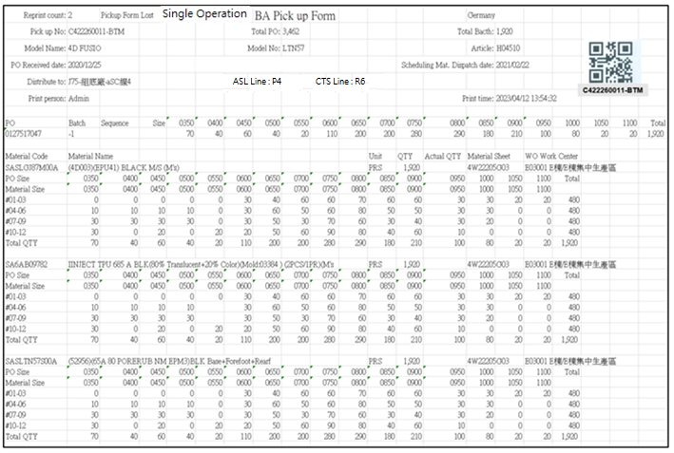

[圖MPS102_5] Regular Pickup Form – Size Material

|  |  |  |  |  |  |  |
| --- | --- | --- | --- | --- | --- | --- |
| Print Regular Pickup Form – Size Material 列印一般取料單-有尺寸料號 | | | | | | |
| NO | 顯示名稱 | 必填 | 唯讀 | 存改 | 對應欄位 | 欄位型態  欄位說明 |
|  | Reprint count  重印次數 |  |  |  | REPRINT_CNT | Int |
|  | Reprint Reason  重印原因 |  |  |  | User key in Reprint Reason | String |
| SQL  select PRINT_CNT AS REPRINT_CNT  from dbo.CST_MPS_PICKFORM  where PUFGROUP = 'CPUF202302231300073' -- (User select row) | | | | | | |
|  | Form Title Type |  |  |  | TYPE_SPECIAL | String |
|  | Form Title Kind  表單類型 |  |  |  | KIND | String |
|  | Shipping Location  出貨地點 |  |  |  | SHIPPING_LOCATION | String |
| SQL  select top 1 t1.SHIPPING_LOCATION  from [dbo].[ERP_SO] t1  inner join [dbo].[ERP_SOBatch] t2 on t1.SO_NO = t2.SO_NO  where t2.PO_BATCH = '0132957503-4' | | | | | | |
|  | Pickup No  取料單編號 |  |  |  | User selected row | String |
|  | Total Bacth  批次數量 |  |  |  | QUANTITY | Numeric |
|  | Model Name  型體名稱 |  |  |  | MODEL_NAME | String |
|  | Model No  型體編號 |  |  |  | MODEL_NO | String |
|  | Article  Article |  |  |  | ARTICLE | String |
|  | PO Received Date  訂單接單日 |  |  |  | RECEIVED_DATE | Date  yyyy-MM-dd |
|  | PO  訂單號碼 |  |  |  | PO_No | String |
|  | Batch  批次 |  |  |  | BATCH | String |
| SQL：  -- SQL01  SELECT a.TYPE_SPECIAL , a.KIND , b.PO_NO , REPLACE(a.PO_BATCH, b.PO_NO,'') AS BATCH , a.PO_BATCH , b.QUANTITY, c.ARTICLE , c.MODEL_NAME , c.MODEL_NO , a.[SEQUENCE] , a.DEPT_ID , c.RECEIVED_DATE  FROM ( select top 1 TYPE_SPECIAL , PO_BATCH , [SEQUENCE] , DEPT_ID , KIND from dbo.CST_MPS_PICKFORM  where PUFGROUP = 'CPUF202302231300073' ) a -- (User select row)  left join dbo.ERP_SOBATCH b on a.PO_BATCH = b.PO_BATCH  left join dbo.ERP_SO c on b.PO_NO = c.PO_NO | | | | | | |
|  | Total PO  訂單數量 |  |  |  | PO_QUANTITY | Numeric |
| SQL：  -- Get PO Total Qty ( by PO_NO )  SELECT sum(QUANTITY) AS PO_QUANTITY  FROM dbo.ERP_SOBATCH  where PO_NO = '0127517047' -- (SQL01's PO_NO) | | | | | | |
|  | ~~Mat. Standard onhand date~~  ~~標準材料到廠日~~ |  |  |  | ~~Mat_Standard_Onhand_Date~~ | ~~Date~~  ~~yyyy-MM-dd~~  ~~If Mat_Standard_Onhand_Date = 00000000, let it remain empty.~~ |
|  | Scheduling Mat. Dispatch date  配送日期 |  |  |  | Scheduling_Mat_Dispatch_Date | Date  yyyy-MM-dd  If Scheduling_Mat_Dispatch_Date = 00000000, let it remain empty. |
| SQL：  SELECT CASE t1.KIND  WHEN 'AA' THEN Upper_Mat_Plan_On_Hand  WHEN 'PA' THEN Upper_Mat_Plan_On_Hand  WHEN 'UA' THEN Stitching_Mat_Plan_On_Hand  WHEN 'BA' THEN Bottom_Mat_Plan_On_Hand  WHEN 'FA' THEN Assembly_Mat_Plan_On_Hand  ELSE ''  END Mat_Standard_onhand_date  , CASE t1.KIND  WHEN 'AA' THEN t2.CUT_START_DATE  WHEN 'PA' THEN t2.CUT_START_DATE  WHEN 'UA' THEN t2.ST_START_DATE  WHEN 'BA' THEN t2.SF_START_DATE  WHEN 'FA' THEN t2.AS_START_DATE  ELSE ''  END Scheduling_Mat_Dispatch_Date  from dbo.CST_MPS_PICKFORM t1  left join dbo.ERP_PROD_SCHED t2 on t1.PO_BATCH = t2.PO_BATCH  where t1.PUFGROUP = 'CPUF202310071463398' | | | | | | |
|  | Distribute to  分發給 |  |  |  | DEPT_DESC | String |
| SQL：  EXEC dbo.PRD_GET_MPS_Dispatch_WorkCenter_PickupForm 'CPUF202302231300073' | | | | | | |
|  | ASL Line  成型線別 |  |  |  | AS_CELL | String |
|  | CTS Line  針車線別 |  |  |  | ST_TEAM | String |
|  | Print Person  列印人員 |  |  |  | (Login User_Account) | String |
|  | Print Time  列印時間 |  |  |  | User print date and time  (Get from server side) | String  yyyy-MM-dd HH:mm:ss |
| SQL：  -- Production Line (by PO_Batch)  SELECT AS_CELL , ST_TEAM  FROM ERP_PROD_SCHED  WHERE PO_Batch = '0900058014001' | | | | | | |
|  | Sequence  迴轉數 |  |  |  | SEQUENCE | String |
|  | Size  尺寸 |  |  |  | (List All PO’s Size and Qty) | String |
|  | Total (Row)  加總 (每個PO) |  |  |  | SUM (Qty of PO) | Numeric |
| SQL：  -- Size Run Information SQL  -- If SEQUENCE only one number(e.g:#03), then start and end = 3  SELECT SEQUENCE , PO_SIZE , sum(QUANTITY) QUANTITY  FROM dbo.ERP_CYNO_DETAIL  where PO_BATCH = '0127517047-1' -- (SQL01's PO_BATCH)  --and CAST(REPLACE(SEQUENCE, '#', '') AS INT) >= 1 -- (SQL01's SEQUENCE start) -- If Sequence no data, ignore this condition  --and CAST(REPLACE(SEQUENCE, '#', '') AS INT) <= 4 -- (SQL01's SEQUENCE end) -- If Sequence no data, ignore this condition  group by SEQUENCE , PO_SIZE  order by SEQUENCE , PO_SIZE  IF No data found in above SQL (Size Run Information) :  Begin  --Check PUF Kind  If KIND = ‘AA’ (all gridview checked rows Kind = AA)  Begin  Need not print “Size Run Information” (leave empty)  Continue to execute subsequent programs -- keep print out all other PUF information  End    If KIND <> ‘AA’ (any one of gridview checked rows Kind <> AA)  Begin  Show alert message “PO: XXXXXXXXXX-X have no Size run data” – (from column : PO_No , BATCH)  Stop print & Exit program  End  END | | | | | | |
|  | Material Code  料號 |  |  |  | MATERIALNO | String |
|  | Material Name  材料名稱 |  |  |  | MATERIAL_SPEC | String |
|  | Unit  單位 |  |  |  | UNIT | String |
|  | QTY  數量 |  |  |  | SUM(PLAN_QTY)  By every C_MATERIAL_SHEET_NO | Numeric |
|  | Actual QTY  實際數量 |  |  |  | Let it remain empty. | Numeric |
|  | Material Sheet  發料單號 |  |  |  | C_MATERIAL_SHEET_NO | String |
|  | WO Work Center  工單工作中心 |  |  |  | WO_Work_Center | String |
|  | PO Size  訂單尺寸 |  |  |  | PO_SIZE | String |
|  | Material Size  材料尺寸 |  |  |  | MATERIAL_SIZE | String |
|  | Total  總計 |  |  |  | SUM(PLAN_QTY)  By every C_MATERIAL_SHEET_NO | Numeric |
| SQL：  -- Get all C_MATERIAL_SHEET_NO、Material Type (SA、非SA) : by PUFGROUP  select b.C_MATERIAL_SHEET_NO , max( substring(b.MATERIALNO,1,2) )  FROM dbo.CST_MPS_PICKFORM a , dbo.CST_MPS_PICKFORM_DETAIL b , dbo.ERP_ISSUE_DTL d  where a.PUFGROUP = 'CPUF202302231300073' -- (User select row)  and a.PUF = b.PUF  and b.C_MATERIAL_SHEET_NO = d.C_MATERIAL_SHEET_NO  and b.MATERIALNO = d.MATERIALNO  and d.STATUS <> 'D' -- (Always is D)  group by b.C_MATERIAL_SHEET_NO  order by b.C_MATERIAL_SHEET_NO  -- Loop all C_MATERIAL_SHEET_NO  -- Get GENERIC_MATERIAL 、 Material Name 、 Unit  SELECT TOP 1 T3.MATERIALNO, T3.MATERIAL_SPEC, T3.UNIT, (t2.DEPT_ID + ' ' + t4.DEPT_DESC) WO_Work_Center  FROM dbo.CST_MPS_PICKFORM_DETAIL T1  left join dbo.ERP_ISSUE_DTL T2 on T1.C_MATERIAL_SHEET_NO = T2.C_MATERIAL_SHEET_NO and T1.MATERIALNO = T2.MATERIALNO  left join dbo.ERP_MATERIAL T3 on T2.GENERIC_MATERIAL = T3.MATERIALNO  left join dbo.ERP_ORGANIZATION t4 on t2.DEPT_ID = t4.DEPT_ID  where T1.C_MATERIAL_SHEET_NO = '4W22205ABCGC020001'  -- Get max SEQUENCE by PO_BATCH  -- If max SEQUENCE is NULL or Empty, show "No Cycle Sequence data 沒有迴轉表資料" error message, and stop print all Pickup Form (user select)  -- SQL02  SELECT max(CAST(REPLACE(SEQUENCE, '#', '') AS INT)) max_SEQUENCE  FROM dbo.ERP_CYNO_DETAIL  where ( PO_BATCH = '0127517047-1')　-- (SQL01's PO_BATCH)  -- Every three SEQUENCE is a group  -- eg. if SQL02 get max_SEQUENCE = 8, please get 1~3、4~6、7~8, three rows data  -- eg. if SQL02 get max_SEQUENCE = 4, please get 1~3、4~4, two rows data  -- Sum Total QTY Total by every C_MATERIAL_SHEET_NO  select t1.PO_BATCH , t1.PO_SIZE , t2.MATERIAL_SIZE , t1.QUANTITY  from (  SELECT PO_BATCH , PO_SIZE , sum(QUANTITY) AS QUANTITY  FROM dbo.ERP_CYNO_DETAIL  where ( PO_BATCH = '0127517047-1') -- (SQL01's PO_BATCH)  and CAST(REPLACE(SEQUENCE, '#', '') AS INT) >= 1 -- Every three SEQUENCE is a group  and CAST(REPLACE(SEQUENCE, '#', '') AS INT) <= 3 -- Every three SEQUENCE is a group  group by PO_BATCH , PO_SIZE  ) AS t1  left join dbo.ERP_ISSUE_DTL t2  on t1.PO_BATCH = t2.PO_BATCH  and t1.PO_SIZE = t2.PO_SIZE  and t2.C_MATERIAL_SHEET_NO = '4W22205ABCGC020001' -- (C_MATERIAL_SHEET_NO)  order by t1.PO_BATCH , t1.PO_SIZE | | | | | | |
| Check if need to print “Strip information”  1. Only PA Pickup Form need to check  Form Title Kind = ‘PA’  select Remark01 as Factory from MES_WPC_EXTENDITEM where CLASS = 'Factory'  - Get materialno list need to print Strip information  SQL：  if Factory = '2020'  exit sub (do nothing, Factory 2020 need not to call procedure)  else  exec PRD_GET_MPS_Pickup_Form_AA_STRIP_MATERIALNO_List @PUFGroup = 'NCPUF202308221007059' ,@PO_BATCH = '0133474933'  - if no row return，need not to print  else  1. Print a separate line first  2. Loop all return rows  Begin  -- (call procedure PRD_GET_MPS_Pickup_Form_AA_STRIP_Info to get and print Strip information)  exec PRD_GET_MPS_Pickup_Form_AA_STRIP_Info @PUFGroup = 'NCPUF202308221007059'  ,@PO_BATCH = '0133474933' , @MATERIALNO = 'RAPAD000000124'  End  2. Only AA Pickup Form need to check “MT Instruction” (**Function MT Instruction**)  (Form Title Kind = ‘AA’)  (MT Instruction is all the same , click Ctrl and link to go to MT Instruction)    [圖MPS102_5_1] Regular Pickup Form – Size Material with strip material information   |  |  |  |  |  |  |  | | --- | --- | --- | --- | --- | --- | --- | |  | Material Name  料號名稱 |  |  |  | Material_SPEC | String  Put on top of grid table in one row | |  | Material Code  料號 |  |  |  | MATERIALNO | String | |  | Qty  數量 |  |  |  | Qty | Numeric | |  | Unit  單位 |  |  |  | Unit | String | |  | AA_MATERIALNO  AA料號 |  |  |  | AA_MATERIALNO | String | |  | MATERIAL Name  AA料號名稱 |  |  |  | AA_MATERIAL_SPEC | String | |  | AA_Qty  數量 |  |  |  | AA_Qty | Numeric | |  | AA_Unit  AA單位 |  |  |  | AA_Unit | String | |  | Size_Area  尺寸分布 |  |  |  | Size_Area | String | | | | | | | |
| After Print，Update [CST_MPS_PICKFORM].[PRINT_CNT] and [CST_MPS_PICKFORM].[PRINT_TIME] (use server time)  SQL：  update dbo.CST_MPS_PICKFORM  set PRINT_CNT = PRINT_CNT + 1  , REPRINT_REASON = 'Pickup Form Lost' --(User key in Reprint Reason)  , PRINT_TIME = GETDATE() -- Server time，yyyy/MM/dd HH:mm:ss  where PUFGROUP = 'CPUF202302231300073' --(User select row) | | | | | | |

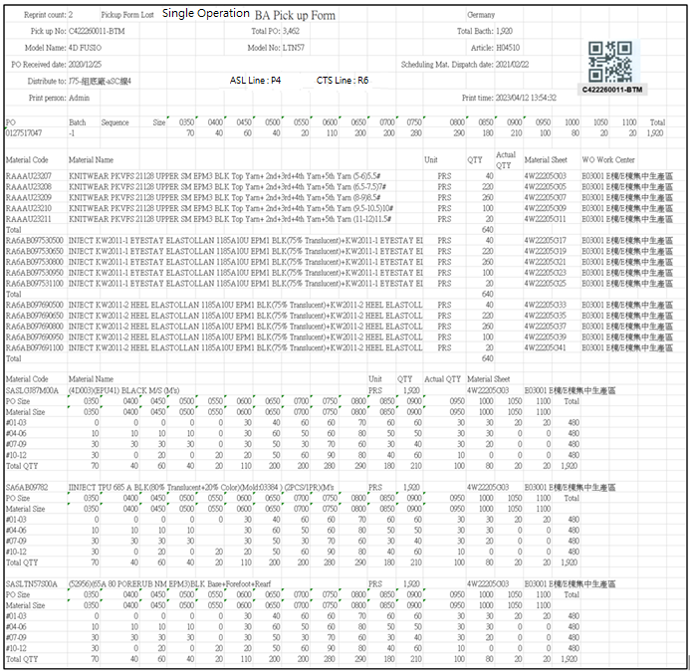

[圖MPS102_6] Regular Pickup Form – Mix Material

|  |  |  |  |  |  |  |
| --- | --- | --- | --- | --- | --- | --- |
| Print Regular Pickup Form – Mix Material (No size + Size) 列印一般取料單-混合料號 (無尺寸 + 有尺寸) | | | | | | |
| NO | 顯示名稱 | 必填 | 唯讀 | 存改 | 對應欄位 | 欄位型態  欄位說明 |
|  | Reprint count  重印次數 |  |  |  | REPRINT_CNT | Int |
|  | Reprint Reason  重印原因 |  |  |  | User key in Reprint Reason | String |
| SQL  select PRINT_CNT AS REPRINT_CNT  from dbo.CST_MPS_PICKFORM  where PUFGROUP = 'CPUF202302231300001' -- (User select row) | | | | | | |
|  | Form Title Type |  |  |  | TYPE_SPECIAL | String |
|  | Form Title Kind  表單類型 |  |  |  | KIND | String |
|  | Shipping Location  出貨地點 |  |  |  | SHIPPING_LOCATION | String |
| SQL  select top 1 t1.SHIPPING_LOCATION  from [dbo].[ERP_SO] t1  inner join [dbo].[ERP_SOBatch] t2 on t1.SO_NO = t2.SO_NO  where t2.PO_BATCH = '0132957503-4' | | | | | | |
|  | Pickup No  取料單編號 |  |  |  | User selected row | String |
|  | Total Bacth  批次數量 |  |  |  | QUANTITY | Numeric |
|  | Model Name  型體名稱 |  |  |  | MODEL_NAME | String |
|  | Model No  型體編號 |  |  |  | MODEL_NO | String |
|  | Article  Article |  |  |  | ARTICLE | String |
|  | PO Received Date  訂單接單日 |  |  |  | RECEIVED_DATE | Date  yyyy-MM-dd |
|  | PO  訂單號碼 |  |  |  | PO_No | String |
|  | Batch  批次 |  |  |  | BATCH | String |
| SQL：  -- SQL01  SELECT a.TYPE_SPECIAL , a.KIND , b.PO_NO , REPLACE(a.PO_BATCH, b.PO_NO,'') AS BATCH , a.PO_BATCH , b.QUANTITY, c.ARTICLE , c.MODEL_NAME , c.MODEL_NO , a.[SEQUENCE] , a.DEPT_ID , c.RECEIVED_DATE  FROM ( select top 1 TYPE_SPECIAL , PO_BATCH , [SEQUENCE] , DEPT_ID , KIND from dbo.CST_MPS_PICKFORM  where PUFGROUP = 'CPUF202302231300001' ) a -- (User select row)  left join dbo.ERP_SOBATCH b on a.PO_BATCH = b.PO_BATCH  left join dbo.ERP_SO c on b.PO_NO = c.PO_NO | | | | | | |
|  | Total PO  訂單數量 |  |  |  | PO_QUANTITY | Numeric |
| SQL：  -- Get PO Total Qty ( by PO_NO )  SELECT sum(QUANTITY) AS PO_QUANTITY  FROM dbo.ERP_SOBATCH  where PO_NO = '0127517048' -- (SQL01's PO_NO) | | | | | | |
|  | ~~Mat. Standard onhand date~~  ~~標準材料到廠日~~ |  |  |  | ~~Mat_Standard_Onhand_Date~~ | ~~Date~~  ~~yyyy-MM-dd~~  ~~If Mat_Standard_Onhand_Date = 00000000, let it remain empty.~~ |
|  | Scheduling Mat. Dispatch date  配送日期 |  |  |  | Scheduling_Mat_Dispatch_Date | Date  yyyy-MM-dd  If Scheduling_Mat_Dispatch_Date = 00000000, let it remain empty. |
| SQL：  SELECT CASE t1.KIND  WHEN 'AA' THEN Upper_Mat_Plan_On_Hand  WHEN 'PA' THEN Upper_Mat_Plan_On_Hand  WHEN 'UA' THEN Stitching_Mat_Plan_On_Hand  WHEN 'BA' THEN Bottom_Mat_Plan_On_Hand  WHEN 'FA' THEN Assembly_Mat_Plan_On_Hand  ELSE ''  END Mat_Standard_onhand_date  , CASE t1.KIND  WHEN 'AA' THEN t2.CUT_START_DATE  WHEN 'PA' THEN t2.CUT_START_DATE  WHEN 'UA' THEN t2.ST_START_DATE  WHEN 'BA' THEN t2.SF_START_DATE  WHEN 'FA' THEN t2.AS_START_DATE  ELSE ''  END Scheduling_Mat_Dispatch_Date  from dbo.CST_MPS_PICKFORM t1  left join dbo.ERP_PROD_SCHED t2 on t1.PO_BATCH = t2.PO_BATCH  where t1.PUFGROUP = 'CPUF202310071463398' | | | | | | |
|  | Distribute to  分發給 |  |  |  | DEPT_DESC | String |
| SQL：  EXEC dbo.PRD_GET_MPS_Dispatch_WorkCenter_PickupForm 'CPUF202302231300001' | | | | | | |
|  | ASL Line  成型線別 |  |  |  | AS_CELL | String |
|  | CTS Line  針車線別 |  |  |  | ST_TEAM | String |
|  | Print Person  列印人員 |  |  |  | (Login User_Account) | String |
|  | Print Time  列印時間 |  |  |  | User print date and time  (Get from server side) | String  yyyy-MM-dd HH:mm:ss |
| SQL：  -- Production Line (by PO_Batch)  SELECT AS_CELL , ST_TEAM  FROM ERP_PROD_SCHED  WHERE PO_Batch = '0900058014001' | | | | | | |
|  | Sequence  迴轉數 |  |  |  | SEQUENCE | String |
|  | Size  尺寸 |  |  |  | (List All PO’s Size and Qty) | String |
|  | Total (Row)  加總 (每個PO) |  |  |  | SUM (Qty of PO) | Numeric |
| SQL：  -- Size Run Information SQL  -- If SEQUENCE only one number(e.g:#03), then start and end = 3  SELECT SEQUENCE , PO_SIZE , sum(QUANTITY) QUANTITY  FROM dbo.ERP_CYNO_DETAIL  where PO_BATCH = '0127517048' -- (SQL01's PO_BATCH)  and CAST(REPLACE(SEQUENCE, '#', '') AS INT) >= 1 -- (SQL01's SEQUENCE start) -- If Sequence no data, ignore this condition  and CAST(REPLACE(SEQUENCE, '#', '') AS INT) <= 4 -- (SQL01's SEQUENCE end) -- If Sequence no data, ignore this condition  group by SEQUENCE , PO_SIZE  order by SEQUENCE , PO_SIZE  IF No data found in above SQL (Size Run Information) :  Begin  --Check PUF Kind  If KIND = ‘AA’ (all gridview checked rows Kind = AA)  Begin  Need not print “Size Run Information” (leave empty)  Continue to execute subsequent programs -- keep print out all other PUF information  End    If KIND <> ‘AA’ (any one of gridview checked rows Kind <> AA)  Begin  Show alert message “PO: XXXXXXXXXX-X have no Size run data” – (from column : PO_No , BATCH)  Stop print & Exit program  End  END | | | | | | |
| **Get all C_MATERIAL_SHEET_NO、MATERIAL_CATEGORY** | | | | | | |
| **SQL：**  -- Get all C_MATERIAL_SHEET_NO、MATERIAL_CATEGORY : by PUFGROUP  select b.C_MATERIAL_SHEET_NO , max( c.MATERIAL_CATEGORY ) AS MATERIAL_CATEGORY  FROM dbo.CST_MPS_PICKFORM a , dbo.CST_MPS_PICKFORM_DETAIL b , dbo.ERP_MATERIAL c , dbo.ERP_ISSUE_DTL d  where a.PUFGROUP = 'CPUF202304040800001' --(User select row)  and a.PUF = b.PUF  and b.MATERIALNO = c.MATERIALNO  and b.C_MATERIAL_SHEET_NO = d.C_MATERIAL_SHEET_NO  and b.MATERIALNO = d.MATERIALNO  and d.STATUS <> 'D' -- (Always is D)  group by b.C_MATERIAL_SHEET_NO  order by max( c.MATERIAL_CATEGORY ) , b.C_MATERIAL_SHEET_NO | | | | | | |
| **No Size Part：If MATERIAL_CATEGORY != ‘02’** | | | | | | |
|  | Material Code  料號 |  |  |  | MATERIALNO | String |
|  | Material Name  材料名稱 |  |  |  | MATERIAL_SPEC | String |
|  | Unit  單位 |  |  |  | UNIT | String |
|  | QTY  數量 |  |  |  | PLAN_QTY | Numeric |
|  | Actual QTY  實際數量 |  |  |  | Let it remain empty. | Numeric |
|  | Material Sheet  發料單號 |  |  |  | ~~MATERIAL_SHEET_NO~~  C_MATERIAL_SHEET_NO | String |
|  | WO Work Center  工單工作中心 |  |  |  | WO_Work_Center | String |
|  | Total  總計 |  |  |  | SUM(PLAN_QTY)  By every C_MATERIAL_SHEET_NO | Numeric |
| SQL：  -- Loop all C_MATERIAL_SHEET_NO  -- Sum PLAN_QTY Total by every C_MATERIAL_SHEET_NO  SELECT distinct T1.MATERIALNO, T3.MATERIAL_SPEC, T3.UNIT, T1.PLAN_QTY, T1.C_MATERIAL_SHEET_NO,  ( ISNULL(t5.DEPT_ID , t2.DEPT_ID) + ' ' + t4.DEPT_DESC) WO_work_center  FROM dbo.CST_MPS_PICKFORM_DETAIL T1  left join dbo.ERP_ISSUE_DTL T2 on T1.C_MATERIAL_SHEET_NO = T2.C_MATERIAL_SHEET_NO and T1.MATERIALNO = T2.MATERIALNO  and T1.MATERIAL_SHEET_NO = T2.MATERIAL_SHEET_NO  inner join dbo.CST_MPS_PICKFORM T0 on T0.puf = T1.puf  left join ERP_ISSUE_DTL_Dept_DTL T5 on T5.C_MATERIAL_SHEET_NO = T1.C_MATERIAL_SHEET_NO  and T5.MATERIAL_SHEET_NO = T1.MATERIAL_SHEET_NO  and T5.MATERIALNO = T1.MATERIALNO  and T5.PO_BATCH = T0.PO_BATCH  and T5.Item_NO = T2.Item_NO  and T5.DEPT_ID = T1.DEPT_ID_Original  left join dbo.ERP_MATERIAL T3 on T2.MATERIALNO = T3.MATERIALNO and T1.MATERIALNO = T3.MATERIALNO  left join dbo.ERP_ORGANIZATION t4 on ISNULL(t5.DEPT_ID , t2.DEPT_ID) = t4.DEPT_ID  where T1.C_MATERIAL_SHEET_NO = 'C4W241212003338'  and T0.pufgroup = 'CPUF202412191593043' --User selected row  order by T1.MATERIALNO | | | | | | |
| **Size Part：If MATERIAL_CATEGORY = ‘02’** | | | | | | |
|  | Material Code  料號 |  |  |  | TOP 1 MATERIALNO | String |
|  | Material Name  材料名稱 |  |  |  | TOP 1 MATERIAL_SPEC | String |
|  | Unit  單位 |  |  |  | TOP 1 UNIT | String |
|  | QTY  數量 |  |  |  | SUM(PLAN_QTY)  By every C_MATERIAL_SHEET_NO | Numeric |
|  | Actual QTY  實際數量 |  |  |  | Let it remain empty | Numeric |
|  | Material Sheet  發料單號 |  |  |  | C_MATERIAL_SHEET_NO | String |
|  | WO Work Center  工單工作中心 |  |  |  | TOP 1 WO_Work_Center | String |
|  | PO Size  訂單尺寸 |  |  |  | PO_SIZE | String |
|  | Material Size  材料尺寸 |  |  |  | MATERIAL_SIZE | String |
|  | Total  總計 |  |  |  | SUM(PLAN_QTY)  By every C_MATERIAL_SHEET_NO | Numeric |
| SQL：  -- Loop all C_MATERIAL_SHEET_NO  -- Get GENERIC_MATERIAL 、 Material Name 、 Unit  SELECT TOP 1 T3.MATERIALNO, T3.MATERIAL_SPEC, T3.UNIT, (t2.DEPT_ID + ' ' + t4.DEPT_DESC) WO_Work_Center  FROM dbo.CST_MPS_PICKFORM_DETAIL T1  left join dbo.ERP_ISSUE_DTL T2 on T1.C_MATERIAL_SHEET_NO = T2.C_MATERIAL_SHEET_NO and T1.MATERIALNO = T2.MATERIALNO  left join dbo.ERP_MATERIAL T3 on T2.GENERIC_MATERIAL = T3.MATERIALNO  left join dbo.ERP_ORGANIZATION t4 on t2.DEPT_ID = t4.DEPT_ID  where T1.C_MATERIAL_SHEET_NO = '4W22205ABCGC020001'  -- Get max SEQUENCE by PO_BATCH  -- If max SEQUENCE is NULL or Empty, show "No Cycle Sequence data 沒有迴轉表資料" error message, and stop print all Pickup Form (user select)  -- SQL02  SELECT max(CAST(REPLACE(SEQUENCE, '#', '') AS INT)) max_SEQUENCE  FROM dbo.ERP_CYNO_DETAIL  where ( PO_BATCH = '0127517047-1')　-- (SQL01's PO_BATCH)  -- Every three SEQUENCE is a group  -- eg. if SQL02 get max_SEQUENCE = 8, please get 1~3、4~6、7~8, three rows data  -- eg. if SQL02 get max_SEQUENCE = 4, please get 1~3、4~4, two rows data  -- Sum Total QTY Total by every C_MATERIAL_SHEET_NO  select t1.PO_BATCH , t1.PO_SIZE , t2.MATERIAL_SIZE , t1.QUANTITY  from (  SELECT PO_BATCH , PO_SIZE , sum(QUANTITY) AS QUANTITY  FROM dbo.ERP_CYNO_DETAIL  where ( PO_BATCH = '0127517047-1') -- (SQL01's PO_BATCH)  and CAST(REPLACE(SEQUENCE, '#', '') AS INT) >= 1 -- Every three SEQUENCE is a group  and CAST(REPLACE(SEQUENCE, '#', '') AS INT) <= 3 -- Every three SEQUENCE is a group  group by PO_BATCH , PO_SIZE  ) AS t1  left join dbo.ERP_ISSUE_DTL t2  on t1.PO_BATCH = t2.PO_BATCH  and t1.PO_SIZE = t2.PO_SIZE  and t2.C_MATERIAL_SHEET_NO = '4W22205ABCGC020001' -- (C_MATERIAL_SHEET_NO)  order by t1.PO_BATCH , t1.PO_SIZE | | | | | | |
| Check if need to print “Strip information”  1. Only PA Pickup Form need to check  Form Title Kind = ‘PA’  select Remark01 as Factory from MES_WPC_EXTENDITEM where CLASS = 'Factory'  - Get materialno list need to print Strip information  SQL：  if Factory = '2020'  exit sub (do nothing, Factory 2020 need not to call procedure)  else  exec PRD_GET_MPS_Pickup_Form_AA_STRIP_MATERIALNO_List @PUFGroup = 'NCPUF202308221007059' ,@PO_BATCH = '0133474933'  - if no row return，need not to print  else  1. Print a separate line first  2. Loop all return rows  Begin  -- (call procedure PRD_GET_MPS_Pickup_Form_AA_STRIP_Info to get and print Strip information)  exec PRD_GET_MPS_Pickup_Form_AA_STRIP_Info @PUFGroup = 'NCPUF202308221007059'  ,@PO_BATCH = '0133474933' , @MATERIALNO = 'RAPAD000000124'  End  2. Only AA Pickup Form need to check “MT Instruction” (**Function MT Instruction**)  (Form Title Kind = ‘AA’)  (MT Instruction is all the same , click Ctrl and link to go to MT Instruction)    [圖MPS102_6_1] Regular Pickup Form – Mix Material with strip material information   |  |  |  |  |  |  |  | | --- | --- | --- | --- | --- | --- | --- | |  | Material Name  料號名稱 |  |  |  | Material_SPEC | String  Put on top of grid table in one row | |  | Material Code  料號 |  |  |  | MATERIALNO | String | |  | Qty  數量 |  |  |  | Qty | Numeric | |  | Unit  單位 |  |  |  | Unit | String | |  | AA_MATERIALNO  AA料號 |  |  |  | AA_MATERIALNO | String | |  | MATERIAL Name  AA料號名稱 |  |  |  | AA_MATERIAL_SPEC | String | |  | AA_Qty  數量 |  |  |  | AA_Qty | Numeric | |  | AA_Unit  AA單位 |  |  |  | AA_Unit | String | |  | Size_Area  尺寸分布 |  |  |  | Size_Area | String | | | | | | | |
| After Print，Update [CST_MPS_PICKFORM].[PRINT_CNT] and [CST_MPS_PICKFORM].[PRINT_TIME] (use server time)  SQL：  update dbo.CST_MPS_PICKFORM  set PRINT_CNT = PRINT_CNT + 1  , REPRINT_REASON = 'Pickup Form Lost' --(User key in Reprint Reason)  , PRINT_TIME = GETDATE() -- Server time，yyyy/MM/dd HH:mm:ss  where PUFGROUP = 'CPUF202304040800001' --(User select row) | | | | | | |

**B：Print Combined Pickup Form 列印合併取料單**：

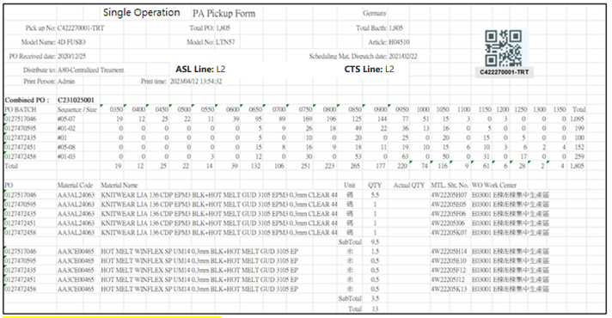

[圖MPS102_7] Combined Pickup Form

|  |  |  |  |  |  |  |
| --- | --- | --- | --- | --- | --- | --- |
| Print Combined Pickup Form 列印合併取料單 | | | | | | |
| NO | 顯示名稱 | 必填 | 唯讀 | 存改 | 對應欄位 | 欄位型態  欄位說明 |
|  | Reprint count  重印次數 |  |  |  | REPRINT_CNT | Int |
|  | Reprint Reason  重印原因 |  |  |  | User key in Reprint Reason | String |
| SQL  select PRINT_CNT AS REPRINT_CNT  from dbo.CST_MPS_PICKFORM  where PUFGROUP = 'CPUF202302231300003' -- (User select row) | | | | | | |
|  | Form Title Type |  |  |  | TYPE_SPECIAL | String |
|  | Form Title Kind  表單類型 |  |  |  | KIND | String |
|  | Shipping Location  出貨地點 |  |  |  | SHIPPING_LOCATION | String |
| SQL  select top 1 t1.SHIPPING_LOCATION  from [dbo].[ERP_SO] t1  inner join [dbo].[ERP_SOBatch] t2 on t1.SO_NO = t2.SO_NO  where t2.PO_BATCH = '0132957503-4' --(TOP 1 PO_BATCH) | | | | | | |
|  | Pickup No  取料單編號 |  |  |  | User selected row | String |
|  | Total Bacth  批次數量 |  |  |  | SUM (QUANTITY) | Numeric |
|  | Model Name  型體名稱 |  |  |  | MODEL_NAME | String |
|  | Model No  型體編號 |  |  |  | TOP 1 MODEL_NO | String |
|  | Article  Article |  |  |  | TOP 1 ARTICLE | String |
|  | PO Received Date  訂單接單日 |  |  |  | TOP 1 RECEIVED_DATE | Date  yyyy-MM-dd |
|  | PO BATCH  訂單號碼 批次 |  |  |  | PO_BATCH | String |
|  | Sequence  迴轉數 |  |  |  | SEQUENCE | String |
| SQL：  --SQL01  SELECT a.TYPE_SPECIAL , a.KIND , b.PO_NO , a.PO_BATCH , b.QUANTITY, c.ARTICLE , c.MODEL_NAME , c.MODEL_NO  , a.SEQUENCE , a.DEPT_ID , c.RECEIVED_DATE  FROM ( select TYPE_SPECIAL , PO_BATCH , [SEQUENCE] , DEPT_ID , KIND from dbo.CST_MPS_PICKFORM  where PUFGROUP = 'CPUF202302231300003' ) AS a -- (User select row)  left join dbo.ERP_SOBATCH b on a.PO_BATCH = b.PO_BATCH  left join dbo.ERP_SO c on b.PO_NO = c.PO_NO  Loop to check  If SQL01’s [SEQUENCE] is empty  -- If SEQUENCE = ''  -- Get max SEQUENCE by PO_BATCH  -- SEQUENCE = #1-#max_SEQUENCE e.g: #1-#12 e.g: #1-#1  SELECT max(CAST([SEQUENCE] AS INT)) max_SEQUENCE  FROM dbo.ERP_CYNO_DETAIL  WHERE ( PO_BATCH = '0126113778') -- (SQL01's PO_BATCH)  IF No data found in above SQL (max_SEQUENCE) :  --Check PUF Kind  If KIND = ‘AA’ (all gridview checked rows Kind = AA)  Begin  Ignore max_SEQUENCE ( the subsequent program will not print size run information)  Continue to execute subsequent programs -- keep print out all other PUF information  End    If KIND <> ‘AA’ (any one of gridview checked rows Kind <> AA)  Begin  Show alert message “PO: XXXXXXXXXX-X have no Size run data” – (from column : PO_No , BATCH)  Stop print & Exit program  End | | | | | | |
|  | Total PO  訂單數量 |  |  |  | PO_QUANTITY | Numeric |
| SQL：  -- Get PO Total Qty ( by PO_NO )  SELECT sum(QUANTITY) AS PO_QUANTITY  FROM dbo.ERP_SOBATCH  where PO_NO in ('0127517048', '0127517049') -- (SQL01's PO_NO) | | | | | | |
|  | ~~Mat. Standard onhand date~~  ~~標準材料到廠日~~ |  |  |  | ~~Mat_Standard_Onhand_Date~~ | ~~Date~~  ~~yyyy-MM-dd~~  ~~If Mat_Standard_Onhand_Date = 00000000, let it remain empty.~~ |
|  | Scheduling Mat. Dispatch date  配送日期 |  |  |  | Scheduling_Mat_Dispatch_Date | Date  yyyy-MM-dd  If Scheduling_Mat_Dispatch_Date = 00000000, let it remain empty. |
| SQL：  SELECT top 1 CASE t1.KIND  WHEN 'AA' THEN Upper_Mat_Plan_On_Hand  WHEN 'PA' THEN Upper_Mat_Plan_On_Hand  WHEN 'UA' THEN Stitching_Mat_Plan_On_Hand  WHEN 'BA' THEN Bottom_Mat_Plan_On_Hand  WHEN 'FA' THEN Assembly_Mat_Plan_On_Hand  ELSE ''  END Mat_Standard_onhand_date  , CASE t1.KIND  WHEN 'AA' THEN t2.CUT_START_DATE  WHEN 'PA' THEN t2.CUT_START_DATE  WHEN 'UA' THEN t2.ST_START_DATE  WHEN 'BA' THEN t2.SF_START_DATE  WHEN 'FA' THEN t2.AS_START_DATE  ELSE ''  END Scheduling_Mat_Dispatch_Date  from dbo.CST_MPS_PICKFORM t1  left join dbo.ERP_PROD_SCHED t2 on t1.PO_BATCH = t2.PO_BATCH  where t1.PUFGROUP = 'CPUF202310071463398'  and t2.CUT_START_DATE <> '00000000'  order by t2.CUT_START_DATE | | | | | | |
|  | Distribute to  分發給 |  |  |  | DEPT_DESC | String |
| SQL：  EXEC dbo.PRD_GET_MPS_Dispatch_WorkCenter_PickupForm 'CPUF202302231300003' | | | | | | |
|  | ASL Line  成型線別 |  |  |  | AS_CELL  join all data by ", " | String  e.g: E3, E4, E5 |
|  | CTS Line  針車線別 |  |  |  | ST_TEAM  join all data by ", " | String  e.g: E3, E4, E5 |
|  | Print Person  列印人員 |  |  |  | (Login User_Account) | String |
|  | Print Time  列印時間 |  |  |  | User print date and time  (Get from server side) | String  yyyy-MM-dd HH:mm:ss |
| SQL：  -- Distinct Production Line (by All PO_Batch)  SELECT DISTINCT AS_CELL  FROM ERP_PROD_SCHED  WHERE PO_Batch in ('0132855033', '0132855034', '0132855035', '0132855036')  -- SQL CTS Line Combined  SELECT DISTINCT ST_TEAM  FROM ERP_PROD_SCHED  WHERE PO_Batch in ('0132855033', '0132855034', '0132855035', '0132855036') | | | | | | |
|  | Combined PO |  |  |  | COMBINE_PO_BATCH | String |
| SQL：  -- Distinct Production Line (by All PO_Batch)  select top 1 COMBINE_PO_BATCH  FROM dbo.CST_MPS_PICKFORM  where PUFGROUP = 'CPUF202311030858327' | | | | | | |
|  | Size  尺寸 |  |  |  | (List All PO’s Size and Qty) | String |
|  | Total (Column)  加總 (每個尺寸) |  |  |  | SUM (Qty of every size) | Numeric |
|  | Total (Row)  加總 (每個PO) |  |  |  | SUM (Qty of every PO) | Numeric |
| SQL：  -- SQL02  select PO_BATCH, SEQUENCE  from dbo.CST_MPS_PICKFORM  where PUFGROUP = 'CPUF202302231300003'  group by PO_BATCH, SEQUENCE  order by PO_BATCH, SEQUENCE  -- Loop all SQL02’s data and Get PO Size run information ( by All PO_BATCH and Sequence in SQL02 )  -- If SEQUENCE only one number(e.g:#03), then start and end = 3  SELECT PO_BATCH , PO_SIZE , sum(QUANTITY) QUANTITY  FROM dbo.ERP_CYNO_DETAIL  where PO_BATCH = '0127517048' -- (SQL02's PO_BATCH)  and CAST(REPLACE(SEQUENCE, '#', '') AS INT) >= 9 -- (SQL02's SEQUENCE start) -- If Sequence no data, ignore this condition  and CAST(REPLACE(SEQUENCE, '#', '') AS INT) <= 10 -- (SQL02's SEQUENCE end) -- If Sequence no data, ignore this condition  group by PO_BATCH , PO_SIZE  order by PO_BATCH , PO_SIZE | | | | | | |
|  | PO  訂單號碼 |  |  |  | PO_BATCH | String |
|  | Material Code  料號 |  |  |  | MATERIALNO | String |
|  | Material Name  材料名稱 |  |  |  | MATERIAL_SPEC | String |
|  | Unit  單位 |  |  |  | UNIT | String |
|  | QTY  數量 |  |  |  | PLAN_QTY | Numeric |
|  | Actual QTY  實際數量 |  |  |  | Let it remain empty | Numeric |
|  | MTL. Sht. No.  發料單號 |  |  |  | ~~MATERIAL_SHEET_NO~~  C_MATERIAL_SHEET_NO | String |
|  | WO Work Center  工單工作中心 |  |  |  | WO_Work_Center | String |
|  | Subtotal  小記 |  |  |  | SUM(PLAN_QTY)  Group By Material No | Numeric |
|  | Total  總計 |  |  |  | SUM(PLAN_QTY) | Numeric |
| SQL：  **-- SQL01**  -- Get all C_MATERIAL_SHEET_NO、Material Type (SA、非SA) : by PUFGROUP  select b.C_MATERIAL_SHEET_NO , max( substring(b.MATERIALNO,1,2) )  FROM dbo.CST_MPS_PICKFORM a , dbo.CST_MPS_PICKFORM_DETAIL b , dbo.ERP_ISSUE_DTL d  where a.PUFGROUP = 'NCPUF20250802103004014W'  and a.PUF = b.PUF  and b.C_MATERIAL_SHEET_NO = d.C_MATERIAL_SHEET_NO  and b.MATERIALNO = d.MATERIALNO  and d.STATUS <> 'D' -- (Always is D)  group by b.C_MATERIAL_SHEET_NO  order by b.C_MATERIAL_SHEET_NO  -- Check TSH PA PUF (separate AA、RA material into different new pages , both need to print pickup form PUF header)  -- Loop all C_MATERIAL_SHEET_NO  SELECT distinct T0.PO_BATCH , T1.MATERIALNO, T3.MATERIAL_SPEC, T3.UNIT, T1.PLAN_QTY, T1.C_MATERIAL_SHEET_NO,  ( ISNULL(t5.DEPT_ID , t2.DEPT_ID) + ' ' + t4.DEPT_DESC) WO_work_center  FROM dbo.CST_MPS_PICKFORM_DETAIL T1  left join dbo.ERP_ISSUE_DTL T2 on T1.C_MATERIAL_SHEET_NO = T2.C_MATERIAL_SHEET_NO and T1.MATERIALNO = T2.MATERIALNO  and T1.MATERIAL_SHEET_NO = T2.MATERIAL_SHEET_NO  inner join dbo.CST_MPS_PICKFORM T0 on T0.puf = T1.puf  left join ERP_ISSUE_DTL_Dept_DTL T5 on T5.C_MATERIAL_SHEET_NO = T1.C_MATERIAL_SHEET_NO  and T5.MATERIAL_SHEET_NO = T1.MATERIAL_SHEET_NO  and T5.MATERIALNO = T1.MATERIALNO  and T5.PO_BATCH = T0.PO_BATCH  and T5.Item_NO = T2.Item_NO  and T5.DEPT_ID = T1.DEPT_ID_Original  left join dbo.ERP_MATERIAL T3 on T2.MATERIALNO = T3.MATERIALNO and T1.MATERIALNO = T3.MATERIALNO  left join dbo.ERP_ORGANIZATION t4 on ISNULL(t5.DEPT_ID , t2.DEPT_ID) = t4.DEPT_ID  where T1.C_MATERIAL_SHEET_NO = 'C4W241212003338'  and T0.pufgroup = 'CPUF202412191593043' --User selected row  order by T1.MATERIALNO | | | | | | |
| Check if need to print “Strip information”  1. Only PA combined Pickup Form need to check  Form Title Kind = ‘PA’  select Remark01 as Factory from MES_WPC_EXTENDITEM where CLASS = 'Factory'  - Get materialno list need to print Strip information  SQL：  if Factory = '2020'  exit sub (do nothing, Factory 2020 need not to call procedure)  else  exec PRD_GET_MPS_Pickup_Form_AA_STRIP_MATERIALNO_List_Combined_PUF @PUFGroup = 'CPUF202311011052982'  3. if no row return，need not to print  else  1. Print a separate line first  2. Loop all return rows  Begin  -- Print Summary  -- (call procedure PRD_GET_MPS_Pickup_Form_AA_STRIP_Info_Combined_PUF to get and print Strip information)  exec PRD_GET_MPS_Pickup_Form_AA_STRIP_Info_Combined_PUF @PUFGroup = 'CPUF202311011052982'  , @MATERIALNO = 'RA2AB000000401'    -- Print Detail  -- for all PO -- (Loop SQL01's PO_Batch List，order by PO_Batch)  Begin  -- (call procedure PRD_GET_MPS_Pickup_Form_AA_STRIP_Info to get and print Strip information)  exec PRD_GET_MPS_Pickup_Form_AA_STRIP_Info @PUFGroup = 'CPUF202311011052982'  ,@PO_BATCH = '0133809590' , @MATERIALNO = 'RA2AB000000401'  End  End    [圖MPS102_8] Combined Pickup Form -- with strip material information  Summary:   |  |  |  |  |  |  |  | | --- | --- | --- | --- | --- | --- | --- | |  | PO_Batch |  |  |  | PO_Batch | String  Put on top of grid table in one row | |  | Material Name  料號名稱 |  |  |  | Material_SPEC | String  Put on top of grid table in one row | |  | Material Code  料號 |  |  |  | MATERIALNO | String | |  | Total_Qty  數量 |  |  |  | Total_Qty | Numeric | |  | Unit  單位 |  |  |  | Unit | String | |  | AA_MATERIALNO  AA料號 |  |  |  | AA_MATERIALNO | String | |  | MATERIAL Name  AA料號名稱 |  |  |  | AA_MATERIAL_SPEC | String | |  | Total_AA_Qty  數量 |  |  |  | Total_AA_Qty | Numeric | |  | AA_Unit  AA單位 |  |  |  | AA_Unit | String | |  | Size_Area  尺寸分布 |  |  |  | Size_Area | String |   Detail:   |  |  |  |  |  |  |  | | --- | --- | --- | --- | --- | --- | --- | |  | Material Name  料號名稱 |  |  |  | Material_SPEC | String  Put on top of grid table in one row | |  | Material Code  料號 |  |  |  | MATERIALNO | String | |  | Qty  數量 |  |  |  | Qty | Numeric | |  | Unit  單位 |  |  |  | Unit | String | |  | AA_MATERIALNO  AA料號 |  |  |  | AA_MATERIALNO | String | |  | MATERIAL Name  AA料號名稱 |  |  |  | AA_MATERIAL_SPEC | String | |  | AA_Qty  數量 |  |  |  | AA_Qty | Numeric | |  | AA_Unit  AA單位 |  |  |  | AA_Unit | String | |  | Size_Area  尺寸分布 |  |  |  | Size_Area | String | | | | | | | |
| After Print，Update [CST_MPS_PICKFORM].[PRINT_CNT] and [CST_MPS_PICKFORM].[PRINT_TIME] (use server time)  SQL：  update dbo.CST_MPS_PICKFORM  set PRINT_CNT = PRINT_CNT + 1  , REPRINT_REASON = 'Pickup Form Lost' --(User key in Reprint Reason)  , PRINT_TIME = GETDATE() -- Server time，yyyy/MM/dd HH:mm:ss  where PUFGROUP = 'CPUF202302231300003' --(User select row) | | | | | | |

* 1. **「MPS103 Print Pickup Form (OEM Order)」MPS103列印取料單(代工訂單)**
  2. 程式名稱：同標題 (Right Name: MPS_Print.Pickup.Form.OEM.Order)
  3. 功能目的：查詢/列印
  4. 使用部門：
  5. 程式說明：

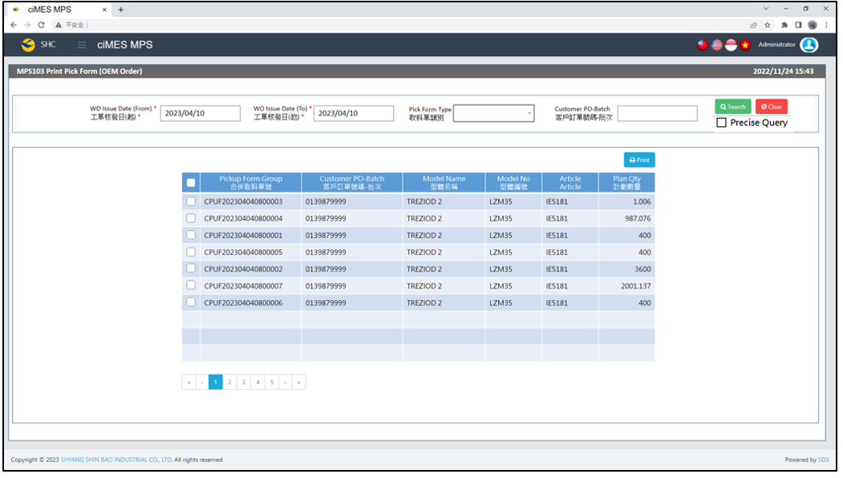

[圖MPS103_1] Main Page主畫面

|  |  |  |  |  |  |  |
| --- | --- | --- | --- | --- | --- | --- |
| Program header 程式標頭 | | | | | | |
| NO | 顯示名稱 | 必填 | 唯讀 | 存改 | 對應欄位 | 說明 |
|  | Title  標題 |  | V |  | CAPTION | String  If there is no get data, please show “Right Name”  SELECT T2.LANGUAGE, T2.CAPTION  FROM [MES_SEC_RIGHT] AS T1  JOIN [MES_MENU_ITEM] AS T2  ON T1.SEC_RIGHT_SID = T2.SEC_RIGHT_SID  WHERE T1.GROUPRIGHTS = 'MPS_Print.Pickup.Form.OEM.Order' --(Right Name) |
|  | System Time  系統時間 |  | V |  | Show current server time | Datetime  yyyy/MM/dd HH:mm |

|  |  |  |  |  |  |  |
| --- | --- | --- | --- | --- | --- | --- |
| Operation button 操作按鈕 | | | | | | |
| NO | 顯示名稱 | 必填 | 唯讀 | 存改 | 對應欄位 | 說明 |
|  | Search  搜尋 |  |  |  |  | Required「WO Issue Date (From)  」and「WO Issue Date (To)」to search |
|  | Clear  清除 |  |  |  |  | Clear Search Condition and Results |
|  | Print  列印 |  |  |  |  | Print the select row data |

|  |  |  |  |  |  |  |
| --- | --- | --- | --- | --- | --- | --- |
| Search Condition 搜尋條件 | | | | | | |
| NO | 顯示名稱 | 必填 | 唯讀 | 存改 | 對應欄位 | 欄位型態  欄位說明 |
|  | WO Issue Date (From)  工單核發日(起) | V |  | V | Filter WO Issue Date column | String  yyyy/MM/dd  Default：Today |
|  | WO Issue Date (To)  工單核發日(訖) | V |  | V | Filter WO Issue Date column | String  yyyy/MM/dd  Default：Today |
|  | Pickup Form Type  取料單類別 |  |  | V | Filter Pickup Form Type column | Dropdown list  SELECT REMARK01 FROM MES_WPC_EXTENDITEM  WHERE CLASS = 'PICKFORM_TYPE'  ORDER BY REMARK01 |
|  | Customer PO-Batch  客戶訂單號碼-批次 |  |  | V | Filter Customer PO-Batch column | String  If chkPrecise is checked  Must exactly matched  Remove % in Search SQL |
|  | Precise Query  精準比對 |  |  | V |  | Check Box : chkPrecise (default : not cheched)  If chkPrecise is checked  Filter Customer PO-Batch column  Must exactly matched  (Remove % in Search SQL Ex : PO_BATCH like '090007695001-1' ) |

|  |  |  |  |  |  |  |
| --- | --- | --- | --- | --- | --- | --- |
| Search 搜尋 | | | | | | |
| NO | 顯示名稱 | 必填 | 唯讀 | 存改 | 對應欄位 | 欄位型態  欄位說明 |
|  | Selector  選擇器 |  |  | V |  | Check Box |
|  | Pickup Form Group  合併取料單號 |  | V |  | PUFGROUP | String |
|  | Customer PO-Batch  客戶訂單號碼-批次 |  | V |  | PO_BATCH | String |
|  | Model Name  型體名稱 |  | V |  | MODEL_NAME | String |
|  | Model No  型體編號 |  | V |  | MODEL_NO | String |
|  | Article  Article |  | V |  | ARTICLE | String |
|  | Plan Qty  計劃數量 |  | V |  | PLAN_QTY | Numeric |
| 程式邏輯說明：  點選 [Search搜尋] 按鈕，依照User填入的搜尋條件(若有)，即可帶出資料。  SQL：  -- 委託他廠CB代工: CST_MPS_PICKFORM.type = '轉交單'  SELECT max(a.KIND) AS KIND , a.PUFGROUP , max(T3.PO_BATCH) AS PO_BATCH , max(c.MODEL_NAME) AS MODEL_NAME ,  max(c.MODEL_NO) AS MODEL_NO , max(c.ARTICLE) AS ARTICLE , sum(b.PLAN_QTY) AS PLAN_QTY  FROM (  select T1.PUFGROUP, string_AGG( T2.PO_BATCH , ', ') PO_BATCH  from (  select PUFGROUP  FROM dbo.CST_MPS_PICKFORM  where PRINT_CNT = 0  and [STATUS] <> 'Terminate'  and type = '轉交單'  and CREATETIME >= '2023/01/01' -- (WO Issue Date (From))  and CREATETIME <= '2024/05/31' -- (WO Issue Date (To))  -- and KIND = 'BA' -- (Pickup Form Type)  -- and PO_BATCH like '0131989861%' -- (Customer PO-Batch)  group by PUFGROUP  ) T1  left join dbo.CST_MPS_PICKFORM T2 on T1.PUFGROUP = T2.PUFGROUP  group by T1.PUFGROUP  ) T3  , dbo.CST_MPS_PICKFORM a , dbo.CST_MPS_PICKFORM_DETAIL b  , ( select PO_NO , max(MODEL_NAME) MODEL_NAME , max(MODEL_NO) MODEL_NO , max(ARTICLE) ARTICLE  from dbo.ERP_SOBATCH group by PO_NO ) c  where T3.PUFGROUP = a.PUFGROUP  and a.PUF = b.PUF  and a.PO_NO = c.PO_NO  and a.PRINT_CNT = 0  group by a.PUFGROUP | | | | | | |

**Print Regular Pickup Form (OEM Order) 列印一般取料單 (代工訂單)**：

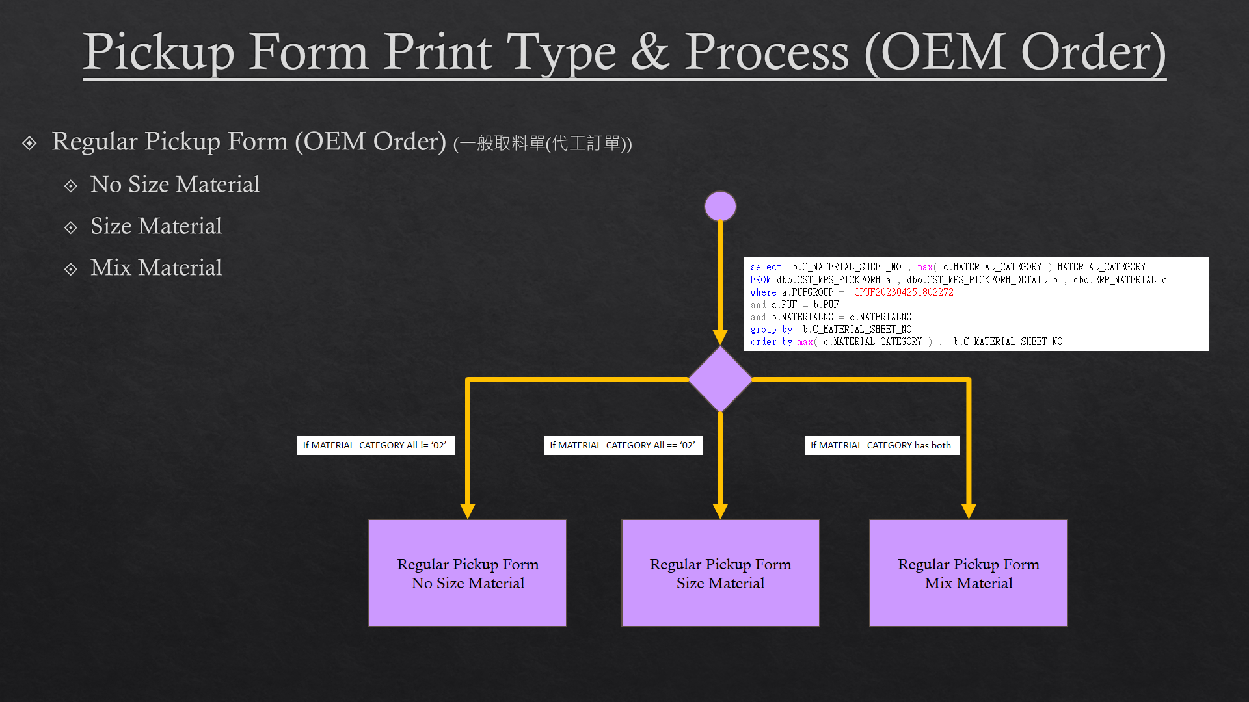

[圖MPS103_2] Pickup Form Print Type & Process (OEM Order)，Check whether there is Size Run

|  |  |  |  |  |  |  |
| --- | --- | --- | --- | --- | --- | --- |
| Print Regular Pickup Form (OEM Order)列印一般取料單 (代工訂單) | | | | | | |
| NO | 顯示名稱 | 必填 | 唯讀 | 存改 | 對應欄位 | 欄位型態  欄位說明 |
|  |  |  |  |  |  |  |
| 程式邏輯說明：  Regular Material Form (OEM Order) need check is Size Run or not Size Run or Mix Material：  If MATERIAL_CATEGORY All == ‘02’，Print「**Regular Pickup Form (OEM Order) – Size Material」**  If MATERIAL_CATEGORY All != ‘02’，Print「**Regular Pickup Form (OEM Order) – No Size Material」**  If MATERIAL_CATEGORY has both，Print「**Regular Pickup Form (OEM Order) – Mix Material」**  SQL：  select b.C_MATERIAL_SHEET_NO , max( c.MATERIAL_CATEGORY ) MATERIAL_CATEGORY  FROM dbo.CST_MPS_PICKFORM a , dbo.CST_MPS_PICKFORM_DETAIL b , dbo.ERP_MATERIAL c  where a.PUFGROUP = 'CPUF202304251802272'  and a.PUF = b.PUF  and b.MATERIALNO = c.MATERIALNO  group by b.C_MATERIAL_SHEET_NO  order by max( c.MATERIAL_CATEGORY ) , max(b.MATERIALNO) | | | | | | |

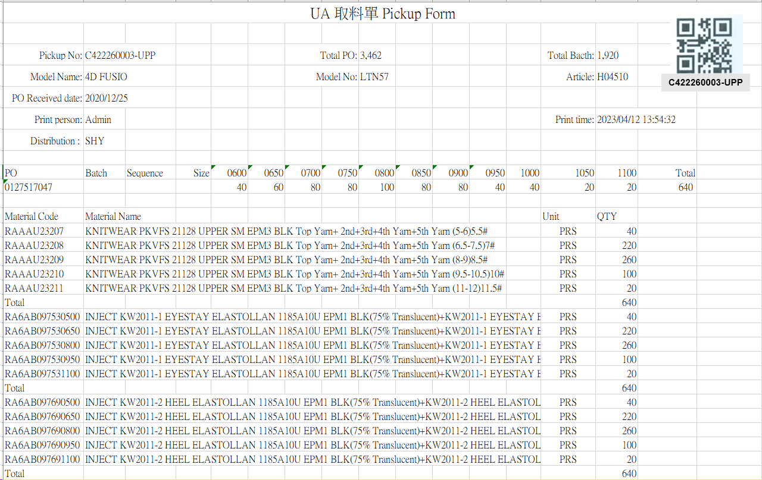

[圖MPS103_3] Regular Pickup Form (OEM Order) – No Size Material

|  |  |  |  |  |  |  |
| --- | --- | --- | --- | --- | --- | --- |
| Print Regular Pickup Form (OEM Order) – No Size Material 列印一般取料單(代工訂單)-無尺寸料號 | | | | | | |
| NO | 顯示名稱 | 必填 | 唯讀 | 存改 | 對應欄位 | 欄位型態  欄位說明 |
|  | Form Title Kind  表單類型 |  |  |  | KIND | String |
|  | Pickup No  取料單編號 |  |  |  | User selected row | String |
|  | Total Bacth  批次數量 |  |  |  | QUANTITY | Numeric |
|  | Model Name  型體名稱 |  |  |  | MODEL_NAME | String |
|  | Model No  型體編號 |  |  |  | MODEL_NO | String |
|  | Article  Article |  |  |  | ARTICLE | String |
|  | PO Received Date  訂單接單日 |  |  |  | RECEIVED_DATE | Date  yyyy-MM-dd |
|  | Print Person  列印人員 |  |  |  | (Login User_Account) | String |
|  | Print Time  列印時間 |  |  |  | User print date and time  (Get from server side) | String  yyyy-MM-dd HH:mm:ss |
|  | Distribution  領料部門 |  |  |  | SUPPLIER_CODE | String |
| SQL:  SELECT top 1 t3.Supplier_Code  FROM ( select * from dbo.CST_MPS_PICKFORM  where PUFGROUP = 'CPUF20231118080000246318' ) t1  inner join dbo.CST_MPS_PICKFORM_DETAIL t2 on t1.PUF = t2.PUF  inner join dbo.ERP_OSISSUE t3 on t2.C_MATERIAL_SHEET_NO = t3.MATERIAL_SHEET_NO | | | | | | |
|  | PO  訂單號碼 |  |  |  | PO_No | String |
|  | Batch  批次 |  |  |  | BATCH | String |
|  | Sequence  迴轉數 |  |  |  | SEQUENCE | String |
| SQL：  -- SQL01  SELECT max(a.KIND) KIND , a.PO_NO , a.PO_NO PO_BATCH , '' BATCH , sum(b.QUANTITY) QUANTITY  , max(c.ARTICLE) ARTICLE , max(c.MODEL_NAME) MODEL_NAME , max(c.MODEL_NO) MODEL_NO  , max(a.[SEQUENCE]) SEQUENCE , max(a.DEPT_ID) DEPT_ID , max(c.RECEIVED_DATE) RECEIVED_DATE  FROM ( select top 1 PO_NO , [SEQUENCE] , DEPT_ID , KIND from dbo.CST_MPS_PICKFORM  where PUFGROUP = 'CPUF20231229170000351419' ) a  left join dbo.ERP_SOBATCH b on a.PO_NO = b.PO_NO  left join dbo.ERP_SO c on b.PO_NO = c.PO_NO  group by a.PO_NO | | | | | | |
|  | Total PO  訂單數量 |  |  |  | PO_QUANTITY | Numeric |
| SQL：  -- Get PO Total Qty ( by PO_NO )  SELECT sum(QUANTITY) AS PO_QUANTITY  FROM dbo.ERP_SOBATCH  where PO_NO = '0134125218' -- (SQL01's PO_NO) | | | | | | |
|  | Size  尺寸 |  |  |  | (List All PO’s Size and Qty) | String |
|  | Total (Row)  加總 (每個PO) |  |  |  | SUM (Qty of PO) | Numeric |
| SQL：  -- Get PO Size run information  SELECT PO_SIZE , sum(QUANTITY) QUANTITY  FROM dbo.ERP_CYNO_DETAIL  where PO_BATCH like '0134125218%' -- (SQL01's PO_NO)  group by PO_SIZE  order by PO_SIZE | | | | | | |
|  | Material Code  料號 |  |  |  | MATERIALNO | String |
|  | Material Name  材料名稱 |  |  |  | MATERIAL_SPEC | String |
|  | Unit  單位 |  |  |  | UNIT | String |
|  | QTY  數量 |  |  |  | PLAN_QTY | Numeric |
|  | Total  總計 |  |  |  | SUM(PLAN_QTY)  By every C_MATERIAL_SHEET_NO | Numeric |
| SQL：  -- Get all C_MATERIAL_SHEET_NO、MATERIAL_CATEGORY : by PUFGROUP  select b.C_MATERIAL_SHEET_NO , max( c.MATERIAL_CATEGORY ) MATERIAL_CATEGORY  FROM dbo.CST_MPS_PICKFORM a , dbo.CST_MPS_PICKFORM_DETAIL b , dbo.ERP_MATERIAL c  where a.PUFGROUP = 'CPUF20231229170000351419'  and a.PUF = b.PUF  and b.MATERIALNO = c.MATERIALNO  group by b.C_MATERIAL_SHEET_NO  order by max( c.MATERIAL_CATEGORY ) , max(b.MATERIALNO)  -- Loop all C_MATERIAL_SHEET_NO  -- Sum PLAN_QTY Total by every C_MATERIAL_SHEET_NO  SELECT T1.MATERIALNO , T3.MATERIAL_SPEC , T3.UNIT , T1.PLAN_QTY  FROM dbo.CST_MPS_PICKFORM_DETAIL T1  left join dbo.ERP_MATERIAL T3 on T1.MATERIALNO = T3.MATERIALNO  where T1.C_MATERIAL_SHEET_NO = 'JW2304250001'  order by T1.MATERIALNO | | | | | | |
| After Print，Update [CST_MPS_PICKFORM].[PRINT_CNT] and [CST_MPS_PICKFORM].[PRINT_TIME] (use server time)  SQL：  update dbo.CST_MPS_PICKFORM  set PRINT_CNT = PRINT_CNT + 1  , PRINT_TIME = GETDATE() -- Server time，yyyy/MM/dd HH:mm:ss  where PUFGROUP = 'CPUF202304251802272' --(User select row) | | | | | | |

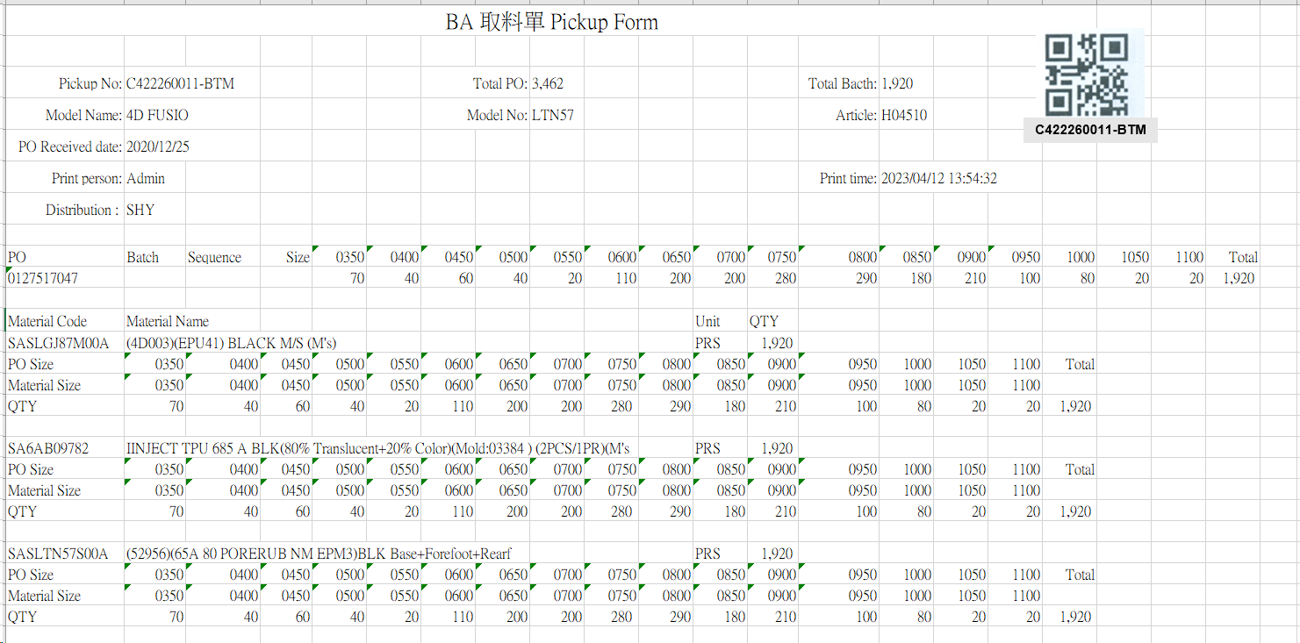

[圖MPS103_4] Regular Pickup Form (OEM Order) – Size Material

|  |  |  |  |  |  |  |
| --- | --- | --- | --- | --- | --- | --- |
| Print Regular Pickup Form (OEM Order) – Size Material 列印一般取料單(代工訂單)-有尺寸料號 | | | | | | |
| NO | 顯示名稱 | 必填 | 唯讀 | 存改 | 對應欄位 | 欄位型態  欄位說明 |
|  | Form Title Kind  表單類型 |  |  |  | KIND | String |
|  | Pickup No  取料單編號 |  |  |  | User selected row | String |
|  | Total Bacth  批次數量 |  |  |  | QUANTITY | Numeric |
|  | Model Name  型體名稱 |  |  |  | MODEL_NAME | String |
|  | Model No  型體編號 |  |  |  | MODEL_NO | String |
|  | Article  Article |  |  |  | ARTICLE | String |
|  | PO Received Date  訂單接單日 |  |  |  | RECEIVED_DATE | Date  yyyy-MM-dd |
|  | Print Person  列印人員 |  |  |  | (Login User_Account) | String |
|  | Print Time  列印時間 |  |  |  | User print date and time  (Get from server side) | String  yyyy-MM-dd HH:mm:ss |
|  | Distribution  領料部門 |  |  |  | SUPPLIER_CODE | String |
| SQL:  SELECT top 1 t3.Supplier_Code  FROM ( select * from dbo.CST_MPS_PICKFORM  where PUFGROUP = 'CPUF20231118080000246318' ) t1  inner join dbo.CST_MPS_PICKFORM_DETAIL t2 on t1.PUF = t2.PUF  inner join dbo.ERP_OSISSUE t3 on t2.C_MATERIAL_SHEET_NO = t3.MATERIAL_SHEET_NO | | | | | | |
|  | PO  訂單號碼 |  |  |  | PO_No | String |
|  | Batch  批次 |  |  |  | BATCH | String |
|  | Sequence  迴轉數 |  |  |  | SEQUENCE | String |
| SQL：  -- SQL01  SELECT max(a.KIND) KIND , a.PO_NO , a.PO_NO PO_BATCH , '' BATCH , sum(b.QUANTITY) QUANTITY  , max(c.ARTICLE) ARTICLE , max(c.MODEL_NAME) MODEL_NAME , max(c.MODEL_NO) MODEL_NO  , max(a.[SEQUENCE]) SEQUENCE , max(a.DEPT_ID) DEPT_ID , max(c.RECEIVED_DATE) RECEIVED_DATE  FROM ( select top 1 PO_NO , [SEQUENCE] , DEPT_ID , KIND from dbo.CST_MPS_PICKFORM  where PUFGROUP = 'CPUF20231229170000351419' ) a  left join dbo.ERP_SOBATCH b on a.PO_NO = b.PO_NO  left join dbo.ERP_SO c on b.PO_NO = c.PO_NO  group by a.PO_NO | | | | | | |
|  | Total PO  訂單數量 |  |  |  | PO_QUANTITY | Numeric |
| SQL：  -- Get PO Total Qty ( by PO_NO )  SELECT sum(QUANTITY) QUANTITY  FROM dbo.ERP_SOBATCH  where PO_NO = '0131989861' -- (SQL01's PO_NO) | | | | | | |
|  | Print Person  列印人員 |  |  |  | (Login User_Account) | String |
|  | Print Time  列印時間 |  |  |  | User print date and time  (Get from server side) | String  yyyy-MM-dd HH:mm:ss |
|  | Size  尺寸 |  |  |  | (List All PO’s Size and Qty) | String |
|  | Total (Row)  加總 (每個PO) |  |  |  | SUM (Qty of PO) | Numeric |
| SQL：  -- Get PO Size run information  SELECT PO_SIZE , sum(QUANTITY) QUANTITY  FROM dbo.ERP_CYNO_DETAIL  where PO_BATCH like '0134125218%' -- (SQL01's PO_NO)  group by PO_SIZE  order by PO_SIZE | | | | | | |
|  | Material Code  料號 |  |  |  | GENERIC_MATERIAL | String |
|  | Material Name  材料名稱 |  |  |  | MATERIAL_SPEC | String |
|  | Unit  單位 |  |  |  | UNIT | String |
|  | QTY  數量 |  |  |  | SUM(PLAN_QTY)  By every C_MATERIAL_SHEET_NO | Numeric |
|  | PO Size  訂單尺寸 |  |  |  | PO_SIZE | String |
|  | Material Size  材料尺寸 |  |  |  | MATERIAL_SIZE | String |
|  | Total  總計 |  |  |  | SUM(PLAN_QTY)  By every C_MATERIAL_SHEET_NO | Numeric |
| SQL：  -- Get all C_MATERIAL_SHEET_NO、MATERIAL_CATEGORY : by PUFGROUP  select b.C_MATERIAL_SHEET_NO , max( c.MATERIAL_CATEGORY ) MATERIAL_CATEGORY  FROM dbo.CST_MPS_PICKFORM a , dbo.CST_MPS_PICKFORM_DETAIL b , dbo.ERP_MATERIAL c  where a.PUFGROUP = 'CPUF20231229170000351419'  and a.PUF = b.PUF  and b.MATERIALNO = c.MATERIALNO  group by b.C_MATERIAL_SHEET_NO  order by max( c.MATERIAL_CATEGORY ) , max(b.MATERIALNO)  -- Loop all C_MATERIAL_SHEET_NO  -- Get GENERIC_MATERIAL 、 Material Name 、 Unit  SELECT top 1 T2.GENERIC_MATERIAL , T3.MATERIAL_SPEC , T3.UNIT  FROM dbo.CST_MPS_PICKFORM_DETAIL T1  -- left join dbo.ERP_OSISSUE_DTL T2 on T1.C_MATERIAL_SHEET_NO = T2.C_MATERIAL_SHEET_NO and T1.MATERIALNO = T2.MATERIALNO  left join dbo.ERP_MATERIAL T2 on T1.MATERIALNO = T2.MATERIALNO  left join dbo.ERP_MATERIAL T3 on T2.GENERIC_MATERIAL = T3.MATERIALNO  where T1.C_MATERIAL_SHEET_NO = 'JW2304250054'  -- Get PO_BATCH , PO_SIZE , MATERIAL_SIZE , QUANTITY  -- by PO、 MATERIAL_SHEET_NO  select t1.PO_BATCH , t1.PO_SIZE , t2.MATERIAL_SIZE , t1.QUANTITY from  (  SELECT t2.PO_NO PO_BATCH , PO_SIZE , sum(t1.QUANTITY) QUANTITY  FROM dbo.ERP_CYNO_DETAIL t1  inner join dbo.ERP_SOBatch t2 on t1.PO_BATCH = t2.PO_BATCH  where ( t1.PO_BATCH like '0134125218%') -- (SQL01's PO_BATCH)  -- and CAST(SEQUENCE AS INT) >= 1 and CAST(SEQUENCE AS INT) <= 3  group by t2.PO_NO , PO_SIZE  ) t1  left join dbo.ERP_OSISSUE_DTL t2  on t1.PO_BATCH = t2.PO_NO and t1.PO_SIZE = t2.PO_SIZE and t2.MATERIAL_SHEET_NO = ' JW2312290001'　-- (C_MATERIAL_SHEET_NO)  order by PO_BATCH , PO_SIZE | | | | | | |
| After Print，Update [CST_MPS_PICKFORM].[PRINT_CNT] and [CST_MPS_PICKFORM].[PRINT_TIME] (use server time)  SQL：  update dbo.CST_MPS_PICKFORM  set PRINT_CNT = PRINT_CNT + 1  , PRINT_TIME = GETDATE() -- Server time，yyyy/MM/dd HH:mm:ss  where PUFGROUP = 'CPUF202304251802271' --(User select row) | | | | | | |

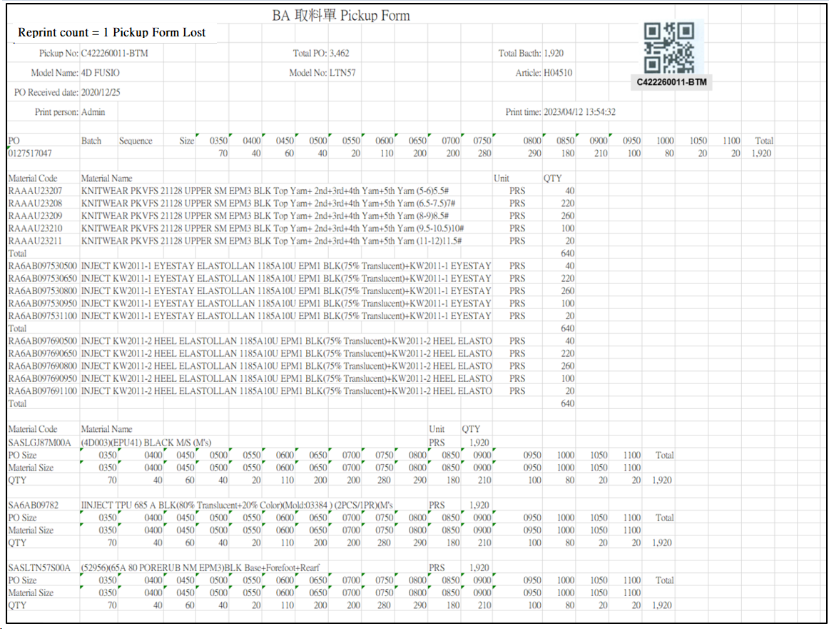

[圖MPS104_5] Regular Pickup Form – Mix Material

|  |  |  |  |  |  |  |
| --- | --- | --- | --- | --- | --- | --- |
| Print Regular Pickup Form – Mix Material (No size + Size) 列印一般取料單-混合料號 (無尺寸 + 有尺寸) | | | | | | |
| NO | 顯示名稱 | 必填 | 唯讀 | 存改 | 對應欄位 | 欄位型態  欄位說明 |
|  | Reprint count  重印次數 |  |  |  | REPRINT_CNT | Int |
|  | Reprint Reason  重印原因 |  |  |  | User key in Reprint Reason | String |
| SQL  select PRINT_CNT AS REPRINT_CNT  from dbo.CST_MPS_PICKFORM  where PUFGROUP = 'CPUF202302231300001' -- (User select row) | | | | | | |
|  | | | | | | |
|  | Form Title Kind  表單類型 |  |  |  | KIND | String |
|  | Pickup No  取料單編號 |  |  |  | User selected row | String |
|  | Total Bacth  批次數量 |  |  |  | QUANTITY | Numeric |
|  | Model Name  型體名稱 |  |  |  | MODEL_NAME | String |
|  | Model No  型體編號 |  |  |  | MODEL_NO | String |
|  | Article  Article |  |  |  | ARTICLE | String |
|  | PO Received Date  訂單接單日 |  |  |  | RECEIVED_DATE | Date  yyyy-MM-dd |
|  | PO  訂單號碼 |  |  |  | PO_No | String |
|  | Batch  批次 |  |  |  | BATCH | String |
|  | Sequence  迴轉數 |  |  |  | SEQUENCE | String |
| SQL：  -- SQL01  SELECT max(a.KIND) KIND , a.PO_NO , a.PO_NO PO_BATCH , '' BATCH , sum(b.QUANTITY) QUANTITY  , max(c.ARTICLE) ARTICLE , max(c.MODEL_NAME) MODEL_NAME , max(c.MODEL_NO) MODEL_NO  , max(a.[SEQUENCE]) SEQUENCE , max(a.DEPT_ID) DEPT_ID , max(c.RECEIVED_DATE) RECEIVED_DATE  FROM ( select top 1 PO_NO , [SEQUENCE] , DEPT_ID , KIND from dbo.CST_MPS_PICKFORM  where PUFGROUP = 'CPUF20231229170000351419' ) a  left join dbo.ERP_SOBATCH b on a.PO_NO = b.PO_NO  left join dbo.ERP_SO c on b.PO_NO = c.PO_NO  group by a.PO_NO | | | | | | |
|  | Total PO  訂單數量 |  |  |  | PO_QUANTITY | Numeric |
| SQL：  -- Get PO Total Qty ( by PO_NO )  SELECT sum(QUANTITY) AS PO_QUANTITY  FROM dbo.ERP_SOBATCH  where PO_NO = '0131989861' -- (SQL01's PO_NO) | | | | | | |
|  | Print Person  列印人員 |  |  |  | (Login User_Account) | String |
|  | Print Time  列印時間 |  |  |  | User print date and time  (Get from server side) | String  yyyy-MM-dd HH:mm:ss |
|  | Size  尺寸 |  |  |  | (List All PO’s Size and Qty) | String |
|  | Total (Row)  加總 (每個PO) |  |  |  | SUM (Qty of PO) | Numeric |
| SQL：  -- Get PO Size run information  SELECT PO_SIZE , sum(QUANTITY) QUANTITY  FROM dbo.ERP_CYNO_DETAIL  where PO_BATCH like '0134125218%' -- (SQL01's PO_NO)  group by PO_SIZE  order by PO_SIZE | | | | | | |
| **Get all C_MATERIAL_SHEET_NO、MATERIAL_CATEGORY** | | | | | | |
| **SQL：**  -- Get all C_MATERIAL_SHEET_NO、MATERIAL_CATEGORY : by PUFGROUP  select b.C_MATERIAL_SHEET_NO , max( c.MATERIAL_CATEGORY ) MATERIAL_CATEGORY  FROM dbo.CST_MPS_PICKFORM a , dbo.CST_MPS_PICKFORM_DETAIL b , dbo.ERP_MATERIAL c  where a.PUFGROUP = 'CPUF20231229170000351419'  and a.PUF = b.PUF  and b.MATERIALNO = c.MATERIALNO  group by b.C_MATERIAL_SHEET_NO  order by max( c.MATERIAL_CATEGORY ) , max(b.MATERIALNO) | | | | | | |
| **No Size Part：If MATERIAL_CATEGORY != ‘02’** | | | | | | |
|  | Material Code  料號 |  |  |  | MATERIALNO | String |
|  | Material Name  材料名稱 |  |  |  | MATERIAL_SPEC | String |
|  | Unit  單位 |  |  |  | UNIT | String |
|  | QTY  數量 |  |  |  | PLAN_QTY | Numeric |
|  | Total  總計 |  |  |  | SUM(PLAN_QTY)  By every C_MATERIAL_SHEET_NO | Numeric |
| SQL：  -- Loop all C_MATERIAL_SHEET_NO  -- Sum PLAN_QTY Total by every C_MATERIAL_SHEET_NO  SELECT T1.MATERIALNO , T3.MATERIAL_SPEC , T3.UNIT , T1.PLAN_QTY  FROM dbo.CST_MPS_PICKFORM_DETAIL T1  left join dbo.ERP_MATERIAL T3 on T1.MATERIALNO = T3.MATERIALNO  where T1.C_MATERIAL_SHEET_NO = 'JW2304250001'  order by T1.MATERIALNO | | | | | | |
| **Size Part：If MATERIAL_CATEGORY = ‘02’** | | | | | | |
|  | Material Code  料號 |  |  |  | TOP 1 GENERIC_MATERIAL | String |
|  | Material Name  材料名稱 |  |  |  | TOP 1 MATERIAL_SPEC | String |
|  | Unit  單位 |  |  |  | TOP 1 UNIT | String |
|  | QTY  數量 |  |  |  | SUM(PLAN_QTY)  By every C_MATERIAL_SHEET_NO | Numeric |
|  | PO Size  訂單尺寸 |  |  |  | PO_SIZE | String |
|  | Material Size  材料尺寸 |  |  |  | MATERIAL_SIZE | String |
|  | Total  總計 |  |  |  | SUM(PLAN_QTY)  By every C_MATERIAL_SHEET_NO | Numeric |
| SQL：  -- Loop all C_MATERIAL_SHEET_NO  -- Get GENERIC_MATERIAL 、 Material Name 、 Unit  SELECT top 1 T2.GENERIC_MATERIAL , T3.MATERIAL_SPEC , T3.UNIT  FROM dbo.CST_MPS_PICKFORM_DETAIL T1  -- left join dbo.ERP_OSISSUE_DTL T2 on T1.C_MATERIAL_SHEET_NO = T2.C_MATERIAL_SHEET_NO and T1.MATERIALNO = T2.MATERIALNO  left join dbo.ERP_MATERIAL T2 on T1.MATERIALNO = T2.MATERIALNO  left join dbo.ERP_MATERIAL T3 on T2.GENERIC_MATERIAL = T3.MATERIALNO  where T1.C_MATERIAL_SHEET_NO = 'JW2304250054'  -- Get PO_BATCH , PO_SIZE , MATERIAL_SIZE , QUANTITY  -- by PO、 MATERIAL_SHEET_NO  select t1.PO_BATCH , t1.PO_SIZE , t2.MATERIAL_SIZE , t1.QUANTITY from  (  SELECT t2.PO_NO PO_BATCH , PO_SIZE , sum(t1.QUANTITY) QUANTITY  FROM dbo.ERP_CYNO_DETAIL t1  inner join dbo.ERP_SOBatch t2 on t1.PO_BATCH = t2.PO_BATCH  where ( t1.PO_BATCH like '0134125218%') -- (SQL01's PO_BATCH)  -- and CAST(SEQUENCE AS INT) >= 1 and CAST(SEQUENCE AS INT) <= 3  group by t2.PO_NO , PO_SIZE  ) t1  left join dbo.ERP_OSISSUE_DTL t2  on t1.PO_BATCH = t2.PO_NO and t1.PO_SIZE = t2.PO_SIZE and t2.MATERIAL_SHEET_NO = 'JW2304250054'　-- (C_MATERIAL_SHEET_NO)  order by PO_BATCH , PO_SIZE | | | | | | |
| After Print，Update [CST_MPS_PICKFORM].[PRINT_CNT] and [CST_MPS_PICKFORM].[PRINT_TIME] (use server time)  SQL：  update dbo.CST_MPS_PICKFORM  set PRINT_CNT = PRINT_CNT + 1  , PRINT_TIME = GETDATE() -- Server time，yyyy/MM/dd HH:mm:ss  where PUFGROUP = 'CPUF202304251802271' --(User select row) | | | | | | |

* 1. **「MPS104 Reprint Pickup Form (OEM Order)」MPS104重列印取料單(代工訂單)**
  2. 程式名稱：同標題 (Right Name: MPS_Reprint.Pickup.Form.OEM.Order)
  3. 功能目的：查詢/列印
  4. 使用部門：
  5. 程式說明：

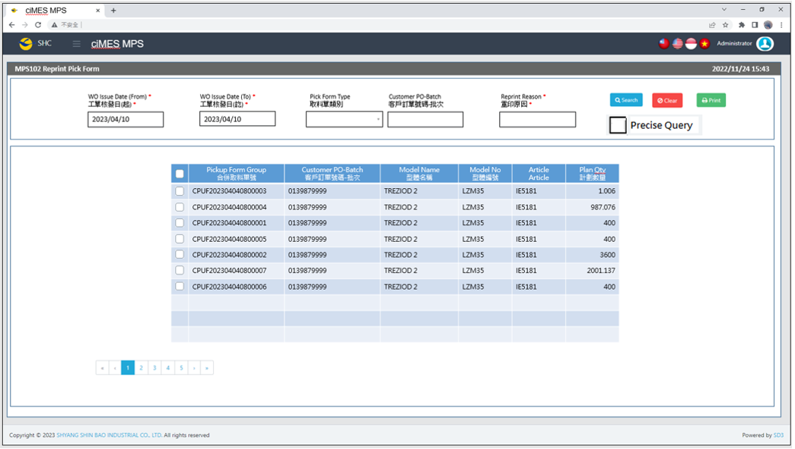

[圖MPS104_1] Main Page主畫面

|  |  |  |  |  |  |  |
| --- | --- | --- | --- | --- | --- | --- |
| Program header 程式標頭 | | | | | | |
| NO | 顯示名稱 | 必填 | 唯讀 | 存改 | 對應欄位 | 說明 |
|  | Title  標題 |  | V |  | CAPTION | String  If there is no get data, please show “Right Name”  SELECT T2.LANGUAGE, T2.CAPTION  FROM [MES_SEC_RIGHT] AS T1  JOIN [MES_MENU_ITEM] AS T2  ON T1.SEC_RIGHT_SID = T2.SEC_RIGHT_SID  WHERE T1.GROUPRIGHTS = 'MPS_Reprint.Pickup.Form.OEM.Order' --(Right Name) |
|  | System Time  系統時間 |  | V |  | Show current server time | Datetime  yyyy/MM/dd HH:mm |

|  |  |  |  |  |  |  |
| --- | --- | --- | --- | --- | --- | --- |
| Operation button 操作按鈕 | | | | | | |
| NO | 顯示名稱 | 必填 | 唯讀 | 存改 | 對應欄位 | 說明 |
|  | Search  搜尋 |  |  |  |  | Required「WO Issue Date (From)  」and「WO Issue Date (To)」to search |
|  | Clear  清除 |  |  |  |  | Clear Search Condition and Results |
|  | Print  列印 |  |  |  |  | Print the select row data |

|  |  |  |  |  |  |  |
| --- | --- | --- | --- | --- | --- | --- |
| Search Condition 搜尋條件 | | | | | | |
| NO | 顯示名稱 | 必填 | 唯讀 | 存改 | 對應欄位 | 欄位型態  欄位說明 |
|  | WO Issue Date (From)  工單核發日(起) | V |  | V | Filter WO Issue Date column | String  yyyy/MM/dd  Default：Today |
|  | WO Issue Date (To)  工單核發日(訖) | V |  | V | Filter WO Issue Date column | String  yyyy/MM/dd  Default：Today |
|  | Pickup Form Type  取料單類別 |  |  | V | Filter Pickup Form Type column | Dropdown list  SELECT REMARK01 FROM MES_WPC_EXTENDITEM  WHERE CLASS = 'PICKFORM_TYPE'  ORDER BY REMARK01 |
|  | Customer PO-Batch  客戶訂單號碼-批次 |  |  | V | Filter Customer PO-Batch column | String  If chkPrecise is checked  Must exactly matched  Remove % in Search SQL |
|  | Reprint Reason  重印原因 | V |  | V |  | String  Required when printing |
|  | Precise Query  精準比對 |  |  | V |  | Check Box : chkPrecise (default : not cheched)  If chkPrecise is checked  Filter Customer PO-Batch column  Must exactly matched  (Remove % in Search SQL Ex : PO_BATCH like '090007695001-1' ) |

|  |  |  |  |  |  |  |
| --- | --- | --- | --- | --- | --- | --- |
| Search 搜尋 | | | | | | |
| NO | 顯示名稱 | 必填 | 唯讀 | 存改 | 對應欄位 | 欄位型態  欄位說明 |
|  | Selector  選擇器 |  |  | V |  | Check Box |
|  | Pickup Form Group  合併取料單號 |  | V |  | PUFGROUP | String |
|  | Customer PO-Batch  客戶訂單號碼-批次 |  | V |  | PO_BATCH | String |
|  | Model Name  型體名稱 |  | V |  | MODEL_NAME | String |
|  | Model No  型體編號 |  | V |  | MODEL_NO | String |
|  | Article  Article |  | V |  | ARTICLE | String |
|  | Plan Qty  計劃數量 |  | V |  | PLAN_QTY | Numeric |
| 程式邏輯說明：  點選 [Search搜尋] 按鈕，依照User填入的搜尋條件(若有)，即可帶出資料。  SQL：  -- 委託他廠CB代工: CST_MPS_PICKFORM.type = '轉交單'  SELECT max(a.KIND) AS KIND , a.PUFGROUP , max(T3.PO_BATCH) AS PO_BATCH , max(c.MODEL_NAME) AS MODEL_NAME ,  max(c.MODEL_NO) AS MODEL_NO , max(c.ARTICLE) AS ARTICLE , sum(b.PLAN_QTY) AS PLAN_QTY  FROM (  select T1.PUFGROUP, string_AGG( T2.PO_BATCH , ', ') PO_BATCH  from (  select PUFGROUP  FROM dbo.CST_MPS_PICKFORM  where PRINT_CNT > 0  and [STATUS] <> 'Terminate'  and type = '轉交單'  and CREATETIME >= '2023/01/01' -- (WO Issue Date (From))  and CREATETIME <= '2024/05/31' -- (WO Issue Date (To))  -- and KIND = 'BA' -- (Pickup Form Type)  -- and PO_BATCH like '0131989861%' -- (Customer PO-Batch)  group by PUFGROUP  ) T1  left join dbo.CST_MPS_PICKFORM T2 on T1.PUFGROUP = T2.PUFGROUP  group by T1.PUFGROUP  ) T3  , dbo.CST_MPS_PICKFORM a , dbo.CST_MPS_PICKFORM_DETAIL b  , ( select PO_NO , max(MODEL_NAME) MODEL_NAME , max(MODEL_NO) MODEL_NO , max(ARTICLE) ARTICLE  from dbo.ERP_SOBATCH group by PO_NO ) c  where T3.PUFGROUP = a.PUFGROUP  and a.PUF = b.PUF  and a.PO_NO = c.PO_NO  and a.PRINT_CNT > 0  group by a.PUFGROUP | | | | | | |

**Print Regular Pickup Form (OEM Order) 列印一般取料單 (代工訂單)**：



[圖MPS103_2] Pickup Form Print Type & Process (OEM Order)，Check whether there is Size Run

|  |  |  |  |  |  |  |
| --- | --- | --- | --- | --- | --- | --- |
| Print Regular Pickup Form (OEM Order)列印一般取料單 (代工訂單) | | | | | | |
| NO | 顯示名稱 | 必填 | 唯讀 | 存改 | 對應欄位 | 欄位型態  欄位說明 |
|  |  |  |  |  |  |  |
| 程式邏輯說明：  Regular Material Form (OEM Order) need check is Size Run or not Size Run or Mix Material：  If MATERIAL_CATEGORY All == ‘02’，Print「**Regular Pickup Form (OEM Order) – Size Material」**  If MATERIAL_CATEGORY All != ‘02’，Print「**Regular Pickup Form (OEM Order) – No Size Material」**  If MATERIAL_CATEGORY has both，Print「**Regular Pickup Form (OEM Order) – Mix Material」**  SQL：  select b.C_MATERIAL_SHEET_NO , max( c.MATERIAL_CATEGORY ) MATERIAL_CATEGORY  FROM dbo.CST_MPS_PICKFORM a , dbo.CST_MPS_PICKFORM_DETAIL b , dbo.ERP_MATERIAL c  where a.PUFGROUP = 'CPUF202304251802272'  and a.PUF = b.PUF  and b.MATERIALNO = c.MATERIALNO  group by b.C_MATERIAL_SHEET_NO  order by max( c.MATERIAL_CATEGORY ) , max(b.MATERIALNO) | | | | | | |

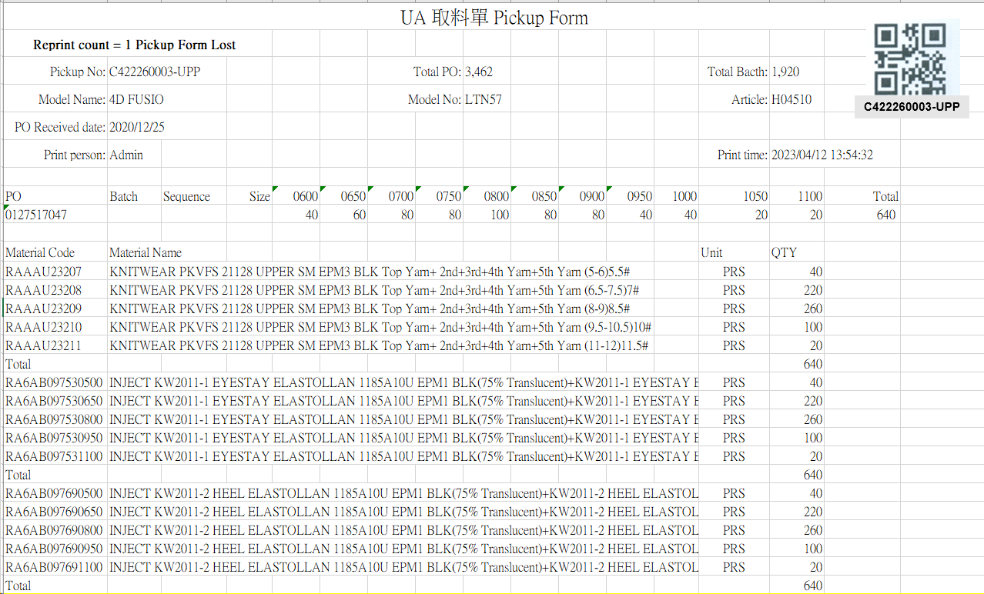

[圖MPS104_3] Regular Pickup Form (OEM Order) – No Size Material

|  |  |  |  |  |  |  |
| --- | --- | --- | --- | --- | --- | --- |
| Print Regular Pickup Form (OEM Order) – No Size Material 列印一般取料單(代工訂單)-無尺寸料號 | | | | | | |
| NO | 顯示名稱 | 必填 | 唯讀 | 存改 | 對應欄位 | 欄位型態  欄位說明 |
|  | Reprint count  重印次數 |  |  |  | REPRINT_CNT | Int |
|  | Reprint Reason  重印原因 |  |  |  | User key in Reprint Reason | String |
| SQL  select PRINT_CNT AS REPRINT_CNT  from dbo.CST_MPS_PICKFORM  where PUFGROUP = 'CPUF202302231300001' -- (User select row) | | | | | | |
|  | Form Title Kind  表單類型 |  |  |  | KIND | String |
|  | Pickup No  取料單編號 |  |  |  | User selected row | String |
|  | Total Bacth  批次數量 |  |  |  | QUANTITY | Numeric |
|  | Model Name  型體名稱 |  |  |  | MODEL_NAME | String |
|  | Model No  型體編號 |  |  |  | MODEL_NO | String |
|  | Article  Article |  |  |  | ARTICLE | String |
|  | PO Received Date  訂單接單日 |  |  |  | RECEIVED_DATE | Date  yyyy-MM-dd |
|  | Print Person  列印人員 |  |  |  | (Login User_Account) | String |
|  | Print Time  列印時間 |  |  |  | User print date and time  (Get from server side) | String  yyyy-MM-dd HH:mm:ss |
|  | Distribution  領料部門 |  |  |  | SUPPLIER_CODE | String |
| SQL:  SELECT top 1 t3.Supplier_Code  FROM ( select * from dbo.CST_MPS_PICKFORM  where PUFGROUP = 'CPUF20231118080000246318' ) t1  inner join dbo.CST_MPS_PICKFORM_DETAIL t2 on t1.PUF = t2.PUF  inner join dbo.ERP_OSISSUE t3 on t2.C_MATERIAL_SHEET_NO = t3.MATERIAL_SHEET_NO | | | | | | |
|  | PO  訂單號碼 |  |  |  | PO_No | String |
|  | Batch  批次 |  |  |  | BATCH | String |
|  | Sequence  迴轉數 |  |  |  | SEQUENCE | String |
| SQL：  -- SQL01  SELECT max(a.KIND) KIND , a.PO_NO , a.PO_NO PO_BATCH , '' BATCH , sum(b.QUANTITY) QUANTITY  , max(c.ARTICLE) ARTICLE , max(c.MODEL_NAME) MODEL_NAME , max(c.MODEL_NO) MODEL_NO  , max(a.[SEQUENCE]) SEQUENCE , max(a.DEPT_ID) DEPT_ID , max(c.RECEIVED_DATE) RECEIVED_DATE  FROM ( select top 1 PO_NO , [SEQUENCE] , DEPT_ID , KIND from dbo.CST_MPS_PICKFORM  where PUFGROUP = 'CPUF20231229170000351419' ) a  left join dbo.ERP_SOBATCH b on a.PO_NO = b.PO_NO  left join dbo.ERP_SO c on b.PO_NO = c.PO_NO  group by a.PO_NO | | | | | | |
|  | Total PO  訂單數量 |  |  |  | PO_QUANTITY | Numeric |
| SQL：  -- Get PO Total Qty ( by PO_NO )  SELECT sum(QUANTITY) AS PO_QUANTITY  FROM dbo.ERP_SOBATCH  where PO_NO = '0134125218' -- (SQL01's PO_NO) | | | | | | |
|  | Size  尺寸 |  |  |  | (List All PO’s Size and Qty) | String |
|  | Total (Row)  加總 (每個PO) |  |  |  | SUM (Qty of PO) | Numeric |
| SQL：  -- Get PO Size run information  SELECT PO_SIZE , sum(QUANTITY) QUANTITY  FROM dbo.ERP_CYNO_DETAIL  where PO_BATCH like '0134125218%' -- (SQL01's PO_NO)  group by PO_SIZE  order by PO_SIZE | | | | | | |
|  | Material Code  料號 |  |  |  | MATERIALNO | String |
|  | Material Name  材料名稱 |  |  |  | MATERIAL_SPEC | String |
|  | Unit  單位 |  |  |  | UNIT | String |
|  | QTY  數量 |  |  |  | PLAN_QTY | Numeric |
|  | Total  總計 |  |  |  | SUM(PLAN_QTY)  By every C_MATERIAL_SHEET_NO | Numeric |
| SQL：  -- Get all C_MATERIAL_SHEET_NO、MATERIAL_CATEGORY : by PUFGROUP  select b.C_MATERIAL_SHEET_NO , max( c.MATERIAL_CATEGORY ) MATERIAL_CATEGORY  FROM dbo.CST_MPS_PICKFORM a , dbo.CST_MPS_PICKFORM_DETAIL b , dbo.ERP_MATERIAL c  where a.PUFGROUP = 'CPUF20231229170000351419'  and a.PUF = b.PUF  and b.MATERIALNO = c.MATERIALNO  group by b.C_MATERIAL_SHEET_NO  order by max( c.MATERIAL_CATEGORY ) , max(b.MATERIALNO)  -- Loop all C_MATERIAL_SHEET_NO  -- Sum PLAN_QTY Total by every C_MATERIAL_SHEET_NO  SELECT T1.MATERIALNO , T3.MATERIAL_SPEC , T3.UNIT , T1.PLAN_QTY  FROM dbo.CST_MPS_PICKFORM_DETAIL T1  left join dbo.ERP_MATERIAL T3 on T1.MATERIALNO = T3.MATERIALNO  where T1.C_MATERIAL_SHEET_NO = 'JW2304250001'  order by T1.MATERIALNO | | | | | | |
| After Print，Update [CST_MPS_PICKFORM].[PRINT_CNT] and [CST_MPS_PICKFORM].[PRINT_TIME] (use server time)  SQL：  update dbo.CST_MPS_PICKFORM  set PRINT_CNT = PRINT_CNT + 1  , REPRINT_REASON = 'Pickup Form Lost' --(User key in Reprint Reason)  , PRINT_TIME = GETDATE() -- Server time，yyyy/MM/dd HH:mm:ss  where PUFGROUP = 'CPUF202304251802272' --(User select row) | | | | | | |

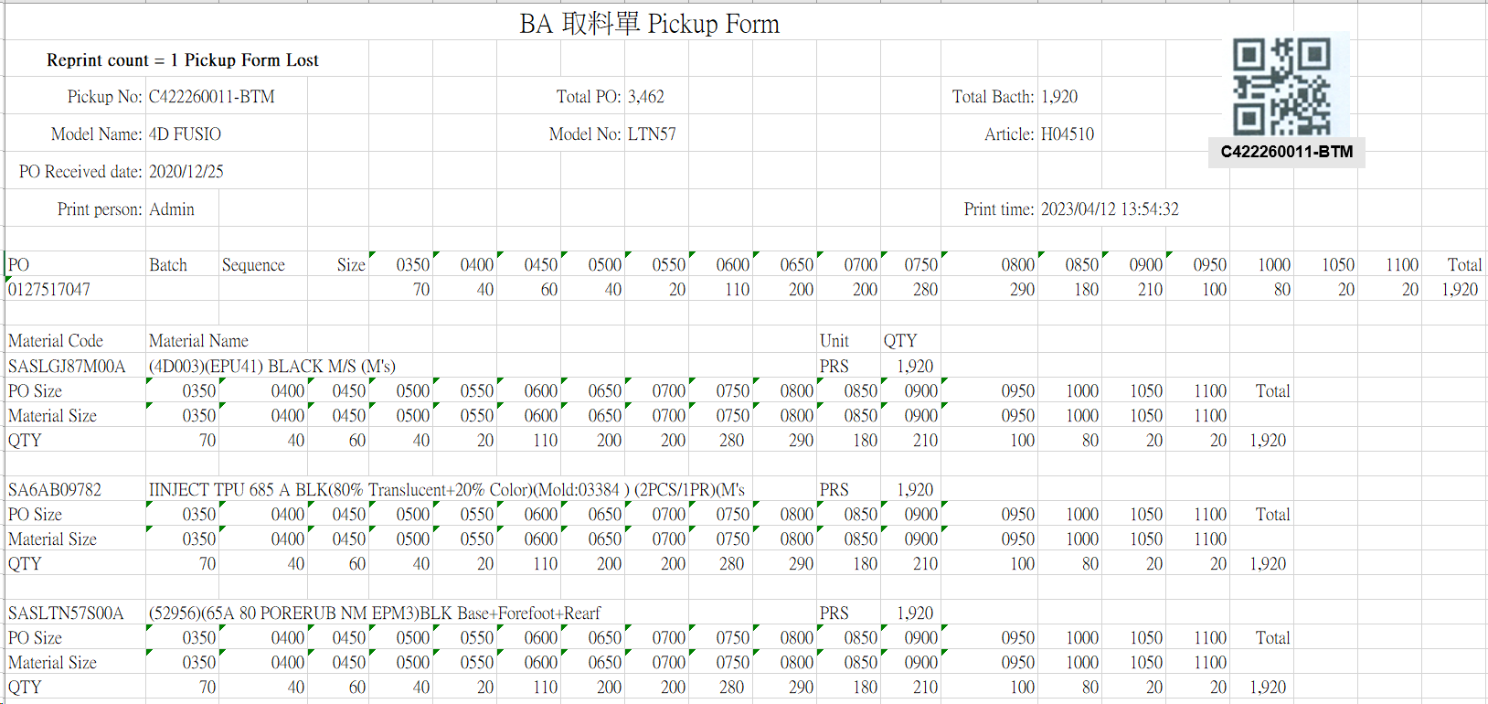

[圖MPS104_4] Regular Pickup Form (OEM Order) – Size Material

|  |  |  |  |  |  |  |
| --- | --- | --- | --- | --- | --- | --- |
| Print Regular Pickup Form (OEM Order) – Size Material 列印一般取料單(代工訂單)-有尺寸料號 | | | | | | |
| NO | 顯示名稱 | 必填 | 唯讀 | 存改 | 對應欄位 | 欄位型態  欄位說明 |
|  | Reprint count  重印次數 |  |  |  | REPRINT_CNT | Int |
|  | Reprint Reason  重印原因 |  |  |  | User key in Reprint Reason | String |
| SQL  select PRINT_CNT AS REPRINT_CNT  from dbo.CST_MPS_PICKFORM  where PUFGROUP = 'CPUF202302231300073' -- (User select row) | | | | | | |
|  | Form Title Kind  表單類型 |  |  |  | KIND | String |
|  | Pickup No  取料單編號 |  |  |  | User selected row | String |
|  | Total Bacth  批次數量 |  |  |  | QUANTITY | Numeric |
|  | Model Name  型體名稱 |  |  |  | MODEL_NAME | String |
|  | Model No  型體編號 |  |  |  | MODEL_NO | String |
|  | Article  Article |  |  |  | ARTICLE | String |
|  | PO Received Date  訂單接單日 |  |  |  | RECEIVED_DATE | Date  yyyy-MM-dd |
|  | Print Person  列印人員 |  |  |  | (Login User_Account) | String |
|  | Print Time  列印時間 |  |  |  | User print date and time  (Get from server side) | String  yyyy-MM-dd HH:mm:ss |
|  | Distribution  領料部門 |  |  |  | SUPPLIER_CODE | String |
| SQL:  SELECT top 1 t3.Supplier_Code  FROM ( select * from dbo.CST_MPS_PICKFORM  where PUFGROUP = 'CPUF20231118080000246318' ) t1  inner join dbo.CST_MPS_PICKFORM_DETAIL t2 on t1.PUF = t2.PUF  inner join dbo.ERP_OSISSUE t3 on t2.C_MATERIAL_SHEET_NO = t3.MATERIAL_SHEET_NO | | | | | | |
|  | PO  訂單號碼 |  |  |  | PO_No | String |
|  | Batch  批次 |  |  |  | BATCH | String |
|  | Sequence  迴轉數 |  |  |  | SEQUENCE | String |
| SQL：  -- SQL01  SELECT max(a.KIND) KIND , a.PO_NO , a.PO_NO PO_BATCH , '' BATCH , sum(b.QUANTITY) QUANTITY  , max(c.ARTICLE) ARTICLE , max(c.MODEL_NAME) MODEL_NAME , max(c.MODEL_NO) MODEL_NO  , max(a.[SEQUENCE]) SEQUENCE , max(a.DEPT_ID) DEPT_ID , max(c.RECEIVED_DATE) RECEIVED_DATE  FROM ( select top 1 PO_NO , [SEQUENCE] , DEPT_ID , KIND from dbo.CST_MPS_PICKFORM  where PUFGROUP = 'CPUF20231229170000351419' ) a  left join dbo.ERP_SOBATCH b on a.PO_NO = b.PO_NO  left join dbo.ERP_SO c on b.PO_NO = c.PO_NO  group by a.PO_NO | | | | | | |
|  | Total PO  訂單數量 |  |  |  | PO_QUANTITY | Numeric |
| SQL：  -- Get PO Total Qty ( by PO_NO )  SELECT sum(QUANTITY) QUANTITY  FROM dbo.ERP_SOBATCH  where PO_NO = '0131989861' -- (SQL01's PO_NO) | | | | | | |
|  | Print Person  列印人員 |  |  |  | (Login User_Account) | String |
|  | Print Time  列印時間 |  |  |  | User print date and time  (Get from server side) | String  yyyy-MM-dd HH:mm:ss |
|  | Size  尺寸 |  |  |  | (List All PO’s Size and Qty) | String |
|  | Total (Row)  加總 (每個PO) |  |  |  | SUM (Qty of PO) | Numeric |
| SQL：  -- Get PO Size run information  SELECT PO_SIZE , sum(QUANTITY) QUANTITY  FROM dbo.ERP_CYNO_DETAIL  where PO_BATCH like '0134125218%' -- (SQL01's PO_NO)  group by PO_SIZE  order by PO_SIZE | | | | | | |
|  | Material Code  料號 |  |  |  | GENERIC_MATERIAL | String |
|  | Material Name  材料名稱 |  |  |  | MATERIAL_SPEC | String |
|  | Unit  單位 |  |  |  | UNIT | String |
|  | QTY  數量 |  |  |  | SUM(PLAN_QTY)  By every C_MATERIAL_SHEET_NO | Numeric |
|  | PO Size  訂單尺寸 |  |  |  | PO_SIZE | String |
|  | Material Size  材料尺寸 |  |  |  | MATERIAL_SIZE | String |
|  | Total  總計 |  |  |  | SUM(PLAN_QTY)  By every C_MATERIAL_SHEET_NO | Numeric |
| SQL：  -- Get all C_MATERIAL_SHEET_NO、MATERIAL_CATEGORY : by PUFGROUP  select b.C_MATERIAL_SHEET_NO , max( c.MATERIAL_CATEGORY ) MATERIAL_CATEGORY  FROM dbo.CST_MPS_PICKFORM a , dbo.CST_MPS_PICKFORM_DETAIL b , dbo.ERP_MATERIAL c  where a.PUFGROUP = 'CPUF20231229170000351419'  and a.PUF = b.PUF  and b.MATERIALNO = c.MATERIALNO  group by b.C_MATERIAL_SHEET_NO  order by max( c.MATERIAL_CATEGORY ) , max(b.MATERIALNO)  -- Loop all C_MATERIAL_SHEET_NO  -- Get GENERIC_MATERIAL 、 Material Name 、 Unit  SELECT top 1 T2.GENERIC_MATERIAL , T3.MATERIAL_SPEC , T3.UNIT  FROM dbo.CST_MPS_PICKFORM_DETAIL T1  -- left join dbo.ERP_OSISSUE_DTL T2 on T1.C_MATERIAL_SHEET_NO = T2.C_MATERIAL_SHEET_NO and T1.MATERIALNO = T2.MATERIALNO  left join dbo.ERP_MATERIAL T2 on T1.MATERIALNO = T2.MATERIALNO  left join dbo.ERP_MATERIAL T3 on T2.GENERIC_MATERIAL = T3.MATERIALNO  where T1.C_MATERIAL_SHEET_NO = 'JW2304250054'  -- Get PO_BATCH , PO_SIZE , MATERIAL_SIZE , QUANTITY  -- by PO、 MATERIAL_SHEET_NO  select t1.PO_BATCH , t1.PO_SIZE , t2.MATERIAL_SIZE , t1.QUANTITY from  (  SELECT t2.PO_NO PO_BATCH , PO_SIZE , sum(t1.QUANTITY) QUANTITY  FROM dbo.ERP_CYNO_DETAIL t1  inner join dbo.ERP_SOBatch t2 on t1.PO_BATCH = t2.PO_BATCH  where ( t1.PO_BATCH like '0134125218%') -- (SQL01's PO_BATCH)  -- and CAST(SEQUENCE AS INT) >= 1 and CAST(SEQUENCE AS INT) <= 3  group by t2.PO_NO , PO_SIZE  ) t1  left join dbo.ERP_OSISSUE_DTL t2  on t1.PO_BATCH = t2.PO_NO and t1.PO_SIZE = t2.PO_SIZE and t2.MATERIAL_SHEET_NO = ' JW2312290001'　-- (C_MATERIAL_SHEET_NO)  order by PO_BATCH , PO_SIZE | | | | | | |
| After Print，Update [CST_MPS_PICKFORM].[PRINT_CNT] and [CST_MPS_PICKFORM].[PRINT_TIME] (use server time)  SQL：  update dbo.CST_MPS_PICKFORM  set PRINT_CNT = PRINT_CNT + 1  , REPRINT_REASON = 'Pickup Form Lost' --(User key in Reprint Reason)  , PRINT_TIME = GETDATE() -- Server time，yyyy/MM/dd HH:mm:ss  where PUFGROUP = 'CPUF202304251802271' --(User select row) | | | | | | |

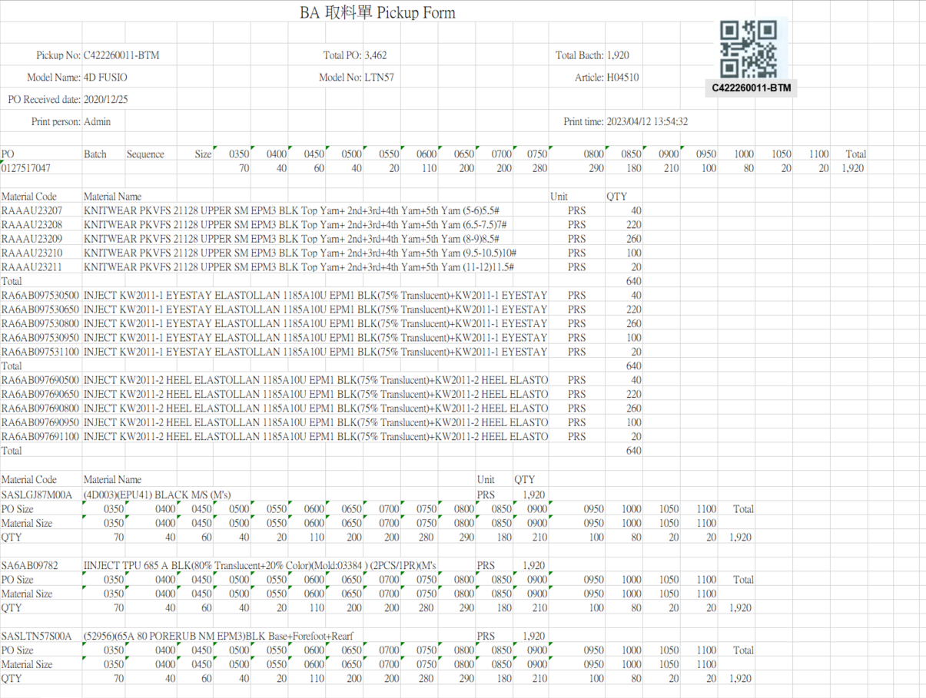

[圖MPS104_5] Regular Pickup Form – Mix Material

|  |  |  |  |  |  |  |
| --- | --- | --- | --- | --- | --- | --- |
| Print Regular Pickup Form – Mix Material (No size + Size) 列印一般取料單-混合料號 (無尺寸 + 有尺寸) | | | | | | |
| NO | 顯示名稱 | 必填 | 唯讀 | 存改 | 對應欄位 | 欄位型態  欄位說明 |
|  | Reprint count  重印次數 |  |  |  | REPRINT_CNT | Int |
|  | Reprint Reason  重印原因 |  |  |  | User key in Reprint Reason | String |
| SQL  select PRINT_CNT AS REPRINT_CNT  from dbo.CST_MPS_PICKFORM  where PUFGROUP = 'CPUF202302231300001' -- (User select row) | | | | | | |
|  | Form Title Kind  表單類型 |  |  |  | KIND | String |
|  | Pickup No  取料單編號 |  |  |  | User selected row | String |
|  | Total Bacth  批次數量 |  |  |  | QUANTITY | Numeric |
|  | Model Name  型體名稱 |  |  |  | MODEL_NAME | String |
|  | Model No  型體編號 |  |  |  | MODEL_NO | String |
|  | Article  Article |  |  |  | ARTICLE | String |
|  | PO Received Date  訂單接單日 |  |  |  | RECEIVED_DATE | Date  yyyy-MM-dd |
|  | PO  訂單號碼 |  |  |  | PO_No | String |
|  | Batch  批次 |  |  |  | BATCH | String |
|  | Sequence  迴轉數 |  |  |  | SEQUENCE | String |
| SQL：  -- SQL01  SELECT max(a.KIND) KIND , a.PO_NO , a.PO_NO PO_BATCH , '' BATCH , sum(b.QUANTITY) QUANTITY  , max(c.ARTICLE) ARTICLE , max(c.MODEL_NAME) MODEL_NAME , max(c.MODEL_NO) MODEL_NO  , max(a.[SEQUENCE]) SEQUENCE , max(a.DEPT_ID) DEPT_ID , max(c.RECEIVED_DATE) RECEIVED_DATE  FROM ( select top 1 PO_NO , [SEQUENCE] , DEPT_ID , KIND from dbo.CST_MPS_PICKFORM  where PUFGROUP = 'CPUF20231229170000351419' ) a  left join dbo.ERP_SOBATCH b on a.PO_NO = b.PO_NO  left join dbo.ERP_SO c on b.PO_NO = c.PO_NO  group by a.PO_NO | | | | | | |
|  | Total PO  訂單數量 |  |  |  | PO_QUANTITY | Numeric |
| SQL：  -- Get PO Total Qty ( by PO_NO )  SELECT sum(QUANTITY) AS PO_QUANTITY  FROM dbo.ERP_SOBATCH  where PO_NO = '0131989861' -- (SQL01's PO_NO) | | | | | | |
|  | Print Person  列印人員 |  |  |  | (Login User_Account) | String |
|  | Print Time  列印時間 |  |  |  | User print date and time  (Get from server side) | String  yyyy-MM-dd HH:mm:ss |
|  | Size  尺寸 |  |  |  | (List All PO’s Size and Qty) | String |
|  | Total (Row)  加總 (每個PO) |  |  |  | SUM (Qty of PO) | Numeric |
| SQL：  -- Get PO Size run information  SELECT PO_SIZE , sum(QUANTITY) QUANTITY  FROM dbo.ERP_CYNO_DETAIL  where PO_BATCH like '0134125218%' -- (SQL01's PO_NO)  group by PO_SIZE  order by PO_SIZE | | | | | | |
| **Get all C_MATERIAL_SHEET_NO、MATERIAL_CATEGORY** | | | | | | |
| **SQL：**  -- Get all C_MATERIAL_SHEET_NO、MATERIAL_CATEGORY : by PUFGROUP  select b.C_MATERIAL_SHEET_NO , max( c.MATERIAL_CATEGORY ) MATERIAL_CATEGORY  FROM dbo.CST_MPS_PICKFORM a , dbo.CST_MPS_PICKFORM_DETAIL b , dbo.ERP_MATERIAL c  where a.PUFGROUP = 'CPUF20231229170000351419'  and a.PUF = b.PUF  and b.MATERIALNO = c.MATERIALNO  group by b.C_MATERIAL_SHEET_NO  order by max( c.MATERIAL_CATEGORY ) , max(b.MATERIALNO) | | | | | | |
| **No Size Part：If MATERIAL_CATEGORY != ‘02’** | | | | | | |
|  | Material Code  料號 |  |  |  | MATERIALNO | String |
|  | Material Name  材料名稱 |  |  |  | MATERIAL_SPEC | String |
|  | Unit  單位 |  |  |  | UNIT | String |
|  | QTY  數量 |  |  |  | PLAN_QTY | Numeric |
|  | Total  總計 |  |  |  | SUM(PLAN_QTY)  By every C_MATERIAL_SHEET_NO | Numeric |
| SQL：  -- Loop all C_MATERIAL_SHEET_NO  -- Sum PLAN_QTY Total by every C_MATERIAL_SHEET_NO  SELECT T1.MATERIALNO , T3.MATERIAL_SPEC , T3.UNIT , T1.PLAN_QTY  FROM dbo.CST_MPS_PICKFORM_DETAIL T1  left join dbo.ERP_MATERIAL T3 on T1.MATERIALNO = T3.MATERIALNO  where T1.C_MATERIAL_SHEET_NO = 'JW2304250001'  order by T1.MATERIALNO | | | | | | |
| **Size Part：If MATERIAL_CATEGORY = ‘02’** | | | | | | |
|  | Material Code  料號 |  |  |  | TOP 1 GENERIC_MATERIAL | String |
|  | Material Name  材料名稱 |  |  |  | TOP 1 MATERIAL_SPEC | String |
|  | Unit  單位 |  |  |  | TOP 1 UNIT | String |
|  | QTY  數量 |  |  |  | SUM(PLAN_QTY)  By every C_MATERIAL_SHEET_NO | Numeric |
|  | PO Size  訂單尺寸 |  |  |  | PO_SIZE | String |
|  | Material Size  材料尺寸 |  |  |  | MATERIAL_SIZE | String |
|  | Total  總計 |  |  |  | SUM(PLAN_QTY)  By every C_MATERIAL_SHEET_NO | Numeric |
| SQL：  -- Loop all C_MATERIAL_SHEET_NO  -- Get GENERIC_MATERIAL 、 Material Name 、 Unit  SELECT top 1 T2.GENERIC_MATERIAL , T3.MATERIAL_SPEC , T3.UNIT  FROM dbo.CST_MPS_PICKFORM_DETAIL T1  -- left join dbo.ERP_OSISSUE_DTL T2 on T1.C_MATERIAL_SHEET_NO = T2.C_MATERIAL_SHEET_NO and T1.MATERIALNO = T2.MATERIALNO  left join dbo.ERP_MATERIAL T2 on T1.MATERIALNO = T2.MATERIALNO  left join dbo.ERP_MATERIAL T3 on T2.GENERIC_MATERIAL = T3.MATERIALNO  where T1.C_MATERIAL_SHEET_NO = 'JW2304250054'  -- Get PO_BATCH , PO_SIZE , MATERIAL_SIZE , QUANTITY  -- by PO、 MATERIAL_SHEET_NO  select t1.PO_BATCH , t1.PO_SIZE , t2.MATERIAL_SIZE , t1.QUANTITY from  (  SELECT t2.PO_NO PO_BATCH , PO_SIZE , sum(t1.QUANTITY) QUANTITY  FROM dbo.ERP_CYNO_DETAIL t1  inner join dbo.ERP_SOBatch t2 on t1.PO_BATCH = t2.PO_BATCH  where ( t1.PO_BATCH like '0134125218%') -- (SQL01's PO_BATCH)  -- and CAST(SEQUENCE AS INT) >= 1 and CAST(SEQUENCE AS INT) <= 3  group by t2.PO_NO , PO_SIZE  ) t1  left join dbo.ERP_OSISSUE_DTL t2  on t1.PO_BATCH = t2.PO_NO and t1.PO_SIZE = t2.PO_SIZE and t2.MATERIAL_SHEET_NO = 'JW2304250054'　-- (C_MATERIAL_SHEET_NO)  order by PO_BATCH , PO_SIZE | | | | | | |
| After Print，Update [CST_MPS_PICKFORM].[PRINT_CNT] and [CST_MPS_PICKFORM].[PRINT_TIME] (use server time)  SQL：  update dbo.CST_MPS_PICKFORM  set PRINT_CNT = PRINT_CNT + 1  , REPRINT_REASON = 'Pickup Form Lost' --(User key in Reprint Reason)  , PRINT_TIME = GETDATE() -- Server time，yyyy/MM/dd HH:mm:ss  where PUFGROUP = 'CPUF202304251802271' --(User select row) | | | | | | |

* 1. **「MPS105 Print Transfer Sheet (Pickup Form)」MPS105列印轉交單(取料單)**
  2. 程式名稱：同標題 (Right Name: MPS_Print.Pickup.Transfer.Sheet.Form)
  3. 功能目的：查詢/列印
  4. 使用部門：
  5. 程式說明：

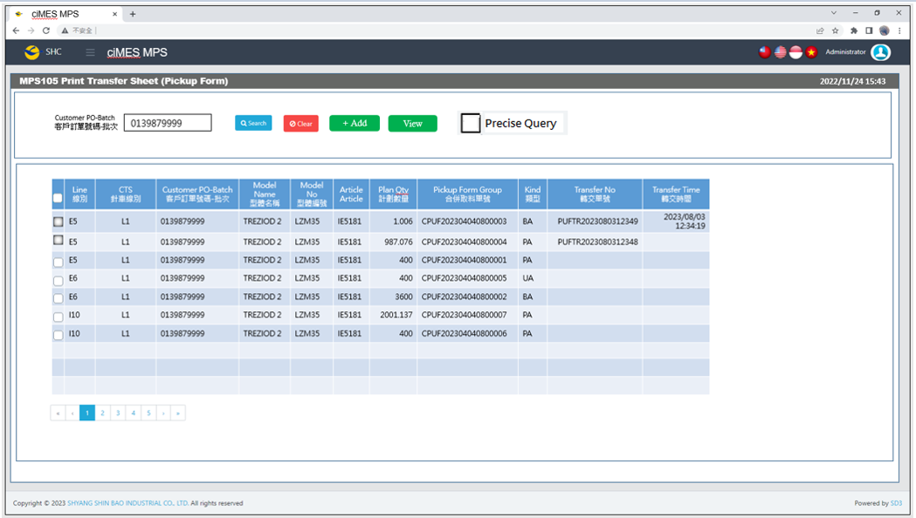

[Pic MPS105_1] Main Page主畫面

|  |  |  |  |  |  |  |
| --- | --- | --- | --- | --- | --- | --- |
| Program header 程式標頭 | | | | | | |
| NO | 顯示名稱 | 必填 | 唯讀 | 存改 | 對應欄位 | 說明 |
|  | Title  標題 |  | V |  | CAPTION | String  If there is no get data, please show “Right Name”  SELECT T2.LANGUAGE, T2.CAPTION  FROM [MES_SEC_RIGHT] AS T1  JOIN [MES_MENU_ITEM] AS T2  ON T1.SEC_RIGHT_SID = T2.SEC_RIGHT_SID  WHERE T1.GROUPRIGHTS = 'MPS_Print.Pickup.Transfer.Sheet.Form' --(Right Name) |
|  | System Time  系統時間 |  | V |  | Show current server time | Datetime  yyyy/MM/dd HH:mm |

|  |  |  |  |  |  |  |
| --- | --- | --- | --- | --- | --- | --- |
| Operation button 操作按鈕 | | | | | | |
| NO | 顯示名稱 | 必填 | 唯讀 | 存改 | 對應欄位 | 說明 |
|  | Search  搜尋 |  |  |  |  | Required「Customer PO-Batch  」to search |
|  | Clear  清除 |  |  |  |  | Clear Search Condition and Results |
|  | Add  新增 |  |  |  |  | Add selected PUFgroup row data to Modal window gridview) |
|  | View  顯示選取取料單清單視窗 |  |  |  |  | Show selected Pickup Form list (Modal window) |

|  |  |  |  |  |  |  |
| --- | --- | --- | --- | --- | --- | --- |
| Search Condition 搜尋條件 | | | | | | |
| NO | 顯示名稱 | 必填 | 唯讀 | 存改 | 對應欄位 | 欄位型態  欄位說明 |
|  | Customer PO-Batch  客戶訂單號碼-批次 | V |  | V | Filter Customer PO-Batch column | String (Required)  If chkPrecise is checked  Must exactly matched  Remove % in Search SQL |
|  | Precise Query  精準比對 |  |  | V |  | Check Box : chkPrecise (default : not cheched)  If chkPrecise is checked  Filter Customer PO-Batch column  Must exactly matched  (Remove % in Search SQL Ex : PO_BATCH like '090007695001-1' ) |

|  |  |  |  |  |  |  |
| --- | --- | --- | --- | --- | --- | --- |
| Search 搜尋 | | | | | | |
| NO | 顯示名稱 | 必填 | 唯讀 | 存改 | 對應欄位 | 欄位型態  欄位說明 |
|  | Selector  選擇器 |  |  | V |  | Check Box  Disable Selector Check Box  If “Transfer No” is not null |
|  | Line  線別 |  | V |  | Line | String |
|  | CTS  針車線別 |  | V |  | CTS | String |
|  | Customer PO-Batch  客戶訂單號碼-批次 |  | V |  | PO_BATCH | String |
|  | Model Name  型體名稱 |  | V |  | MODEL_NAME | String |
|  | Model No  型體編號 |  | V |  | MODEL_NO | String |
|  | Article  Article |  | V |  | ARTICLE | String |
|  | Plan Qty  計劃數量 |  | V |  | PLAN_QTY | String |
|  | Pickup Form Group  合併取料單號 |  | V |  | PUFGROUP | String |
|  | Kind  類型 |  | V |  | KIND | String |
|  | Transfer No  轉交單號 |  | V |  | TRANS_NO | String |
|  | Transfer Time  轉交時間 |  | V |  | TRANS_TIME | String |
| 程式邏輯說明：  Step 1:  點選 [Search搜尋] 按鈕，依照User填入的搜尋條件(若有)，即可帶出資料。  Click Search button , and get data by “Customer PO-Batch”  SQL：  SELECT max(tb4.AS_CELL) Line  , max(tb4.ST_TEAM) CTS  , max(T3.PO_BATCH) PO_BATCH  , max(tb3.MODEL_NAME) MODEL_NAME , max(tb3.MODEL_NO) MODEL_NO , max(tb3.ARTICLE) ARTICLE  , cast( sum(tb2.PLAN_QTY) as float) PLAN_QTY  , tb1.PUFGROUP , max(tb1.KIND) KIND  , max(tb1.TRANS_NO) TRANS_NO, max(tb1.TRANS_TIME) TRANS_TIME  FROM  (  select T1.PUFGROUP  , CASE when max(T3.COMBINE_PO_BATCH) <> '' THEN max(T3.COMBINE_PO_BATCH) ELSE max(T1.PO_BATCH) END PO_BATCH  FROM (select * from dbo.CST_MPS_PICKFORM  where PO_BATCH like '0132990865%' or COMBINE_PO_BATCH = '0132990865' ) T1  inner join dbo.CST_MPS_PICKFORM_DETAIL T2 on T1.PUF = T2.PUF  inner join dbo.ERP_ISSUE T3 on T2.C_MATERIAL_SHEET_NO = T3.C_MATERIAL_SHEET_NO  inner join dbo.ERP_ISSUE_Dtl T4 on T3.C_MATERIAL_SHEET_NO = T4.C_MATERIAL_SHEET_NO  and T4.PO_BATCH = t1.PO_BATCH  where ~~( T1.PO_BATCH like '0133505490%' or T3.COMBINE_PO_BATCH = '0133505490')~~  ~~and~~ T1.[STATUS] <> 'Terminate'  and T4.[STATUS] <> 'D'  and T1.PRINT_CNT > 0  group by T1.PUFGROUP  ) T3  inner join dbo.CST_MPS_PICKFORM tb1 on T3.PUFGROUP = tb1.PUFGROUP  inner join dbo.CST_MPS_PICKFORM_DETAIL tb2 on tb1.PUF = tb2.PUF  left join dbo.ERP_SOBATCH tb3 on tb1.PO_BATCH = tb3.PO_BATCH  left join dbo.ERP_PROD_SCHED tb4 on tb1.PO_BATCH = tb4.PO_BATCH  where tb1.PRINT_CNT > 0  group by tb1.PUFGROUP  order by Kind  已經產生轉交單號的取料單，不可以重複產生  PUFGroup already has Transfer No, can’t generate Transfer No again  Disable Selector Check Box，If “Transfer No” is not null  Step 2:  Select Pickup Form by click checkbox  Step 3:  點選 [Add] 按鈕，將勾選的取料單欄位，帶到Modal Gridview。  Click [Add] button , copy selected PUFGroup information to Modal window Gridview [Pic MPS104_2]  Includes columns:  Line、CTS、PO_BATCH、MODEL_NAME、MODEL_NO、ARTICLE、PLAN_QTY、  PUFGROUP、KIND  PUFGROUP is unique , if PUFGROUP already exist in Modal window Gridview, ignore and need not insert into gridview again  Click [View] button，show Modal window，user can check all selected PUFgroup，and print transfer sheet. | | | | | | |

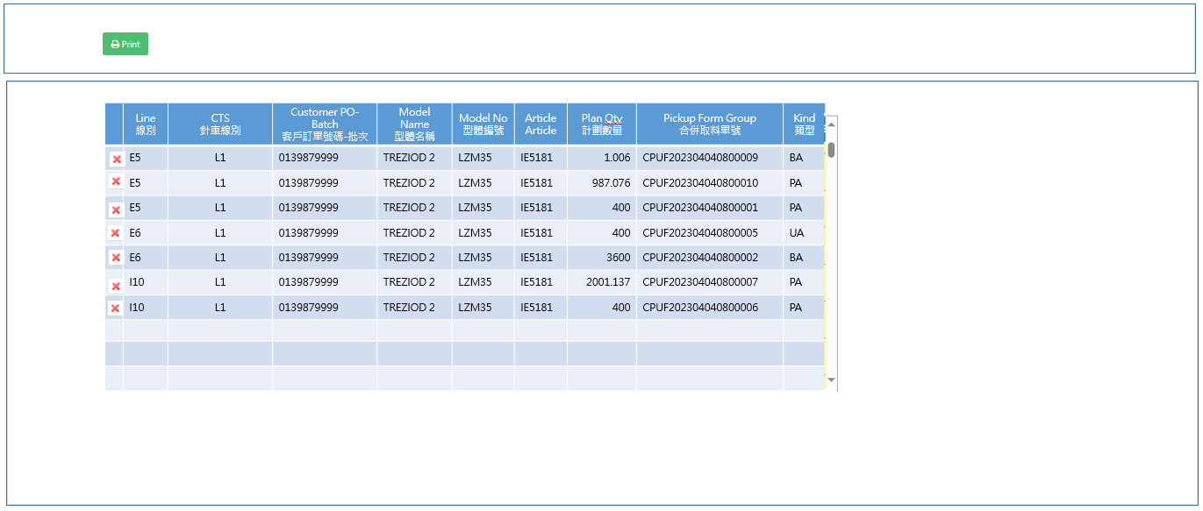

[Pic MPS105_2] Modal window Gridview

|  |  |  |  |  |  |  |
| --- | --- | --- | --- | --- | --- | --- |
| NO | 顯示名稱 | 必填 | 唯讀 | 存改 | 對應欄位 | 欄位型態  欄位說明 |
|  | Delete Button |  |  | V |  | Delete Button  When click Delete Button  Return Confirm message  “Delete PUF : ” + current row PUFGroup + “?” |
|  | Line  線別 |  | V |  | Line | String |
|  | CTS  針車線別 |  | V |  | CTS | String |
|  | Customer PO-Batch  客戶訂單號碼-批次 |  | V |  | PO_BATCH | String |
|  | Model Name  型體名稱 |  | V |  | MODEL_NAME | String |
|  | Model No  型體編號 |  | V |  | MODEL_NO | String |
|  | Article  Article |  | V |  | ARTICLE | String |
|  | Plan Qty  計劃數量 |  | V |  | PLAN_QTY | String |
|  | Pickup Form Group  合併取料單號 |  | V |  | PUFGROUP | String |
|  | Kind  類型 |  | V |  | KIND | String |

|  |
| --- |
| 程式邏輯說明：  1. IF user click row Delete button and confirm , remove current row by PUFGroup  2. Gridview Sorting by PO-Batch , PUFGROUP  4. Transfer No encoding rules  PUFTRNOyyyyMMddHHmmss  Ex : PUFTRNO20231007123020 |

|  |  |
| --- | --- |
| Print Transfer Sheet列印取料單轉交單 | |
| 顯示名稱 |
|  |
| 程式邏輯說明：  1. Pickup Form Transfer Sheet columns is all the same with [Pic MPS104_2] Modal window Gridview columns, Except delete button.  2. Sorting by PO-Batch , PUFGROUP  3. QR code : Transfer No  4. After print Pickup Form Transfer Sheet，loop all rows to Update TRANS_NO by PUFGROUP  SQL :  update dbo.CST_MPS_PICKFORM  set TRANS_NO = 'PUFTRNO20231007123020'  where PUFGROUP = 'CPUF202304040800003'  and TRANS_NO is null  5. Clear Modal window Gridview rows and close Modal window. | |

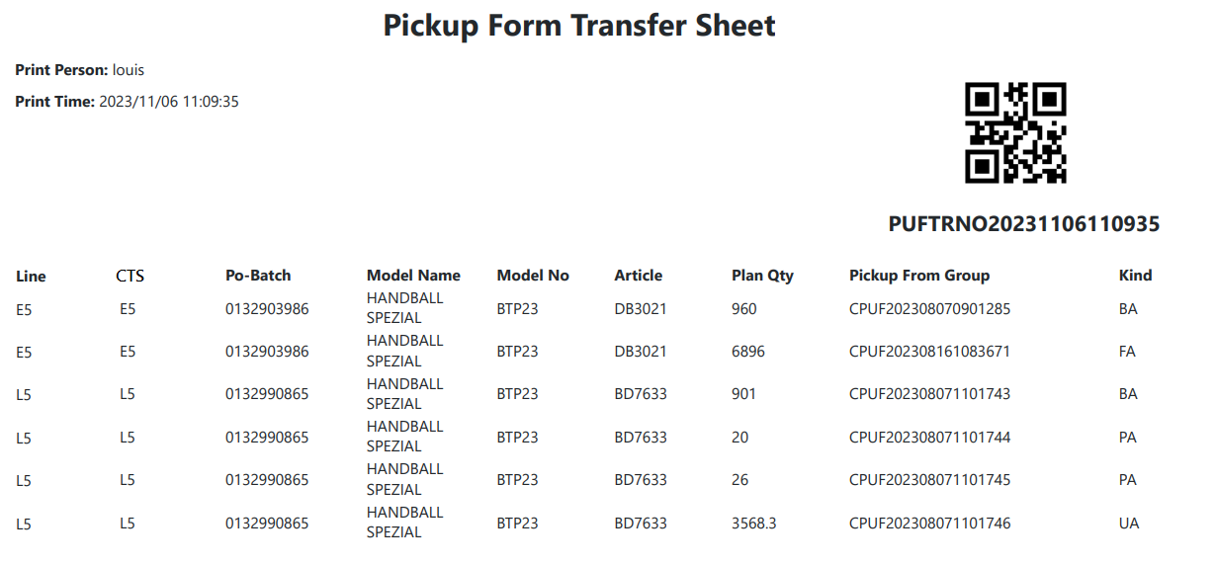

[Fig MPS105_3] Pickup Form Transfer Sheet，A4 size

* 1. **「MPS106 Scan Transfer Sheet (Pickup Form)」MPS106掃描轉交單(取料單)**
  2. 程式名稱：同標題 (Right Name: MPS_Scan.Pickup.Transfer.Sheet.Form)
  3. 功能目的：掃描轉交單(取料單)
  4. 使用部門：
  5. 程式說明：

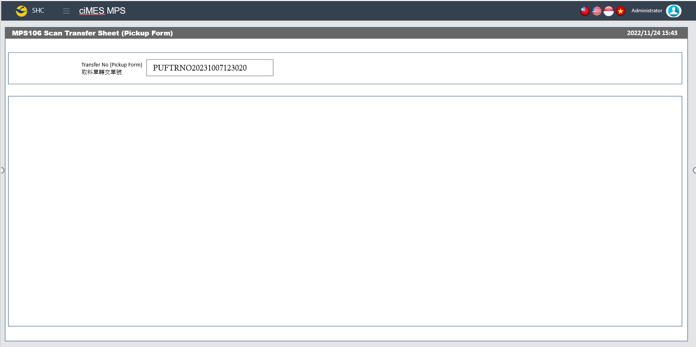

[圖MPS106_1] Main Page主畫面

|  |  |  |  |  |  |  |
| --- | --- | --- | --- | --- | --- | --- |
| Program header 程式標頭 | | | | | | |
| NO | 顯示名稱 | 必填 | 唯讀 | 存改 | 對應欄位 | 說明 |
|  | Title  標題 |  | V |  | CAPTION | String  If there is no get data, please show “Right Name”  SELECT T2.LANGUAGE, T2.CAPTION  FROM [MES_SEC_RIGHT] AS T1  JOIN [MES_MENU_ITEM] AS T2  ON T1.SEC_RIGHT_SID = T2.SEC_RIGHT_SID  WHERE T1.GROUPRIGHTS = 'MPS_Scan.Pickup.Transfer.Sheet.Form' --(Right Name) |
|  | System Time  系統時間 |  | V |  | Show current server time | Datetime  yyyy/MM/dd HH:mm |

|  |  |  |  |  |  |  |
| --- | --- | --- | --- | --- | --- | --- |
| Scan Transfer Sheet掃描轉交單 | | | | | | |
| NO | 顯示名稱 | 必填 | 唯讀 | 存改 | 對應欄位 | 欄位型態  欄位說明 |
| 程式邏輯說明：  使用者輸入或掃描Transfer No並按Enter後，更新轉交單掃描時間  After user scan or input Transfer No and click Enter  1. update Transfer No scan time。  2. Show update successful message  SQL：  update dbo.CST_MPS_PICKFORM  set Trans_USER = '(Login User_Account)' -- (Login User_Account)  , TRANS_TIME = GETDATE() -- (yyyy/MM/dd HH:mm:ss)  where TRANS_NO = 'PUFTRNO20231007123020' -- (User key in or scan Transfer Sheet No)  and TRANS_TIME is null | | | | | | |

* 1. **「MPS201 Pickup Form Status Change」MPS201 取料單狀態變更**
  2. 程式名稱：同標題 (Right Name: MPS_Pickup.Form.Status.Change)
  3. 功能目的：變更取料單的狀態
  4. 使用部門：
  5. 程式說明：

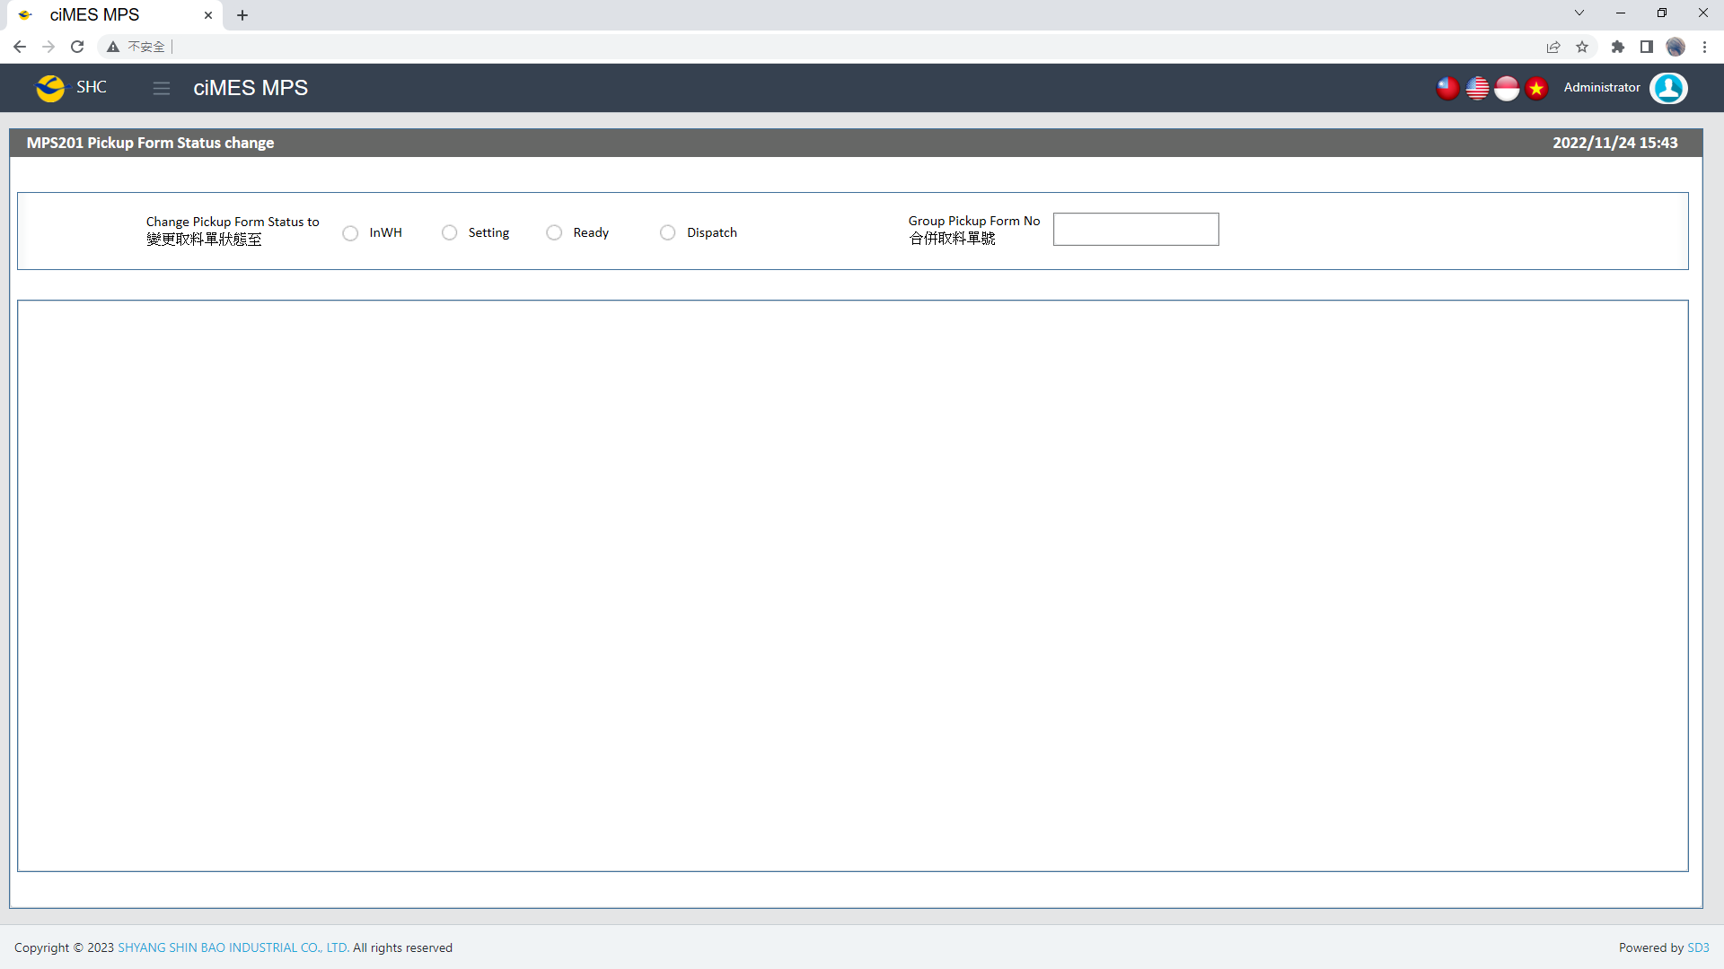

**[MPS201_1]** Main Page主畫面

|  |  |  |  |  |  |  |
| --- | --- | --- | --- | --- | --- | --- |
| Program header 程式標頭 | | | | | | |
| NO | 顯示名稱 | 必填 | 唯讀 | 存改 | 對應欄位 | 說明 |
|  | Title  標題 |  | V |  | CAPTION | String  If there is no get data, please show “Right Name”  SELECT T2.LANGUAGE, T2.CAPTION  FROM [MES_SEC_RIGHT] AS T1  JOIN [MES_MENU_ITEM] AS T2  ON T1.SEC_RIGHT_SID = T2.SEC_RIGHT_SID  WHERE T1.GROUPRIGHTS = 'MPS_Pickup.Form.Status.Change' --(Right Name) |
|  | System Time  系統時間 |  | V |  | Show current server time | Datetime  yyyy/MM/dd HH:mm |

|  |  |  |  |  |  |  |
| --- | --- | --- | --- | --- | --- | --- |
| Action Item 動作項目 | | | | | | |
| NO | 顯示名稱 | 必填 | 唯讀 | 存改 | 對應欄位 | 欄位型態  欄位說明 |
|  | Change Pickup Form Status to  變更取料單狀態至 | V |  | V |  | Radio button  InWH  Setting  Ready  Dispatch |

|  |  |  |  |  |  |  |
| --- | --- | --- | --- | --- | --- | --- |
| Change Pickup Form Status 變更取料單狀態 | | | | | | |
| NO | 顯示名稱 | 必填 | 唯讀 | 存改 | 對應欄位 | 欄位型態  欄位說明 |
|  | Group Pickup Form No  合併取料單號 | V |  | V |  | String |
| 程式邏輯說明：  Check if need to disable Radio button : Ready  SQL :  Check_Ready_Func{  select cnt = count(*)  from MES_WPC_EXTENDITEM  where CLASS = 'PUF_SCAN_READY_GROUP'  If cnt = 0  enable "Ready" --(Radio button)  exit sub –- exit Check_Ready_Func  If cnt > 0  Begin  Step 1  diable "Ready" --(Radio button)  Step 2  check SQL:  select cnt = count(*)  from  ( select REMARK01 from MES_WPC_EXTENDITEM  where CLASS = 'PUF_SCAN_READY_GROUP' ) t0  inner join MES_SEC_GRP t2 on t0.REMARK01 = t2.GROUPNAME  inner join MES_SEC_GRP_USER t1 on t1.SEC_GRP_SID = t2.SEC_GRP_SID  inner join MES_SEC_USER_PRFL t3 on t1.SEC_USER_PRFL_SID = t3.SEC_USER_PRFL_SID  and t1.SEC_USER_PRFL_SID = '(Login User_Account)' -- (Login User_Account)    If cnt > 0 enable "Ready" --(Radio button)  End  }  選擇 Change Pickup Form Status to 後，掃描或輸入Pickup Form No，按下Enter，並通過檢查，即可改變取料單狀態，檢查邏輯如下。  SQL：  -- Step 1: Use Group Pickup Form No to Select all Pickup From  SELECT KIND, PUFGROUP, PUF, CALLING_FLAG, IN_WH_TIME, SETTING_TIME, READY_TIME, DISPATCH_TIME, CALLING_TIME  FROM dbo.CST_MPS_PICKFORM  WHERE PUFGROUP = 'CPUF202302231300050' -- (User key in Group Pickup Form No)  -- Step2: Check DISPATCH_TIME column, if DISPATCH_TIME != NULL or DISPATCH_TIME != '', then can not change the Status, and show「This Group Pickup Form No is already Dispatch」    -- Step 3: Get All Executable Status (if counts of data = 0, then can not change the Status, and show「Pickup Form No Status is wrong」)  SELECT DISTINCT REMARK04 AS Executable_Status  FROM dbo.MES_WPC_EXTENDITEM  WHERE CLASS = 'PICKFORM_STATUS_CHANGE_CHECK'  AND ( REMARK02 = 'ALL' OR REMARK02 = 'PA' ) -- ('PA' is STEP 1's TOP 1 KIND)  AND REMARK03 = 'Ready' -- (User select's Change Pickup Form Status to)  -- Step 4: Check All Executable Status (If check is fail, show「Pickup Form No Status can not change」)  -- If has multiple Executable Status, if there is one Executable Status has data, then step 4's check is pass  -- All data is pass, then step 4's check is pass    -- Step 5: If (Change Pickup Form Status to) = 'Dispatch', and IF Kind <> 'BA' need check [CALLING_FLAG] column  -- If [CALLING_FLAG] = 1, then step 5's check is pass  -- If [CALLING_FLAG] = 0, then step 5's check is fail    -- Step 6: If all check is Pass, update the "TIME" and "USER", and Show「Change Pickup Form Status Success」  -- InWH: UPDATE [IN_WH_TIME], [IN_WH_USER]  -- Setting: UPDATE [SETTING_TIME], [SETTING_USER]  -- Ready: UPDATE [READY_TIME], [READY_USER]  -- Dispatch: UPDATE [DISPATCH_TIME], [DISPATCH_USER]  UPDATE dbo.CST_MPS_PICKFORM  SET STATUS = 'Ready' -- (User select's Change Pickup Form Status to)  , READY_TIME = '(Current server time)' -- (yyyy/MM/dd HH:mm:ss)  , READY_USER = '(Login User_Account)' -- (Login User_Account)  , USERID = '(Login User_Account)' -- (Login User_Account)  , UPDATETIME = '(Current server time)' -- (yyyy/MM/dd HH:mm:ss)  WHERE PUFGROUP = 'CPUF202302231300050' -- (User key in Group Pickup Form No) | | | | | | |

* 1. **「MPS202 Cancel Pickup Form」MPS202 取消取料單**
  2. 程式名稱：同標題 (Right Name: MPS_Cancel.Pickup.Form)
  3. 功能目的：將取料單取消
  4. 使用部門：
  5. 程式說明：

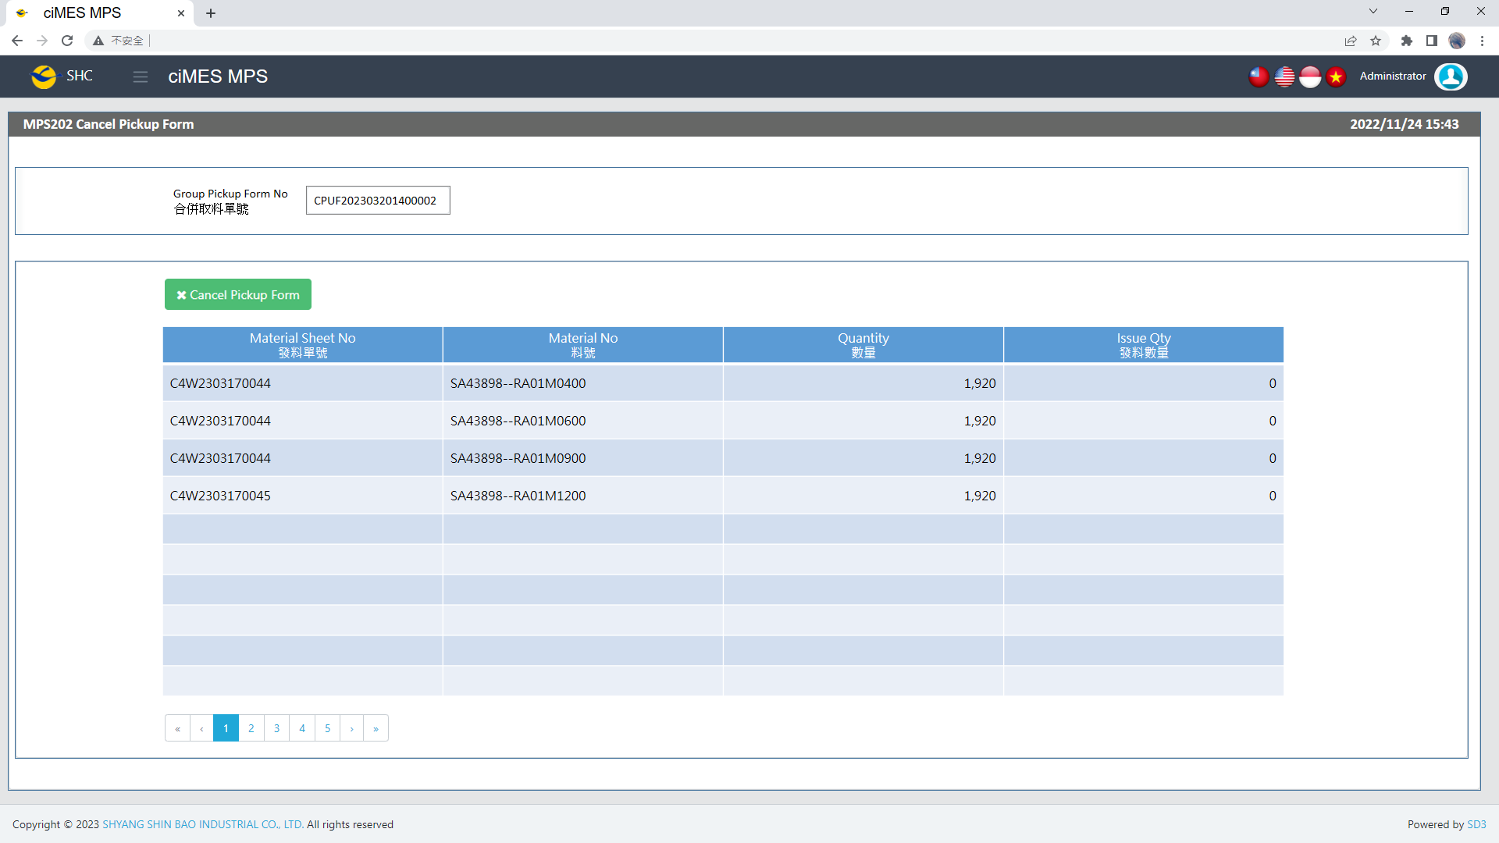

[圖MPS202_1] Main Page主畫面

|  |  |  |  |  |  |  |
| --- | --- | --- | --- | --- | --- | --- |
| Program header 程式標頭 | | | | | | |
| NO | 顯示名稱 | 必填 | 唯讀 | 存改 | 對應欄位 | 說明 |
|  | Title  標題 |  | V |  | CAPTION | String  If there is no get data, please show “Right Name”  SELECT T2.LANGUAGE, T2.CAPTION  FROM [MES_SEC_RIGHT] AS T1  JOIN [MES_MENU_ITEM] AS T2  ON T1.SEC_RIGHT_SID = T2.SEC_RIGHT_SID  WHERE T1.GROUPRIGHTS = 'MPS_Cancel.Pickup.Form' --(Right Name) |
|  | System Time  系統時間 |  | V |  | Show current server time | Datetime  yyyy/MM/dd HH:mm |

|  |  |  |  |  |  |  |
| --- | --- | --- | --- | --- | --- | --- |
| Operation button 操作按鈕 | | | | | | |
| NO | 顯示名稱 | 必填 | 唯讀 | 存改 | 對應欄位 | 說明 |
|  | Cancel Pickup Form  取消取料單 |  |  |  |  | Button  Please use double confirm window |

|  |  |  |  |  |  |  |
| --- | --- | --- | --- | --- | --- | --- |
| Search Condition 搜尋條件 | | | | | | |
| NO | 顯示名稱 | 必填 | 唯讀 | 存改 | 對應欄位 | 欄位型態  欄位說明 |
|  | Group Pickup Form No  合併取料單號 | V |  | V |  | String  User Key in or Scan |

|  |  |  |  |  |  |  |
| --- | --- | --- | --- | --- | --- | --- |
| Cancel Pickup Form 取消取料單 | | | | | | |
| NO | 顯示名稱 | 必填 | 唯讀 | 存改 | 對應欄位 | 欄位型態  欄位說明 |
|  | Material Sheet No  發料單號 |  | V |  | C_MATERIAL_SHEET_NO | String |
|  | Material No  料號 |  | V |  | MATERIALNO | String |
|  | Quantity  數量 |  | V |  | QUANTITY | Numeric |
|  | Issue Qty  發料數量 |  | V |  | Issue_Qty | Numeric |
| 程式邏輯說明：  使用者輸入或掃描Group Pickup Form No並按Enter後，帶出資料。  SQL：  SELECT c.C_MATERIAL_SHEET_NO , c.MATERIALNO , c.QUANTITY , c.ACCQTY AS Issue_Qty  FROM dbo.CST_MPS_PICKFORM a , dbo.CST_MPS_PICKFORM_DETAIL b , dbo.ERP_ISSUE_DTL c  WHERE a.PUF = b.PUF  AND a.PO_BATCH = c.PO_BATCH  AND b.C_MATERIAL_SHEET_NO = c.C_MATERIAL_SHEET_NO  AND b.MATERIALNO = c.MATERIALNO  AND a.PUFGROUP = 'CPUF202303201400002' -- (User key in or scan Group Pickup Form No)  Cancel Pickup Form Button click：  -- Step 1: If any Issue_Qty > 0, then can not cancel the Pickup Form, and show「Material already issued，cannot cancel Pickup Form.」  -- (Need check Issue_Qty in DB again, when Button click)  -- Step 2: If check is pass, Update Pickup Form STATUS = 'Terminate', and show「Cancel pickup form successful.」  UPDATE CST_MPS_PICKFORM  SET STATUS = 'Terminate'  , USERID = '(Login User_Account)' -- (Login User_Account)  , UPDATETIME = '(Current server time)' -- (yyyy/MM/dd HH:mm:ss)  WHERE PUFGROUP = 'CPUF202303201400002' -- (User key in Group Pickup Form No) | | | | | | |

* 1. **「MPS203 PO Close」MPS203 訂單結案**
  2. 程式名稱：同標題 (Right Name: MPS_PO.Close)
  3. 功能目的：將訂單結案
  4. 使用部門：
  5. 程式說明：

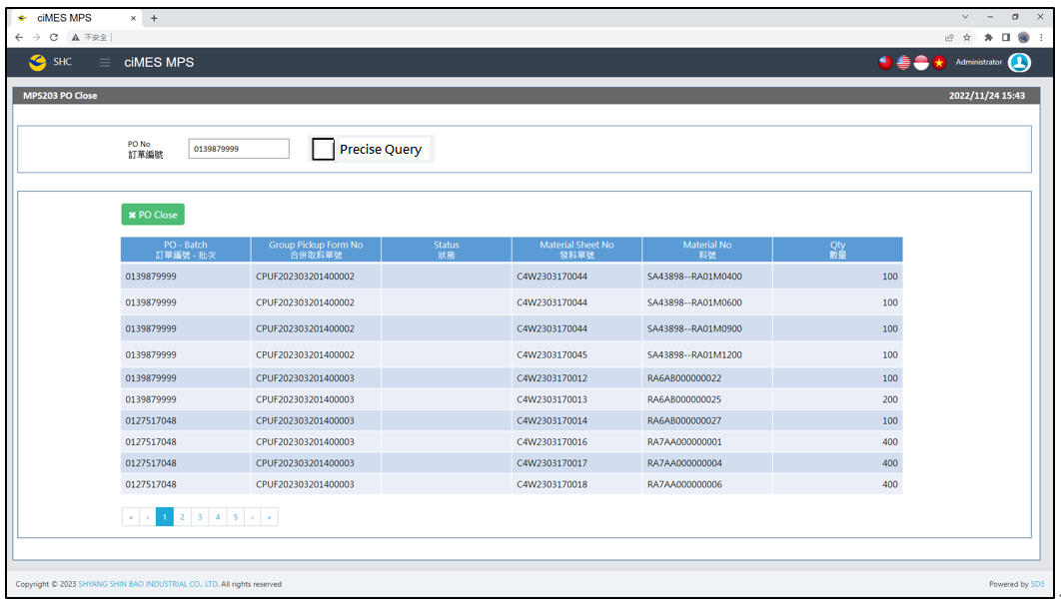

[圖MPS203_1] Main Page主畫面

|  |  |  |  |  |  |  |
| --- | --- | --- | --- | --- | --- | --- |
| Program header 程式標頭 | | | | | | |
| NO | 顯示名稱 | 必填 | 唯讀 | 存改 | 對應欄位 | 說明 |
|  | Title  標題 |  | V |  | CAPTION | String  If there is no get data, please show “Right Name”  SELECT T2.LANGUAGE, T2.CAPTION  FROM [MES_SEC_RIGHT] AS T1  JOIN [MES_MENU_ITEM] AS T2  ON T1.SEC_RIGHT_SID = T2.SEC_RIGHT_SID  WHERE T1.GROUPRIGHTS = 'MPS_PO.Close' --(Right Name) |
|  | System Time  系統時間 |  | V |  | Show current server time | Datetime  yyyy/MM/dd HH:mm |

|  |  |  |  |  |  |  |
| --- | --- | --- | --- | --- | --- | --- |
| Operation button 操作按鈕 | | | | | | |
| NO | 顯示名稱 | 必填 | 唯讀 | 存改 | 對應欄位 | 說明 |
|  | PO Close  訂單結案 |  |  |  |  | Button  Please use double confirm window |

|  |  |  |  |  |  |  |
| --- | --- | --- | --- | --- | --- | --- |
| Search Condition 搜尋條件 | | | | | | |
| NO | 顯示名稱 | 必填 | 唯讀 | 存改 | 對應欄位 | 欄位型態  欄位說明 |
|  | PO No  訂單編號 | V |  | V |  | String  User Key in or Scan |

|  |  |  |  |  |  |  |
| --- | --- | --- | --- | --- | --- | --- |
| PO Close 訂單結案 | | | | | | |
| NO | 顯示名稱 | 必填 | 唯讀 | 存改 | 對應欄位 | 欄位型態  欄位說明 |
|  | PO - Batch  訂單編號 - 批次 |  | V |  | PO_BATCH | String |
|  | Group Pickup Form No  合併取料單號 |  | V |  | PUFGROUP | String |
|  | Status  狀態 |  | V |  | STATUS | String |
|  | Material Sheet No  發料單號 |  |  |  | C_MATERIAL_SHEET_NO | String |
|  | Material No  料號 |  | V |  | MATERIALNO | String |
|  | Qty  數量 |  | V |  | Qty | Numeric |
| 程式邏輯說明：  使用者輸入或掃描PO No並按Enter後，帶出資料。  SQL：  -- Step 1: Get PO_No List  select PO_NO  from CST_MPS_PICKFORM AS t1  INNER join  (select PUFGROUP  from dbo.CST_MPS_PICKFORM  where PO_NO like '0139879999%' -- (User key in or scan PO No)  group by PUFGROUP ) AS t2  on t1.PUFGROUP = t2.PUFGROUP  group by PO_NO  order by PO_NO  -- Step 2: Get PO data to show  select t1.PO_BATCH , t1.PUFGROUP , t1.STATUS , t2.C_MATERIAL_SHEET_NO , t2.MATERIALNO , t2.PLAN_QTY Qty  FROM dbo.CST_MPS_PICKFORM AS t1 , dbo.CST_MPS_PICKFORM_DETAIL AS t2  where t1.PO_NO in ('0139879999', '0127517049') -- Step 1's PO_NO List  and t1.PUF = t2.PUF  order by t1.PO_BATCH , t1.PUFGROUP , t2.C_MATERIAL_SHEET_NO , t2.MATERIALNO  PO Close Button click：  -- Step 1: Show PO_NO List in double confirm window for use confirm.  -- Step 2: Check all Pickup Form status cannot be Ready、Calling、Dispatch, If CountQty > 0, then can not Close, and show「Already issue, can't close PO.」  select COUNT(*) AS CountQty  FROM dbo.CST_MPS_PICKFORM  where PO_NO in ('0139879999','0127517049') -- Step 1's PO_NO List  and [STATUS] in ('Ready','Calling','Dispatch')  -- Step 3: If check is pass, Update Pickup Form STATUS = 'Terminate', and show「PO Close successful.」  update CST_MPS_PICKFORM  set STATUS = 'Terminate'  , USERID = '(Login User_Account)' -- (Login User_Account)  , UPDATETIME = '(Current server time)' -- (yyyy/MM/dd HH:mm:ss)  where PO_NO in ('0139879999','0127517049') -- Step 1's PO_NO List | | | | | | |

* 1. **「MPS301 Material Calling PA」MPS301 PA料號叫料**
  2. 程式名稱：同標題 (Right Name: MPS_Material.Calling.PA)
  3. 功能目的：PA料號叫料
  4. 使用部門：
  5. 程式說明：

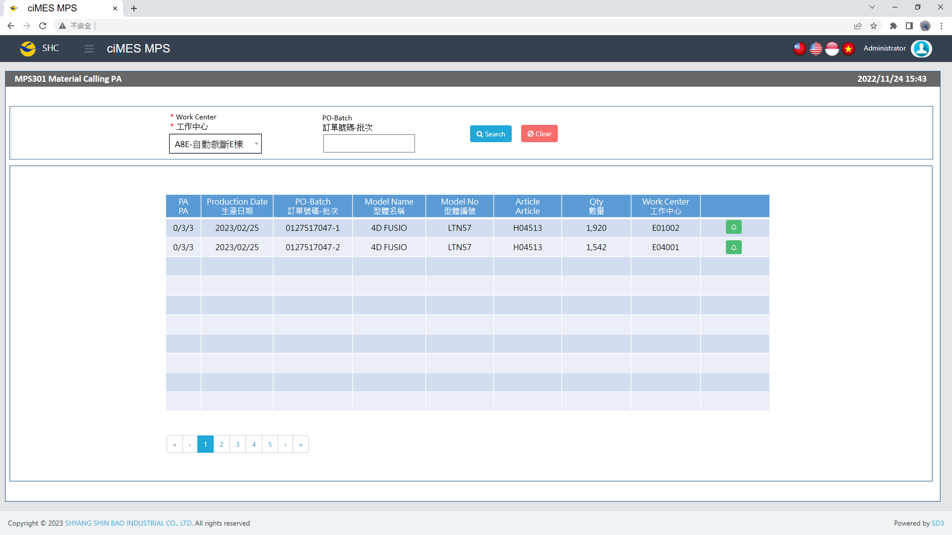

[圖MPS301_1] Main Page主畫面

|  |  |  |  |  |  |  |
| --- | --- | --- | --- | --- | --- | --- |
| Program header程式標頭 | | | | | | |
| NO | 顯示名稱 | 必填 | 唯讀 | 存改 | 對應欄位 | 說明 |
|  | Title  標題 |  | V |  | CAPTION | String  If there is no get data, please show “Right Name”  SELECT T2.LANGUAGE, T2.CAPTION  FROM [MES_SEC_RIGHT] AS T1  JOIN [MES_MENU_ITEM] AS T2  ON T1.SEC_RIGHT_SID = T2.SEC_RIGHT_SID  WHERE T1.GROUPRIGHTS = 'MPS_Material.Calling.PA' --(Right Name) |
|  | System Time  系統時間 |  | V |  | Show current server time | Datetime  yyyy/MM/dd HH:mm |

|  |  |  |  |  |  |  |
| --- | --- | --- | --- | --- | --- | --- |
| Operation button 操作按鈕 | | | | | | |
| NO | 顯示名稱 | 必填 | 唯讀 | 存改 | 對應欄位 | 說明 |
|  | Search  搜尋 |  |  |  |  | Required「Work Center」to search |
|  | Clear  清除 |  |  |  |  | Clear Search Condition and Results |
|  | Calling Page  叫料畫面 |  |  |  |  | Switch to Calling Page |

|  |  |  |  |  |  |  |
| --- | --- | --- | --- | --- | --- | --- |
| Search Condition 搜尋條件 | | | | | | |
| NO | 顯示名稱 | 必填 | 唯讀 | 存改 | 對應欄位 | 欄位型態  欄位說明 |
|  | Work Center  工作中心 | V |  | V |  | Dropdown list  SELECT DEPT_ID, DEPT_ID + '-' + DEPT_DESC AS DEPT_ID_DESC  FROM [ERP_ORGANIZATION]  ORDER BY DEPT_ID |
|  | PO-Batch  訂單號碼-批次 |  |  | V | ~~Filter PO-Batch column~~ | String |

|  |  |  |  |  |  |  |
| --- | --- | --- | --- | --- | --- | --- |
| Search 搜尋 | | | | | | |
| NO | 顯示名稱 | 必填 | 唯讀 | 存改 | 對應欄位 | 欄位型態  欄位說明 |
|  | PA  PA |  | V |  | Called / NotCalled / Total_PUF | String |
|  | Production Date  生產日期 |  | V |  | Process_SDate | String  yyyy/MM/dd |
|  | PO-Batch  訂單號碼-批次 |  | V |  | PO_BATCH | String |
|  | Model Name  型體名稱 |  | V |  | MODEL_NAME | String |
|  | Model No  型體編號 |  | V |  | MODEL_NO | String |
|  | Article  Article |  | V |  | ARTICLE | String |
|  | Qty  數量 |  | V |  | QUANTITY | Numeric |
|  | Work Center  工作中心 |  | V |  | DEPT_ID | String |
|  | Calling Page button  叫料畫面按鈕 |  |  |  | Switch to Calling Page | Button  Button color：  If NotCalled > 0，Green (btn-success)  If NotCalled = 0，Grey (btn-secondary) |
| 程式邏輯說明：  選擇 Work Center 後，點選 [Search搜尋] 按鈕，即可帶出資料。  SQL：  EXEC P_Get_Each_PS_And_WorkCenter_Calling 'JAS', 'PA', ' 0132985410-1' | | | | | | |

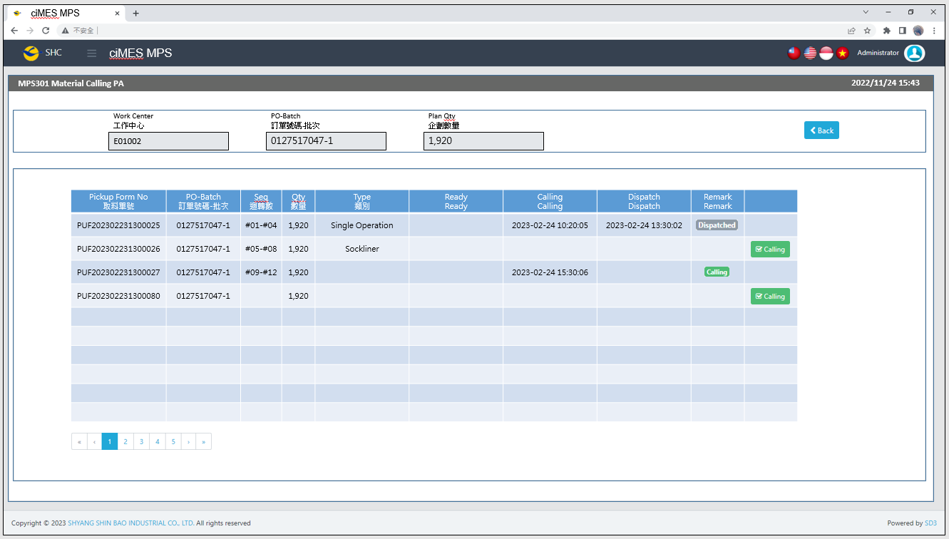

[圖MPS301_2] Calling Page叫料畫面

|  |  |  |  |  |  |  |
| --- | --- | --- | --- | --- | --- | --- |
| Calling Page 叫料畫面 | | | | | | |
| NO | 顯示名稱 | 必填 | 唯讀 | 存改 | 對應欄位 | 欄位型態  欄位說明 |
|  | Work Center  工作中心 |  | V |  | User selected row | String |
|  | PO-Batch  訂單號碼-批次 |  | V |  | User selected row | String |
|  | Plan Qty  企劃數量 |  | V |  | User selected row | Numeric |
|  | Pickup Form No  取料單號 |  | V |  | PUFGROUP | String |
|  | PO-Batch  訂單號碼-批次 |  | V |  | PO_BATCH | String |
|  | Seq  迴轉數 |  | V |  | SEQUENCE | String |
|  | Qty  數量 |  | V |  | Plan_Qty | Numeric |
|  | Type  類別 |  | V |  | TYPE_SPECIAL | String |
|  | ~~In WH~~  ~~In WH~~ |  | ~~V~~ |  | ~~IN_WH_TIME~~ | ~~String~~  ~~yyyy-MM-dd HH:mm:ss~~ |
|  | ~~Setting~~  ~~Setting~~ |  | ~~V~~ |  | ~~SETTING_TIME~~ | ~~String~~  ~~yyyy-MM-dd HH:mm:ss~~ |
|  | Ready  Ready |  | V |  | READY_TIME | String  yyyy-MM-dd HH:mm:ss |
|  | Calling  Calling |  | V |  | CALLING_TIME | String  yyyy-MM-dd HH:mm:ss |
|  | Dispatch  Dispatch |  | V |  | DISPATCH_TIME | String  yyyy-MM-dd HH:mm:ss |
|  | Remark  Remark |  | V |  | IF DISPATCH_TIME not NULL，Show Dispatched  Else IF DISPATCH_TIME is NULL And CALLING_FLAG = 1，  Show Calling  Else  Show (Empty) | String  Dispatched color：Grey (badge-secondary)  Calling color：Green (badge-success) |
|  | Calling  叫料 |  |  |  | If CALLING_FLAG = 0 And PRINT_CNT > 0，Show  ELSE，Hide | Button  Please use double confirm window |
| 程式邏輯說明：  依照User點選的資料列，帶出該資料列的明細資料。  SQL：  --Param 1: User select row's Work Center (Not dropdown list)  --Param 2: User select row's PO-Batch  --Param 3: Always PA  --Param 4: User select's Work Center (Dropdown list)  --Param 5: Login User account  EXEC P_Get_PUFList_ByDeptAndPOBatch 'E01002', '0127517047-1', 'PA', 'E04001' , 'louis' -- Login User account | | | | | | |
| Calling Button click：  UPDATE CST_MPS_PICKFORM SET CALLING_FLAG = 1,  CALLING_TIME = GETDATE(), -- yyyy/MM/dd HH:mm:ss, (Server Time)  CALLING_USER = '' -- Login User account  WHERE PUFGROUP = 'PUF202302231300026'  AND KIND = 'PA' | | | | | | |

* 1. **「MPS302 Material Calling UA」MPS302 UA料號叫料**
  2. 程式名稱：同標題 (Right Name: MPS_Material.Calling.UA)
  3. 功能目的：UA料號叫料
  4. 使用部門：
  5. 程式說明：

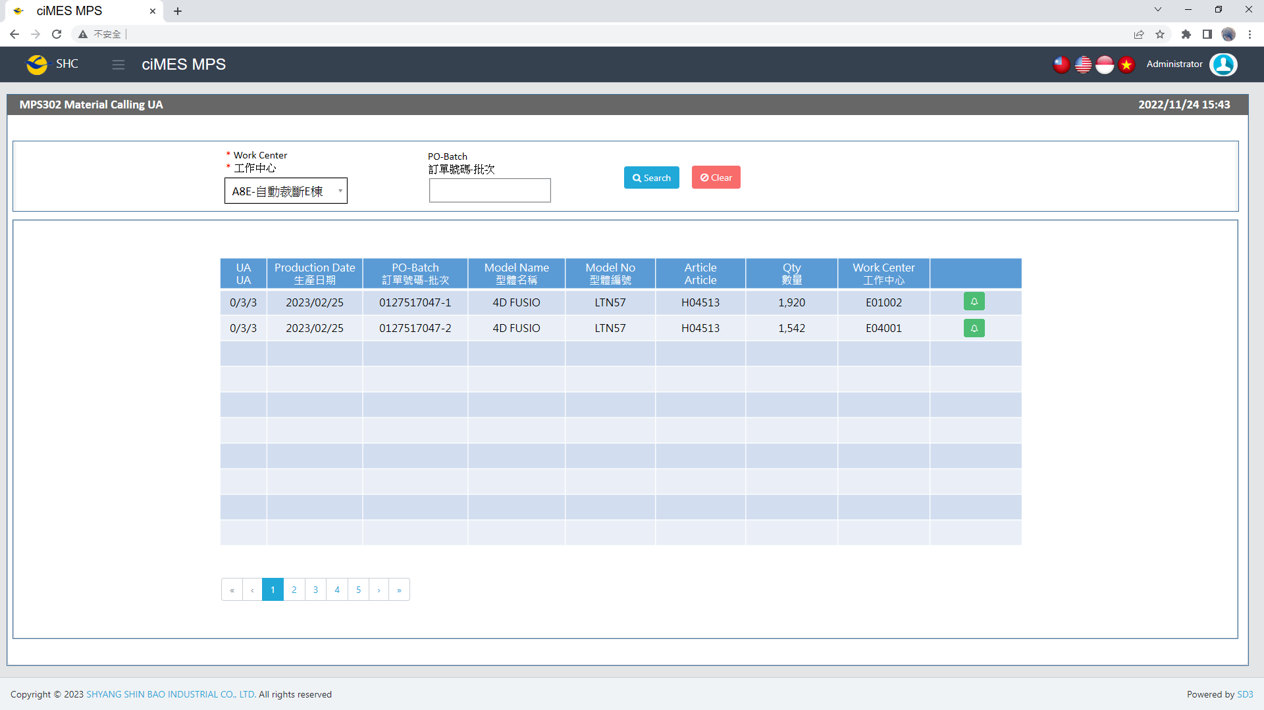

[圖MPS302_1] Main Page主畫面

|  |  |  |  |  |  |  |
| --- | --- | --- | --- | --- | --- | --- |
| Program header 程式標頭 | | | | | | |
| NO | 顯示名稱 | 必填 | 唯讀 | 存改 | 對應欄位 | 說明 |
|  | Title  標題 |  | V |  | CAPTION | String  If there is no get data, please show “Right Name”  SELECT T2.LANGUAGE, T2.CAPTION  FROM [MES_SEC_RIGHT] AS T1  JOIN [MES_MENU_ITEM] AS T2  ON T1.SEC_RIGHT_SID = T2.SEC_RIGHT_SID  WHERE T1.GROUPRIGHTS = 'MPS_Material.Calling.UA' --(Right Name) |
|  | System Time  系統時間 |  | V |  | Show current server time | Datetime  yyyy/MM/dd HH:mm |

|  |  |  |  |  |  |  |
| --- | --- | --- | --- | --- | --- | --- |
| Operation button 操作按鈕 | | | | | | |
| NO | 顯示名稱 | 必填 | 唯讀 | 存改 | 對應欄位 | 說明 |
|  | Search  搜尋 |  |  |  |  | Required「Work Center」to search |
|  | Clear  清除 |  |  |  |  | Clear Search Condition and Results |
|  | Calling Page  叫料畫面 |  |  |  |  | Switch to Calling Page |

|  |  |  |  |  |  |  |
| --- | --- | --- | --- | --- | --- | --- |
| Search Condition 搜尋條件 | | | | | | |
| NO | 顯示名稱 | 必填 | 唯讀 | 存改 | 對應欄位 | 欄位型態  欄位說明 |
|  | Work Center  工作中心 | V |  | V |  | Dropdown list  SELECT DEPT_ID, DEPT_ID + '-' + DEPT_DESC AS DEPT_ID_DESC  FROM [ERP_ORGANIZATION]  ORDER BY DEPT_ID |
|  | PO-Batch  訂單號碼-批次 |  |  | V | ~~Filter PO-Batch column~~ | String |

|  |  |  |  |  |  |  |
| --- | --- | --- | --- | --- | --- | --- |
| Search 搜尋 | | | | | | |
| NO | 顯示名稱 | 必填 | 唯讀 | 存改 | 對應欄位 | 欄位型態  欄位說明 |
|  | UA  UA |  | V |  | Called / NotCalled / Total_PUF | String |
|  | Production Date  生產日期 |  | V |  | Process_SDate | String  yyyy/MM/dd |
|  | PO-Batch  訂單號碼-批次 |  | V |  | PO_BATCH | String |
|  | Model Name  型體名稱 |  | V |  | MODEL_NAME | String |
|  | Model No  型體編號 |  | V |  | MODEL_NO | String |
|  | Article  Article |  | V |  | ARTICLE | String |
|  | Qty  數量 |  | V |  | QUANTITY | Numeric |
|  | Work Center  工作中心 |  | V |  | DEPT_ID | String |
|  | Calling Page button  叫料畫面按鈕 |  |  |  | Switch to Calling Page | Button  Button color：  If NotCalled > 0，Green (btn-success)  If NotCalled = 0，Grey (btn-secondary) |
| 程式邏輯說明：  選擇 Work Center 後，點選 [Search搜尋] 按鈕，即可帶出資料。  SQL：  EXEC P_Get_Each_PS_And_WorkCenter_Calling 'JAS', 'UA', ' 0132985410-1' | | | | | | |

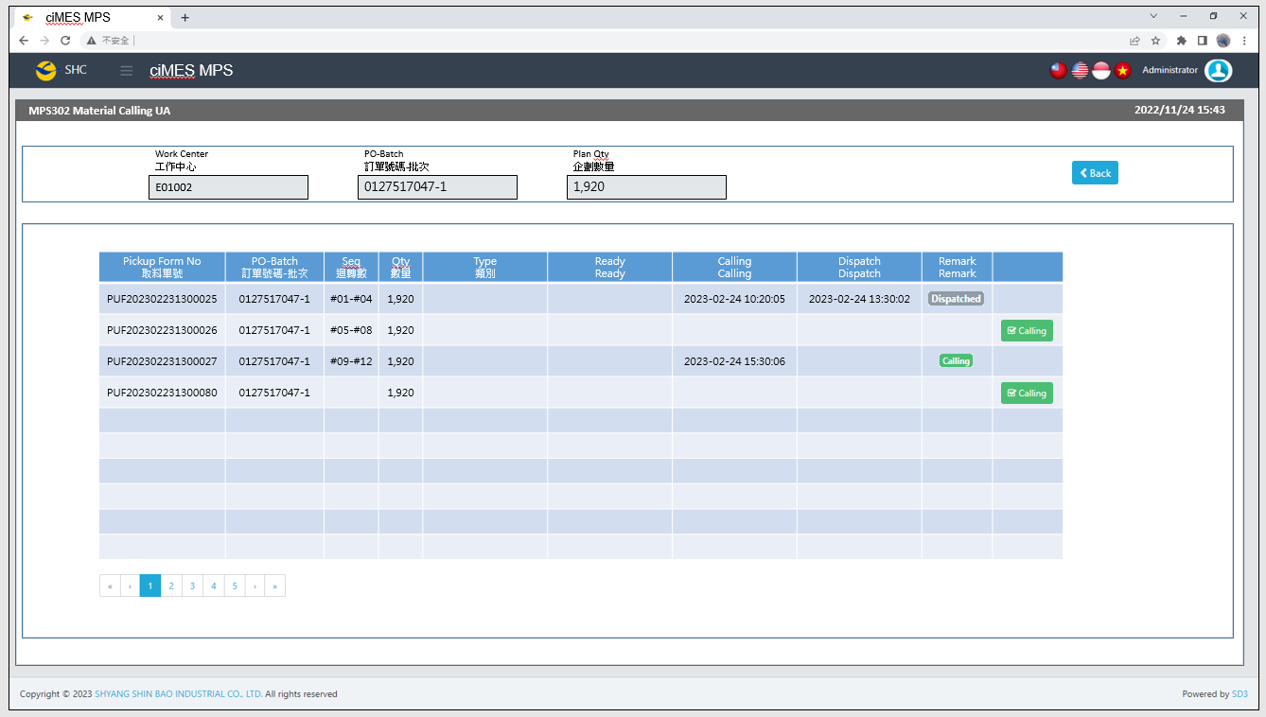

[圖MPS302_2] Calling Page 叫料畫面

|  |  |  |  |  |  |  |
| --- | --- | --- | --- | --- | --- | --- |
| Calling Page 叫料畫面 | | | | | | |
| NO | 顯示名稱 | 必填 | 唯讀 | 存改 | 對應欄位 | 欄位型態  欄位說明 |
|  | Work Center  工作中心 |  | V |  | User selected row | String |
|  | PO-Batch  訂單號碼-批次 |  | V |  | User selected row | String |
|  | Plan Qty  企劃數量 |  | V |  | User selected row | Numeric |
|  | Pickup Form No  取料單號 |  | V |  | PUFGROUP | String |
|  | PO-Batch  訂單號碼-批次 |  | V |  | PO_BATCH | String |
|  | Seq  迴轉數 |  | V |  | SEQUENCE | String |
|  | Qty  數量 |  | V |  | Plan_Qty | Numeric |
|  | Type  類別 |  | V |  | TYPE_SPECIAL | String |
|  | ~~In WH~~  ~~In WH~~ |  | ~~V~~ |  | ~~IN_WH_TIME~~ | ~~String~~  ~~yyyy-MM-dd HH:mm:ss~~ |
|  | ~~Setting~~  ~~Setting~~ |  | ~~V~~ |  | ~~SETTING_TIME~~ | ~~String~~  ~~yyyy-MM-dd HH:mm:ss~~ |
|  | Ready  Ready |  | V |  | READY_TIME | String  yyyy-MM-dd HH:mm:ss |
|  | Calling  Calling |  | V |  | CALLING_TIME | String  yyyy-MM-dd HH:mm:ss |
|  | Dispatch  Dispatch |  | V |  | DISPATCH_TIME | String  yyyy-MM-dd HH:mm:ss |
|  | Remark  Remark |  | V |  | IF DISPATCH_TIME not NULL，Show Dispatched  Else IF DISPATCH_TIME is NULL And CALLING_FLAG = 1，  Show Calling  Else  Show (Empty) | String  Dispatched color：Grey (badge-secondary)  Calling color：Green (badge-success) |
|  | Calling  叫料 |  |  |  | If CALLING_FLAG = 0 And PRINT_CNT > 0，Show  ELSE，Hide | Button  Please use double confirm window |
| 程式邏輯說明：  依照User點選的資料列，帶出該資料列的明細資料。  SQL：  --Param 1: User select row's Work Center (Not dropdown list)  --Param 2: User select row's PO-Batch  --Param 3: Always UA  --Param 4: User select's Work Center (Dropdown list)  --Param 5: Login User account  EXEC P_Get_PUFList_ByDeptAndPOBatch 'E01002', '0127517047-1', 'PA', 'E04001' , 'louis' -- Login User account | | | | | | |
| Calling Button click：  UPDATE CST_MPS_PICKFORM SET CALLING_FLAG = 1,  CALLING_TIME = GETDATE(), -- yyyy/MM/dd HH:mm:ss, (Server Time)  CALLING_USER = '' -- Login User account  WHERE PUFGROUP = 'PUF202302231300026'  AND KIND = 'UA' | | | | | | |

* 1. **「MPS303 Material Calling BA」MPS303 BA料號叫料**
  2. 程式名稱：同標題 (Right Name: MPS_Material.Calling.BA)
  3. 功能目的：BA料號叫料
  4. 使用部門：
  5. 程式說明：

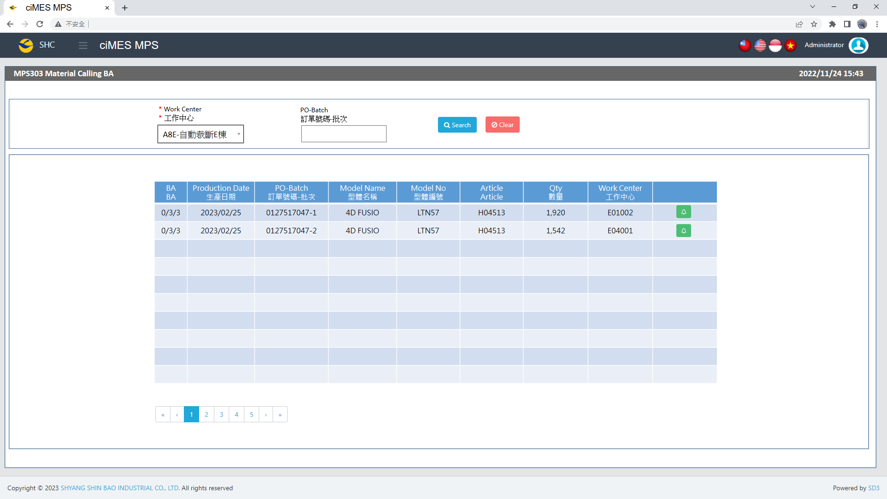

[圖MPS303_1] Main Page主畫面

|  |  |  |  |  |  |  |
| --- | --- | --- | --- | --- | --- | --- |
| Program header 程式標頭 | | | | | | |
| NO | 顯示名稱 | 必填 | 唯讀 | 存改 | 對應欄位 | 說明 |
|  | Title  標題 |  | V |  | CAPTION | String  If there is no get data, please show “Right Name”  SELECT T2.LANGUAGE, T2.CAPTION  FROM [MES_SEC_RIGHT] AS T1  JOIN [MES_MENU_ITEM] AS T2  ON T1.SEC_RIGHT_SID = T2.SEC_RIGHT_SID  WHERE T1.GROUPRIGHTS = 'MPS_Material.Calling.BA' --(Right Name) |
|  | System Time  系統時間 |  | V |  | Show current server time | Datetime  yyyy/MM/dd HH:mm |

|  |  |  |  |  |  |  |
| --- | --- | --- | --- | --- | --- | --- |
| Operation button 操作按鈕 | | | | | | |
| NO | 顯示名稱 | 必填 | 唯讀 | 存改 | 對應欄位 | 說明 |
|  | Search  搜尋 |  |  |  |  | Required「Work Center」to search |
|  | Clear  清除 |  |  |  |  | Clear Search Condition and Results |
|  | Calling Page  叫料畫面 |  |  |  |  | Switch to Calling Page |

|  |  |  |  |  |  |  |
| --- | --- | --- | --- | --- | --- | --- |
| Search Condition 搜尋條件 | | | | | | |
| NO | 顯示名稱 | 必填 | 唯讀 | 存改 | 對應欄位 | 欄位型態  欄位說明 |
|  | Work Center  工作中心 | V |  | V |  | Dropdown list  SELECT DEPT_ID, DEPT_ID + '-' + DEPT_DESC AS DEPT_ID_DESC  FROM [ERP_ORGANIZATION]  ORDER BY DEPT_ID |
|  | PO-Batch  訂單號碼-批次 |  |  | V | ~~Filter PO-Batch column~~ | String |

|  |  |  |  |  |  |  |
| --- | --- | --- | --- | --- | --- | --- |
| Search 搜尋 | | | | | | |
| NO | 顯示名稱 | 必填 | 唯讀 | 存改 | 對應欄位 | 欄位型態  欄位說明 |
|  | BA  BA |  | V |  | Called / NotCalled / Total_PUF | String |
|  | Production Date  生產日期 |  | V |  | Process_SDate | String  yyyy/MM/dd |
|  | PO-Batch  訂單號碼-批次 |  | V |  | PO_BATCH | String |
|  | Model Name  型體名稱 |  | V |  | MODEL_NAME | String |
|  | Model No  型體編號 |  | V |  | MODEL_NO | String |
|  | Article  Article |  | V |  | ARTICLE | String |
|  | Qty  數量 |  | V |  | QUANTITY | Numeric |
|  | Work Center  工作中心 |  | V |  | DEPT_ID | String |
|  | Calling Page button  叫料畫面按鈕 |  |  |  | Switch to Calling Page | Button  Button color：  If NotCalled > 0，Green (btn-success)  If NotCalled = 0，Grey (btn-secondary) |
| 程式邏輯說明：  選擇 Work Center 後，點選 [Search搜尋] 按鈕，即可帶出資料。  SQL：  EXEC P_Get_Each_PS_And_WorkCenter_Calling 'JAS', 'BA', ' 0132985410-1' | | | | | | |

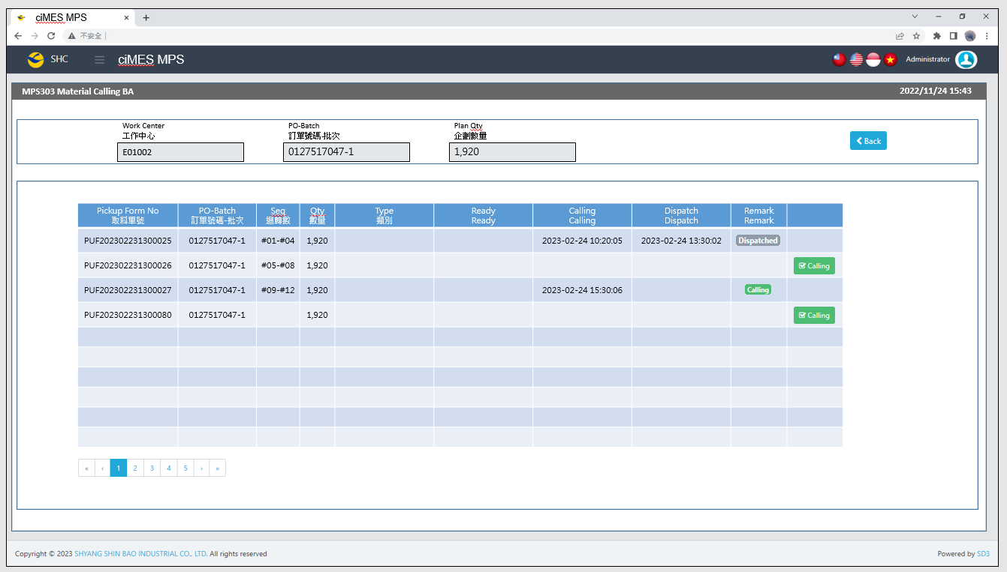

[圖MPS303_2] Calling Page 叫料畫面

|  |  |  |  |  |  |  |
| --- | --- | --- | --- | --- | --- | --- |
| Calling Page 叫料畫面 | | | | | | |
| NO | 顯示名稱 | 必填 | 唯讀 | 存改 | 對應欄位 | 欄位型態  欄位說明 |
|  | Work Center  工作中心 |  | V |  | User selected row | String |
|  | PO-Batch  訂單號碼-批次 |  | V |  | User selected row | String |
|  | Plan Qty  企劃數量 |  | V |  | User selected row | Numeric |
|  | Pickup Form No  取料單號 |  | V |  | PUFGROUP | String |
|  | PO-Batch  訂單號碼-批次 |  | V |  | PO_BATCH | String |
|  | Seq  迴轉數 |  | V |  | SEQUENCE | String |
|  | Qty  數量 |  | V |  | Plan_Qty | Numeric |
|  | Type  類別 |  | V |  | TYPE_SPECIAL | String |
|  | ~~In WH~~  ~~In WH~~ |  | ~~V~~ |  | ~~IN_WH_TIME~~ | ~~String~~  ~~yyyy-MM-dd HH:mm:ss~~ |
|  | ~~Setting~~  ~~Setting~~ |  | ~~V~~ |  | ~~SETTING_TIME~~ | ~~String~~  ~~yyyy-MM-dd HH:mm:ss~~ |
|  | Ready  Ready |  | V |  | READY_TIME | String  yyyy-MM-dd HH:mm:ss |
|  | Calling  Calling |  | V |  | CALLING_TIME | String  yyyy-MM-dd HH:mm:ss |
|  | Dispatch  Dispatch |  | V |  | DISPATCH_TIME | String  yyyy-MM-dd HH:mm:ss |
|  | Remark  Remark |  | V |  | IF DISPATCH_TIME not NULL，Show Dispatched  Else IF DISPATCH_TIME is NULL And CALLING_FLAG = 1，  Show Calling  Else  Show (Empty) | String  Dispatched color：Grey (badge-secondary)  Calling color：Green (badge-success) |
|  | Calling  叫料 |  |  |  | If CALLING_FLAG = 0 And PRINT_CNT > 0，Show  ELSE，Hide | Button  Please use double confirm window |
| 程式邏輯說明：  依照User點選的資料列，帶出該資料列的明細資料。  SQL：  --Param 1: User select row's Work Center (Not dropdown list)  --Param 2: User select row's PO-Batch  --Param 3: Always BA  --Param 4: User select's Work Center (Dropdown list)  --Param 5: Login User account  EXEC P_Get_PUFList_ByDeptAndPOBatch 'E01002', '0127517047-1', 'PA', 'E04001' , 'louis' -- Login User account | | | | | | |
| Calling Button click：  UPDATE CST_MPS_PICKFORM SET CALLING_FLAG = 1,  CALLING_TIME = GETDATE(), -- yyyy/MM/dd HH:mm:ss, (Server Time)  CALLING_USER = '' -- Login User account  WHERE PUFGROUP = 'PUF202302231300026'  AND KIND = 'BA' | | | | | | |

* 1. **「MPS304 Material Calling FA」MPS304 FA料號叫料**
  2. 程式名稱：同標題 (Right Name: MPS_Material.Calling.FA)
  3. 功能目的：FA料號叫料
  4. 使用部門：
  5. 程式說明：

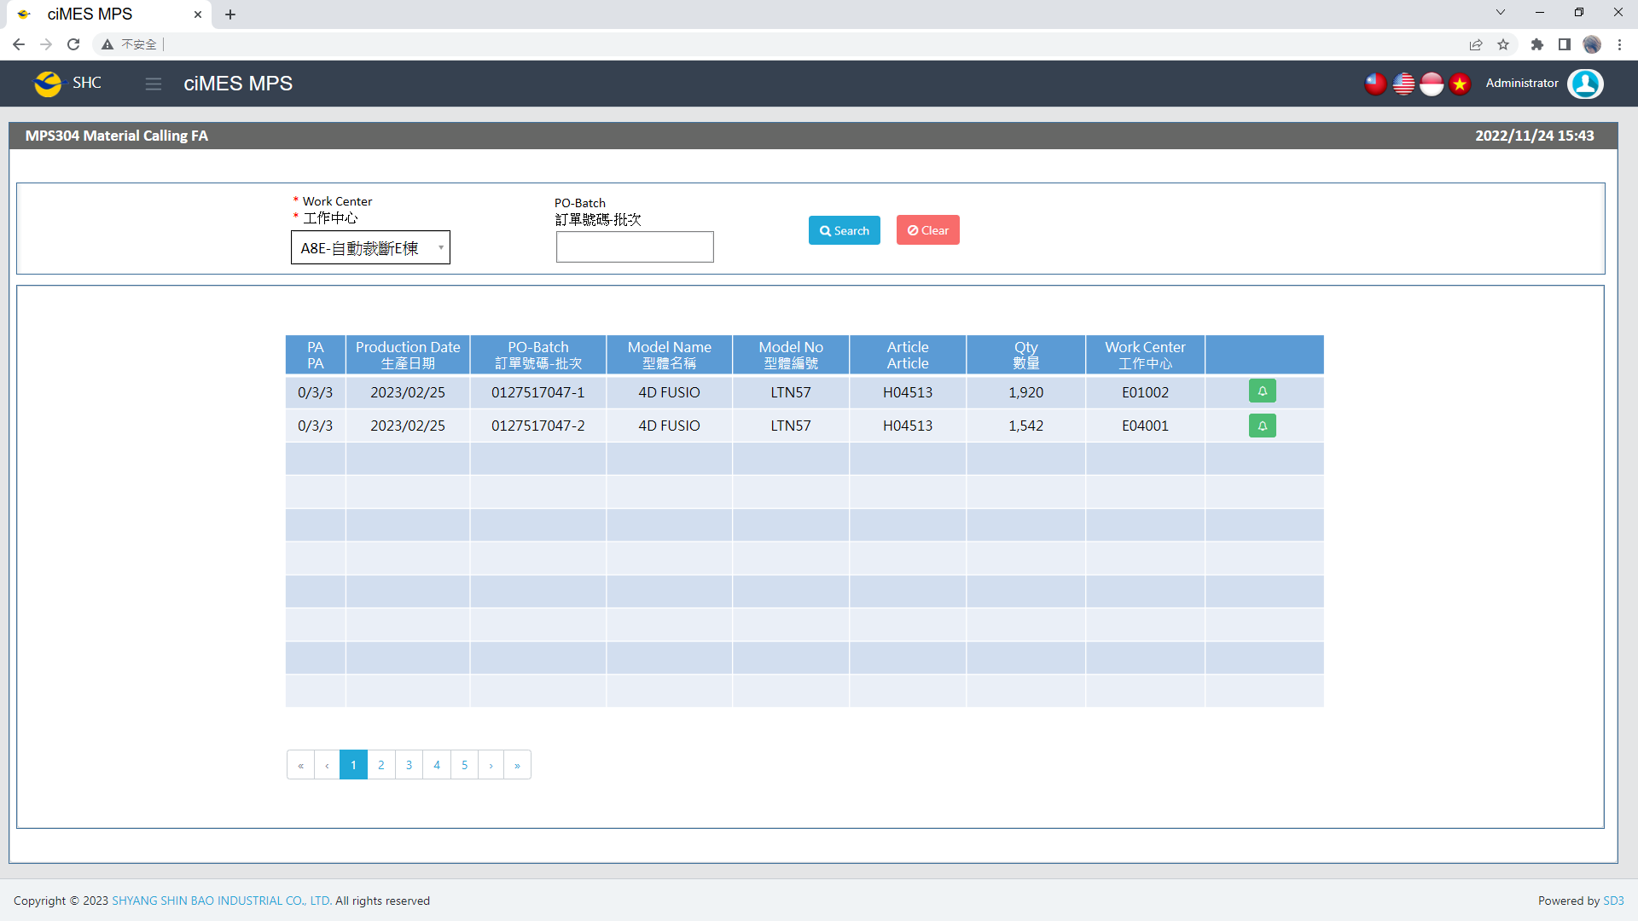

[圖MPS304_1] Main Page主畫面

|  |  |  |  |  |  |  |
| --- | --- | --- | --- | --- | --- | --- |
| Program header 程式標頭 | | | | | | |
| NO | 顯示名稱 | 必填 | 唯讀 | 存改 | 對應欄位 | 說明 |
|  | Title  標題 |  | V |  | CAPTION | String  If there is no get data, please show “Right Name”  SELECT T2.LANGUAGE, T2.CAPTION  FROM [MES_SEC_RIGHT] AS T1  JOIN [MES_MENU_ITEM] AS T2  ON T1.SEC_RIGHT_SID = T2.SEC_RIGHT_SID  WHERE T1.GROUPRIGHTS = 'MPS_Material.Calling.FA' --(Right Name) |
|  | System Time  系統時間 |  | V |  | Show current server time | Datetime  yyyy/MM/dd HH:mm |

|  |  |  |  |  |  |  |
| --- | --- | --- | --- | --- | --- | --- |
| Operation button 操作按鈕 | | | | | | |
| NO | 顯示名稱 | 必填 | 唯讀 | 存改 | 對應欄位 | 說明 |
|  | Search  搜尋 |  |  |  |  | Required「Work Center」to search |
|  | Clear  清除 |  |  |  |  | Clear Search Condition and Results |
|  | Calling Page  叫料畫面 |  |  |  |  | Switch to Calling Page |

|  |  |  |  |  |  |  |
| --- | --- | --- | --- | --- | --- | --- |
| Search Condition 搜尋條件 | | | | | | |
| NO | 顯示名稱 | 必填 | 唯讀 | 存改 | 對應欄位 | 欄位型態  欄位說明 |
|  | Work Center  工作中心 | V |  | V |  | Dropdown list  SELECT DEPT_ID, DEPT_ID + '-' + DEPT_DESC AS DEPT_ID_DESC  FROM [ERP_ORGANIZATION]  ORDER BY DEPT_ID |
|  | PO-Batch  訂單號碼-批次 |  |  | V | ~~Filter PO-Batch column~~ | String |

|  |  |  |  |  |  |  |
| --- | --- | --- | --- | --- | --- | --- |
| Search 搜尋 | | | | | | |
| NO | 顯示名稱 | 必填 | 唯讀 | 存改 | 對應欄位 | 欄位型態  欄位說明 |
|  | FA  FA |  | V |  | Called / NotCalled / Total_PUF | String |
|  | Production Date  生產日期 |  | V |  | Process_SDate | String  yyyy/MM/dd |
|  | PO-Batch  訂單號碼-批次 |  | V |  | PO_BATCH | String |
|  | Model Name  型體名稱 |  | V |  | MODEL_NAME | String |
|  | Model No  型體編號 |  | V |  | MODEL_NO | String |
|  | Article  Article |  | V |  | ARTICLE | String |
|  | Qty  數量 |  | V |  | QUANTITY | Numeric |
|  | Work Center  工作中心 |  | V |  | DEPT_ID | String |
|  | Calling Page button  叫料畫面按鈕 |  |  |  | Switch to Calling Page | Button  Button color：  If NotCalled > 0，Green (btn-success)  If NotCalled = 0，Grey (btn-secondary) |
| 程式邏輯說明：  選擇 Work Center 後，點選 [Search搜尋] 按鈕，即可帶出資料。  SQL：  EXEC P_Get_Each_PS_And_WorkCenter_Calling 'JAS', 'FA', ' 0132985410-1' | | | | | | |

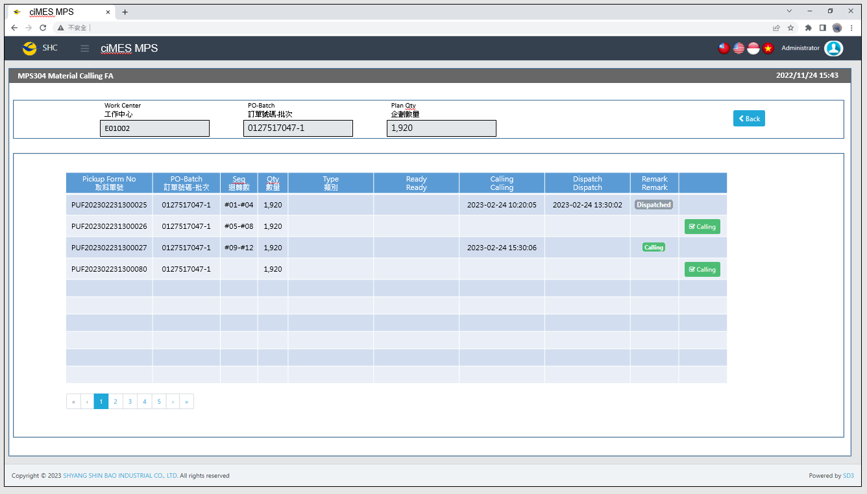

[圖MPS304_2] Calling Page叫料畫面

|  |  |  |  |  |  |  |
| --- | --- | --- | --- | --- | --- | --- |
| Calling Page 叫料畫面 | | | | | | |
| NO | 顯示名稱 | 必填 | 唯讀 | 存改 | 對應欄位 | 欄位型態  欄位說明 |
|  | Work Center  工作中心 |  | V |  | User selected row | String |
|  | PO-Batch  訂單號碼-批次 |  | V |  | User selected row | String |
|  | Plan Qty  企劃數量 |  | V |  | User selected row | Numeric |
|  | Pickup Form No  取料單號 |  | V |  | PUFGROUP | String |
|  | PO-Batch  訂單號碼-批次 |  | V |  | PO_BATCH | String |
|  | Seq  迴轉數 |  | V |  | SEQUENCE | String |
|  | Qty  數量 |  | V |  | Plan_Qty | Numeric |
|  | Type  類別 |  | V |  | TYPE_SPECIAL | String |
|  | ~~In WH~~  ~~In WH~~ |  | ~~V~~ |  | ~~IN_WH_TIME~~ | ~~String~~  ~~yyyy-MM-dd HH:mm:ss~~ |
|  | ~~Setting~~  ~~Setting~~ |  | ~~V~~ |  | ~~SETTING_TIME~~ | ~~String~~  ~~yyyy-MM-dd HH:mm:ss~~ |
|  | Ready  Ready |  | V |  | READY_TIME | String  yyyy-MM-dd HH:mm:ss |
|  | Calling  Calling |  | V |  | CALLING_TIME | String  yyyy-MM-dd HH:mm:ss |
|  | Dispatch  Dispatch |  | V |  | DISPATCH_TIME | String  yyyy-MM-dd HH:mm:ss |
|  | Remark  Remark |  | V |  | IF DISPATCH_TIME not NULL，Show Dispatched  Else IF DISPATCH_TIME is NULL And CALLING_FLAG = 1，  Show Calling  Else  Show (Empty) | String  Dispatched color：Grey (badge-secondary)  Calling color：Green (badge-success) |
|  | Calling  叫料 |  |  |  | If CALLING_FLAG = 0 And PRINT_CNT > 0，Show  ELSE，Hide | Button  Please use double confirm window |
| 程式邏輯說明：  依照User點選的資料列，帶出該資料列的明細資料。  SQL：  --Param 1: User select row's Work Center (Not dropdown list)  --Param 2: User select row's PO-Batch  --Param 3: Always FA  --Param 4: User select's Work Center (Dropdown list)  --Param 5: Login User account  EXEC P_Get_PUFList_ByDeptAndPOBatch 'E01002', '0127517047-1', 'PA', 'E04001' , 'louis' -- Login User account | | | | | | |
| Calling Button click：  UPDATE CST_MPS_PICKFORM SET CALLING_FLAG = 1,  CALLING_TIME = GETDATE(), -- yyyy/MM/dd HH:mm:ss, (Server Time)  CALLING_USER = '' -- Login User account  WHERE PUFGROUP = 'PUF202302231300026'  AND KIND = 'FA' | | | | | | |

* 1. **「MPS305 Material Calling AA」MPS305 AA料號叫料**
  2. 程式名稱：同標題 (Right Name: MPS_Material.Calling.AA)
  3. 功能目的：AA料號叫料
  4. 使用部門：
  5. 程式說明：

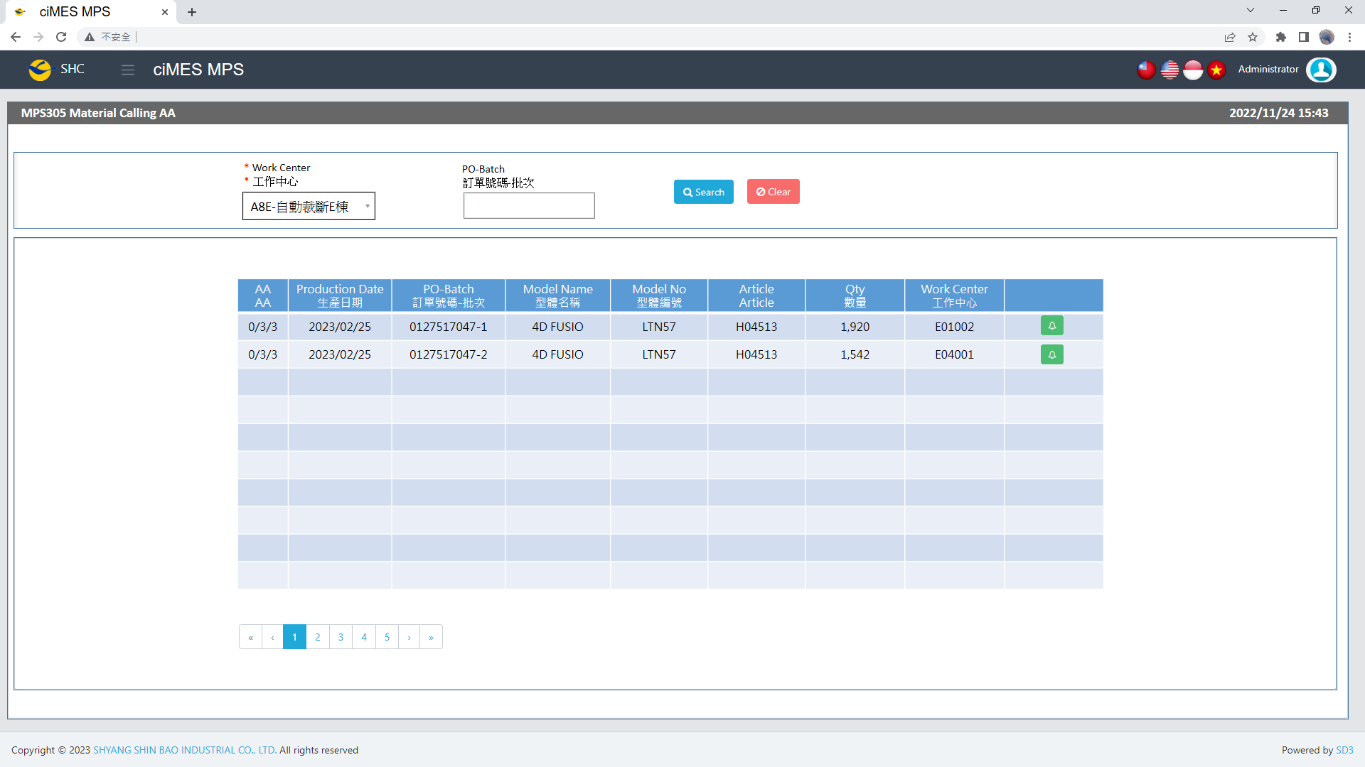

[圖MPS305_1] Main Page主畫面

|  |  |  |  |  |  |  |
| --- | --- | --- | --- | --- | --- | --- |
| Program header 程式標頭 | | | | | | |
| NO | 顯示名稱 | 必填 | 唯讀 | 存改 | 對應欄位 | 說明 |
|  | Title  標題 |  | V |  | CAPTION | String  If there is no get data, please show “Right Name”  SELECT T2.LANGUAGE, T2.CAPTION  FROM [MES_SEC_RIGHT] AS T1  JOIN [MES_MENU_ITEM] AS T2  ON T1.SEC_RIGHT_SID = T2.SEC_RIGHT_SID  WHERE T1.GROUPRIGHTS = 'MPS_Material.Calling.AA' --(Right Name) |
|  | System Time  系統時間 |  | V |  | Show current server time | Datetime  yyyy/MM/dd HH:mm |

|  |  |  |  |  |  |  |
| --- | --- | --- | --- | --- | --- | --- |
| Operation button 操作按鈕 | | | | | | |
| NO | 顯示名稱 | 必填 | 唯讀 | 存改 | 對應欄位 | 說明 |
|  | Search  搜尋 |  |  |  |  | Required「Work Center」to search |
|  | Clear  清除 |  |  |  |  | Clear Search Condition and Results |
|  | Calling Page  叫料畫面 |  |  |  |  | Switch to Calling Page |

|  |  |  |  |  |  |  |
| --- | --- | --- | --- | --- | --- | --- |
| Search Condition 搜尋條件 | | | | | | |
| NO | 顯示名稱 | 必填 | 唯讀 | 存改 | 對應欄位 | 欄位型態  欄位說明 |
|  | Work Center  工作中心 | V |  | V |  | Dropdown list  SELECT DEPT_ID, DEPT_ID + '-' + DEPT_DESC AS DEPT_ID_DESC  FROM [ERP_ORGANIZATION]  ORDER BY DEPT_ID |
|  | PO-Batch  訂單號碼-批次 |  |  | V | ~~Filter PO-Batch column~~ | String |

|  |  |  |  |  |  |  |
| --- | --- | --- | --- | --- | --- | --- |
| Search 搜尋 | | | | | | |
| NO | 顯示名稱 | 必填 | 唯讀 | 存改 | 對應欄位 | 欄位型態  欄位說明 |
|  | FA  FA |  | V |  | Called / NotCalled / Total_PUF | String |
|  | Production Date  生產日期 |  | V |  | Process_SDate | String  yyyy/MM/dd |
|  | PO-Batch  訂單號碼-批次 |  | V |  | PO_BATCH | String |
|  | Model Name  型體名稱 |  | V |  | MODEL_NAME | String |
|  | Model No  型體編號 |  | V |  | MODEL_NO | String |
|  | Article  Article |  | V |  | ARTICLE | String |
|  | Qty  數量 |  | V |  | QUANTITY | Numeric |
|  | Work Center  工作中心 |  | V |  | DEPT_ID | String |
|  | Calling Page button  叫料畫面按鈕 |  |  |  | Switch to Calling Page | Button  Button color：  If NotCalled > 0，Green (btn-success)  If NotCalled = 0，Grey (btn-secondary) |
| 程式邏輯說明：  選擇 Work Center 後，點選 [Search搜尋] 按鈕，即可帶出資料。  SQL：  EXEC P_Get_Each_PS_And_WorkCenter_Calling 'JAS', 'AA', ' 0132985410-1' | | | | | | |

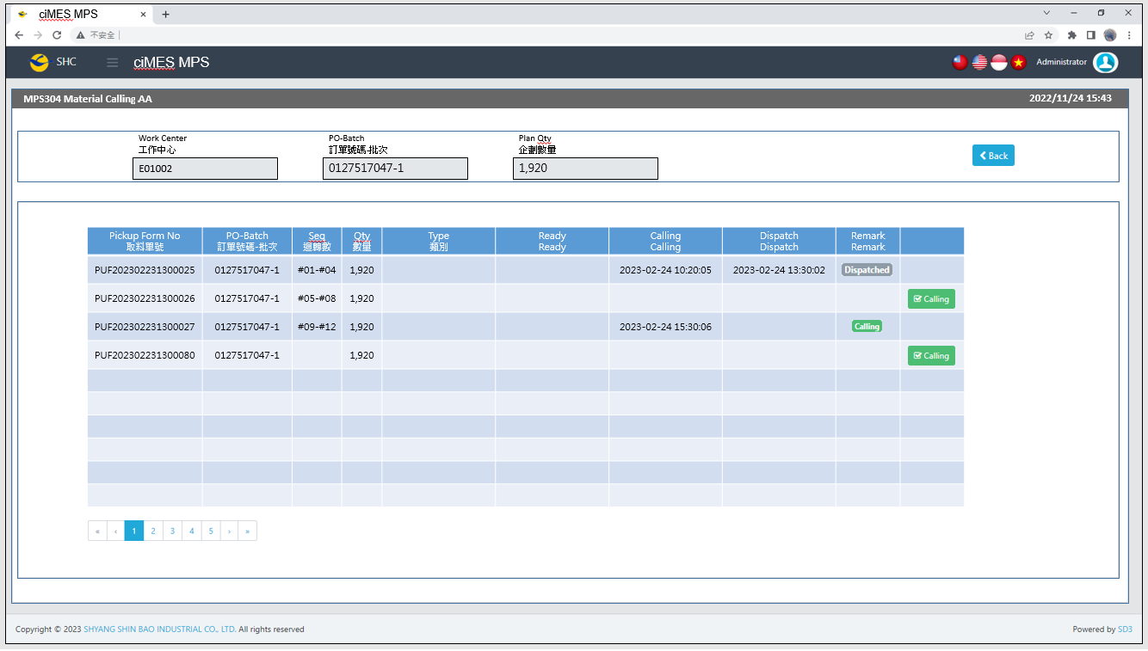

[圖MPS305_2] Calling Page叫料畫面

|  |  |  |  |  |  |  |
| --- | --- | --- | --- | --- | --- | --- |
| Calling Page 叫料畫面 | | | | | | |
| NO | 顯示名稱 | 必填 | 唯讀 | 存改 | 對應欄位 | 欄位型態  欄位說明 |
|  | Work Center  工作中心 |  | V |  | User selected row | String |
|  | PO-Batch  訂單號碼-批次 |  | V |  | User selected row | String |
|  | Plan Qty  企劃數量 |  | V |  | User selected row | Numeric |
|  | Pickup Form No  取料單號 |  | V |  | PUFGROUP | String |
|  | PO-Batch  訂單號碼-批次 |  | V |  | PO_BATCH | String |
|  | Seq  迴轉數 |  | V |  | SEQUENCE | String |
|  | Qty  數量 |  | V |  | Plan_Qty | Numeric |
|  | Type  類別 |  | V |  | TYPE_SPECIAL | String |
|  | ~~In WH~~  ~~In WH~~ |  | ~~V~~ |  | ~~IN_WH_TIME~~ | ~~String~~  ~~yyyy-MM-dd HH:mm:ss~~ |
|  | ~~Setting~~  ~~Setting~~ |  | ~~V~~ |  | ~~SETTING_TIME~~ | ~~String~~  ~~yyyy-MM-dd HH:mm:ss~~ |
|  | Ready  Ready |  | V |  | READY_TIME | String  yyyy-MM-dd HH:mm:ss |
|  | Calling  Calling |  | V |  | CALLING_TIME | String  yyyy-MM-dd HH:mm:ss |
|  | Dispatch  Dispatch |  | V |  | DISPATCH_TIME | String  yyyy-MM-dd HH:mm:ss |
|  | Remark  Remark |  | V |  | IF DISPATCH_TIME not NULL，Show Dispatched  Else IF DISPATCH_TIME is NULL And CALLING_FLAG = 1，  Show Calling  Else  Show (Empty) | String  Dispatched color：Grey (badge-secondary)  Calling color：Green (badge-success) |
|  | Calling  叫料 |  |  |  | If CALLING_FLAG = 0 And PRINT_CNT > 0，Show  ELSE，Hide | Button  Please use double confirm window |
| 程式邏輯說明：  依照User點選的資料列，帶出該資料列的明細資料。  SQL：  --Param 1: User select row's Work Center (Not dropdown list)  --Param 2: User select row's PO-Batch  --Param 3: Always AA  --Param 4: User select's Work Center (Dropdown list)  --Param 5: Login User account  EXEC P_Get_PUFList_ByDeptAndPOBatch 'E01002', '0127517047-1', 'PA', 'E04001' , 'louis' -- Login User account | | | | | | |
| Calling Button click：  UPDATE CST_MPS_PICKFORM SET CALLING_FLAG = 1,  CALLING_TIME = GETDATE(), -- yyyy/MM/dd HH:mm:ss, (Server Time)  CALLING_USER = '' -- Login User account  WHERE PUFGROUP = 'PUF202302231300026'  AND KIND = 'AA' | | | | | | |

* 1. **「MPS306 Material Calling (OEM PUF)」MPS306委託他廠代工叫料**
  2. 程式名稱：同標題 (Right Name: MPS_Material.Calling.OEM.PUF)
  3. 功能目的：委託他廠代工叫料 (PA BA UA AA FA)
  4. 使用部門：
  5. 程式說明：

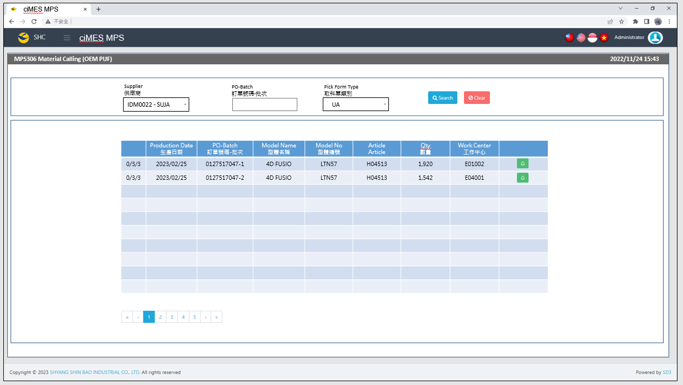

[圖MPS306_1] Main Page主畫面

|  |  |  |  |  |  |  |
| --- | --- | --- | --- | --- | --- | --- |
| Program header 程式標頭 | | | | | | |
| NO | 顯示名稱 | 必填 | 唯讀 | 存改 | 對應欄位 | 說明 |
|  | Title  標題 |  | V |  | CAPTION | String  If there is no get data, please show “Right Name”  SELECT T2.LANGUAGE, T2.CAPTION  FROM [MES_SEC_RIGHT] AS T1  JOIN [MES_MENU_ITEM] AS T2  ON T1.SEC_RIGHT_SID = T2.SEC_RIGHT_SID  WHERE T1.GROUPRIGHTS = 'MPS_Material.Calling.OEM.PUF ' --(Right Name) |
|  | System Time  系統時間 |  | V |  | Show current server time | Datetime  yyyy/MM/dd HH:mm |

|  |  |  |  |  |  |  |
| --- | --- | --- | --- | --- | --- | --- |
| Operation button 操作按鈕 | | | | | | |
| NO | 顯示名稱 | 必填 | 唯讀 | 存改 | 對應欄位 | 說明 |
|  | Search  搜尋 |  |  |  |  | Input「Supplier」and「PO-Batch」  (2 enter at least one)  、「Kind」to search |
|  | Clear  清除 |  |  |  |  | Clear Search Condition and Results |
|  | Calling Page  叫料畫面 |  |  |  |  | Switch to Calling Page |

|  |  |  |  |  |  |  |
| --- | --- | --- | --- | --- | --- | --- |
| Search Condition 搜尋條件 | | | | | | |
| NO | 顯示名稱 | 必填 | 唯讀 | 存改 | 對應欄位 | 欄位型態  欄位說明 |
|  | Supplier  供應商 | V |  | V |  | Dropdown list  SELECT SUPPLIER_CODE , SUPPLIER  FROM [ERP_SUPPLIER]  ORDER BY SUPPLIER_CODE |
|  | PO-Batch  訂單號碼-批次 |  |  | V |  | String |
|  | Pick Form Type  取料單類別 | V |  | V |  | Dropdown list  SELECT REMARK01 FROM MES_WPC_EXTENDITEM  WHERE CLASS = 'PICKFORM_TYPE'  ORDER BY REMARK01  (default value : NULL blank) |

|  |  |  |  |  |  |  |
| --- | --- | --- | --- | --- | --- | --- |
| Search 搜尋 | | | | | | |
| NO | 顯示名稱 | 必填 | 唯讀 | 存改 | 對應欄位 | 欄位型態  欄位說明 |
|  | NULL |  | V |  | Called / NotCalled / Total_PUF | String |
|  | Kind |  | V |  | Kind | String |
|  | Production Date  生產日期 |  | V |  | Process_SDate | String  yyyy/MM/dd |
|  | PO-Batch  訂單號碼-批次 |  | V |  | PO_BATCH | String |
|  | Model Name  型體名稱 |  | V |  | MODEL_NAME | String |
|  | Model No  型體編號 |  | V |  | MODEL_NO | String |
|  | Article  Article |  | V |  | ARTICLE | String |
|  | Qty  數量 |  | V |  | QUANTITY | Numeric |
|  | Work Center  工作中心 |  | V |  | DEPT_ID | String |
|  | Calling Page button  叫料畫面按鈕 |  |  |  | Switch to Calling Page | Button  Button color：  If NotCalled > 0，Green (btn-success)  If NotCalled = 0，Grey (btn-secondary) |
| 程式邏輯說明：  選擇Supplier 後，點選 [Search搜尋] 按鈕，即可帶出資料。  SQL：  ~~EXEC P_Get_Each_PS_And_WorkCenter_Calling 'JAS', 'AA', ' 0132985410-1'~~  exec P_Get_Each_PS_And_WorkCenter_Calling_Subcon 'DUNG HAO', 'UA', '0900362669001'  exec P_Get_Each_PS_And_WorkCenter_Calling_Subcon NULL, NULL, '0900362669001'  (parameters : SUPPLIER (Supplier name) 、 Pick Form Type 、 PO-Batch) | | | | | | |

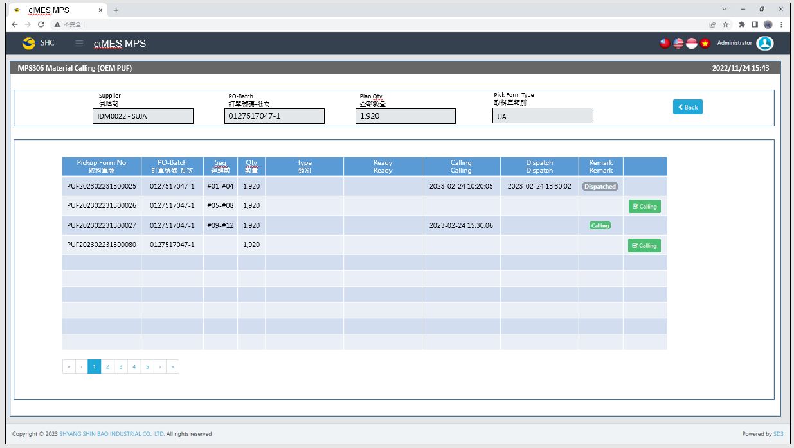

[圖MPS306_2] Calling Page叫料畫面

|  |  |  |  |  |  |  |
| --- | --- | --- | --- | --- | --- | --- |
| Calling Page 叫料畫面 | | | | | | |
| NO | 顯示名稱 | 必填 | 唯讀 | 存改 | 對應欄位 | 欄位型態  欄位說明 |
|  | Supplier  供應商 |  | V |  | User selected row | String |
|  | PO-Batch  訂單號碼-批次 |  | V |  | User selected row | String |
|  | Plan Qty  企劃數量 |  | V |  | User selected row | Numeric |
|  | Pick Form Type  取料單類別 |  | V |  | User selected row | String |
|  | Pickup Form No  取料單號 |  | V |  | PUFGROUP | String |
|  | PO-Batch  訂單號碼-批次 |  | V |  | PO_BATCH | String |
|  | Seq  迴轉數 |  | V |  | SEQUENCE | String |
|  | Qty  數量 |  | V |  | Plan_Qty | Numeric |
|  | Type  類別 |  | V |  | TYPE_SPECIAL | String |
|  | Ready  Ready |  | V |  | READY_TIME | String  yyyy-MM-dd HH:mm:ss |
|  | Calling  Calling |  | V |  | CALLING_TIME | String  yyyy-MM-dd HH:mm:ss |
|  | Dispatch  Dispatch |  | V |  | DISPATCH_TIME | String  yyyy-MM-dd HH:mm:ss |
|  | Remark  Remark |  | V |  | IF DISPATCH_TIME not NULL，Show Dispatched  Else IF DISPATCH_TIME is NULL And CALLING_FLAG = 1，  Show Calling  Else  Show (Empty) | String  Dispatched color：Grey (badge-secondary)  Calling color：Green (badge-success) |
|  | Calling  叫料 |  |  |  | If CALLING_FLAG = 0 And PRINT_CNT > 0，Show  ELSE，Hide | Button  Please use double confirm window |
| 程式邏輯說明：  依照User點選的資料列，帶出該資料列的明細資料。  SQL：  --Param 1: User select row's Work Center (Not dropdown list)  --Param 3: User select row's PO-Batch  --Param 3: User select row's Pick Form Type  --Param 4: User select's Work Center (Dropdown list)  --Param 5: Login User account  ~~EXEC P_Get_PUFList_ByDeptAndPOBatch 'E01002', '0127517047-1', 'PA', 'E04001' , 'louis' -- Login User account~~  EXEC P_Get_PUFList_ByDeptAndPOBatch_Subcon 'DUNG HAO', '0900362669001', 'UA', 'DUNG HAO ' , 'louis' -- Login User account | | | | | | |
| Calling Button click：  UPDATE CST_MPS_PICKFORM SET CALLING_FLAG = 1,  CALLING_TIME = GETDATE(), -- yyyy/MM/dd HH:mm:ss, (Server Time)  CALLING_USER = 'louis' -- Login User account  WHERE PUFGROUP = 'PUF202302231300026' --User select row's Pick Form No (PUFGROUP)  AND KIND = 'UA' --User select row's Pick Form Type | | | | | | |

1. 附錄